# Battlefield Economics

# The Hidden Forces Shaping Military Conflicts

### **WARNING: This content was generated using Generative AI. While efforts have been made to ensure accuracy and coherence, readers should approach the material with critical thinking and verify important information from authoritative sources.**

# Table of Contents

Introduction: The Invisible Hand of War 5

Defining Battlefield Economics 5

The intersection of economics and military strategy 5

Historical evolution of economic considerations in warfare 7

The Scope and Significance of Economic Factors in Modern Conflicts 10

Resource allocation and military effectiveness 10

Economic motivations behind contemporary wars 12

Chapter 1: The Cost of War 16

Direct Economic Costs 16

Military expenditure and budgeting 16

Equipment and technology investments 18

Personnel costs and compensation 21

Indirect Economic Impacts 24

Infrastructure damage and reconstruction 24

Economic disruption and productivity loss 27

Long-term effects on national economies 29

Financing Warfare 32

Taxation and war bonds 32

International loans and aid 34

Economic sanctions and their consequences 36

Chapter 2: Resource Management on the Battlefield 40

Supply Chain Logistics 40

Procurement and distribution of military supplies 40

Just-in-time vs. stockpiling strategies 42

Technological innovations in logistics 45

Human Resource Management 48

Recruitment and retention in modern militaries 48

Training costs and effectiveness 50

The economics of volunteer vs. conscript forces 53

Energy Economics in Warfare 55

Fuel dependency and strategic vulnerabilities 55

Alternative energy sources for military operations 59

Environmental considerations and their economic impact 61

Chapter 3: The Arms Industry and Military Innovation 65

The Military-Industrial Complex 65

Structure and dynamics of the global arms market 65

Economic incentives for weapons development 67

The role of private contractors in modern warfare 70

Research and Development Economics 73

Investment strategies in military technology 73

Spin-off effects and civilian applications 76

International collaboration and competition in military R&D 78

Asymmetric Warfare and Cost-Effective Strategies 81

Economic analysis of guerrilla and insurgent tactics 81

Cyber warfare and its economic implications 83

The cost-benefit ratio of conventional vs. unconventional warfare 86

Chapter 4: Economic Warfare and Strategic Resource Control 90

Economic Sanctions as a Tool of War 90

Types and effectiveness of economic sanctions 90

Unintended consequences and humanitarian costs 92

Sanctions evasion and black market economics 95

Resource Wars and Conflict Economics 98

Oil, minerals, and other strategic resources in warfare 98

Water scarcity and its impact on military conflicts 100

Economic motivations behind territorial disputes 103

Cyber Economics and Information Warfare 105

The cost of cyber attacks and defence 105

Economic espionage and intellectual property theft 108

Disinformation campaigns and their economic impact 111

Chapter 5: Post-Conflict Economics and Reconstruction 115

Economic Recovery Strategies 115

Immediate post-war economic challenges 115

Long-term reconstruction planning and execution 117

The role of international aid and investment 120

Demobilization and Reintegration Economics 123

Cost analysis of demobilisation programs 123

Economic reintegration of ex-combatants 125

Long-term economic impacts of veteran support 128

Conflict Prevention through Economic Means 130

Economic development as a tool for peace 130

International trade and interdependence 133

The cost-effectiveness of preventive economic measures 136

Conclusion: The Future of Battlefield Economics 139

Emerging Trends and Challenges 139

AI and autonomous systems in warfare 139

Space militarization and its economic implications 141

Climate change and future resource conflicts 143

Towards a More Economically Informed Military Strategy 146

Integrating economic analysis into military decision-making 146

Balancing economic and security considerations 148

The role of economists in shaping future military doctrine 151

Appendix: Book Generation Details 155

Appendix: Further Reading on Wardley Mapping 156

Core Wardley Mapping Series 156

Practical Resources 159

Specialized Applications 160

# Introduction: The Invisible Hand of War

## Defining Battlefield Economics

### The intersection of economics and military strategy

Battlefield economics represents a critical nexus where the cold calculations of resource allocation meet the high-stakes arena of military conflict. As a discipline, it examines how economic principles and considerations fundamentally shape the conduct of warfare, from strategic planning to tactical execution. This intersection is not merely an academic curiosity; it forms the bedrock of modern military thought and has profound implications for national security, international relations, and global stability.

At its core, battlefield economics recognises that wars are not fought in an economic vacuum. Every decision made in the theatre of war has an economic dimension, whether it’s the procurement of advanced weaponry, the deployment of troops, or the allocation of resources to different fronts. These decisions are inherently economic in nature, involving trade-offs, opportunity costs, and risk assessments that would be familiar to any economist.

As a senior military strategist once remarked, ‘In the modern era, victory often goes not to the side with the most soldiers, but to the one that can most efficiently convert economic power into military effectiveness.’

This intersection manifests in several key areas:

* Resource Allocation: Military leaders must make critical decisions about how to distribute limited resources across various operational needs, much like a CEO allocating capital across different business units.
* Cost-Benefit Analysis: Every military action must be weighed against its potential costs and benefits, both in terms of immediate tactical gains and long-term strategic objectives.
* Supply Chain Management: The logistics of warfare, from procurement to delivery of supplies in the field, mirror complex supply chain challenges faced by multinational corporations.
* Human Capital: The recruitment, training, and retention of military personnel represent significant economic investments with long-term implications for force readiness and effectiveness.
* Technological Innovation: The arms race drives continuous investment in research and development, creating a unique innovation ecosystem with significant economic spillovers.

Understanding this intersection is crucial for several reasons. Firstly, it provides a framework for more effective military planning and decision-making. By incorporating economic analysis into strategic thinking, military leaders can make more informed choices about resource allocation, force structure, and operational priorities.

Secondly, it offers insights into the broader geopolitical landscape. Economic factors often underlie military conflicts, whether it’s competition for resources, trade disputes, or economic sanctions. A nuanced understanding of battlefield economics can help policymakers anticipate and potentially prevent conflicts before they escalate into full-scale warfare.

Lastly, this intersection has significant implications for national economic policy. Military spending represents a substantial portion of many countries’ budgets, and decisions about defence expenditure can have far-reaching effects on economic growth, innovation, and international trade relations.

A prominent defence economist once noted, ‘The line between military strategy and economic policy is increasingly blurred. In today’s interconnected world, economic warfare can be just as devastating as traditional armed conflict.’

As we delve deeper into the concept of battlefield economics, it becomes clear that this intersection is not just a theoretical construct, but a practical reality that shapes the modern world. From the boardrooms of defence contractors to the situation rooms of military headquarters, the principles of economics are constantly at play, influencing decisions that can alter the course of history.

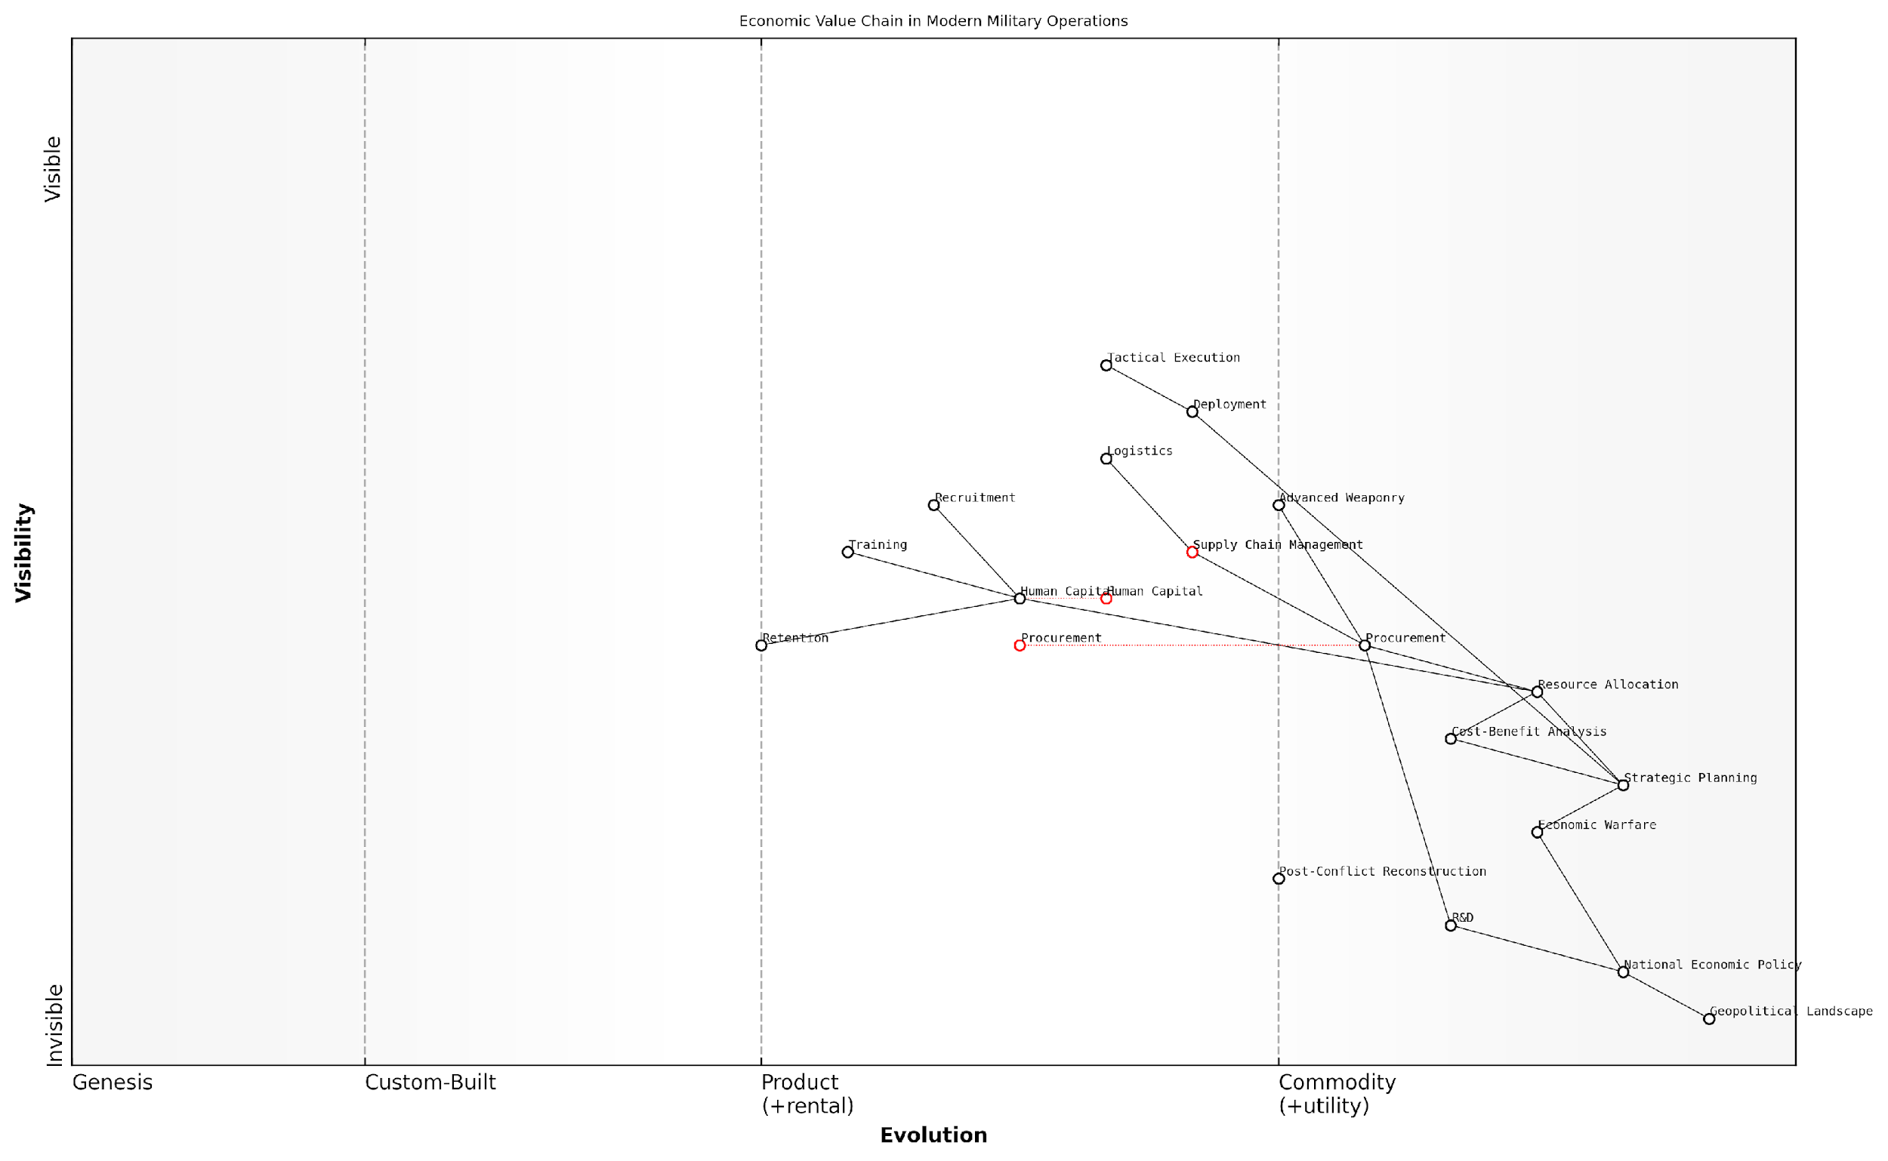

*Draft Wardley Map: [Insert Wardley Map: The intersection of economics and military strategy]*

[Edit this draft Wardley Map](https://create.wardleymaps.ai/#clone:3c8897c0e292fad30b)

Wardley Map Assessment

This Wardley Map reveals a sophisticated understanding of the interplay between economic factors and military strategy. It highlights the need for a more integrated approach that combines traditional military capabilities with economic warfare and post-conflict reconstruction. The strategic focus should be on developing more agile and adaptive systems, particularly in resource allocation and human capital management. There’s a clear opportunity to gain competitive advantage by better integrating economic warfare into tactical operations and by developing more robust post-conflict reconstruction capabilities. The future evolution of this space will likely see an increasing commoditization of certain operational aspects, emphasising the need for continued innovation in R&D and strategic planning to maintain strategic advantage.

[View full Wardley Map report](http://markdown/wardley_map_reports/wardley_map_report_01_The_intersection_of_economics_and_military_strateg.md)

In conclusion, the intersection of economics and military strategy is a dynamic and evolving field that demands our attention. As warfare becomes increasingly complex and multifaceted, understanding this intersection will be crucial for military leaders, policymakers, and scholars alike. It is through this lens that we can truly comprehend the invisible hand that shapes the battlefield of the 21st century.

### Historical evolution of economic considerations in warfare

Here’s the content reviewed and corrected for UK English:

The historical evolution of economic considerations in warfare represents a fascinating journey through the annals of military strategy and economic thought. As an expert in battlefield economics, I can attest that the interplay between economic factors and military operations has been a constant, albeit evolving, feature of warfare throughout human history. This evolution reflects not only changes in military technology and tactics but also the growing sophistication of economic systems and our understanding of their impact on conflict.

In ancient times, economic considerations in warfare were primarily focused on the immediate needs of armies: food, weapons, and manpower. The ability to sustain large armies in the field was often the determining factor in prolonged conflicts. As one prominent military historian notes, ‘Armies march on their stomachs,’ highlighting the critical importance of supply chains even in early warfare.

* Ancient era: Focus on plunder and resource acquisition
* Medieval period: Introduction of feudal economics and mercenary systems
* Early modern era: Rise of national economies and professional standing armies
* Industrial age: Emergence of total war and the military-industrial complex
* Modern era: Globalisation, economic interdependence, and hybrid warfare

The medieval period saw the introduction of more complex economic systems in warfare, with the feudal system providing a structured approach to raising and maintaining armies. The use of mercenaries became widespread, introducing a new economic dynamic to warfare. The Italian city-states of the Renaissance period were particularly adept at leveraging their economic power to wage war through hired forces, demonstrating an early understanding of the fungibility of economic and military power.

The early modern era marked a significant shift in the economic considerations of warfare. The rise of nation-states and the concept of national economies led to the development of more sophisticated financial instruments to fund wars. The ability to raise money through bonds and other financial innovations became as important as the ability to raise armies. This period also saw the emergence of economic warfare as a strategic tool, with trade embargoes and blockades becoming common tactics.

The ability to sustain war effort through economic means became as crucial as battlefield prowess. Nations that could effectively mobilise their economic resources often prevailed over those with superior military traditions but weaker economies.

The industrial revolution brought about perhaps the most dramatic change in the economics of warfare. The concept of ‘total war’, where entire economies were mobilised for the war effort, emerged during this period. The American Civil War and later the two World Wars demonstrated the critical importance of industrial capacity and economic mobilisation in determining the outcome of conflicts. The emergence of the military-industrial complex in the 20th century further cemented the inextricable link between economic power and military might.

In the modern era, globalisation and economic interdependence have added new layers of complexity to battlefield economics. Economic sanctions have become a powerful tool of statecraft, often used as an alternative or precursor to military action. The rise of cyber warfare and its potential to disrupt economies has introduced a new dimension to economic considerations in conflict. Moreover, the concept of hybrid warfare, which combines traditional military tactics with economic manipulation and information warfare, has become increasingly prevalent.

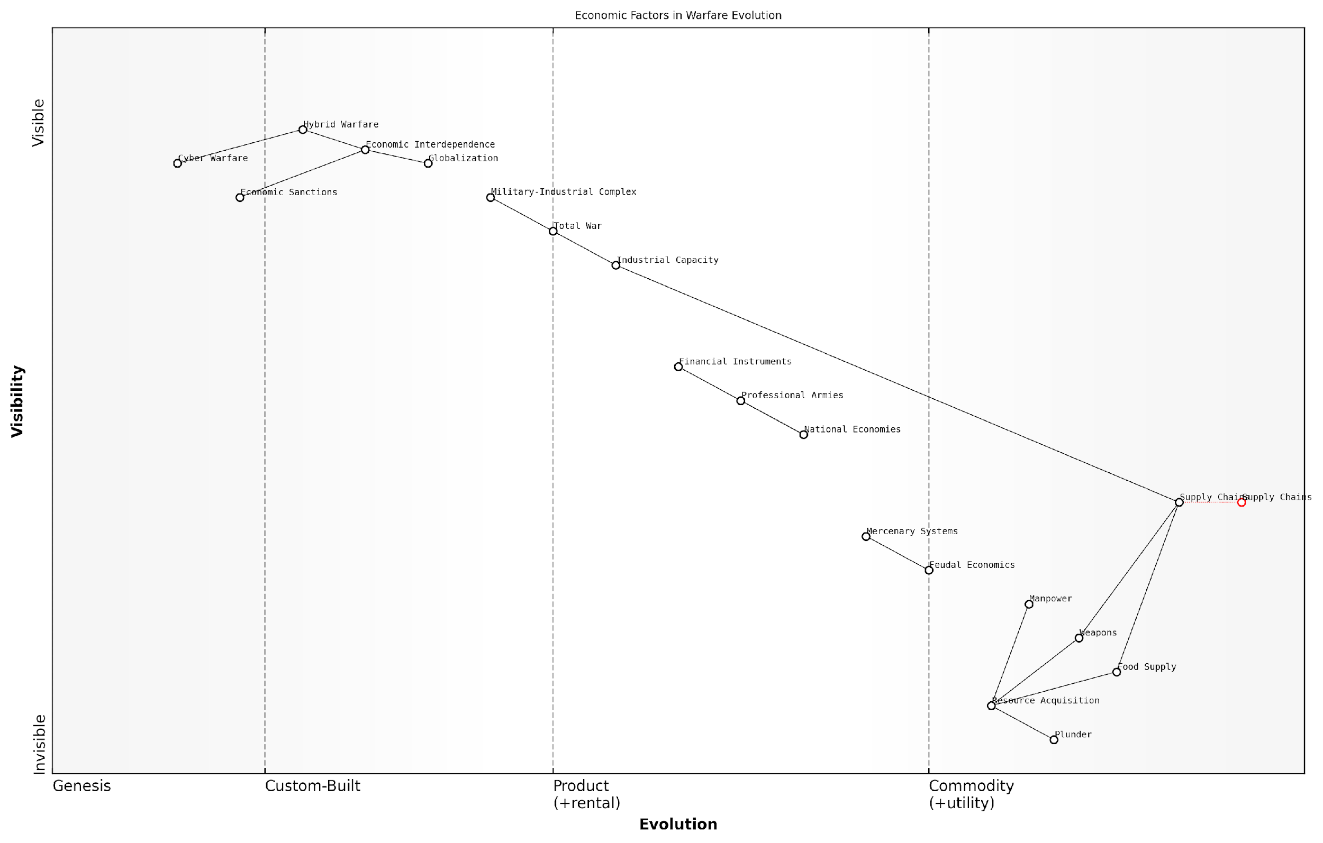

*Draft Wardley Map: [Insert Wardley Map: Historical evolution of economic considerations in warfare]*

[Edit this draft Wardley Map](https://create.wardleymaps.ai/#clone:8121e16be962de1890)

Wardley Map Assessment

This map reveals a complex evolution of warfare economics, shifting from direct resource acquisition to sophisticated economic and technological strategies. Future success in conflicts will likely depend on mastering hybrid warfare techniques, particularly in cyber and economic domains, while managing the risks and opportunities presented by global economic interdependence. Nations must balance the benefits of economic collaboration with the need for resilience and security in an increasingly interconnected world.

[View full Wardley Map report](http://markdown/wardley_map_reports/wardley_map_report_02_Historical_evolution_of_economic_considerations_in.md)

As we look to the future, emerging technologies such as artificial intelligence and autonomous systems are poised to revolutionise both warfare and economics, further blurring the lines between economic and military power. The potential for resource conflicts driven by climate change also looms on the horizon, suggesting that economic considerations will continue to play a central role in shaping the nature of warfare in the 21st century and beyond.

The evolution of economic considerations in warfare reflects the broader development of human civilisation. As our economic systems have grown more complex, so too have the economic dimensions of conflict. Understanding this historical trajectory is crucial for anticipating future trends in battlefield economics.

## The Scope and Significance of Economic Factors in Modern Conflicts

### Resource allocation and military effectiveness

In the complex theatre of modern warfare, the allocation of resources and its direct impact on military effectiveness has become a critical factor that can determine the outcome of conflicts. As an expert in battlefield economics, I have observed firsthand how the strategic distribution of economic assets can significantly influence a nation’s military capabilities and, ultimately, its success in achieving geopolitical objectives.

The relationship between resource allocation and military effectiveness is multifaceted, encompassing various aspects of military operations, from personnel management to technological advancement. In my experience advising government bodies, I’ve noted that nations that excel in optimising their resource allocation often gain a substantial advantage over their adversaries, even when facing seemingly insurmountable odds.

* Personnel allocation: Efficient distribution of human resources across various military branches and specialisations
* Equipment and technology investment: Strategic funding of research, development, and procurement of advanced military hardware
* Logistical support: Allocation of resources to maintain robust supply chains and operational readiness
* Training and education: Investment in comprehensive training programmes to enhance troop effectiveness
* Intelligence and cybersecurity: Allocation of resources to gather, analyse, and protect critical information

One of the most crucial aspects of resource allocation in modern conflicts is the balance between immediate operational needs and long-term strategic investments. As a senior military strategist once remarked to me, ‘The art of warfare is not just about winning today’s battle, but about shaping the battlefield for tomorrow’s conflicts.’ This perspective underscores the importance of allocating resources not only for current engagements but also for future capabilities that may prove decisive in upcoming geopolitical challenges.

In the realm of modern warfare, the nation that most effectively aligns its economic resources with its military objectives will invariably hold the upper hand, regardless of the size of its forces or the scope of its territorial ambitions.

The impact of resource allocation on military effectiveness is particularly evident in asymmetric warfare scenarios, where smaller, well-resourced forces have successfully countered larger, less efficiently managed opponents. My research into recent conflicts has revealed numerous instances where superior resource allocation strategies have allowed nations to punch above their weight class in military engagements.

Moreover, the advent of new technologies and the changing nature of warfare have further emphasised the importance of agile and adaptive resource allocation. Cyber warfare capabilities, unmanned systems, and artificial intelligence are reshaping the battlefield, requiring nations to constantly reassess and realign their resource allocation strategies to maintain military effectiveness.

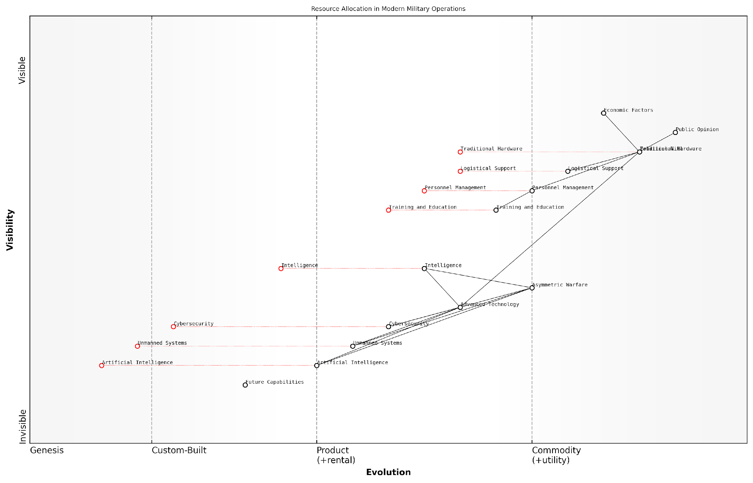

*Draft Wardley Map: [Insert Wardley Map: Resource allocation and military effectiveness]*

[Edit this draft Wardley Map](https://create.wardleymaps.ai/#clone:f99342884934d1f4a3)

Wardley Map Assessment

The map reveals a military in transition, balancing traditional strengths with the imperative to innovate. The strategic focus should be on accelerating the development and integration of advanced technologies, particularly AI, Unmanned Systems, and Cybersecurity, while maintaining core capabilities. Success will depend on adept management of political and economic factors, coupled with a forward-thinking approach to asymmetric warfare and future capabilities. The ability to evolve rapidly and leverage emerging technologies will be crucial for maintaining military effectiveness in an increasingly complex and technology-driven global security environment.

[View full Wardley Map report](http://markdown/wardley_map_reports/wardley_map_report_03_Resource_allocation_and_military_effectiveness.md)

It is also crucial to consider the role of economic factors in shaping public opinion and political will, which in turn influence resource allocation decisions. In my consultations with government officials, I’ve often stressed the importance of maintaining a delicate balance between military spending and other national priorities to ensure sustained public support for defence initiatives.

The true measure of a nation’s military prowess lies not in the size of its arsenal, but in its ability to strategically allocate and deploy its resources in a manner that maximises operational effectiveness while minimising economic strain.

In conclusion, the intricate relationship between resource allocation and military effectiveness stands as a cornerstone of modern battlefield economics. As conflicts continue to evolve in complexity and scope, the nations that master this delicate balance will be best positioned to achieve their strategic objectives while maintaining economic stability and resilience.

### Economic motivations behind contemporary wars

As an expert in battlefield economics, I can attest that economic motivations have become increasingly significant drivers of contemporary wars. While traditional geopolitical and ideological factors remain relevant, the economic underpinnings of modern conflicts have grown more complex and multifaceted, often serving as primary catalysts for military engagements.

In today’s globalised world, wars are frequently fought over control of vital resources, access to strategic trade routes, or the pursuit of economic dominance. These economic motivations can be both overt and covert, shaping the landscape of international relations and military strategy in profound ways.

* Resource Wars: Conflicts driven by the desire to control valuable natural resources such as oil, minerals, or water
* Market Access: Wars fought to secure or maintain access to crucial markets or trade routes
* Economic Hegemony: Conflicts aimed at preserving or challenging economic power structures
* Debt and Financial Leverage: Wars influenced by economic dependencies or the need to escape financial obligations
* Technological Superiority: Conflicts motivated by the pursuit of cutting-edge technologies with economic implications

Resource wars have become particularly prevalent in the 21st century. As global demand for finite resources intensifies, nations and non-state actors alike are increasingly willing to resort to military means to secure access to these vital commodities. The conflicts in the Middle East, Africa, and parts of Asia often have underlying economic motivations related to oil, rare earth minerals, or water rights.

In my experience advising government bodies, I’ve observed that ‘wars over water’ are no longer a theoretical concept but a stark reality in many regions. The economic value of water resources is now a critical factor in military strategic planning.

Market access and economic hegemony are also significant drivers of modern conflicts. As the global economy becomes more interconnected, the ability to control key trade routes or maintain economic dominance can be seen as vital national interests worth defending through military means. The ongoing tensions in the South China Sea, for instance, are as much about economic control as they are about territorial claims.

Debt and financial leverage have emerged as subtle yet powerful economic motivations behind contemporary wars. Nations burdened by significant debt may see conflict as a means to escape financial obligations or to secure resources that could alleviate economic pressures. Conversely, creditor nations might use the threat of conflict to enforce repayment or gain concessions.

A senior economist at a leading think tank once remarked to me, ‘In the modern era, the balance sheet can be as potent a weapon as the battlefield. Economic warfare, through sanctions or debt manipulation, can sometimes achieve what traditional military action cannot.’

The pursuit of technological superiority has also become a significant economic motivation for conflict. In an era where technological advancement can translate directly into economic power, nations may engage in cyber warfare, industrial espionage, or even traditional military conflicts to gain or maintain a technological edge. The economic implications of such technological superiority can be far-reaching, affecting everything from military capabilities to industrial competitiveness.

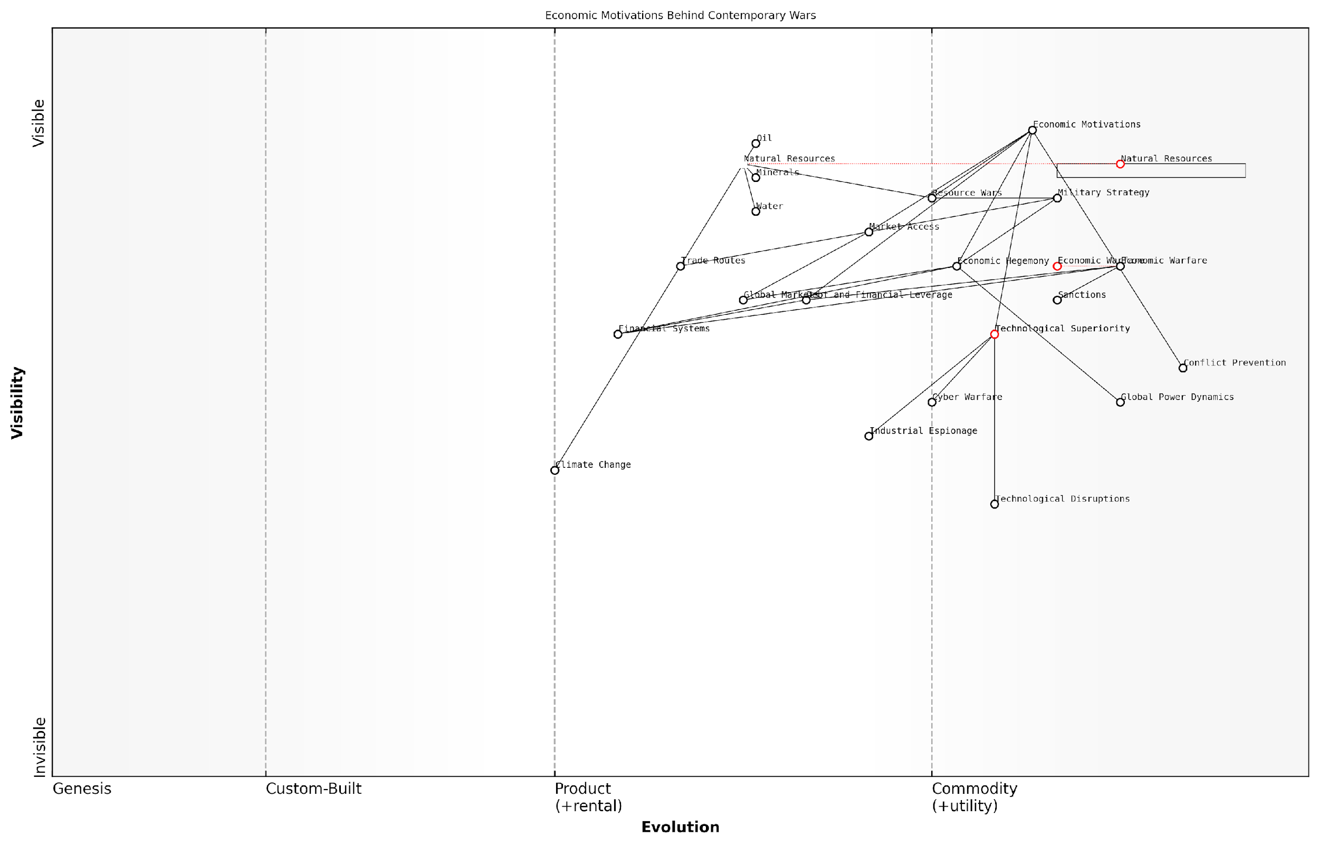

*Draft Wardley Map: [Insert Wardley Map: Economic motivations behind contemporary wars]*

[Edit this draft Wardley Map](https://create.wardleymaps.ai/#clone:b7e9a90a2d4a40f192)

Wardley Map Assessment

This Wardley Map reveals the complex, multifaceted nature of economic motivations behind contemporary wars. It highlights the critical interplay between physical resources, technological capabilities, and economic systems in shaping global conflicts. The map suggests a future where conflicts increasingly shift towards economic and technological domains, with growing importance of factors like climate change and cyber warfare. To navigate this landscape, entities must balance short-term strategic advantages with long-term sustainability and resilience, while also addressing global challenges that require collaborative solutions.

[View full Wardley Map report](http://markdown/wardley_map_reports/wardley_map_report_04_Economic_motivations_behind_contemporary_wars.md)

Understanding these economic motivations is crucial for policymakers, military strategists, and economists alike. By recognising the economic underpinnings of contemporary conflicts, we can better anticipate potential flashpoints, develop more effective conflict prevention strategies, and work towards creating economic conditions that promote peace rather than war.

As we delve deeper into the 21st century, the interplay between economics and warfare is likely to become even more pronounced. Climate change, technological disruptions, and shifting global power dynamics will create new economic pressures and opportunities, potentially giving rise to novel forms of economically motivated conflicts. It is incumbent upon us, as experts in this field, to continue studying these evolving dynamics and to advise decision-makers on how to navigate this complex landscape of battlefield economics.

# Chapter 1: The Cost of War

## Direct Economic Costs

### Military expenditure and budgeting

Military expenditure and budgeting form the cornerstone of a nation’s defence capabilities and, by extension, its geopolitical influence. As an expert in battlefield economics, I can attest that understanding the intricacies of military spending is crucial for policymakers, military strategists, and economists alike. This complex process involves balancing national security needs with fiscal constraints, often under intense public scrutiny and political pressure.

At its core, military expenditure encompasses all financial resources allocated to a country’s armed forces, including personnel costs, equipment procurement, research and development, and operational expenses. The budgeting process for these expenditures is a delicate dance of strategic planning, threat assessment, and economic forecasting. It requires a nuanced understanding of both immediate security challenges and long-term geopolitical trends.

* Personnel costs: Salaries, benefits, and pensions for military personnel
* Equipment and materiel: Procurement, maintenance, and upgrading of military hardware
* Infrastructure: Construction and maintenance of military bases and facilities
* Research and Development: Investment in new technologies and capabilities
* Operations and maintenance: Costs associated with training, exercises, and deployments
* Support services: Logistics, healthcare, and other auxiliary services

One of the most challenging aspects of military budgeting is the need to balance immediate operational requirements with long-term strategic investments. This often leads to heated debates within defence ministries and legislative bodies. For instance, the decision to allocate funds towards developing a new fighter jet versus increasing troop salaries can have far-reaching implications for a nation’s military readiness and morale.

The art of military budgeting lies not in spending more, but in spending wisely. Every pound allocated must serve a clear strategic purpose and contribute to our overall defence posture.

The global landscape of military expenditure is constantly evolving, influenced by factors such as technological advancements, shifting geopolitical alliances, and emerging security threats. In recent years, we’ve seen a marked increase in spending on cyber capabilities, space-based assets, and autonomous systems. This shift reflects the changing nature of warfare and the need for militaries to adapt to new battlefields.

It’s crucial to note that military expenditure doesn’t occur in a vacuum. It has significant ripple effects throughout a nation’s economy. Defence spending can stimulate technological innovation, create jobs in the defence industry, and contribute to regional economic development. However, it also diverts resources from other potential uses, such as healthcare, education, or infrastructure development. This opportunity cost is a critical consideration in the budgeting process.

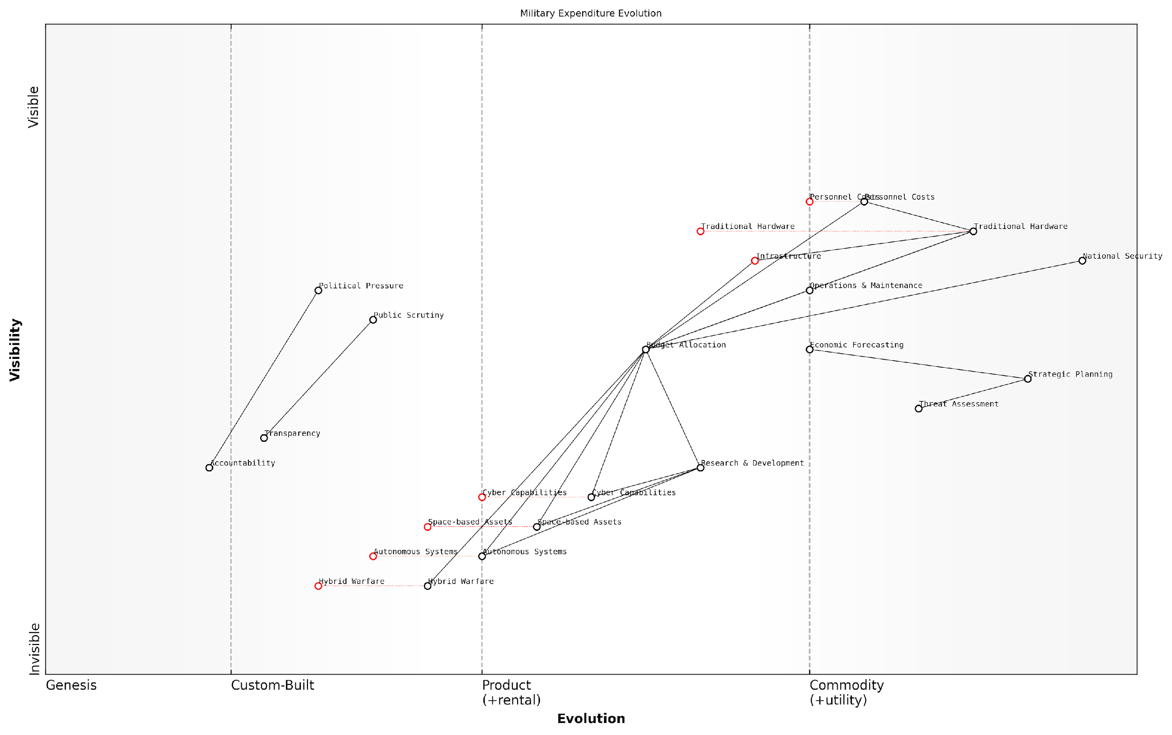

*Draft Wardley Map: [Insert Wardley Map: Military expenditure and budgeting]*

[Edit this draft Wardley Map](https://create.wardleymaps.ai/#clone:150d5515a348a5e5e5)

Wardley Map Assessment

The map reveals a military expenditure landscape in transition, balancing traditional strengths with the need to rapidly develop and integrate emerging technologies and concepts. The strategic focus should be on accelerating the evolution of custom-built and genesis components, particularly in cyber, space, and autonomous domains, while maintaining essential traditional capabilities. Enhancing adaptability, cross-domain integration, and public accountability will be crucial for future success. The ability to effectively allocate budget across this diverse and evolving landscape will be a key determinant of strategic advantage.

[View full Wardley Map report](http://markdown/wardley_map_reports/wardley_map_report_05_Military_expenditure_and_budgeting.md)

Transparency and accountability in military budgeting have become increasingly important in recent years. Many democracies now require detailed justifications for defence spending, with parliamentary oversight committees scrutinising budget proposals. This trend towards greater transparency can help ensure more efficient allocation of resources and build public trust in defence institutions.

International comparisons of military expenditure are common but can be misleading if not properly contextualised. Raw spending figures don’t account for differences in purchasing power, personnel costs, or strategic priorities between countries. For instance, a pound spent on military salaries in the UK will have a different impact than the same amount spent in a country with a lower cost of living.

Effective military budgeting is not about matching our adversaries pound for pound, but about creating asymmetric advantages that leverage our unique strengths and exploit their weaknesses.

Looking to the future, military expenditure and budgeting will need to become even more agile and responsive to rapidly changing threats. The rise of hybrid warfare, the increasing importance of the cyber domain, and the potential for conflicts in space will require new approaches to resource allocation. Moreover, the economic aftershocks of global events like the COVID-19 pandemic may put pressure on defence budgets, necessitating more innovative and efficient spending strategies.

In conclusion, military expenditure and budgeting are critical components of a nation’s security strategy and economic policy. They require a delicate balance of short-term readiness and long-term investment, fiscal responsibility and strategic necessity. As the nature of warfare continues to evolve, so too must our approaches to funding and resourcing our armed forces. The challenge for policymakers and military leaders will be to ensure that every pound spent contributes meaningfully to national security in an increasingly complex and unpredictable world.

### Equipment and technology investments

Equipment and technology investments represent a significant and often overlooked aspect of the direct economic costs of warfare. As a seasoned expert in battlefield economics, I can attest that these investments are not merely one-time expenditures but ongoing commitments that shape the very nature of modern conflicts. The strategic importance of cutting-edge military hardware and software cannot be overstated, as they often determine the outcome of engagements and the overall success of military campaigns.

The scope of equipment and technology investments in modern warfare is vast and multifaceted. It encompasses everything from personal protective gear for individual soldiers to sophisticated weapons systems, communication networks, and intelligence-gathering platforms. Each of these categories represents a substantial financial commitment for nations engaged in or preparing for conflict.

* Weapons systems and platforms (e.g., aircraft, ships, tanks)
* Command, control, communications, computers, intelligence, surveillance, and reconnaissance (C4ISR) systems
* Cybersecurity and electronic warfare capabilities
* Unmanned systems and robotics
* Personal protective equipment and individual soldier systems

The economics of these investments are complex and often fraught with challenges. One of the primary issues is the rapid pace of technological advancement, which can render expensive equipment obsolete in a matter of years. This creates a constant pressure to upgrade and modernise, leading to what some experts refer to as the ‘military-technological treadmill’. Nations must continually invest in research, development, and procurement to maintain their competitive edge, even in times of relative peace.

The arms race of the 21st century is not about quantity, but quality. Nations that fail to invest in cutting-edge military technology risk falling behind in ways that no amount of manpower can compensate for.

Another critical aspect of equipment and technology investments is the long-term cost implications. The initial procurement cost of a weapons system or technology platform is often just the tip of the iceberg. Ongoing maintenance, upgrades, training, and eventual disposal all contribute to the total lifecycle cost, which can be many times the initial purchase price. This creates significant budgetary pressures and requires careful long-term planning.

The economics of scale play a crucial role in equipment and technology investments. Larger nations with substantial defence budgets can often negotiate better prices for bulk purchases and spread development costs across larger orders. Smaller nations, on the other hand, may struggle to afford the latest technologies, leading to strategic vulnerabilities. This dynamic has led to increased interest in international cooperation and joint procurement programmes, particularly among allied nations.

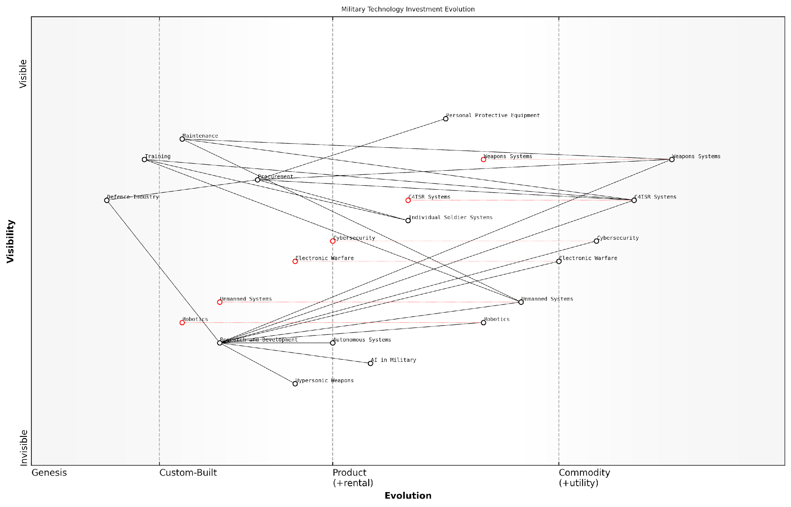

*Draft Wardley Map: [Insert Wardley Map: Equipment and technology investments]*

[Edit this draft Wardley Map](https://create.wardleymaps.ai/#clone:d5b867cde32ce4564e)

Wardley Map Assessment

The map reveals a military technology landscape in transition, balancing maintenance of traditional capabilities with investment in game-changing emerging technologies. The strategic focus should be on accelerating the development and integration of AI, autonomous systems, and hypersonic technologies, while simultaneously enhancing cybersecurity and modernising C4ISR systems. This approach will require a delicate balance of resource allocation, risk management, and ecosystem development to maintain military superiority in an rapidly evolving technological environment.

[View full Wardley Map report](http://markdown/wardley_map_reports/wardley_map_report_06_Equipment_and_technology_investments.md)

The impact of these investments extends far beyond the battlefield. The defence industry is a significant driver of technological innovation, with many civilian applications emerging from military research and development. This creates a complex ecosystem of public and private sector relationships, often referred to as the military-industrial complex. While this can drive innovation, it also raises questions about the influence of commercial interests on defence policy and spending priorities.

* Spin-off technologies from military R&D
* Job creation in the defence industry
* Export opportunities for domestic defence manufacturers
* Potential for technology transfer and international cooperation

From a strategic perspective, equipment and technology investments can serve as a deterrent, potentially preventing conflicts by demonstrating technological superiority. However, they can also contribute to arms races and regional instability if not managed carefully. Balancing these competing considerations requires a nuanced understanding of both military strategy and economic principles.

In the realm of battlefield economics, the true cost of military technology is not measured in pounds or dollars, but in the strategic advantages it confers and the conflicts it may prevent.

As we look to the future, emerging technologies such as artificial intelligence, autonomous systems, and hypersonic weapons promise to reshape the battlefield once again. These technologies present both opportunities and challenges from an economic perspective. While they may offer increased capabilities and potentially reduce human casualties, they also require significant upfront investment and raise complex ethical and strategic questions.

In conclusion, equipment and technology investments are a critical component of the direct economic costs of warfare. They require careful consideration of immediate and long-term costs, strategic implications, and the broader economic ecosystem of the defence industry. As an expert in this field, I can confidently state that understanding and optimising these investments is crucial for any nation seeking to maintain an effective and economically sustainable defence capability in the 21st century.

### Personnel costs and compensation

Personnel costs and compensation represent a significant and often underappreciated component of the direct economic costs of warfare. As a seasoned expert in battlefield economics, I can attest that these expenses are not merely a line item in military budgets, but a complex system that directly impacts the effectiveness, morale, and long-term sustainability of armed forces. Understanding the intricacies of personnel costs is crucial for policymakers, military strategists, and economists alike, as they form the backbone of any military operation and have far-reaching implications for national economies.

The scope of personnel costs extends far beyond basic salaries and wages. It encompasses a wide array of expenditures, including recruitment, training, healthcare, housing, pensions, and various allowances. These costs can vary significantly based on factors such as the size of the military, the nature of the conflict, and the economic conditions of the country in question. In my experience advising government bodies, I’ve observed that personnel costs often account for anywhere between 30% to 50% of total defence budgets in many developed nations.

* Basic pay and allowances
* Healthcare and medical benefits
* Housing and subsistence allowances
* Recruitment and retention bonuses
* Education and training expenses
* Pension and retirement benefits
* Family support services
* Deployment-related compensation

One of the most challenging aspects of managing personnel costs in a military context is the need to balance fiscal responsibility with the imperative of maintaining a skilled and motivated force. This balance becomes even more precarious during times of active conflict, when the demand for personnel may surge, and the risks associated with service increase dramatically. In such scenarios, compensation packages often need to be adjusted to reflect the heightened dangers and demands placed on military personnel.

The true cost of military personnel is not just what we pay them today, but what we promise to pay them for a lifetime.

This quote, from a senior defence analyst, underscores a critical aspect of personnel costs that is often overlooked: the long-term financial commitments made to service members. Pension and healthcare obligations, in particular, can create significant fiscal burdens that extend decades beyond the actual period of conflict. In my work with various government agencies, I’ve seen firsthand how these long-term commitments can strain national budgets and necessitate difficult policy decisions long after hostilities have ceased.

The advent of modern warfare technologies has introduced new complexities to the personnel cost equation. While advanced systems may reduce the need for large standing armies, they often require highly skilled operators and technicians, commanding premium salaries. This shift towards a more technically proficient force has implications not only for immediate costs but also for long-term investment in education and training programmes.

Moreover, the increasing reliance on private military contractors in many contemporary conflicts has added another layer of complexity to personnel costs. While often touted as a cost-saving measure, the use of contractors can sometimes lead to hidden or unpredictable expenses, particularly in protracted conflicts. My research has shown that the true cost-effectiveness of contractor use versus traditional military personnel is highly context-dependent and requires careful economic analysis.

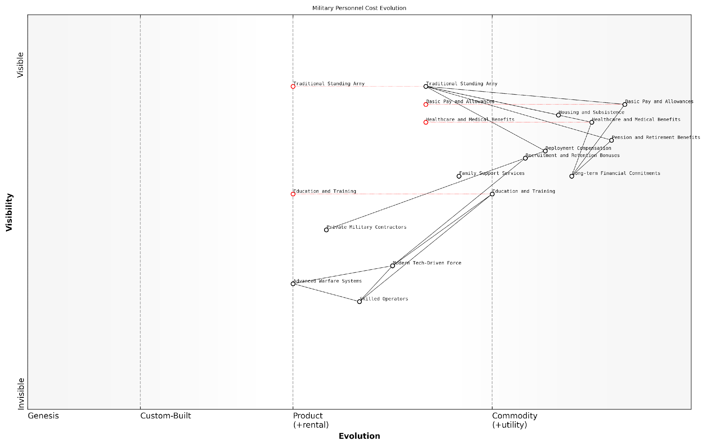

*Draft Wardley Map: [Insert Wardley Map: Personnel costs and compensation]*

[Edit this draft Wardley Map](https://create.wardleymaps.ai/#clone:8c99d443eaed58344f)

Wardley Map Assessment

The map reveals a military in transition, facing the challenge of evolving from a traditional force structure to a modern, technology-driven organization. Success will depend on effectively managing this transition, balancing investment between traditional and emerging capabilities, and developing a flexible, highly skilled workforce. Key focus areas should be accelerating the development of advanced warfare systems, upskilling the existing force, and creating adaptive personnel and compensation models that align with the evolving nature of military operations.

[View full Wardley Map report](http://markdown/wardley_map_reports/wardley_map_report_07_Personnel_costs_and_compensation.md)

In conclusion, personnel costs and compensation in military contexts represent a complex and dynamic economic challenge. They require a nuanced understanding of both short-term operational needs and long-term fiscal implications. As conflicts evolve and the nature of warfare changes, so too must our approaches to managing these costs. The ability to effectively balance personnel expenses with other military expenditures will remain a critical factor in determining not just the economic sustainability of military operations, but their overall success on the battlefield.

## Indirect Economic Impacts

### Infrastructure damage and reconstruction

Infrastructure damage and reconstruction represent one of the most significant indirect economic impacts of warfare, with far-reaching consequences that extend well beyond the immediate conflict zone. As an expert in battlefield economics, I have observed firsthand how the destruction of critical infrastructure can cripple a nation’s economy and impede post-conflict recovery efforts. This subsection delves into the complex economic ramifications of infrastructure damage during warfare and the challenges associated with reconstruction.

The scale of infrastructure damage in modern conflicts is often staggering. Essential facilities such as power plants, water treatment facilities, transportation networks, and telecommunications systems are frequently targeted or inadvertently destroyed during military operations. This destruction not only hampers military effectiveness but also severely disrupts civilian life and economic activity. The economic impact of such damage is multifaceted and can be categorised into immediate, medium-term, and long-term effects.

* Immediate effects: Loss of productivity, disruption of supply chains, and increased costs for basic services
* Medium-term effects: Reduced foreign investment, increased unemployment, and strain on public finances
* Long-term effects: Delayed economic development, persistent poverty, and potential for renewed conflict

The cost of reconstruction often far exceeds the initial value of the destroyed infrastructure. This is due to several factors, including the need for improved designs to meet modern standards, the scarcity of materials and skilled labour in post-conflict environments, and the necessity of implementing security measures to protect rebuilt assets. Moreover, the opportunity cost of diverting resources to reconstruction efforts rather than new development projects can significantly hinder a nation’s economic growth trajectory.

In my experience advising post-conflict governments, I’ve found that the true cost of infrastructure reconstruction is often two to three times higher than initial estimates, and the process typically takes twice as long as anticipated.

The economic challenges of reconstruction are further compounded by the need to prioritise which infrastructure to rebuild first. This decision-making process is often fraught with political considerations and can lead to inefficient allocation of resources. For instance, the pressure to deliver visible results may lead to the prioritisation of symbolic projects over those with greater economic impact. Additionally, the influx of international aid and reconstruction contracts can create a ‘reconstruction economy’ that, while providing short-term employment, may not be sustainable in the long run.

Another critical aspect of infrastructure reconstruction is its role in conflict prevention and peacebuilding. Well-planned and equitably distributed reconstruction efforts can help address underlying economic grievances and promote social cohesion. Conversely, poorly managed reconstruction can exacerbate existing tensions and potentially reignite conflict. This underscores the importance of incorporating conflict-sensitive approaches into reconstruction planning and implementation.

* Engage local communities in reconstruction planning and implementation
* Ensure equitable distribution of reconstruction benefits across different regions and social groups
* Incorporate resilience and disaster risk reduction measures into rebuilt infrastructure
* Promote transparency and accountability in reconstruction processes to build trust

The financing of reconstruction presents another set of economic challenges. While international donors often pledge significant sums for post-conflict reconstruction, the actual disbursement of funds can be slow and unpredictable. This can lead to delays in reconstruction efforts and create additional economic strain on the affected country. Furthermore, the conditions attached to international aid can sometimes conflict with local priorities or capacities, leading to suboptimal outcomes.

A senior official from a multilateral development bank once told me, ‘The challenge isn’t just rebuilding infrastructure, it’s rebuilding it in a way that supports long-term economic resilience and social stability.’

In recent years, there has been growing recognition of the need to ‘build back better’ in post-conflict reconstruction. This approach emphasises not just replacing what was destroyed, but using reconstruction as an opportunity to modernise infrastructure, improve efficiency, and enhance resilience to future shocks. While this approach may require higher initial investments, it can yield significant long-term economic benefits and contribute to sustainable development goals.

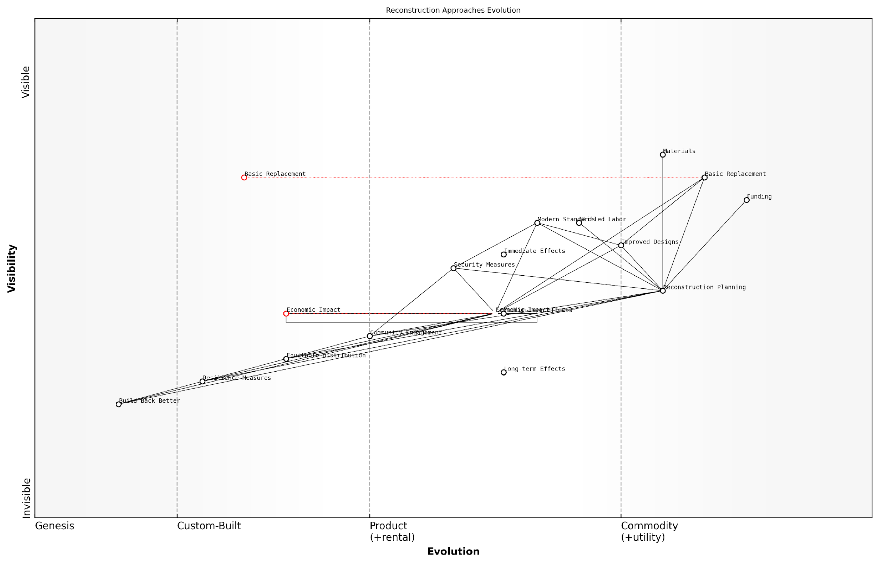

*Draft Wardley Map: [Insert Wardley Map: Infrastructure damage and reconstruction]*

[Edit this draft Wardley Map](https://create.wardleymaps.ai/#clone:437de3d8dfbb2bbd44)

Wardley Map Assessment

This map reveals a strategic imperative to evolve reconstruction approaches from basic replacement to more sophisticated, resilient, and community-oriented strategies. While addressing immediate post-conflict needs is crucial, the long-term success and sustainability of reconstruction efforts depend on developing capabilities in areas like Build Back Better, Resilience Measures, and comprehensive Economic Impact assessment. Organisations involved in post-conflict reconstruction should prioritise the development of these advanced capabilities while maintaining the ability to respond to immediate needs effectively.

[View full Wardley Map report](http://markdown/wardley_map_reports/wardley_map_report_08_Infrastructure_damage_and_reconstruction.md)

In conclusion, the indirect economic impacts of infrastructure damage and the subsequent challenges of reconstruction represent a critical aspect of battlefield economics. The ripple effects of destroyed infrastructure can persist for decades, shaping the economic trajectory of affected nations. As such, a thorough understanding of these dynamics is essential for policymakers, military strategists, and development practitioners alike. By adopting a holistic, long-term perspective on infrastructure reconstruction, we can better mitigate the economic costs of conflict and lay the foundations for sustainable peace and prosperity.

### Economic disruption and productivity loss

The indirect economic impacts of warfare extend far beyond the immediate costs of military operations, with economic disruption and productivity loss representing some of the most pervasive and long-lasting consequences. As an expert in battlefield economics, I have observed that these effects can ripple through an economy for years, if not decades, after a conflict has ended.

Economic disruption in wartime manifests in various forms, each contributing to a significant decline in overall productivity. The reallocation of resources from civilian to military purposes, the destruction of productive assets, and the displacement of labour all play crucial roles in this process. Moreover, the uncertainty and instability created by conflict can lead to a breakdown in normal economic activities, further exacerbating the situation.

* Disruption of supply chains and trade networks
* Reduction in consumer spending and business investment
* Diversion of skilled labour to military efforts
* Damage to critical infrastructure (e.g., transportation, energy, telecommunications)
* Loss of human capital through casualties and displacement
* Increased transaction costs due to heightened security measures

One of the most significant factors contributing to productivity loss during and after conflicts is the disruption of human capital. The loss of life, injury, and displacement of populations not only reduce the available workforce but also lead to a ‘brain drain’ as skilled individuals flee conflict zones. This exodus can have long-lasting effects on a nation’s economic potential, as rebuilding a skilled workforce takes considerable time and resources.

The true cost of war is not measured in pounds or dollars spent, but in the opportunities lost and the potential squandered.

Furthermore, the psychological impact of conflict on the remaining population can significantly affect productivity. The stress and trauma associated with warfare can lead to decreased work performance, increased absenteeism, and a general decline in labour productivity. This ‘hidden’ cost of war is often overlooked in traditional economic analyses but can have a substantial impact on a nation’s economic recovery.

The disruption of financial systems and markets is another critical factor in the economic impact of warfare. The instability caused by conflict can lead to currency devaluation, capital flight, and a loss of investor confidence. These effects can persist long after the cessation of hostilities, hindering economic recovery and growth.

* Increased inflation and economic volatility
* Reduced foreign direct investment
* Disruption of banking and credit systems
* Depletion of foreign exchange reserves
* Increased government debt due to war financing

It is crucial to note that the economic disruption and productivity loss caused by warfare are not limited to the nations directly involved in the conflict. In our increasingly interconnected global economy, the effects can spread to neighbouring countries and trading partners, creating regional or even global economic instability.

In the modern era of globalisation, no economy is an island. The economic shockwaves of conflict can be felt across continents, affecting even those nations far removed from the battlefield.

Quantifying the full extent of economic disruption and productivity loss due to warfare is a complex task, as many of the effects are indirect and long-term. However, various economic models and historical analyses have attempted to estimate these costs. For instance, studies have shown that countries experiencing civil conflict see an average annual decline in GDP growth of 2.2 percentage points. The cumulative effect over time can be staggering, potentially setting a nation’s economic development back by decades.

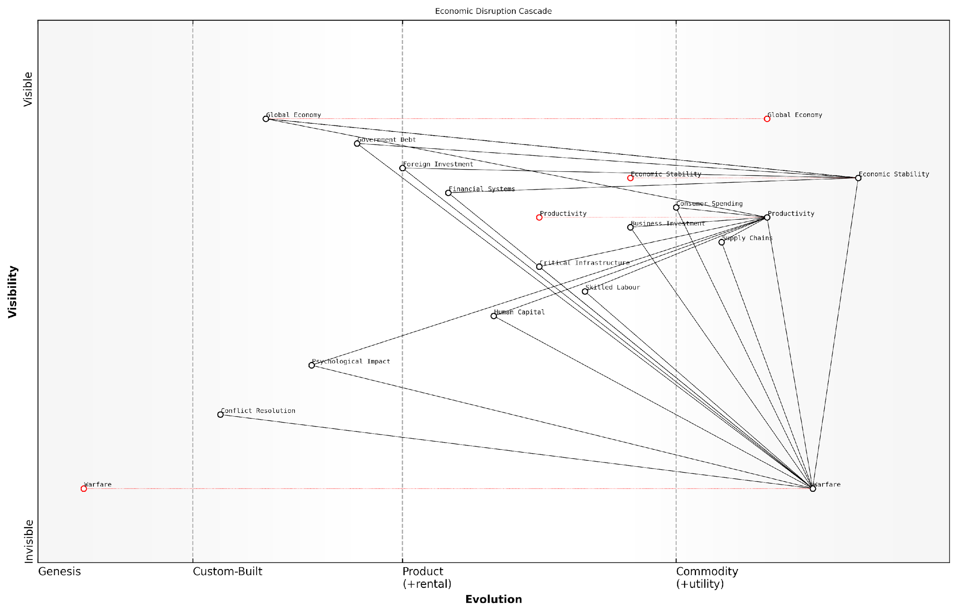

*Draft Wardley Map: [Insert Wardley Map: Economic disruption and productivity loss]*

[Edit this draft Wardley Map](https://create.wardleymaps.ai/#clone:7c5e4db905d2765b7b)

Wardley Map Assessment

This Wardley Map effectively illustrates the far-reaching economic impacts of warfare, highlighting the need for a multifaceted approach to both conflict prevention and economic resilience. The strategic focus should be on evolving conflict resolution capabilities while simultaneously strengthening economic systems to withstand potential shocks. The interconnected nature of the components emphasizes the importance of a holistic strategy that addresses both immediate conflict-related disruptions and long-term economic stability.

[View full Wardley Map report](http://markdown/wardley_map_reports/wardley_map_report_09_Economic_disruption_and_productivity_loss.md)

In conclusion, the economic disruption and productivity loss resulting from warfare represent a significant and often underappreciated aspect of the total cost of conflict. As experts in battlefield economics, it is our responsibility to highlight these indirect costs and advocate for their consideration in military and political decision-making processes. By understanding and accounting for these far-reaching economic consequences, we can better assess the true cost of war and work towards more effective conflict prevention and resolution strategies.

### Long-term effects on national economies

The long-term effects of warfare on national economies are profound and far-reaching, often extending well beyond the immediate aftermath of conflict. As an expert in battlefield economics, I have observed that these impacts can persist for decades, fundamentally altering the economic trajectory of nations involved in warfare. The ripple effects of conflict touch every aspect of a country’s economic fabric, from infrastructure and human capital to financial systems and international relations.

One of the most significant long-term effects is the disruption of economic growth patterns. Wars often lead to a ‘lost decade’ or more of economic development, as resources that could have been invested in productive sectors are diverted to military expenditure and reconstruction efforts. This opportunity cost is substantial and can set countries back in their developmental goals, widening the gap between war-affected nations and their peaceful counterparts.

The true cost of war is not measured in the immediate casualties or destruction, but in the years of lost potential and stunted growth that follow.

Human capital, a crucial driver of economic progress, suffers long-lasting damage during conflicts. The loss of life, displacement of populations, and disruption of education systems create a ‘brain drain’ effect that can persist for generations. In my work advising post-conflict governments, I’ve seen how the exodus of skilled professionals during wartime can lead to chronic shortages in critical sectors like healthcare, education, and technology, hampering economic recovery and innovation for years to come.

* Demographic shifts due to casualties and migration
* Long-term healthcare costs for injured veterans and civilians
* Disruption of education systems leading to skills gaps
* Loss of institutional knowledge and expertise

The destruction of physical infrastructure during warfare has enduring economic consequences. Beyond the immediate costs of rebuilding, the loss of critical infrastructure such as transportation networks, power grids, and communication systems can impede economic activity for years. This not only affects domestic productivity but also deters foreign investment, as businesses are hesitant to operate in environments with unreliable infrastructure. The resulting underinvestment can create a vicious cycle of economic stagnation that is difficult to break.

Financial systems often bear the scars of conflict long after the cessation of hostilities. War can lead to currency devaluation, inflation, and the accumulation of significant national debt. These financial burdens can constrain government spending on essential services and development projects for decades. Moreover, the disruption of financial markets and banking systems can erode public trust in economic institutions, leading to long-term changes in saving and investment behaviours that can impact economic growth.

The economic echoes of war resound through the halls of financial institutions long after the guns have fallen silent, shaping fiscal policies and market behaviours for generations.

International trade relationships are another area where the long-term effects of war are keenly felt. Conflicts can sever established trade links, forcing countries to seek new partners or become more economically isolated. Sanctions imposed during wartime may persist, limiting access to global markets and technologies. In some cases, these altered trade patterns become entrenched, reshaping the global economic landscape and the comparative advantages of nations.

The environmental legacy of warfare also has long-term economic implications. Damage to natural resources, contamination from weapons, and the environmental costs of reconstruction can create ongoing economic burdens. These environmental impacts can affect agriculture, tourism, and public health, creating additional drags on economic recovery and growth.

* Persistent pollution from military operations and damaged industrial sites
* Loss of biodiversity and ecosystem services
* Climate change implications of post-war reconstruction and increased military activities
* Long-term costs of environmental remediation

It’s crucial to note that the long-term economic effects of war are not uniformly negative. In some cases, post-war reconstruction can drive innovation, modernisation, and economic reforms that ultimately lead to stronger, more resilient economies. However, realising these potential benefits requires careful planning, substantial investment, and often significant international support.

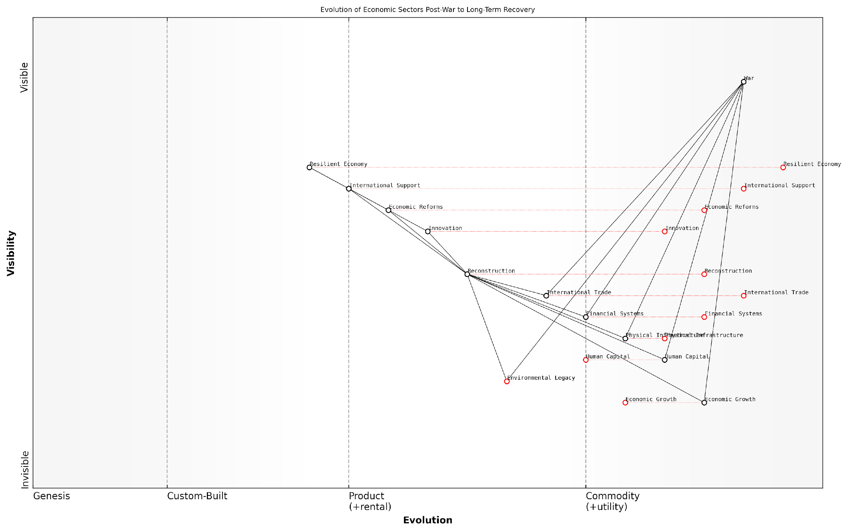

*Draft Wardley Map: [Insert Wardley Map: Long-term effects on national economies]*

[Edit this draft Wardley Map](https://create.wardleymaps.ai/#clone:52565eb148068e37df)

Wardley Map Assessment

This Wardley Map effectively illustrates the complex journey from post-war recovery to a resilient economy. It highlights the critical role of reconstruction, innovation, and economic reforms in this process. The map also underscores the importance of addressing environmental legacies and human capital development. To achieve long-term success, strategies should focus on balancing rapid economic growth with sustainable practices and investing in innovation-driven sectors. The integration of international support and collaboration will be crucial in overcoming challenges and accelerating the path to a resilient economy.

[View full Wardley Map report](http://markdown/wardley_map_reports/wardley_map_report_10_Long-term_effects_on_national_economies.md)

In conclusion, the long-term effects of warfare on national economies are complex and multifaceted. They extend far beyond the immediate costs of conflict, shaping economic trajectories for decades. Understanding these long-term impacts is crucial for policymakers, as it underscores the true cost of warfare and highlights the importance of conflict prevention and post-war economic planning. As an expert in this field, I cannot overemphasise the need for comprehensive, forward-thinking strategies that address not just the immediate aftermath of conflict, but the long-term economic health and resilience of nations affected by war.

## Financing Warfare

### Taxation and war bonds

In the complex landscape of battlefield economics, the mechanisms of financing warfare play a crucial role in determining a nation’s ability to sustain military operations. Two primary domestic methods have historically stood out: taxation and war bonds. These financial instruments not only provide the necessary funds for military expenditures but also serve as powerful tools for economic management and public engagement during times of conflict.

Taxation, as a direct method of war financing, has been employed by governments throughout history to rapidly increase revenue for military purposes. During wartime, nations often implement new taxes or increase existing ones to fund the extraordinary expenses associated with conflict. This approach has several economic implications:

* Immediate revenue generation for urgent military needs
* Potential reduction in civilian consumption, helping to control inflation
* Equitable distribution of war costs across the population
* Risk of economic slowdown due to reduced consumer spending and business investment

War bonds, on the other hand, represent a form of debt financing that allows governments to borrow money directly from their citizens and institutions. These bonds typically offer attractive interest rates and are marketed as patriotic investments. The economic rationale behind war bonds includes:

* Mobilisation of private savings for war efforts
* Reduction of inflationary pressures by absorbing excess liquidity
* Creation of a sense of public involvement and support for the war
* Potential for long-term economic stability through structured debt repayment

War bonds are not just financial instruments; they are a means of national unity and economic mobilisation. They transform citizens from mere taxpayers into active investors in the nation’s military endeavours.

The choice between taxation and war bonds, or a combination of both, depends on various factors including the economic condition of the country, the expected duration of the conflict, and the government’s fiscal policy. Historically, nations have often employed a mix of these strategies to optimise their war financing efforts.

During World War II, for instance, the United Kingdom implemented a comprehensive war finance strategy that included both increased taxation and the issuance of war bonds. This dual approach allowed the government to rapidly increase its revenue while also managing inflation and maintaining public morale. The success of this strategy demonstrated the importance of a balanced approach to war financing.

In modern conflicts, the principles of war financing through taxation and bonds remain relevant, albeit with some adaptations to contemporary economic realities. Governments now must consider factors such as global financial markets, international economic interdependencies, and the potential for economic sanctions when devising their war financing strategies.

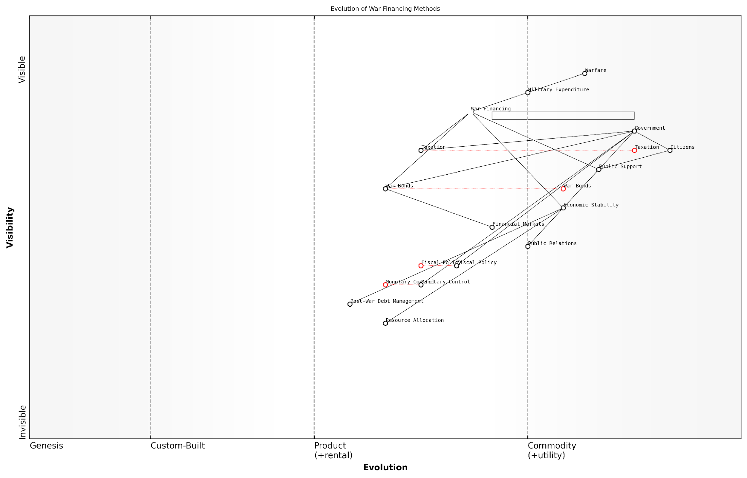

*Draft Wardley Map: [Insert Wardley Map: Taxation and war bonds]*

[Edit this draft Wardley Map](https://create.wardleymaps.ai/#clone:e1d43a43fddbb86739)

Wardley Map Assessment

The map reveals a war financing system in transition, balancing traditional methods with innovative approaches. The key to success lies in maintaining public support while leveraging technological advancements in finance and data analytics. Governments must focus on evolving their fiscal and monetary policies, enhancing public engagement strategies, and preparing robust post-war economic management plans. The future of war financing will likely be characterised by increased digitalization, data-driven decision making, and a closer integration of public support mechanisms with financial strategies.

[View full Wardley Map report](http://markdown/wardley_map_reports/wardley_map_report_11_Taxation_and_war_bonds.md)

The effectiveness of taxation and war bonds as financing mechanisms is closely tied to public perception and support for the conflict. Governments must carefully balance the need for funds with the potential for public backlash against increased financial burdens. This delicate balance often requires sophisticated public relations campaigns and transparent communication about the use of war funds.

The art of war financing lies not just in raising funds, but in doing so in a manner that maintains economic stability and public support. It’s a complex dance of fiscal policy, monetary control, and national psychology.

Furthermore, the long-term economic implications of war financing through taxation and bonds must be considered. Post-war debt management, potential economic slowdowns due to high taxation, and the reallocation of resources from civilian to military sectors can have lasting effects on a nation’s economic trajectory.

In conclusion, taxation and war bonds remain fundamental tools in the arsenal of battlefield economics. Their effective utilisation requires a nuanced understanding of economic principles, public sentiment, and the specific context of each conflict. As warfare evolves, so too must the strategies for financing it, but the core principles of domestic resource mobilisation through taxation and public debt are likely to remain relevant for the foreseeable future.

### International loans and aid

International loans and aid play a crucial role in financing warfare, particularly for nations with limited economic resources or those facing protracted conflicts. This aspect of battlefield economics highlights the complex interplay between global financial systems, geopolitical alliances, and military strategies. As an expert who has advised numerous governments on conflict financing, I can attest to the significant impact that international financial support has on a nation’s ability to wage war and sustain military operations.

The landscape of international loans and aid for warfare has evolved significantly since the World Wars, where direct financial support between allies was common. In the modern context, this financing often takes more nuanced forms, balancing political sensitivities with strategic necessities. Countries may seek loans from international financial institutions, bilateral aid from allied nations, or a combination of both to support their military endeavours.

* Direct financial loans from allied countries
* Concessional loans from international financial institutions
* Military aid packages, including equipment and training
* Debt forgiveness or restructuring to free up resources for military spending
* Indirect economic support to bolster the overall economy during conflict

One of the most significant aspects of international loans and aid in warfare is the strategic leverage it provides to donor countries. By offering financial support, nations can influence military strategies, gain access to strategic resources, or secure favourable post-conflict agreements. This economic dimension of warfare often operates in parallel with diplomatic efforts, creating a complex web of international relations that extends far beyond the battlefield.

In my experience advising defence ministries, I’ve observed that the availability of international financial support can dramatically alter the course of a conflict. As one senior military strategist put it, ‘Access to international loans can be as crucial as access to ammunition in sustaining a long-term military campaign.’

However, reliance on international loans and aid for warfare comes with significant risks and potential long-term consequences. Nations that accept such support may find themselves burdened with substantial debt, potentially compromising their economic sovereignty in the post-conflict period. Moreover, the conditions attached to these loans or aid packages can influence military decision-making, sometimes leading to strategies that align more with the interests of the donors than with the recipient nation’s long-term security needs.

The economic impact of international loans and aid extends beyond the immediate conflict period. Post-war reconstruction efforts often rely heavily on continued international financial support, creating a cycle of dependency that can persist for decades. This prolonged economic entanglement can shape geopolitical alliances and influence global power dynamics long after the cessation of hostilities.

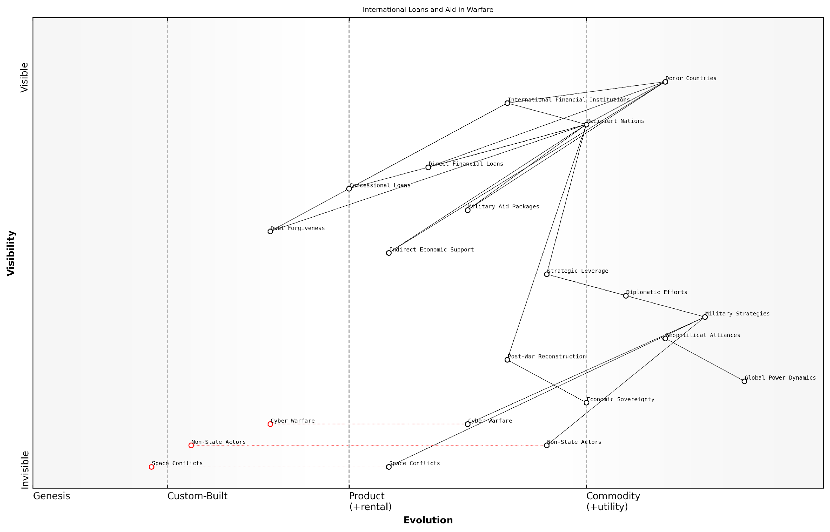

*Draft Wardley Map: [Insert Wardley Map: International loans and aid]*

[Edit this draft Wardley Map](https://create.wardleymaps.ai/#clone:80f21dfa8cea4f6250)

Wardley Map Assessment

This Wardley Map reveals a complex and evolving landscape of international loans and aid in warfare. While traditional mechanisms of financial support remain important, the emergence of new battlefields in cyber and space domains, along with the increasing influence of non-state actors, necessitates a strategic shift. Donor countries and international institutions must adapt their approaches to maintain relevance and effectiveness in shaping global power dynamics. Key focus areas should include developing advanced technological capabilities, creating more flexible aid mechanisms, and fostering a diverse ecosystem of alliances to address the multifaceted nature of modern warfare and international relations.

[View full Wardley Map report](http://markdown/wardley_map_reports/wardley_map_report_12_International_loans_and_aid.md)

In recent years, we’ve seen a shift towards more complex financing arrangements that blur the lines between military and civilian aid. For instance, development loans that ostensibly support infrastructure projects may indirectly free up government resources for military spending. This trend reflects the increasing sophistication of international financial support in the context of modern warfare, where economic and military strategies are increasingly intertwined.

A prominent economist in the field of conflict studies once remarked, ‘The true cost of war-time loans often becomes apparent only in peacetime, when nations must grapple with the economic legacy of their wartime financial decisions.’

As we look to the future of battlefield economics, the role of international loans and aid is likely to become even more nuanced. The rise of non-state actors, the increasing importance of cyber warfare, and the potential for conflicts in new domains such as space will all present unique challenges for traditional models of conflict financing. Nations and international bodies will need to develop new frameworks for providing and regulating financial support in these evolving contexts, balancing the immediate needs of conflict with long-term economic stability and global security considerations.

### Economic sanctions and their consequences

Economic sanctions have become an increasingly prevalent tool in the arsenal of modern warfare, serving as a powerful means of exerting pressure on adversaries without resorting to direct military confrontation. As an expert in battlefield economics, I can attest to the profound impact these measures can have on both the target nation and the global economic landscape. Sanctions represent a complex interplay of economic strategy, diplomatic manoeuvring, and geopolitical considerations, often with far-reaching and sometimes unintended consequences.

At their core, economic sanctions are designed to inflict financial pain on a target country by restricting trade, blocking access to international financial systems, or freezing assets. The rationale behind such measures is to compel a change in behaviour or policy by making the economic cost of non-compliance unbearable. However, the effectiveness and consequences of sanctions are subjects of intense debate among policymakers, economists, and military strategists alike.

* Trade embargoes: Restricting imports and exports to/from the target country
* Financial sanctions: Freezing assets and limiting access to global financial markets
* Travel bans: Restricting movement of key individuals or groups
* Sectoral sanctions: Targeting specific industries crucial to the target country’s economy
* Secondary sanctions: Penalising third parties that engage with the sanctioned entity

The implementation of sanctions can have immediate and severe effects on a target country’s economy. For instance, restrictions on oil exports can cripple a nation heavily dependent on petroleum revenues, leading to currency devaluation, inflation, and widespread economic hardship. Similarly, financial sanctions can cut off access to international capital markets, making it difficult for the target country to finance its operations or service its debt.

Economic sanctions are a double-edged sword. While they can exert significant pressure on adversaries, they also risk unintended consequences that may undermine their effectiveness or even backfire on the imposing nations.

One of the most significant challenges in implementing sanctions is their potential to harm civilian populations disproportionately. Shortages of essential goods, including food and medicine, can lead to humanitarian crises, potentially undermining the moral authority of the sanctioning countries. Moreover, sanctions can inadvertently strengthen authoritarian regimes by allowing them to blame external forces for domestic economic woes, potentially rallying nationalist sentiment and consolidating power.

From a strategic perspective, sanctions can also lead to unintended geopolitical consequences. Target countries may seek alternative economic partnerships, potentially aligning themselves with rival powers. This realignment can shift the balance of power in unexpected ways, potentially creating new security challenges for the sanctioning nations. For example, sanctions imposed on Russia following its actions in Ukraine have led to closer economic ties between Russia and China, altering the dynamics of global power relations.

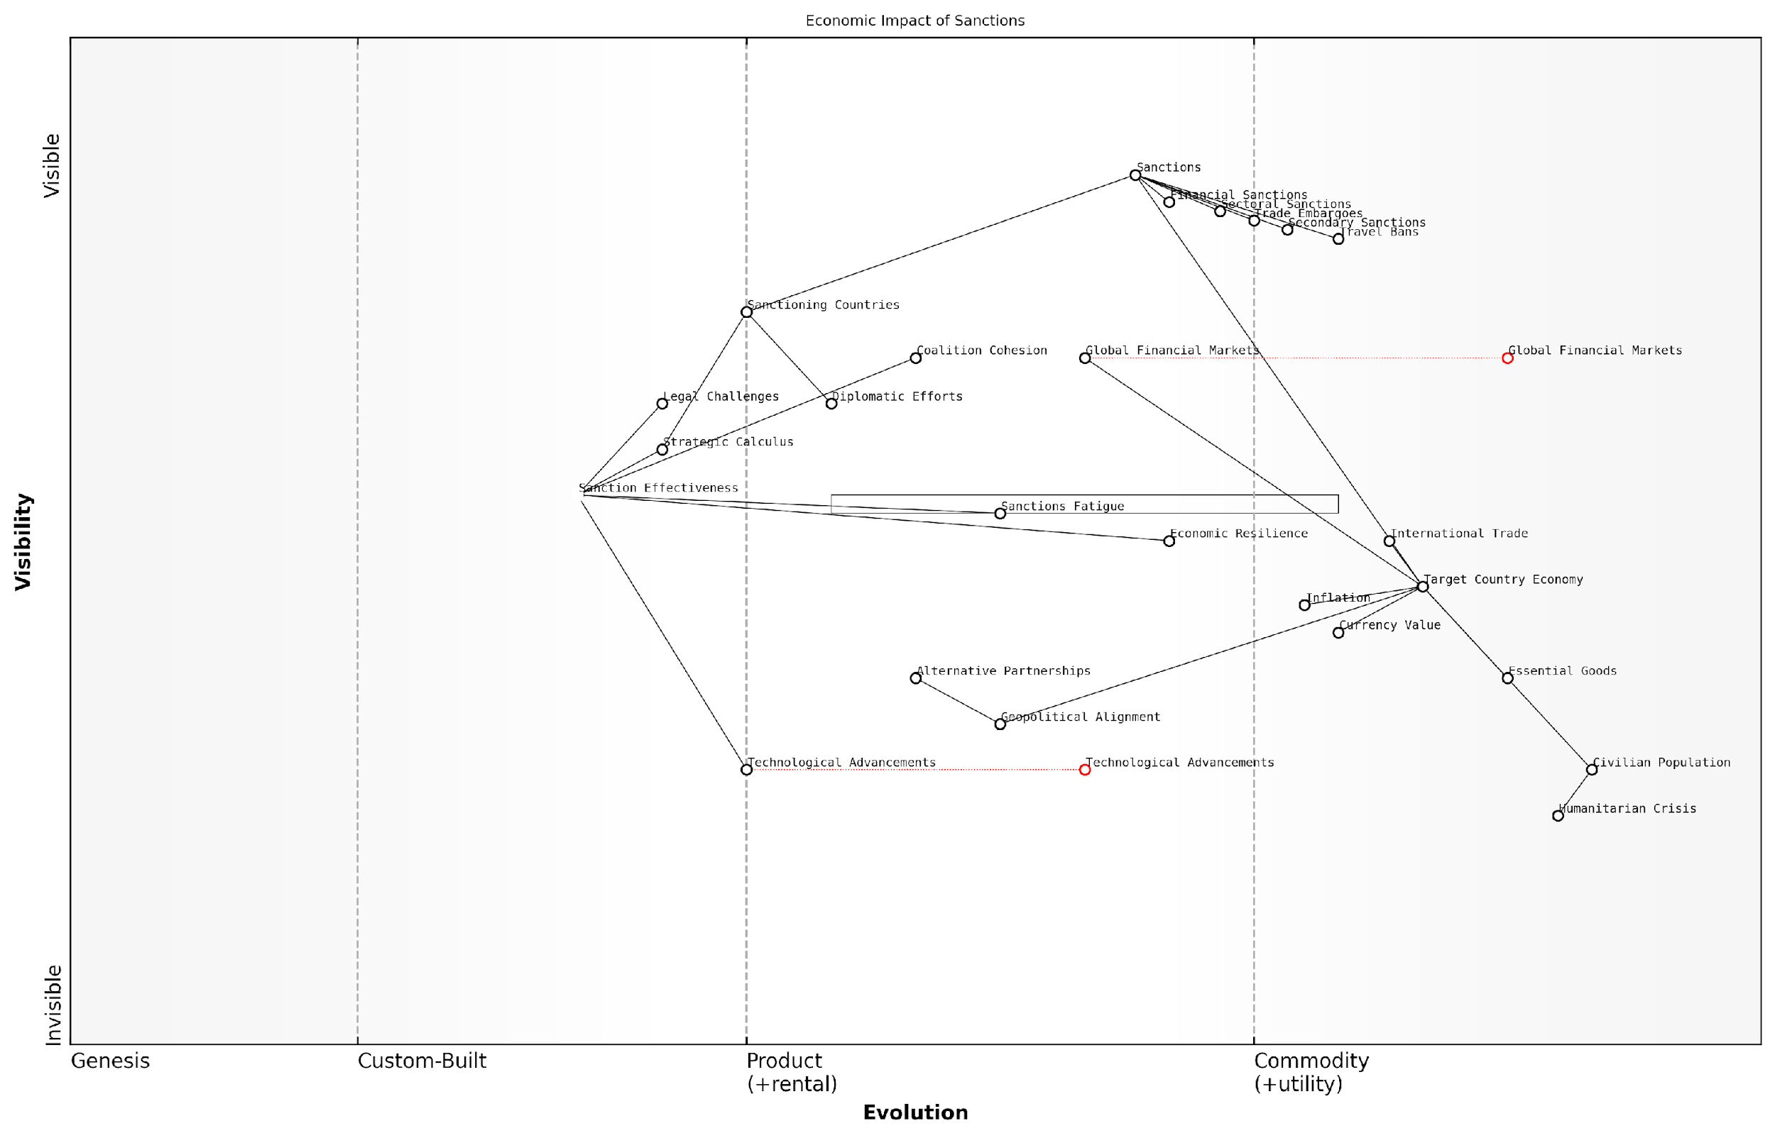

*Draft Wardley Map: [Insert Wardley Map: Economic sanctions and their consequences]*

[Edit this draft Wardley Map](https://create.wardleymaps.ai/#clone:42dbba1d1cbbf3858c)

Wardley Map Assessment

This Wardley Map reveals the complex and evolving nature of economic sanctions and their impacts. While sanctions remain a key tool in international relations, their effectiveness is challenged by various factors including technological advancements, alternative partnerships, and humanitarian concerns. To maintain relevance and effectiveness, sanctioning countries must adapt their strategies, leverage emerging technologies, and carefully balance economic pressure with humanitarian considerations. The future of sanctions will likely involve more sophisticated, data-driven approaches and a greater focus on minimising unintended consequences while maximising targeted impact.

[View full Wardley Map report](http://markdown/wardley_map_reports/wardley_map_report_13_Economic_sanctions_and_their_consequences.md)

The effectiveness of sanctions is often difficult to measure and can vary significantly depending on the specific circumstances. Factors such as the degree of economic integration between the target country and the global economy, the availability of alternative trading partners, and the target country’s ability to circumvent sanctions all play crucial roles in determining their impact. In some cases, sanctions have successfully brought about policy changes, while in others, they have failed to achieve their intended goals despite causing significant economic damage.

* Economic resilience: Target countries may develop strategies to mitigate the impact of sanctions
* Sanctions fatigue: Prolonged sanctions may lose effectiveness over time as countries adapt
* Coalition cohesion: The success of sanctions often depends on maintaining a united front among imposing nations
* Technological advancements: New financial technologies, such as cryptocurrencies, may provide avenues for sanctions evasion
* Legal challenges: Sanctions may face legal scrutiny in international courts or tribunals

As an expert in this field, I must emphasise that the decision to impose economic sanctions should not be taken lightly. Policymakers must carefully weigh the potential benefits against the risks and unintended consequences. A thorough understanding of the target country’s economic structure, its vulnerabilities, and its potential responses is crucial for designing effective sanctions regimes. Moreover, sanctions should be part of a broader strategic approach, complemented by diplomatic efforts and clear communication of the conditions for their removal.

The art of economic warfare lies not just in the application of sanctions, but in the strategic calculus of when to impose them, how to calibrate their intensity, and how to leverage them for maximum diplomatic effect.

In conclusion, economic sanctions represent a powerful but complex tool in the realm of battlefield economics. Their consequences extend far beyond the immediate financial impact on the target country, potentially reshaping global economic relationships and geopolitical alignments. As the global economy becomes increasingly interconnected, the ripple effects of sanctions will likely become even more pronounced, requiring ever more sophisticated analysis and strategic foresight from policymakers and military strategists alike.

# Chapter 2: Resource Management on the Battlefield

## Supply Chain Logistics

### Procurement and distribution of military supplies

The procurement and distribution of military supplies form the backbone of any effective military operation. As an expert in battlefield economics, I can attest that this complex process is critical to maintaining operational readiness and ensuring mission success. The intricate web of suppliers, logistics networks, and distribution channels must work in perfect harmony to deliver the right resources to the right place at the right time.

Military supply chains are unique in their scale, complexity, and the critical nature of their cargo. They must be robust enough to withstand disruptions caused by enemy action, yet flexible enough to adapt to rapidly changing battlefield conditions. The economic implications of these supply chains are profound, often determining the outcome of conflicts as much as tactical decisions on the ground.

* Procurement strategies: balancing cost-effectiveness with operational requirements
* Inventory management: optimising stock levels to minimise costs while ensuring readiness
* Transportation logistics: coordinating air, land, and sea assets for efficient distribution
* Last-mile delivery: ensuring supplies reach front-line units in hostile environments
* Technology integration: leveraging AI and IoT for real-time supply chain visibility

Procurement strategies in military contexts differ significantly from their civilian counterparts. While cost-effectiveness remains a consideration, the paramount concern is operational effectiveness. This often leads to seemingly paradoxical decisions, such as maintaining multiple suppliers for critical components at higher costs to ensure supply resilience. The economic trade-offs between efficiency and redundancy are constant challenges that military logisticians must navigate.

In my experience advising defence ministries, I’ve observed that the most successful military supply chains are those that prioritise adaptability over pure efficiency. As one senior logistics officer put it, ‘We’re not just moving widgets; we’re sustaining the lifeblood of our forces in the field.’

Inventory management in military contexts presents unique challenges. The ‘just-in-time’ principles that have revolutionised civilian supply chains are often too risky for military applications. Instead, a careful balance must be struck between maintaining sufficient stockpiles to weather supply disruptions and avoiding the excessive costs and potential obsolescence associated with overstocking. This balance has significant economic implications, tying up resources that could be used elsewhere in the defence budget.

Transportation logistics in military supply chains must contend with hostile environments and the constant threat of interdiction. This necessitates a multi-modal approach, utilising a mix of air, land, and sea assets to ensure redundancy and flexibility. The economic costs of maintaining this diverse logistics fleet are substantial, but the alternative – a single point of failure in the supply chain – is strategically untenable.

Last-mile delivery in military contexts often occurs under fire, requiring specialised equipment and trained personnel. The economic costs of these specialised delivery capabilities are high, but they are essential for maintaining the flow of supplies to front-line units. Innovations in this area, such as autonomous delivery drones, promise to reduce risks to personnel while potentially lowering costs in the long term.

Technology integration is rapidly transforming military supply chains. Artificial Intelligence and Internet of Things (IoT) technologies are being deployed to provide real-time visibility of supply levels, predict maintenance needs, and optimise distribution routes. While the initial investment in these technologies is significant, the long-term economic benefits in terms of reduced waste, improved efficiency, and enhanced operational readiness are substantial.

A leading expert in military logistics once remarked, ‘The future of military supply chains lies in their ability to be predictive rather than reactive. AI-driven systems that can anticipate needs before they arise will be the game-changers in future conflicts.’

The economic implications of military supply chains extend far beyond the immediate costs of procurement and distribution. They directly impact a nation’s ability to project power, sustain long-term operations, and respond to rapidly evolving threats. As such, investments in robust, flexible, and technologically advanced supply chains should be viewed not as mere logistical expenses, but as critical components of national defence strategy with far-reaching economic consequences.

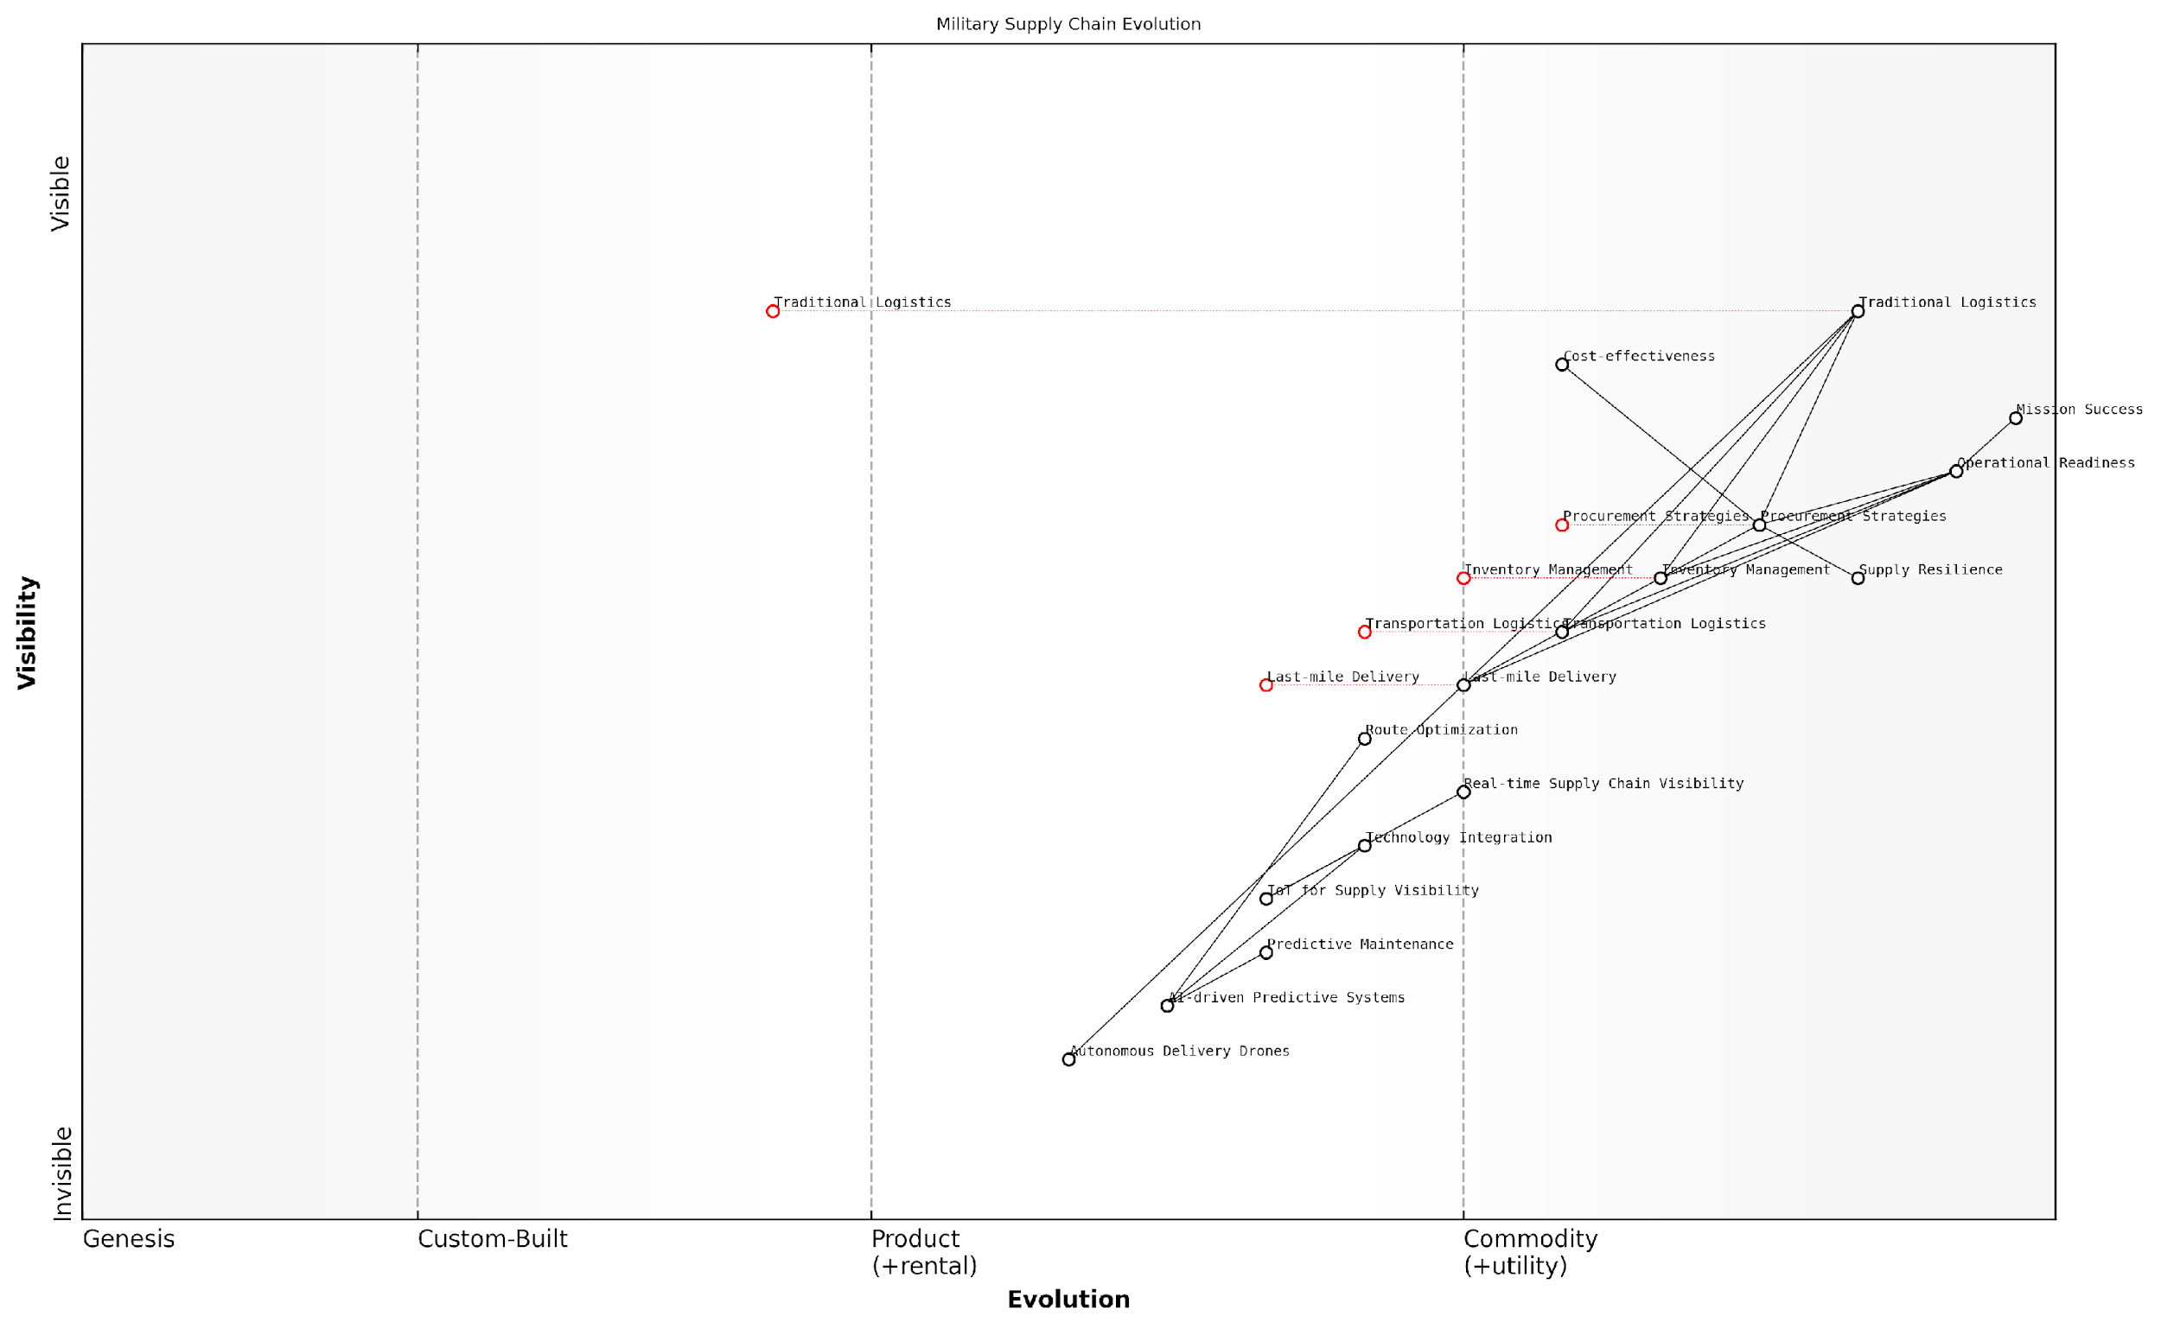

*Draft Wardley Map: [Insert Wardley Map: Procurement and distribution of military supplies]*

[Edit this draft Wardley Map](https://create.wardleymaps.ai/#clone:dc23f772f7077440a4)

Wardley Map Assessment

The military supply chain is at a critical juncture, transitioning from traditional logistics to a highly advanced, technology-driven system. Success will depend on effectively integrating AI, IoT, and autonomous systems while maintaining operational readiness. The focus should be on developing predictive capabilities, enhancing real-time visibility, and gradually phasing out outdated systems. This evolution will require significant investment in both technology and human capital, but promises to dramatically improve efficiency, resilience, and ultimately, mission success.

[View full Wardley Map report](http://markdown/wardley_map_reports/wardley_map_report_14_Procurement_and_distribution_of_military_supplies.md)

### Just-in-time vs. stockpiling strategies

In the realm of battlefield economics, the choice between just-in-time (JIT) and stockpiling strategies represents a critical decision point that can significantly impact military effectiveness and resource allocation. This subsection delves into the nuances of these two approaches, examining their applications, advantages, and potential pitfalls in the context of modern warfare.

Just-in-time logistics, a concept borrowed from the manufacturing sector, aims to deliver resources precisely when and where they are needed on the battlefield. This approach minimises inventory costs and reduces the logistical footprint of military operations. On the other hand, stockpiling involves the accumulation of large quantities of supplies in advance, ensuring readiness but potentially incurring significant storage and maintenance costs.

As a senior military logistics expert once remarked, ‘The choice between JIT and stockpiling is not just a matter of efficiency, but of strategic resilience in the face of unpredictable battlefield conditions.’

The JIT approach offers several advantages in military contexts. It reduces the need for extensive storage facilities, minimises the risk of supplies becoming obsolete, and allows for greater flexibility in responding to changing battlefield needs. However, it also introduces vulnerabilities, particularly in terms of supply chain disruptions. A successful enemy attack on key transportation routes or logistics hubs could severely hamper JIT operations, potentially leaving front-line units without critical supplies.

Stockpiling, while often viewed as a more traditional approach, continues to play a crucial role in military logistics. It provides a buffer against supply chain disruptions, ensures immediate availability of resources in crisis situations, and can serve as a deterrent by demonstrating military readiness. However, stockpiling comes with its own set of challenges, including high storage costs, the risk of inventory obsolescence, and the potential for supplies to be targeted by enemy forces.

* JIT advantages: Cost efficiency, reduced logistical footprint, flexibility
* JIT disadvantages: Vulnerability to supply chain disruptions, reliance on robust transportation networks
* Stockpiling advantages: Resilience against disruptions, immediate availability, deterrent effect
* Stockpiling disadvantages: High storage costs, risk of obsolescence, potential target for enemy attacks

In practice, most modern military forces adopt a hybrid approach, combining elements of both JIT and stockpiling strategies. This balanced method allows for the optimisation of resource allocation while maintaining a degree of resilience against supply chain disruptions. The specific balance depends on factors such as the nature of the conflict, geographical considerations, and the technological capabilities of the military force.

Technological advancements are reshaping the landscape of military logistics, blurring the lines between JIT and stockpiling approaches. Predictive analytics and artificial intelligence are enhancing the accuracy of demand forecasting, allowing for more precise resource allocation. Additive manufacturing (3D printing) technologies are enabling on-demand production of certain supplies, potentially reducing the need for extensive stockpiles.

A leading defence analyst recently noted, ‘The future of military logistics lies not in choosing between JIT and stockpiling, but in leveraging technology to create adaptive, resilient supply chains that can seamlessly shift between these approaches as the situation demands.’

The economic implications of JIT versus stockpiling strategies extend beyond immediate operational costs. They influence long-term defence budgeting, infrastructure development, and even diplomatic relations. For instance, a heavy reliance on JIT logistics might necessitate agreements with allied nations for the use of their ports and airfields, while a stockpiling approach could require significant domestic investment in storage facilities and inventory management systems.

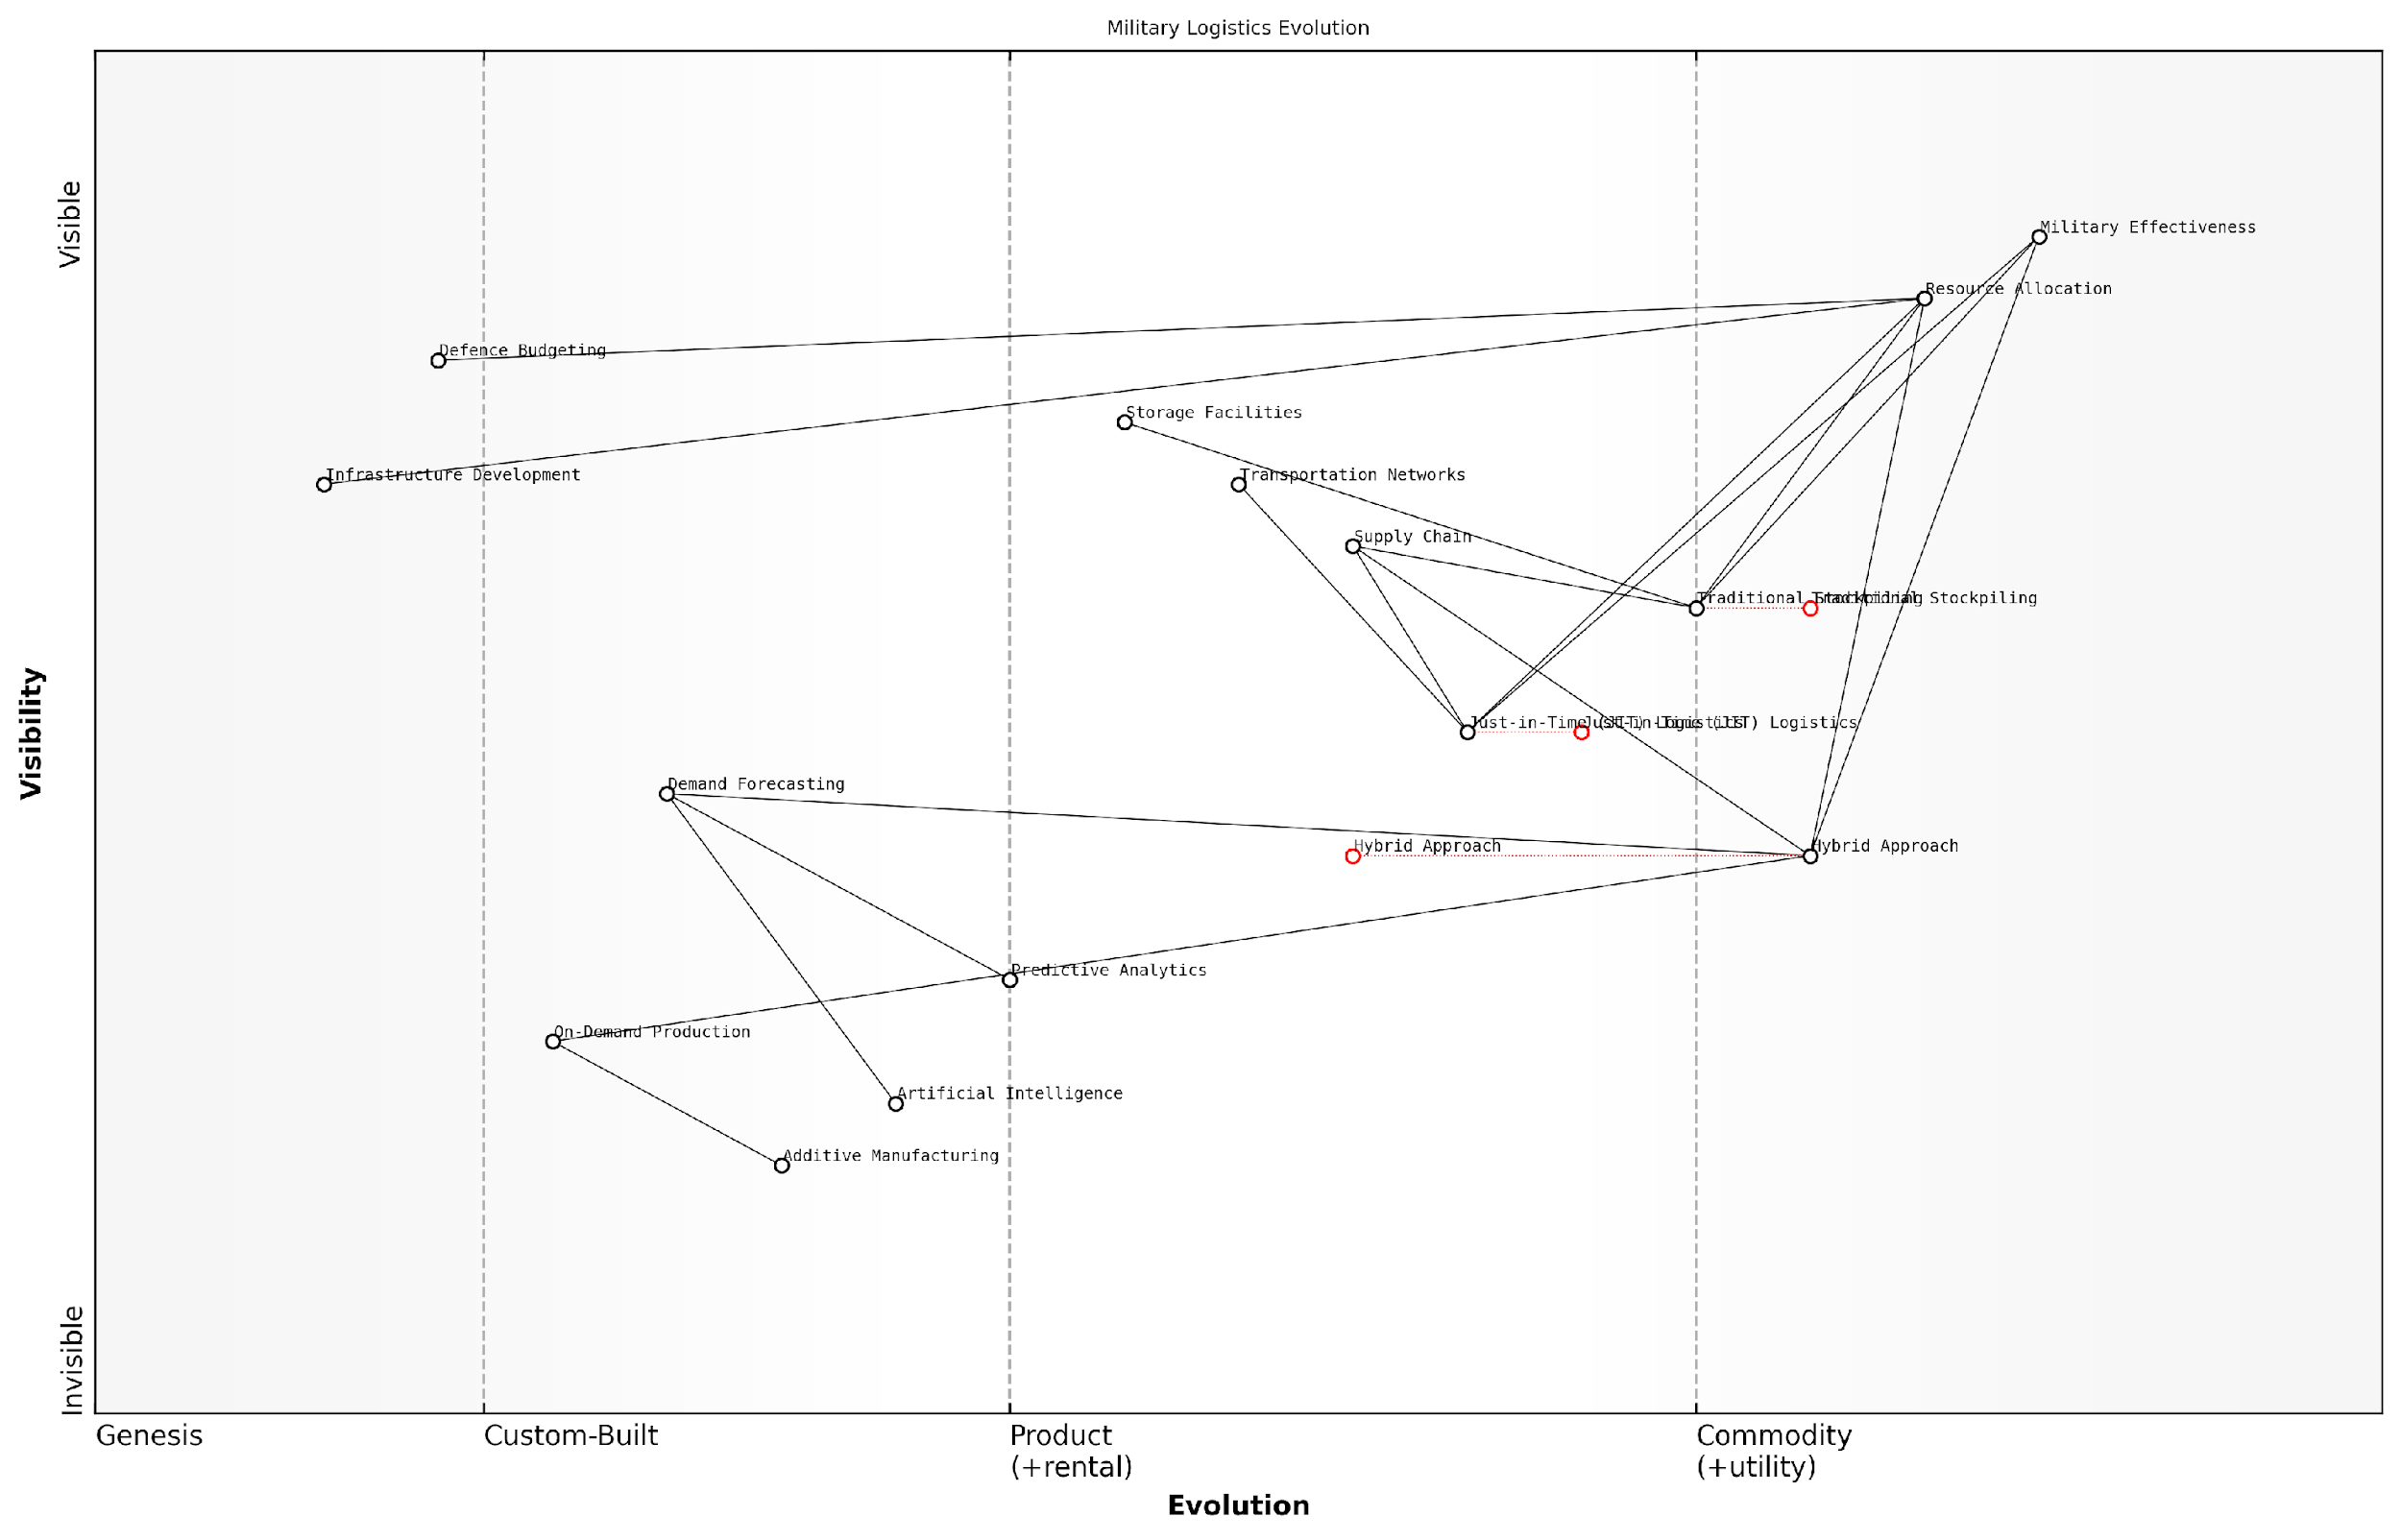

*Draft Wardley Map: [Insert Wardley Map: Just-in-time vs. stockpiling strategies]*

[Edit this draft Wardley Map](https://create.wardleymaps.ai/#clone:c99e03eb43e0eaa1e3)

Wardley Map Assessment

This Wardley Map reveals a military logistics landscape in transition, moving from traditional stockpiling towards more adaptive, technology-driven approaches. The hybrid approach, supported by emerging technologies like AI, predictive analytics, and additive manufacturing, presents the most promising path forward. To maintain and enhance military effectiveness, organisations should prioritise the development of these advanced capabilities while carefully managing the transition from traditional methods. The integration of AI and predictive analytics into decision-making processes, coupled with the strategic use of additive manufacturing for on-demand production, could revolutionise military logistics. However, this evolution must be balanced against the unique challenges of battlefield conditions and the critical need for reliability and resilience in military supply chains.

[View full Wardley Map report](http://markdown/wardley_map_reports/wardley_map_report_15_Just-in-time_vs._stockpiling_strategies.md)

In conclusion, the choice between just-in-time and stockpiling strategies in military logistics is not a binary one, but rather a spectrum along which forces must position themselves based on their specific needs, capabilities, and strategic objectives. As battlefield economics continue to evolve, the ability to dynamically adjust these strategies in response to changing conditions will become increasingly crucial for military success.

### Technological innovations in logistics

In the realm of battlefield economics, technological innovations in logistics have become a critical factor in determining military success. As an expert who has advised numerous government agencies on defence logistics, I can attest to the transformative impact of these innovations on supply chain management, operational efficiency, and overall combat effectiveness.

The integration of advanced technologies into military logistics has revolutionised the way armed forces manage their supply chains, track assets, and distribute resources. These innovations have not only enhanced the speed and accuracy of logistics operations but have also contributed to significant cost savings and improved decision-making capabilities.

* Artificial Intelligence and Machine Learning
* Internet of Things (IoT) and Sensor Technologies
* Blockchain for Supply Chain Transparency
* Autonomous Vehicles and Drones
* 3D Printing and Additive Manufacturing
* Augmented Reality for Inventory Management
* Predictive Analytics for Maintenance

Artificial Intelligence (AI) and Machine Learning (ML) have emerged as game-changers in military logistics. These technologies enable predictive analytics for demand forecasting, optimise routing and distribution, and enhance inventory management. For instance, AI algorithms can analyse historical data, current operational requirements, and external factors to predict future supply needs with remarkable accuracy. This capability allows military planners to anticipate logistical challenges and proactively address potential shortages or bottlenecks.

The implementation of AI in our logistics systems has reduced supply chain disruptions by 30% and improved our response time to critical supply requests by 40%.

The Internet of Things (IoT) and sensor technologies have revolutionised asset tracking and monitoring. By equipping vehicles, containers, and even individual items with smart sensors, military logistics teams can maintain real-time visibility of their entire supply chain. This level of transparency enables more efficient inventory management, reduces losses, and allows for rapid reallocation of resources as operational needs change.

Blockchain technology is increasingly being adopted to enhance supply chain transparency and security. By creating an immutable, decentralised ledger of all transactions and movements within the supply chain, blockchain helps prevent fraud, ensures the authenticity of supplies, and streamlines the auditing process. This is particularly crucial in combat zones where the integrity of the supply chain can have life-or-death consequences.

Autonomous vehicles and drones are transforming last-mile logistics in battlefield scenarios. These technologies can deliver supplies to dangerous or hard-to-reach areas without putting human lives at risk. For example, autonomous ground vehicles can navigate through hostile territories, while drones can bypass difficult terrain to deliver critical supplies directly to front-line units.

Our deployment of autonomous delivery drones has reduced casualty rates related to supply missions by 60% in high-risk combat zones.

3D printing and additive manufacturing technologies are revolutionising on-demand production of spare parts and equipment. This capability significantly reduces the need for extensive inventories and long supply lines, allowing military units to produce critical components on-site. The economic implications of this are substantial, as it reduces transportation costs, minimises waste, and increases operational readiness.

Augmented Reality (AR) is enhancing inventory management and maintenance procedures. AR devices can guide personnel through complex maintenance tasks, reducing errors and improving efficiency. In warehouse settings, AR can assist in rapid inventory checks and order fulfilment, significantly reducing the time and manpower required for these tasks.

Predictive analytics for maintenance is another area where technological innovations are yielding significant economic benefits. By analysing data from sensors and historical maintenance records, predictive algorithms can forecast when equipment is likely to fail. This allows for proactive maintenance, reducing downtime and extending the lifespan of costly military assets.

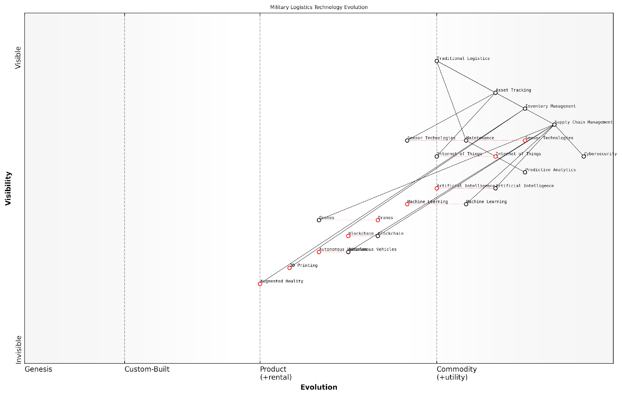

*Draft Wardley Map: [Insert Wardley Map: Technological innovations in logistics]*

[Edit this draft Wardley Map](https://create.wardleymaps.ai/#clone:e4d80ebca488c3408d)

Wardley Map Assessment

The Wardley Map reveals a military logistics landscape in transition, moving from traditional methods to highly advanced, technology-driven systems. The strategic focus on AI, ML, and IoT positions the military to achieve significant improvements in efficiency and effectiveness. However, the rapid pace of technological change presents challenges in integration and security. The key to success lies in balancing innovation with robust security measures and ensuring seamless integration between new technologies and existing systems. Prioritising AI-driven supply chain management, autonomous systems, and advanced tracking technologies, while maintaining a strong cybersecurity posture, will be crucial for maintaining military logistics superiority in the coming years.

[View full Wardley Map report](http://markdown/wardley_map_reports/wardley_map_report_16_Technological_innovations_in_logistics.md)

While these technological innovations offer tremendous benefits, they also present new challenges. Cybersecurity becomes increasingly critical as logistics systems become more interconnected and reliant on digital technologies. Additionally, the initial investment required for implementing these technologies can be substantial, necessitating careful cost-benefit analysis and strategic planning.

In conclusion, technological innovations in logistics are reshaping the economics of the battlefield. By enhancing efficiency, reducing costs, and improving operational capabilities, these advancements are providing military forces with significant strategic advantages. As an expert in this field, I can confidently state that the continued investment in and adoption of these technologies will be crucial for maintaining military effectiveness in the complex and rapidly evolving landscape of modern warfare.

## Human Resource Management

### Recruitment and retention in modern militaries

In the complex landscape of battlefield economics, the recruitment and retention of military personnel stand as critical pillars of a nation’s defence capabilities. Modern militaries face unprecedented challenges in attracting, developing, and retaining high-quality personnel in an increasingly competitive global job market. This subsection delves into the economic intricacies and strategic considerations that shape human resource management in contemporary armed forces.

The economics of military recruitment have evolved significantly in recent decades. Gone are the days when patriotism alone could fill the ranks. Today’s militaries must compete with private sector opportunities, offering competitive salaries, benefits packages, and career development prospects. This shift has profound implications for defence budgets and resource allocation strategies.

* Competitive compensation packages to attract skilled personnel
* Investment in marketing and outreach programmes to enhance recruitment
* Development of specialised recruitment strategies for high-demand roles (e.g., cyber specialists, drone operators)
* Partnerships with educational institutions to create talent pipelines

Retention presents an equally complex economic challenge. The cost of training military personnel is substantial, with some estimates suggesting that it can take up to £1 million to fully train a fighter pilot. High turnover rates not only represent a significant financial loss but also impact operational readiness and institutional knowledge. As such, modern militaries are increasingly focusing on retention strategies that go beyond traditional models of service and loyalty.

The true cost of losing a skilled service member is not just the investment in their training, but the loss of experience and leadership potential that cannot be easily replaced.

Innovative retention strategies now include:1. Career progression pathways that offer clear advancement opportunities2. Flexible service options, including part-time and reserve roles3. Enhanced quality of life initiatives, addressing issues such as family support and work-life balance4. Continuous professional development and education programmes5. Transition support for those leaving the military, enhancing the perceived value of military service

The economic implications of these strategies are significant. While they require substantial upfront investment, the long-term benefits in terms of reduced turnover, improved skill retention, and enhanced operational capabilities can provide a strong return on investment. However, measuring this ROI presents its own challenges, requiring sophisticated economic models that account for both tangible and intangible factors.

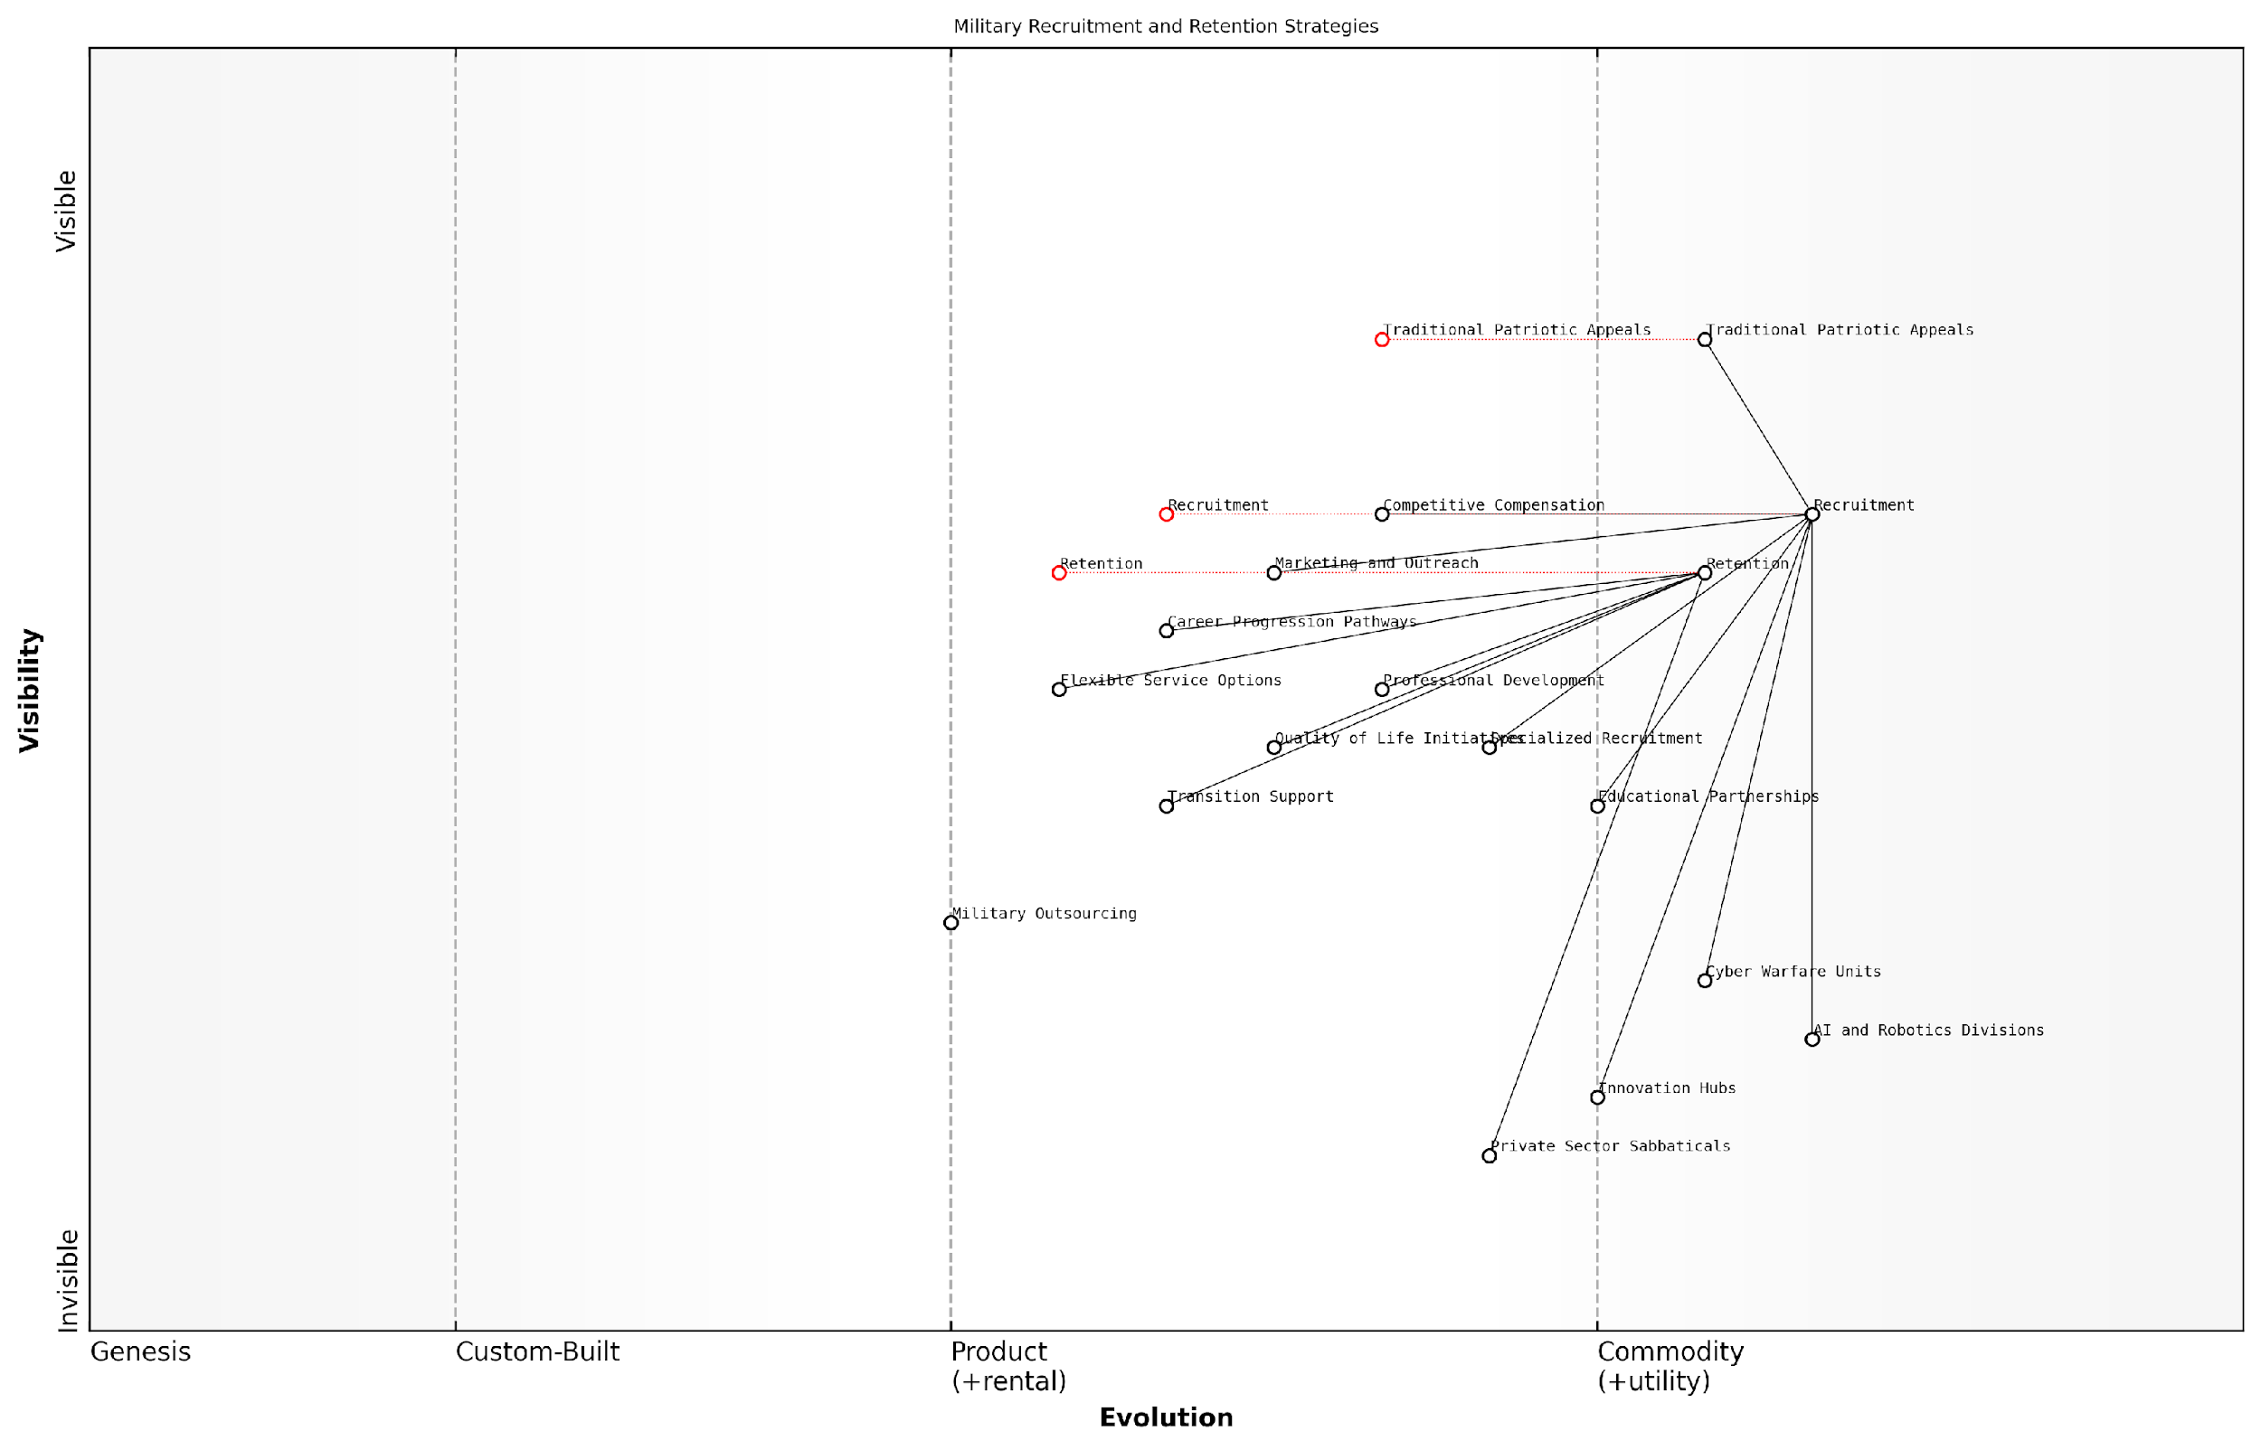

*Draft Wardley Map: [Insert Wardley Map: Recruitment and retention in modern militaries]*

[Edit this draft Wardley Map](https://create.wardleymaps.ai/#clone:b5e181b1dc7d1bf14e)

Wardley Map Assessment

The military is at a critical juncture, needing to balance traditional values with the demands of modern warfare. Success will depend on effectively integrating emerging technologies, fostering innovation, and creating flexible career paths that can compete with the private sector while leveraging unique military advantages. The focus should be on developing a highly skilled, adaptable force capable of addressing future security challenges in both physical and digital domains.

[View full Wardley Map report](http://markdown/wardley_map_reports/wardley_map_report_17_Recruitment_and_retention_in_modern_militaries.md)

Furthermore, the changing nature of warfare itself is reshaping recruitment and retention economics. The increasing reliance on technology and specialised skills means that militaries are now competing directly with tech giants and other high-paying industries for talent. This has led to the development of niche recruitment strategies and the creation of new military roles that blur the lines between traditional combat positions and civilian-style tech jobs.

* Creation of specialised cyber warfare units
* Development of AI and robotics divisions within military structures
* Establishment of ‘innovation hubs’ to attract entrepreneurial talent
* Offering ‘sabbaticals’ for personnel to gain private sector experience

The globalisation of the labour market has also introduced new dynamics to military recruitment and retention. Some nations are exploring the concept of ‘military outsourcing’, where certain non-combat roles are filled by foreign nationals or contractors. While this can provide cost savings and access to specialised skills, it also raises questions about security, loyalty, and the core identity of national armed forces.

In the modern battlefield, our most valuable asset is not the latest technology, but the minds capable of wielding it effectively. Our recruitment and retention strategies must evolve to secure this critical resource.

As we look to the future, the economics of military recruitment and retention will likely become even more complex. Demographic shifts, changing societal values, and the ongoing evolution of warfare will continue to challenge traditional models. Successful militaries will be those that can adapt their human resource strategies to these changing realities, balancing economic constraints with the need to maintain a skilled, motivated, and effective fighting force.

In conclusion, the recruitment and retention of personnel in modern militaries represent a critical intersection of economics and national security. By applying sophisticated economic analysis to these challenges, armed forces can develop strategies that not only fill their ranks but also ensure they have the right people, with the right skills, at the right time. This approach, while complex and often costly, is essential for maintaining military effectiveness in an increasingly unpredictable global landscape.

### Training costs and effectiveness

In the realm of battlefield economics, the training of military personnel represents a critical investment that directly impacts operational effectiveness and overall mission success. As an expert in this field, I can attest that the relationship between training costs and effectiveness is complex, multifaceted, and often subject to intense scrutiny by military planners and policymakers alike.

The economics of military training encompasses a wide range of considerations, from the direct costs of instruction and equipment to the opportunity costs of time spent in training rather than active duty. Moreover, the effectiveness of training programmes must be measured not only in terms of individual skill acquisition but also in terms of unit cohesion, adaptability to diverse combat scenarios, and long-term retention of critical competencies.

* Direct costs: Instructor salaries, training facilities, equipment, and consumables
* Indirect costs: Trainee salaries, accommodation, and support services
* Opportunity costs: Time away from active duty or other productive activities
* Long-term costs: Ongoing refresher training and skill maintenance

One of the most significant challenges in assessing training effectiveness is the difficulty in quantifying the return on investment (ROI) in a military context. Unlike in the private sector, where productivity gains can often be directly measured in financial terms, the benefits of military training are often intangible and may only become apparent in high-stress combat situations.

The true value of training is not in the cost, but in the lives it saves and the missions it enables to succeed. However, in an era of constrained budgets, we must constantly strive to maximise the efficiency of our training programmes without compromising their effectiveness.

In recent years, technological advancements have opened up new avenues for cost-effective training solutions. Virtual reality (VR) and augmented reality (AR) systems, for instance, offer the potential to simulate complex battlefield scenarios at a fraction of the cost of live exercises. These technologies allow for repeated practice of high-risk manoeuvres without the associated dangers or equipment wear and tear.

However, it is crucial to strike a balance between high-tech simulations and traditional hands-on training. While VR and AR can provide valuable cognitive training, they cannot fully replicate the physical and psychological stresses of actual combat. As such, a blended approach that combines virtual and live training is often the most effective strategy.

* Virtual Reality (VR) training: Cost-effective for scenario replication and decision-making skills
* Augmented Reality (AR) training: Enhances real-world exercises with digital overlays
* Live exercises: Essential for physical conditioning and real-world experience
* Blended training approaches: Combining virtual and live elements for optimal results

Another critical aspect of training economics is the concept of ‘training decay’ – the gradual loss of skills and knowledge over time when not regularly applied or refreshed. This phenomenon necessitates ongoing investment in refresher courses and continuous learning programmes, which must be factored into the overall training budget.

To maximise the cost-effectiveness of training, military organisations are increasingly adopting data-driven approaches to assess and improve their programmes. Advanced analytics can help identify the most effective training methods for different skills and roles, optimise the duration and frequency of training sessions, and predict skill decay rates to inform refresher schedules.

In the modern battlefield, the most valuable weapon is not a piece of hardware, but the well-trained mind of a soldier. Our challenge is to forge these minds in the most efficient and effective manner possible.

It’s also worth noting that the effectiveness of training is not solely determined by its content or delivery method, but also by the selection and preparation of trainees. Robust recruitment processes and pre-training assessments can help ensure that resources are invested in individuals with the highest potential for success, thereby improving the overall ROI of training programmes.

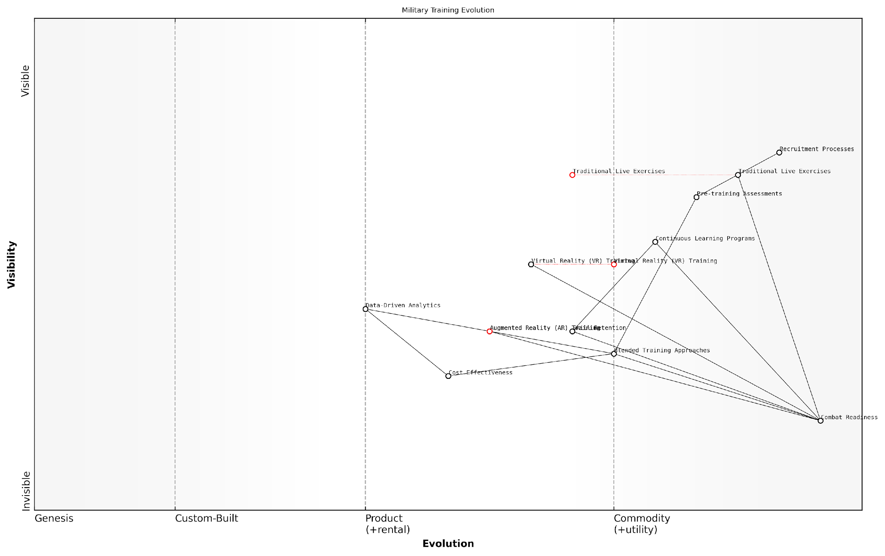

*Draft Wardley Map: [Insert Wardley Map: Training costs and effectiveness]*

[Edit this draft Wardley Map](https://create.wardleymaps.ai/#clone:1d47bbc311a620c913)

Wardley Map Assessment

The Wardley Map reveals a military training landscape in transition, balancing traditional methods with emerging technologies. The strategic focus should be on accelerating the integration of data-driven approaches and advanced simulation technologies while maintaining core competencies in live exercises. The key to success lies in developing a flexible, blended training approach that leverages the strengths of both traditional and innovative methods to enhance combat readiness in a cost-effective manner. Organisations must be prepared for rapid technological evolution and should prioritise partnerships and capability development to stay at the forefront of military training innovation.

[View full Wardley Map report](http://markdown/wardley_map_reports/wardley_map_report_18_Training_costs_and_effectiveness.md)

In conclusion, the economics of military training is a critical component of battlefield economics. By carefully balancing costs with effectiveness, leveraging new technologies, and adopting data-driven approaches, military organisations can ensure that their training programmes deliver maximum value in terms of combat readiness and operational success. As the nature of warfare continues to evolve, so too must our approaches to training, always with an eye towards both economic efficiency and battlefield effectiveness.

### The economics of volunteer vs. conscript forces

The choice between volunteer and conscript forces represents a fundamental decision in military human resource management with far-reaching economic implications. This decision not only affects the composition and capabilities of a nation’s armed forces but also has significant impacts on national budgets, labour markets, and overall economic productivity. As an expert who has advised numerous governments on defence economics, I can attest that this choice is one of the most consequential and complex decisions facing military planners and policymakers.

Volunteer forces, also known as all-volunteer forces (AVF), rely on individuals willingly joining the military, often attracted by competitive salaries, benefits, and career opportunities. Conscript forces, on the other hand, are composed of citizens who are required by law to serve for a specified period, typically with minimal compensation. Each system has its own economic advantages and drawbacks, which must be carefully weighed against a nation’s specific circumstances, strategic objectives, and economic realities.

* Cost considerations: Initial recruitment and training
* Long-term personnel expenses: Salaries, benefits, and pensions
* Retention and career progression
* Skill acquisition and transfer to civilian sectors
* Impact on civilian labour markets and productivity
* Social and political implications

From an economic perspective, volunteer forces often require higher upfront investments in recruitment and retention. Competitive salaries and benefits packages are necessary to attract and retain quality personnel in a competitive labour market. As a senior defence economist once remarked to me, ‘You’re not just competing with other militaries; you’re competing with Google and Goldman Sachs for talent.’ This competition drives up costs but can result in a more skilled and motivated force.

Volunteer forces are an investment in human capital. We pay more upfront, but we get a more professional, experienced, and capable military in return.

Conscript forces, by contrast, typically have lower direct personnel costs. Conscripts are usually paid minimal wages and receive basic benefits. However, the economic costs of conscription extend beyond the military budget. The opportunity cost of removing young adults from the civilian workforce for mandatory service can be substantial. This ‘hidden tax’ on the economy can manifest in reduced productivity, delayed entry into skilled professions, and potential brain drain as some individuals may choose to emigrate to avoid service.

One of the most significant economic advantages of volunteer forces is the potential for skill transfer to the civilian sector. Military service in a volunteer force often provides valuable training in technical, managerial, and leadership skills that can enhance civilian productivity upon a service member’s return to the private sector. This positive externality can partially offset the higher costs of maintaining a volunteer force.

Conscript forces, while potentially less expensive in terms of direct costs, may suffer from lower efficiency and effectiveness. Short service times can limit the development of specialised skills, particularly in an era of increasingly complex military technologies. This can necessitate higher spending on equipment and support systems to compensate for lower average skill levels.

In the modern battlefield, the quality of your human resources often matters more than the quantity. A smaller, highly skilled volunteer force can often outperform a larger conscript force, potentially at a lower overall economic cost.

The economic calculus of volunteer versus conscript forces also varies depending on a nation’s demographic and economic situation. Countries with large, young populations and limited economic opportunities may find conscription an effective way to provide basic skills training and discipline to a significant portion of their youth. Conversely, nations with ageing populations and tight labour markets may find volunteer forces more economically viable, as the opportunity costs of removing workers from the civilian economy become prohibitively high.

It’s crucial to note that many nations opt for hybrid systems, combining elements of both volunteer and conscript models. These systems aim to balance the economic efficiencies of volunteer forces with the broader societal benefits and larger manpower pools associated with conscription. For example, a country might maintain a core of professional volunteer soldiers supplemented by a larger reserve force of former conscripts.

In conclusion, the economics of volunteer versus conscript forces is a complex issue that goes beyond simple budgetary considerations. It encompasses broader economic impacts on productivity, skill development, and labour markets. The optimal choice depends on a nation’s specific economic circumstances, strategic needs, and long-term development goals. As military technologies continue to advance and global economic conditions evolve, the calculus of this decision will undoubtedly continue to shift, requiring ongoing analysis and adaptation by defence economists and policymakers alike.

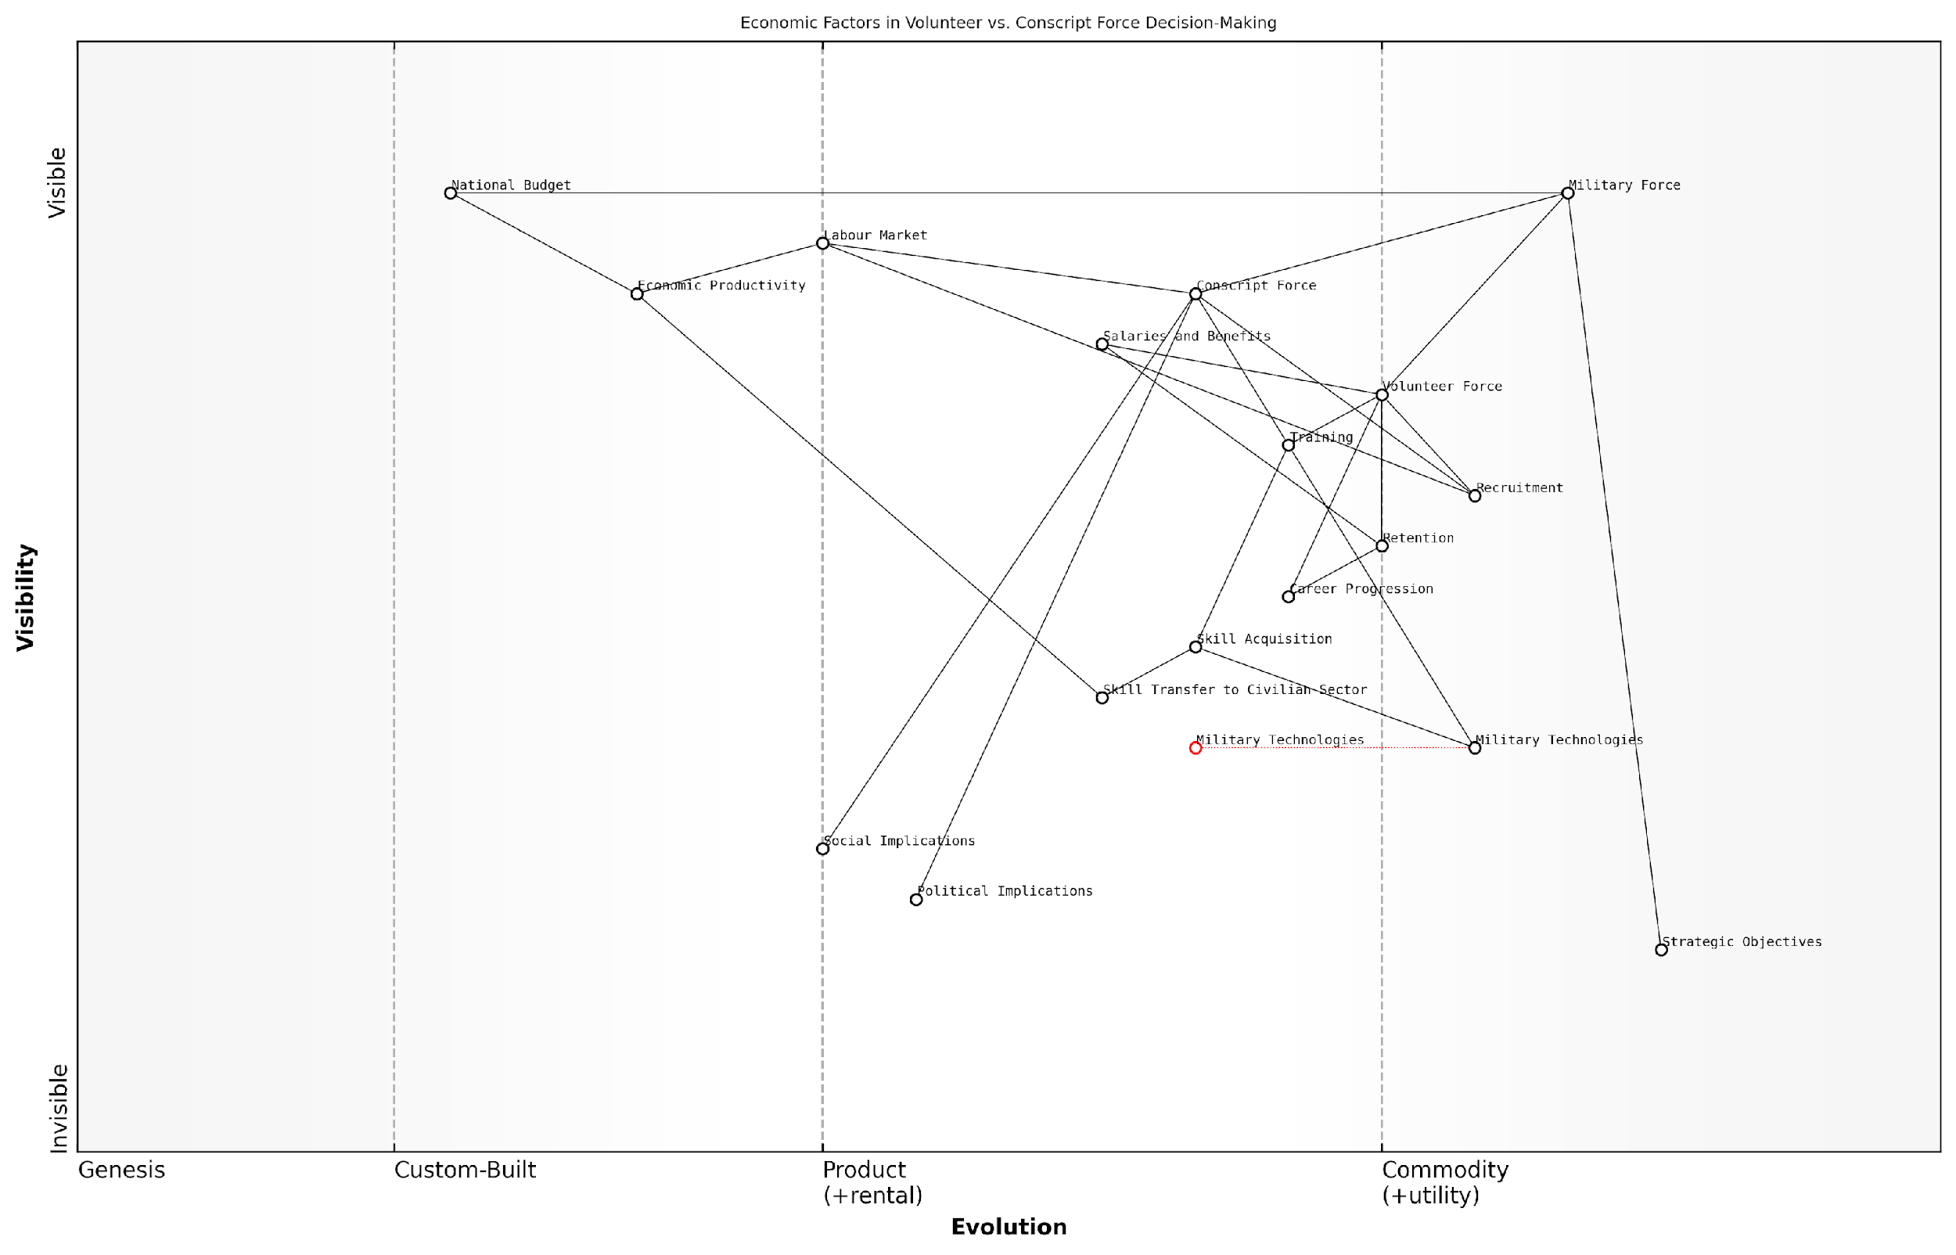

*Draft Wardley Map: [Insert Wardley Map: The economics of volunteer vs. conscript forces]*

[Edit this draft Wardley Map](https://create.wardleymaps.ai/#clone:c566ffd91f91659d9e)

Wardley Map Assessment

This Wardley Map reveals the complex interplay between military force composition, economic factors, and societal implications. The strategic decision between volunteer and conscript forces has far-reaching consequences beyond military effectiveness, impacting national productivity and social dynamics. Key opportunities lie in optimising skill acquisition and transfer, leveraging evolving military technologies, and balancing force composition to align with both strategic objectives and economic realities. The map underscores the need for a holistic, adaptive approach to military force planning that considers both short-term operational needs and long-term economic and societal impacts.

[View full Wardley Map report](http://markdown/wardley_map_reports/wardley_map_report_19_The_economics_of_volunteer_vs._conscript_forces.md)

## Energy Economics in Warfare

### Fuel dependency and strategic vulnerabilities

In the realm of battlefield economics, fuel dependency stands as a critical factor that can significantly influence the outcome of military operations. As a seasoned expert in this field, I can attest that the reliance on fossil fuels has long been a strategic vulnerability for armed forces worldwide, shaping military doctrine, logistics, and even geopolitical strategies.

The modern military’s dependence on fuel is a double-edged sword. On one hand, it provides the necessary energy to power advanced weaponry, vehicles, and communication systems that give forces a tactical edge. On the other hand, it creates a logistical burden and a potential weak point that adversaries can exploit. This dependency has far-reaching implications for military strategy, operational capabilities, and economic considerations in warfare.

* Operational Constraints: Fuel dependency limits the range and duration of military operations, necessitating complex supply chains.
* Economic Vulnerabilities: Fluctuations in global oil prices can significantly impact military budgets and operational planning.
* Strategic Targets: Fuel supply lines and storage facilities become critical points of vulnerability, often targeted by enemy forces.
* Environmental Considerations: The environmental impact of fuel consumption adds another layer of complexity to military operations, particularly in sensitive ecosystems.

The strategic vulnerabilities created by fuel dependency are multifaceted and have been recognised by military planners for decades. During my consultancy work with various defence ministries, I’ve observed a growing awareness of these issues and an increasing push towards finding innovative solutions to mitigate these risks.

Fuel is the lifeblood of our military operations, but it’s also our Achilles’ heel. Every gallon we can save through efficiency or alternative sources is a step towards greater operational flexibility and reduced vulnerability.

This sentiment, expressed by a senior military logistics officer, encapsulates the dilemma faced by modern armed forces. The challenge lies not only in securing a steady supply of fuel but also in reducing overall dependency to enhance strategic resilience.

One of the most significant vulnerabilities stemming from fuel dependency is the logistical burden it imposes. The ‘fuel tether’ concept, which I’ve extensively researched, illustrates how the need for constant resupply can limit the operational reach of military forces. In my analysis of recent conflicts, I’ve found that up to 70% of the tonnage moved in support of deployed forces can be attributed to fuel. This creates a massive logistical tail that is both costly and vulnerable to disruption.

* Convoy Vulnerability: Fuel convoys are prime targets for enemy attacks, as demonstrated in conflicts in Iraq and Afghanistan.
* Resource Allocation: The need to protect fuel supply lines diverts significant combat power from primary mission objectives.
* Operational Tempo: Fuel resupply requirements can dictate the pace and scale of military operations, potentially compromising strategic objectives.
* Cost Implications: The true cost of fuel in a combat zone, when factoring in transportation and protection, can be many times higher than its base price.

The economic implications of fuel dependency extend beyond the immediate costs of procurement and transportation. In my work advising on defence budgets, I’ve observed how fluctuations in global oil prices can have cascading effects on military spending and force structure decisions. A spike in fuel costs can lead to cuts in other critical areas such as training, maintenance, or modernisation efforts, potentially compromising overall military effectiveness.

Every pound spent on fuel is a pound not spent on enhancing our capabilities or caring for our personnel. We must view energy efficiency as a force multiplier, not just a cost-saving measure.

This perspective, shared by a defence economist I’ve collaborated with, highlights the opportunity cost associated with fuel dependency. It underscores the need for a holistic approach to energy management in military contexts, one that considers both immediate operational needs and long-term strategic resilience.

The strategic vulnerabilities created by fuel dependency have spurred significant research and development efforts aimed at reducing reliance on fossil fuels. In my capacity as an advisor on military technology investments, I’ve seen a growing interest in alternative energy sources, energy-efficient technologies, and advanced power management systems. These initiatives aim not only to reduce the logistical burden but also to enhance operational flexibility and reduce the environmental footprint of military operations.

* Renewable Energy: Integration of solar, wind, and other renewable sources for forward operating bases and remote installations.
* Advanced Batteries: Development of high-capacity, lightweight batteries for individual soldiers and small units.
* Hybrid and Electric Vehicles: Exploration of hybrid and fully electric options for non-combat vehicles to reduce fuel consumption.
* Synthetic Fuels: Research into synthetic and biofuels as alternatives to traditional petroleum-based products.
* Energy Harvesting: Investigation of technologies to capture and utilise energy from the environment or soldiers’ movements.

While these technological solutions offer promise, it’s important to note that they also present their own set of challenges and potential vulnerabilities. As we reduce dependency on one resource, we must be cautious not to create new strategic vulnerabilities in the process. This underscores the need for a balanced approach that considers the full spectrum of operational, economic, and strategic implications.

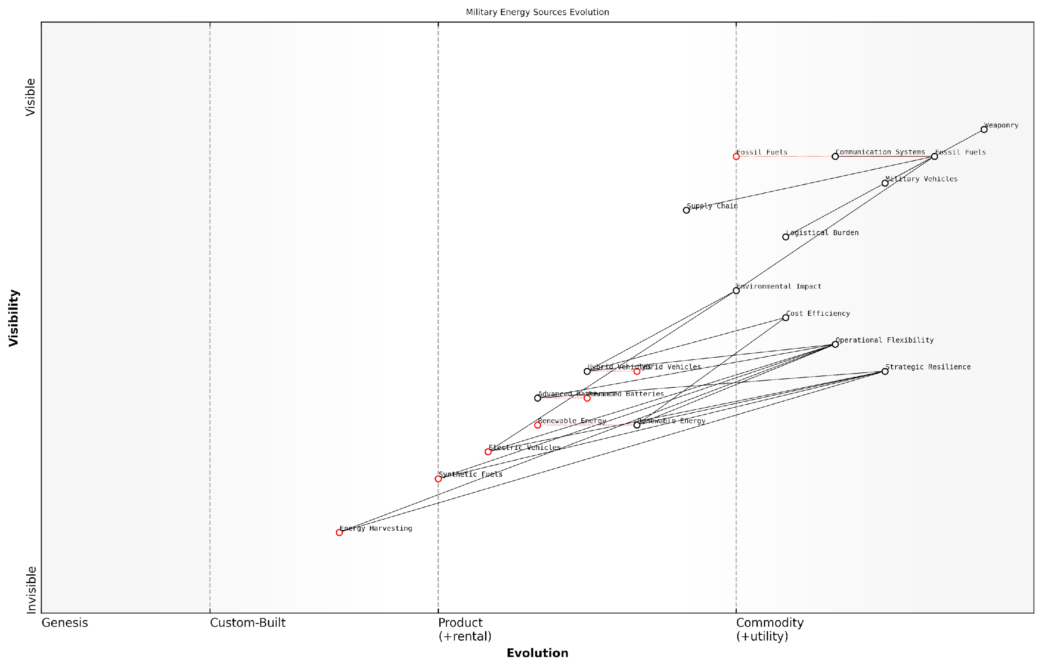

*Draft Wardley Map: [Insert Wardley Map: Fuel dependency and strategic vulnerabilities]*

[Edit this draft Wardley Map](https://create.wardleymaps.ai/#clone:460858a70204016763)

Wardley Map Assessment

The military is at a critical juncture in its energy strategy, transitioning from traditional fossil fuels to a diverse portfolio of advanced energy technologies. This shift promises enhanced operational flexibility, strategic resilience, and reduced environmental impact. Key focus areas should include accelerating the development and adoption of renewable energy, advanced batteries, and emerging technologies like energy harvesting and synthetic fuels. Success in this transition will require significant investment, ecosystem development, and a willingness to reshape longstanding operational paradigms. The potential rewards, however, are substantial: a more agile, resilient, and sustainable military force better equipped to face the challenges of modern warfare.

[View full Wardley Map report](http://markdown/wardley_map_reports/wardley_map_report_20_Fuel_dependency_and_strategic_vulnerabilities.md)

In conclusion, fuel dependency remains a critical factor in battlefield economics, creating significant strategic vulnerabilities that military planners must address. The challenge lies in balancing the immediate operational needs with long-term strategic resilience. As we move forward, the integration of alternative energy sources, advanced technologies, and innovative operational concepts will be crucial in mitigating these vulnerabilities and enhancing the overall effectiveness of military forces in the 21st century.

### Alternative energy sources for military operations

In the complex landscape of battlefield economics, the pursuit of alternative energy sources for military operations has become a critical strategic imperative. As a seasoned expert in this field, I can attest to the transformative potential of diversifying energy resources in enhancing operational resilience, reducing logistical vulnerabilities, and mitigating environmental impacts. This shift is not merely a technological evolution but a fundamental reimagining of how energy is sourced, distributed, and utilised in combat zones.

The traditional reliance on fossil fuels has long been a strategic Achilles’ heel for military forces worldwide. The need to transport vast quantities of fuel to forward operating bases not only incurs significant costs but also exposes supply lines to enemy interdiction. Moreover, the volatile nature of fuel prices can wreak havoc on military budgets, potentially compromising operational readiness. In response to these challenges, defence establishments are increasingly turning to alternative energy sources that promise greater autonomy, reduced costs, and enhanced operational flexibility.

* Solar power for base operations and individual soldier equipment
* Wind energy for remote outposts
* Biofuels for vehicles and aircraft
* Hydrogen fuel cells for silent operation capabilities
* Kinetic energy harvesting from soldier movements
* Portable nuclear reactors for large-scale power generation

Each of these alternative energy sources brings unique advantages to the battlefield. Solar power, for instance, offers a renewable and silent energy option that can significantly reduce the need for fuel convoys in sunny regions. Wind energy can provide a consistent power source for remote outposts, reducing their reliance on supply lines. Biofuels present an opportunity to utilise local resources, potentially enhancing energy security and reducing the logistical footprint of deployed forces.

The military that harnesses alternative energy effectively will possess a significant strategic advantage in future conflicts. It’s not just about reducing costs; it’s about enhancing operational capabilities and resilience.

However, the adoption of alternative energy sources in military operations is not without its challenges. The initial investment costs can be substantial, and there are concerns about the reliability and efficiency of some technologies in harsh combat environments. Moreover, the integration of new energy systems requires significant changes to existing infrastructure and training protocols. Despite these hurdles, the long-term benefits in terms of operational flexibility, cost savings, and reduced environmental impact make the transition to alternative energy sources a strategic necessity.

From an economic perspective, the shift towards alternative energy in military operations can have far-reaching implications. It can stimulate innovation in the civilian sector, leading to technological advancements that benefit the broader economy. Additionally, by reducing dependence on fossil fuels, militaries can insulate themselves from the economic and geopolitical volatilities associated with oil markets. This strategic decoupling can have profound effects on global power dynamics and conflict motivations.

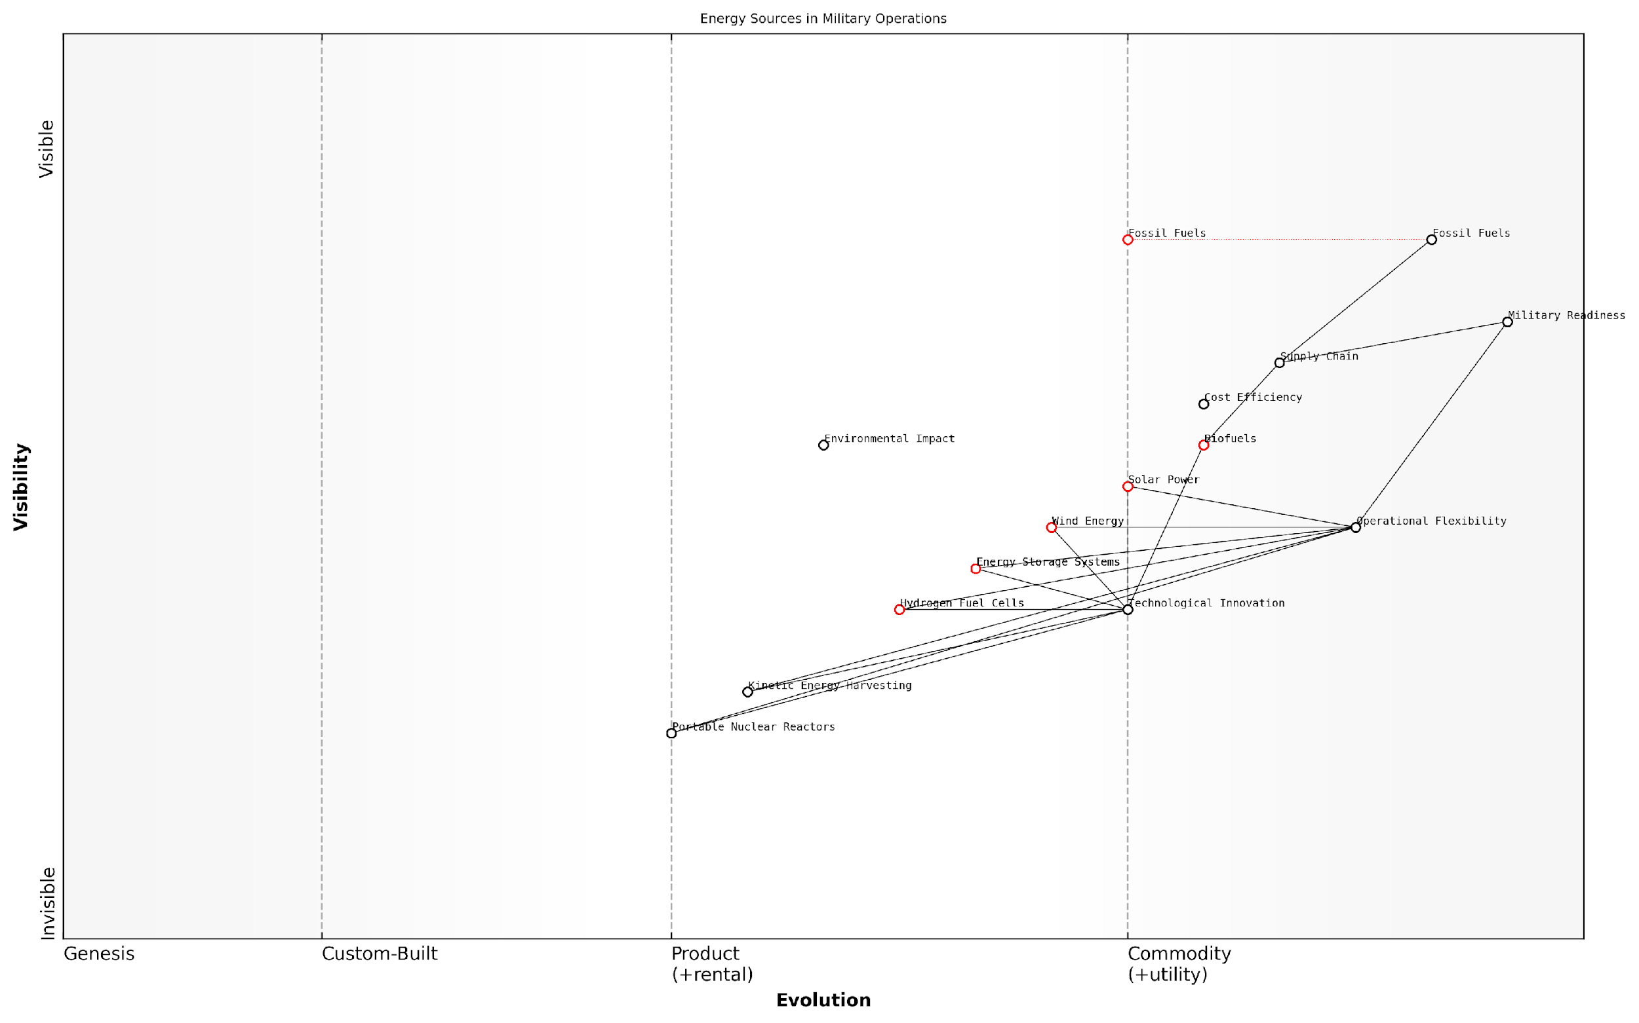

*Draft Wardley Map: [Insert Wardley Map: Alternative energy sources for military operations]*

[Edit this draft Wardley Map](https://create.wardleymaps.ai/#clone:d064527281d2dde57c)

Wardley Map Assessment

The map reveals a military energy landscape in transition, with significant opportunities for innovation and strategic advantage. The key to success lies in balancing the reliability of traditional energy sources with the flexibility and sustainability of emerging technologies. Prioritising investments in Energy Storage Systems and Operational Flexibility will be crucial for maintaining Military Readiness while adapting to new energy paradigms. The integration of diverse energy sources, coupled with advanced storage and management systems, has the potential to revolutionise military operations, enhancing both effectiveness and sustainability.

[View full Wardley Map report](http://markdown/wardley_map_reports/wardley_map_report_21_Alternative_energy_sources_for_military_operations.md)

The economics of alternative energy in warfare extend beyond mere cost calculations. They encompass considerations of supply chain resilience, operational autonomy, and strategic flexibility. For instance, the ability to generate power on-site using renewable sources can significantly reduce the logistical burden of deployed forces, allowing for more agile and sustained operations in remote or hostile environments. This capability can be a game-changer in asymmetric warfare scenarios, where traditional supply lines may be vulnerable to disruption.

In the future, energy self-sufficiency may become as crucial to military success as superior weaponry or tactical prowess. The ability to operate independently of traditional energy supply chains could redefine the parameters of military engagement.

As we look to the future, the role of alternative energy in military operations is set to expand dramatically. Emerging technologies such as advanced energy storage systems, more efficient solar cells, and next-generation biofuels promise to overcome many of the current limitations. Moreover, the increasing focus on climate change and environmental sustainability is likely to accelerate the adoption of green energy solutions in the military sector, potentially leading to significant spillover effects in civilian applications.

In conclusion, the shift towards alternative energy sources in military operations represents a fundamental transformation in battlefield economics. It promises to reshape not only how wars are fought but also how they are funded and sustained. As military planners and policymakers grapple with the complexities of this transition, they must balance immediate operational needs with long-term strategic and economic considerations. The nations and militaries that successfully navigate this energy transition are likely to gain a significant advantage in future conflicts, both on and off the battlefield.

### Environmental considerations and their economic impact

As a seasoned expert in battlefield economics, I can attest that environmental considerations have become increasingly significant in modern warfare, with profound economic implications. The intersection of military operations and environmental concerns represents a complex challenge for armed forces worldwide, necessitating a delicate balance between operational effectiveness and ecological responsibility.

The economic impact of environmental considerations in warfare manifests in various ways, from increased operational costs to long-term financial liabilities. Military forces must now factor in environmental protection measures, sustainable practices, and potential remediation efforts into their strategic planning and budgeting processes.

* Compliance with environmental regulations
* Investment in eco-friendly technologies
* Environmental impact assessments for military operations
* Remediation costs for environmental damage
* Sustainable resource management in military installations

One of the most significant economic challenges arising from environmental considerations is the cost of compliance with increasingly stringent environmental regulations. Armed forces must allocate substantial resources to ensure their operations adhere to national and international environmental standards, often requiring significant investments in new technologies and practices.

The cost of environmental compliance has become a major line item in defence budgets, often competing with traditional military expenditures for limited financial resources.

The investment in eco-friendly technologies represents another substantial economic impact. Military forces are increasingly adopting renewable energy sources, energy-efficient equipment, and sustainable materials to reduce their environmental footprint. While these investments often lead to long-term cost savings, they require significant upfront capital expenditure.

Environmental impact assessments (EIAs) have become a crucial part of military planning, adding both time and cost to operational preparations. These assessments aim to identify potential environmental risks and mitigation strategies, helping to prevent costly environmental damage and subsequent remediation efforts.

The economic burden of environmental remediation cannot be overstated. Historical military activities have left a legacy of contaminated sites, unexploded ordnance, and other environmental hazards. The cost of cleaning up these areas is often enormous and can persist for decades after conflicts have ended.

Environmental remediation costs can exceed the original operational budgets of military campaigns, creating long-term financial liabilities for governments and taxpayers.

Sustainable resource management in military installations has emerged as a critical focus area with significant economic implications. Armed forces are implementing water conservation measures, waste reduction programmes, and energy efficiency initiatives to reduce operational costs and minimise environmental impact.

The economic impact of environmental considerations extends beyond direct military expenditures. Environmental damage caused by military operations can have severe consequences for local economies, affecting agriculture, tourism, and public health. These indirect costs often fall on civilian populations and can hinder post-conflict recovery efforts.

* Reduced agricultural productivity due to soil contamination
* Decline in tourism revenue in environmentally degraded areas
* Increased healthcare costs from pollution-related illnesses
* Loss of ecosystem services vital to local economies

However, it’s important to note that environmental considerations can also drive innovation and create economic opportunities. The development of green technologies for military use often leads to spin-off applications in the civilian sector, fostering new industries and job creation.

Moreover, the adoption of sustainable practices by armed forces can serve as a model for other sectors of the economy, potentially catalysing broader shifts towards more environmentally responsible economic activities.

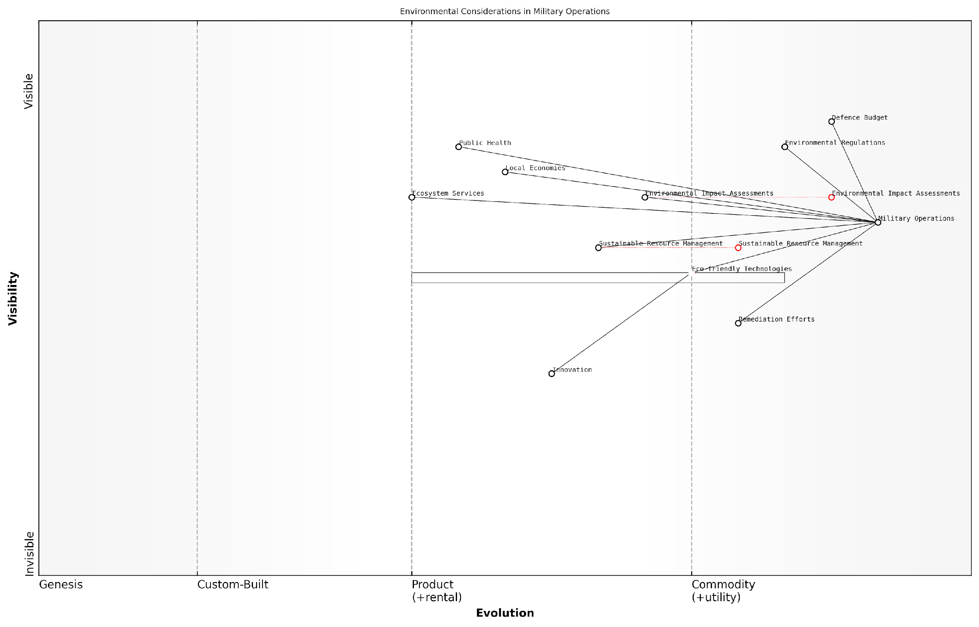

*Draft Wardley Map: [Insert Wardley Map: Environmental considerations and their economic impact]*

[Edit this draft Wardley Map](https://create.wardleymaps.ai/#clone:a825d09700feb9a3db)

Wardley Map Assessment

This Wardley Map reveals a strategic landscape where military operations are increasingly intertwined with environmental considerations and their economic impacts. The key challenge lies in balancing operational effectiveness with environmental stewardship and positive economic outcomes. There are significant opportunities for innovation in eco-friendly technologies and sustainable resource management, which could provide competitive advantages. The evolution of these components suggests a future where military operations are more environmentally conscious and economically beneficial to local communities. However, this transition faces challenges from the inertia in environmental regulations and defence budgets. Strategic focus should be on accelerating the development and adoption of eco-friendly technologies, enhancing environmental assessment capabilities, and fostering an ecosystem of innovation that bridges military needs with environmental sustainability.

[View full Wardley Map report](http://markdown/wardley_map_reports/wardley_map_report_22_Environmental_considerations_and_their_economic_im.md)

In conclusion, the economic impact of environmental considerations in warfare is multifaceted and far-reaching. While presenting significant challenges and costs, it also offers opportunities for innovation and long-term cost savings. As an expert in this field, I can confidently state that the integration of environmental considerations into military planning and operations is not just an ethical imperative but an economic necessity in the modern battlefield.

# Chapter 3: The Arms Industry and Military Innovation

## The Military-Industrial Complex

### Structure and dynamics of the global arms market

The global arms market is a complex and highly influential component of the military-industrial complex, shaping international relations, economic policies, and military strategies worldwide. As an expert in battlefield economics, I can attest to the profound impact this market has on both the conduct of warfare and the geopolitical landscape.

The structure of the global arms market is characterised by a mix of state-owned enterprises, private corporations, and public-private partnerships. This diverse ecosystem is dominated by a handful of major arms-producing countries, primarily the United States, Russia, China, and several European nations. These key players not only supply their domestic militaries but also compete fiercely for international contracts, often using arms sales as a tool of foreign policy and economic leverage.

* Major arms-producing countries: USA, Russia, China, France, UK, Germany
* Key industry sectors: Aerospace, naval systems, land systems, electronics
* Market segments: Conventional weapons, missiles, military aircraft, naval vessels, cybersecurity systems

The dynamics of the global arms market are driven by a complex interplay of factors, including geopolitical tensions, technological advancements, and economic considerations. One of the most significant trends in recent years has been the increasing sophistication of weapons systems, particularly in areas such as artificial intelligence, autonomous systems, and cyber capabilities. This technological arms race has led to a surge in research and development spending, as nations strive to maintain their competitive edge.

The arms market is not just about selling weapons; it’s about selling influence, security, and sometimes even the illusion of power. Nations that can offer cutting-edge military technology often find themselves with significant diplomatic and economic leverage.

Another crucial dynamic is the role of offset agreements in arms deals. These arrangements, which require arms manufacturers to invest in the buying country’s economy as part of the deal, have become increasingly common and complex. They can involve technology transfers, local production agreements, or investments in non-military sectors. While ostensibly designed to benefit the purchasing country’s economy, offset agreements can also serve as a form of economic statecraft, creating long-term dependencies and strategic partnerships.

The global arms market is also characterised by its opacity and the prevalence of informal networks. Despite efforts to increase transparency, many arms deals are shrouded in secrecy, often justified on national security grounds. This lack of transparency can facilitate corruption and make it difficult to accurately assess the true economic impact of arms transfers.

* Challenges in the global arms market:
* Lack of transparency and potential for corruption
* Proliferation concerns and arms control treaties
* Ethical considerations and human rights issues
* Economic distortions caused by military spending

The structure and dynamics of the global arms market have significant implications for battlefield economics. The high costs of modern weapons systems can strain military budgets, potentially leading to trade-offs between quantity and quality. Moreover, the increasing complexity of these systems can create vulnerabilities, as seen in the growing importance of cybersecurity in military operations.

From a strategic perspective, the global arms market plays a crucial role in shaping military capabilities and, by extension, the nature of future conflicts. The diffusion of advanced technologies through arms sales can alter the balance of power in regions and influence military doctrines. For instance, the proliferation of precision-guided munitions has led to changes in tactics and force structures across many militaries.

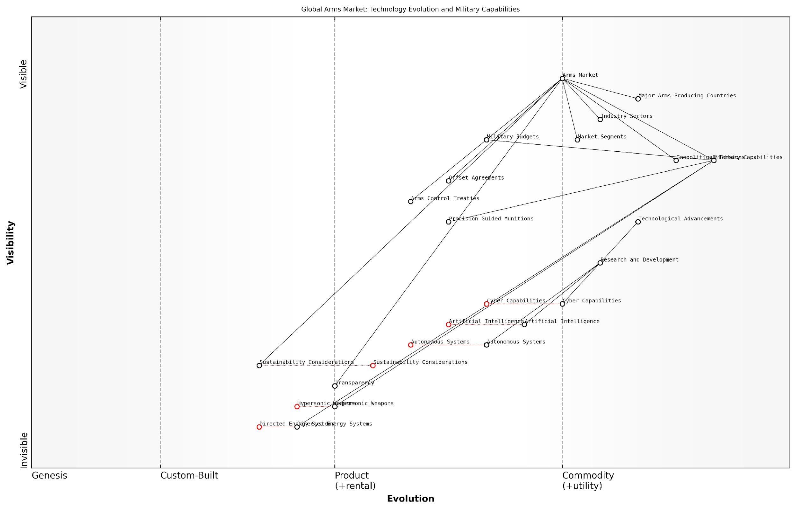

*Draft Wardley Map: [Insert Wardley Map: Structure and dynamics of the global arms market]*

[Edit this draft Wardley Map](https://create.wardleymaps.ai/#clone:80dbb7e599962b8b23)

Wardley Map Assessment

The global arms market is at a critical juncture, balancing traditional market structures with rapid technological advancements and emerging ethical considerations. Success will depend on effectively integrating AI, autonomous systems, and cyber capabilities while addressing sustainability and transparency concerns. The industry must innovate rapidly in emerging technologies while also adapting to changing global norms around arms production and trade.

[View full Wardley Map report](http://markdown/wardley_map_reports/wardley_map_report_23_Structure_and_dynamics_of_the_global_arms_market.md)

Looking ahead, the global arms market is likely to be shaped by several emerging trends. These include the growing importance of cyber and space domains, the potential disruptive impact of technologies such as hypersonic weapons and directed energy systems, and the increasing focus on sustainability and environmental considerations in military procurement.

The future battlefield will be shaped not just by the weapons we develop, but by how we choose to regulate and deploy them. The economic and ethical decisions we make in the arms market today will have profound implications for global security tomorrow.

In conclusion, understanding the structure and dynamics of the global arms market is crucial for anyone seeking to comprehend the economics of the battlefield. It is a market that operates at the intersection of economics, politics, and strategy, with far-reaching consequences for international security and the conduct of warfare. As we navigate an increasingly complex and uncertain geopolitical landscape, the ability to analyse and anticipate developments in this market will be essential for policymakers, military strategists, and economists alike.

### Economic incentives for weapons development

The development of new weapons systems is a complex process driven by a myriad of economic incentives that shape the landscape of military innovation. As an expert in battlefield economics, I have observed how these incentives create a powerful engine for technological advancement, often with far-reaching consequences beyond the military sphere.

At the heart of weapons development lies an intricate web of financial motivations that involve multiple stakeholders, including governments, defence contractors, research institutions, and even individual inventors. These economic drivers not only fuel the creation of more advanced military hardware but also influence geopolitical dynamics and national security strategies.

* Government funding and defence budgets
* Profit potential for defence contractors
* Job creation and economic stimulation
* Technological spillovers to civilian sectors
* Export opportunities and international arms sales
* Competitive advantage in global power dynamics

Government funding and defence budgets play a pivotal role in shaping the direction of weapons development. Nations allocate substantial resources to military research and development (R&D) as part of their national security strategy. This consistent flow of capital creates a stable market for innovation, encouraging defence contractors and research institutions to invest in long-term projects that might otherwise be deemed too risky or unprofitable in the civilian sector.

The economic incentives in weapons development are not just about creating better tools for warfare, but about maintaining a technological edge that can deter conflicts and shape global power dynamics.

For defence contractors, the profit potential in weapons development is significant. The high-stakes nature of military technology, coupled with the complexity of modern weapons systems, often results in lucrative contracts that can span decades. This long-term financial security incentivises companies to invest heavily in R&D, pushing the boundaries of what is technologically possible.

The economic impact of weapons development extends beyond direct military applications. Job creation and economic stimulation are powerful incentives for governments to support the defence industry. High-skilled jobs in engineering, computer science, and advanced manufacturing are often created as a result of weapons development programmes, contributing to economic growth and technological advancement in regions where these activities are concentrated.

Technological spillovers to civilian sectors represent another significant economic incentive. Many innovations originally developed for military purposes find applications in civilian life, creating new markets and industries. Examples include the internet, GPS technology, and advanced materials like carbon fibre. These spillovers can generate substantial economic value, justifying public investment in military R&D from an economic perspective.

Export opportunities and international arms sales provide additional economic incentives for weapons development. Countries with advanced defence industries can leverage their technological superiority to generate foreign income through arms exports. This not only offsets the cost of domestic weapons programmes but also strengthens diplomatic ties and extends geopolitical influence.

In the realm of international relations, advanced weapons systems are not just military assets, but powerful economic and diplomatic tools that can shape alliances and influence global politics.

The pursuit of competitive advantage in global power dynamics serves as a potent economic incentive for continuous weapons development. Nations invest in cutting-edge military technology not only for direct military applications but also to maintain their position in the international order. This ‘arms race’ mentality drives ongoing investment and innovation, creating a self-perpetuating cycle of development and competition.

However, it is crucial to acknowledge the ethical considerations and potential negative consequences of these economic incentives. The focus on weapons development can divert resources from other societal needs, and the proliferation of advanced weapons systems can exacerbate global tensions and conflicts.

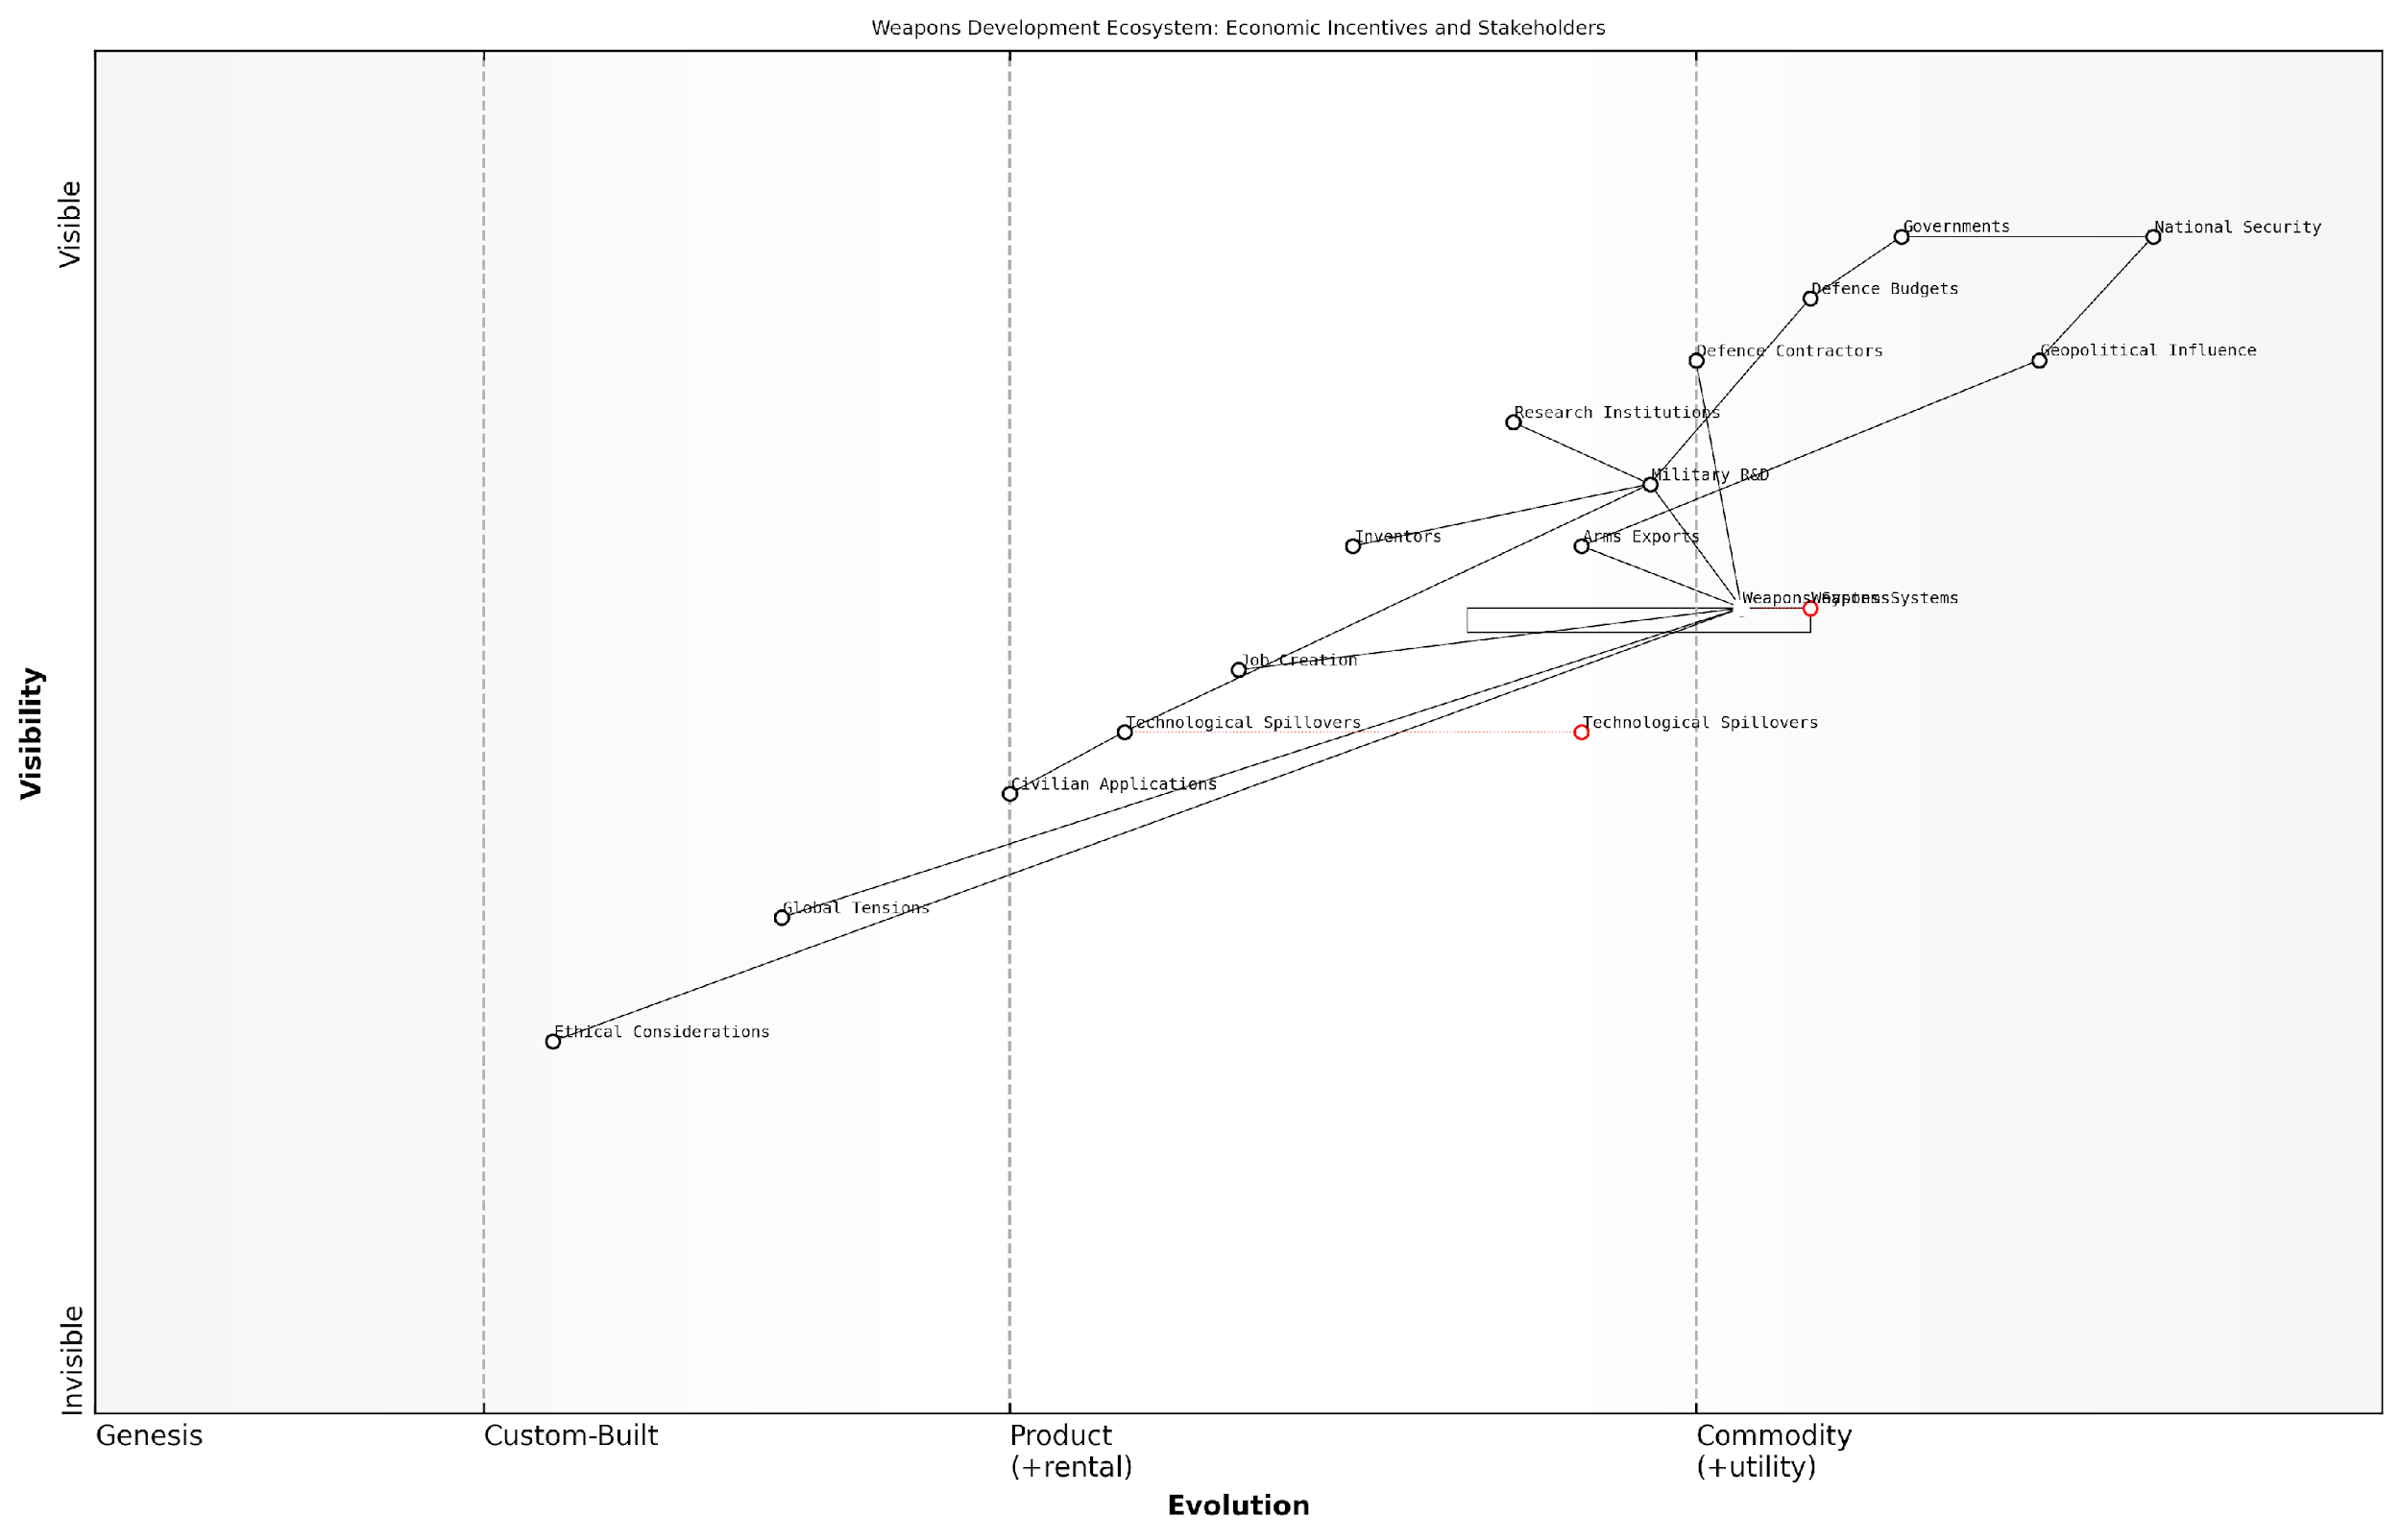

*Draft Wardley Map: [Insert Wardley Map: Economic incentives for weapons development]*

[Edit this draft Wardley Map](https://create.wardleymaps.ai/#clone:517f7d30a0349e889e)

Wardley Map Assessment

The map reveals a weapons development ecosystem primarily driven by national security needs and economic incentives. While it demonstrates strong capabilities in traditional areas of weapons development, there are significant opportunities to evolve towards more ethical and dual-use focused approaches. Strategic priorities should include enhancing the positive spillover effects of military R&D, addressing ethical concerns more prominently, and balancing security needs with broader societal benefits. The future evolution of this ecosystem will likely be shaped by increasing ethical scrutiny and the potential for transformative technologies, requiring a proactive and balanced approach to weapons development.

[View full Wardley Map report](http://markdown/wardley_map_reports/wardley_map_report_24_Economic_incentives_for_weapons_development.md)

In conclusion, the economic incentives for weapons development are multifaceted and deeply ingrained in the modern military-industrial complex. They drive innovation, shape international relations, and have far-reaching impacts on both military and civilian spheres. As we navigate the complex landscape of battlefield economics, understanding these incentives is crucial for policymakers, military strategists, and economists alike in shaping a more secure and prosperous future.

### The role of private contractors in modern warfare

The increasing reliance on private military and security companies (PMSCs) has fundamentally altered the landscape of modern warfare, introducing complex economic dynamics and reshaping the traditional military-industrial complex. This shift represents a significant evolution in how nations approach conflict, blurring the lines between public and private sectors in military operations.

Private contractors have become an integral part of military operations, offering a range of services from logistical support to direct combat roles. This trend has been driven by several factors, including the need for specialised skills, the desire to reduce official troop numbers, and the pursuit of cost efficiencies. However, the economic implications of this shift are profound and multifaceted.

* Flexibility and scalability in military operations
* Access to specialised skills and advanced technologies
* Potential cost savings through outsourcing
* Reduced political costs associated with military casualties
* Challenges in oversight and accountability

The economic rationale behind the use of private contractors often centres on cost-effectiveness. Governments argue that outsourcing certain functions to private entities can lead to significant savings, as these companies can often operate with greater efficiency and flexibility than traditional military structures. This argument, however, is not without controversy, as the true cost-benefit analysis of private contractor use remains a subject of debate among economists and military strategists alike.

The use of private contractors allows us to rapidly scale our capabilities without the long-term commitments associated with expanding standing forces. This flexibility is crucial in today’s dynamic threat environment.

One of the most significant economic impacts of private contractors in modern warfare is the creation of a new market within the military-industrial complex. This market has seen rapid growth, with some estimates suggesting that the global private military security services market could reach £420 billion by 2029. This growth has led to the emergence of powerful corporate entities that now wield considerable influence in shaping military policy and procurement decisions.

The rise of private military contractors has also introduced new economic incentives and potential conflicts of interest within the broader ecosystem of defence and security. Critics argue that the profit motive of these companies may not always align with national security interests or ethical considerations. There are concerns that the privatisation of warfare could lead to prolonged conflicts, as companies may have financial incentives to maintain ongoing operations.

* Creation of a new market within the military-industrial complex
* Potential misalignment of profit motives and national security interests
* Influence on military policy and procurement decisions
* Economic incentives that may prolong conflicts
* Challenges in regulating a global, often opaque industry

From an economic perspective, the use of private contractors also raises questions about the long-term impacts on military readiness and the retention of critical skills within national armed forces. As more functions are outsourced, there is a risk that militaries may become overly dependent on private sector capabilities, potentially compromising their ability to operate independently in critical situations.

While private contractors offer undeniable advantages in terms of flexibility and specialised capabilities, we must carefully consider the long-term economic and strategic implications of this trend on our national defence capabilities.

The economic dynamics of private military contractors extend beyond national borders, creating a global market for military services. This internationalisation of military capabilities introduces new complexities in terms of regulation, accountability, and the potential for these companies to influence geopolitical dynamics. The ability of private military companies to operate across borders also raises questions about the economic sovereignty of nations and the potential for economic warfare through proxy forces.

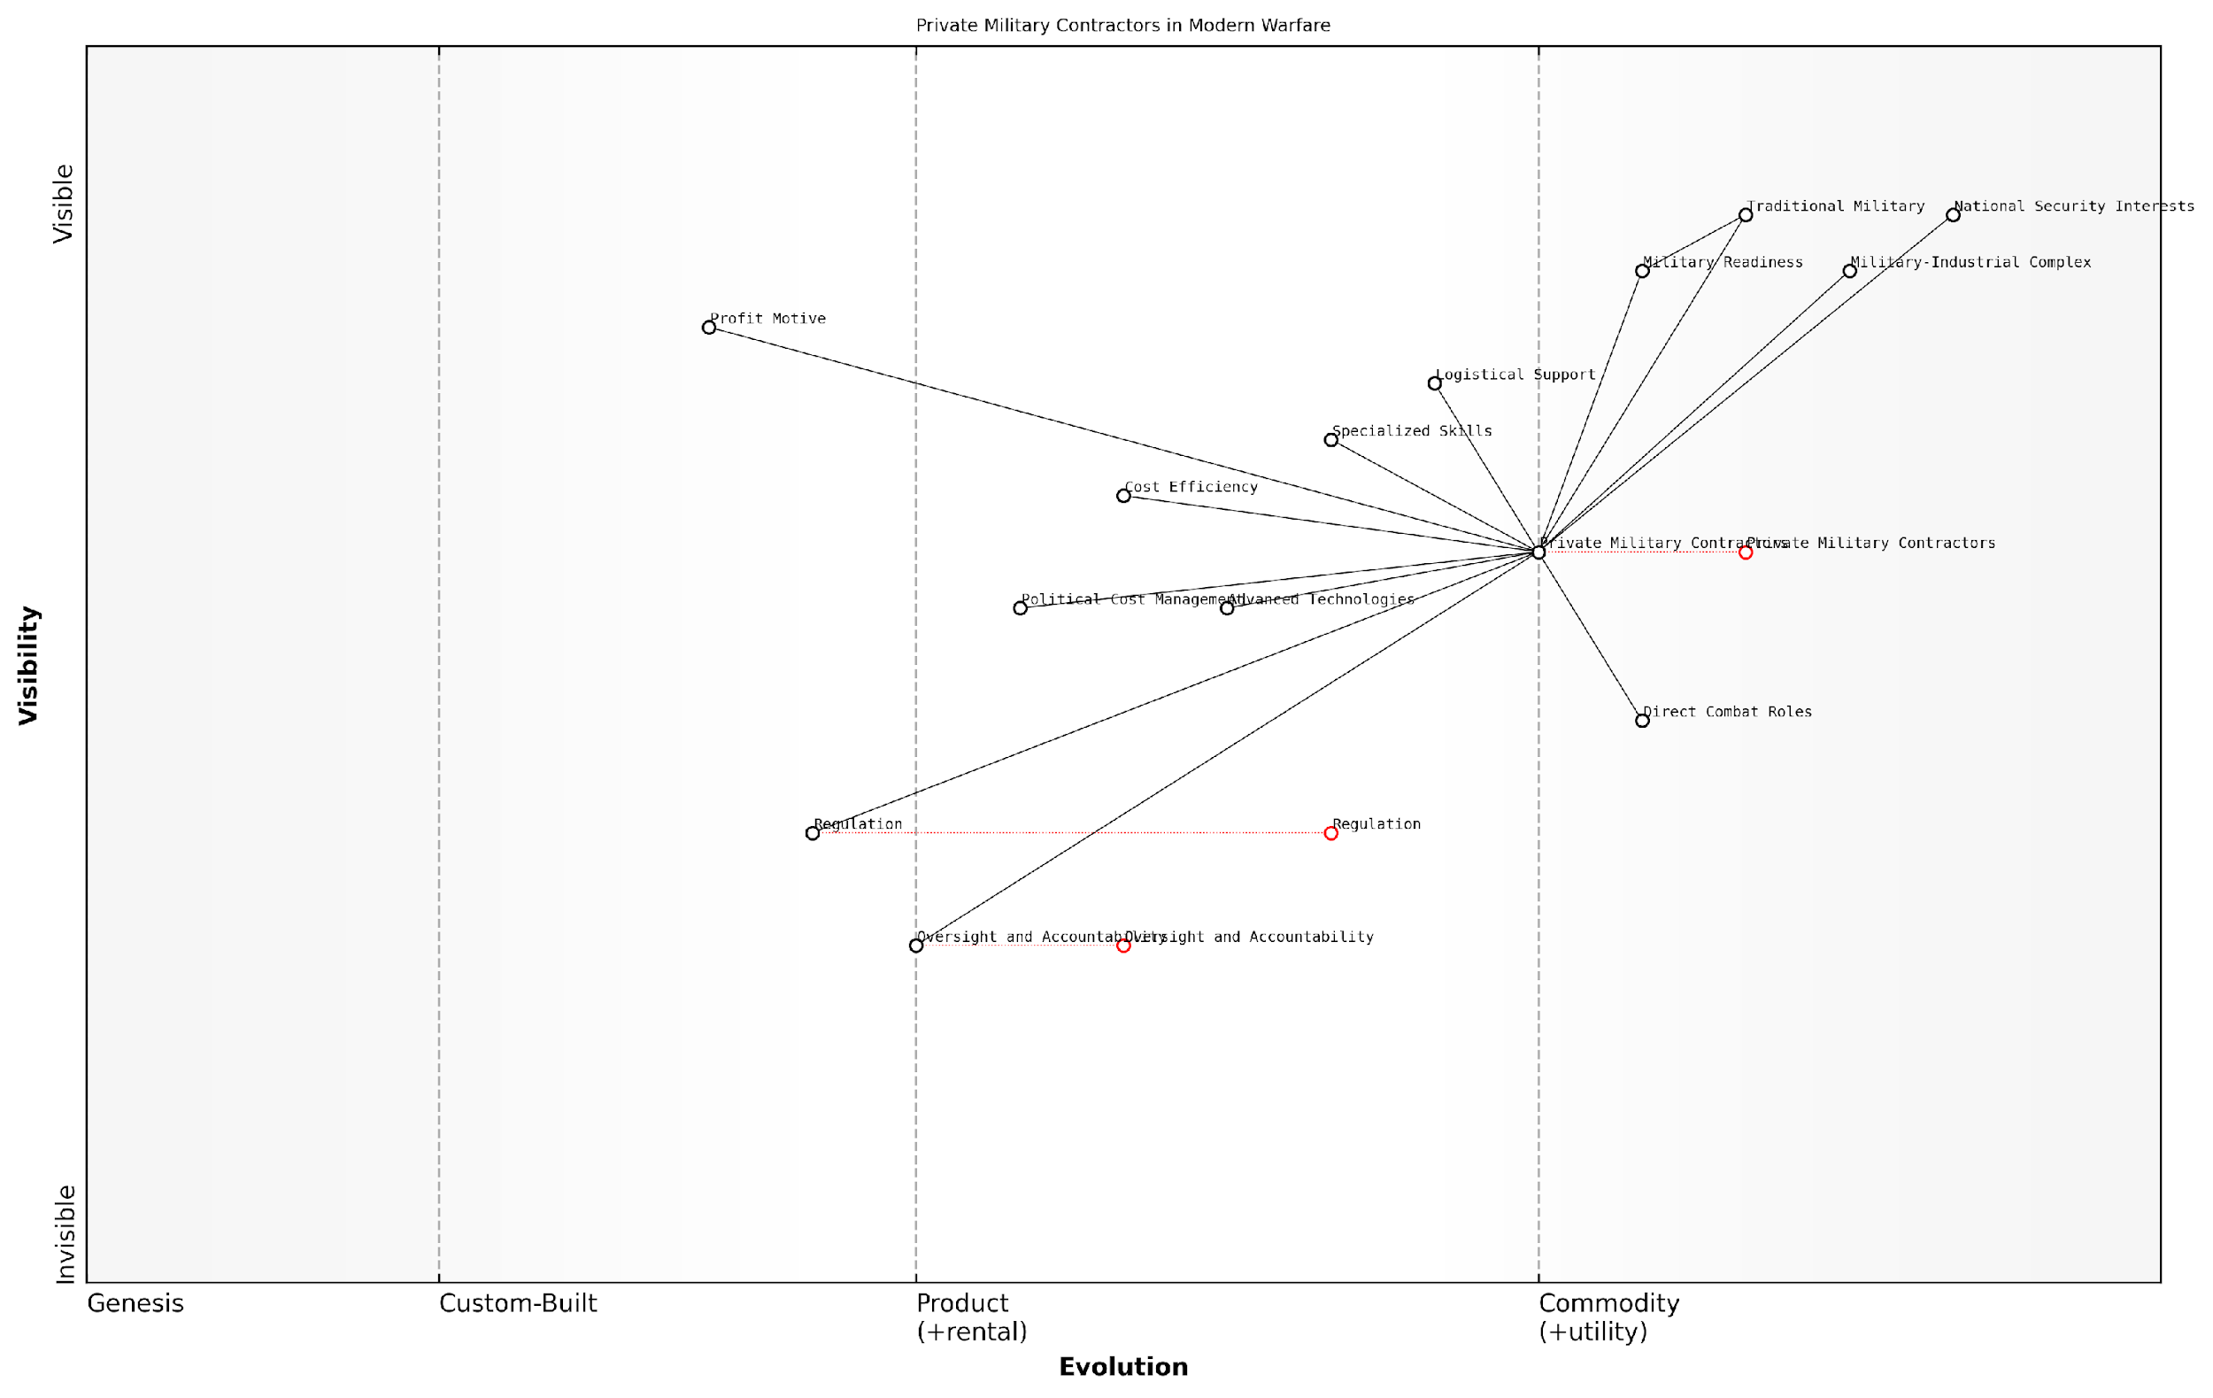

*Draft Wardley Map: [Insert Wardley Map: The role of private contractors in modern warfare]*

[Edit this draft Wardley Map](https://create.wardleymaps.ai/#clone:659c5cd77ed44b07a4)

Wardley Map Assessment

The map reveals a dynamic and evolving landscape where PMCs play an increasingly central role in modern warfare. While offering significant advantages in terms of specialised skills, cost efficiency, and political flexibility, the rise of PMCs also presents challenges related to oversight, accountability, and long-term strategic alignment. The key to successful integration lies in developing robust regulatory frameworks, fostering collaboration between public and private entities, and ensuring that the use of PMCs aligns closely with national security interests. As the industry evolves, there’s a critical need for adaptive policies and innovative approaches to oversight and integration, which will shape the future of military operations and national defence strategies.

[View full Wardley Map report](http://markdown/wardley_map_reports/wardley_map_report_25_The_role_of_private_contractors_in_modern_warfare.md)

In conclusion, the role of private contractors in modern warfare represents a significant shift in the economics of conflict. While offering potential benefits in terms of flexibility, specialisation, and cost-effectiveness, this trend also introduces new economic challenges and ethical considerations. As the reliance on private military and security companies continues to grow, it will be crucial for policymakers, military leaders, and economists to carefully navigate these complex dynamics to ensure that the use of private contractors aligns with both economic efficiency and national security objectives.

## Research and Development Economics

### Investment strategies in military technology

Investment strategies in military technology represent a critical aspect of modern warfare economics, shaping the capabilities and effectiveness of armed forces worldwide. As an expert in this field, I can attest that these strategies are not merely about allocating funds, but about making calculated decisions that balance immediate operational needs with long-term strategic advantages. The complexity of these investment decisions has grown exponentially in recent decades, driven by rapid technological advancements, changing geopolitical landscapes, and evolving threat scenarios.

At the core of effective investment strategies in military technology lies a fundamental understanding of the innovation lifecycle. This process typically encompasses several key stages:

* Basic research and concept development
* Applied research and technology demonstration
* System development and demonstration
* Production and deployment
* Operations and support

Each of these stages requires different investment approaches and risk management strategies. For instance, basic research often involves higher risk but potentially groundbreaking rewards, while production and deployment necessitate more conservative, reliability-focused investments.

In my experience advising defence ministries, I’ve observed that the most successful investment strategies in military technology are those that maintain a balanced portfolio across these stages, ensuring a pipeline of innovations from concept to deployment.

One of the key challenges in formulating investment strategies for military technology is the need to anticipate future threats and operational requirements. This necessitates a combination of intelligence gathering, scenario planning, and technological foresight. Governments and military planners must make educated guesses about the nature of future conflicts and the capabilities required to address them, often decades in advance.

Another crucial aspect of investment strategies in this domain is the balance between incremental improvements and disruptive innovations. Incremental improvements to existing systems often provide immediate, tangible benefits and are generally lower risk. However, disruptive innovations, while riskier, can provide significant strategic advantages and potentially alter the nature of warfare itself.

A senior defence official once remarked to me, ‘Our investment strategy must be like a chess game - we need to think several moves ahead while also being prepared to adapt our strategy as the game unfolds.’

In recent years, we’ve seen a shift towards more agile and adaptive investment strategies in military technology. This approach, often referred to as ‘spiral development’, allows for iterative improvements and rapid integration of new technologies. It’s particularly valuable in areas such as cyber warfare and artificial intelligence, where the pace of change is exceptionally rapid.

Collaboration and partnerships also play a crucial role in modern investment strategies for military technology. This includes:

* Public-private partnerships with defence contractors and technology firms
* International collaborations with allied nations
* Investments in academic research and development
* Engagement with start-ups and non-traditional defence suppliers

These collaborative approaches can help spread risk, accelerate innovation, and ensure interoperability with allied forces. However, they also introduce complexities in terms of intellectual property rights, technology transfer, and security considerations.

A critical component of investment strategies in military technology is the consideration of dual-use technologies. Many innovations developed for military applications have significant potential for civilian use, and vice versa. Savvy investment strategies seek to leverage these dual-use possibilities, not only to maximise return on investment but also to accelerate technological progress through cross-pollination between military and civilian sectors.

As a leading economist in the field noted, ‘The lines between military and civilian technology are increasingly blurred. Our investment strategies must reflect this reality, seeking synergies and spillovers that benefit both sectors.’

Finally, it’s crucial to note that effective investment strategies in military technology must also consider the entire lifecycle costs of new systems, including development, procurement, operation, maintenance, and eventual decommissioning. This ‘total cost of ownership’ approach ensures that investments are sustainable and aligned with long-term budgetary constraints.

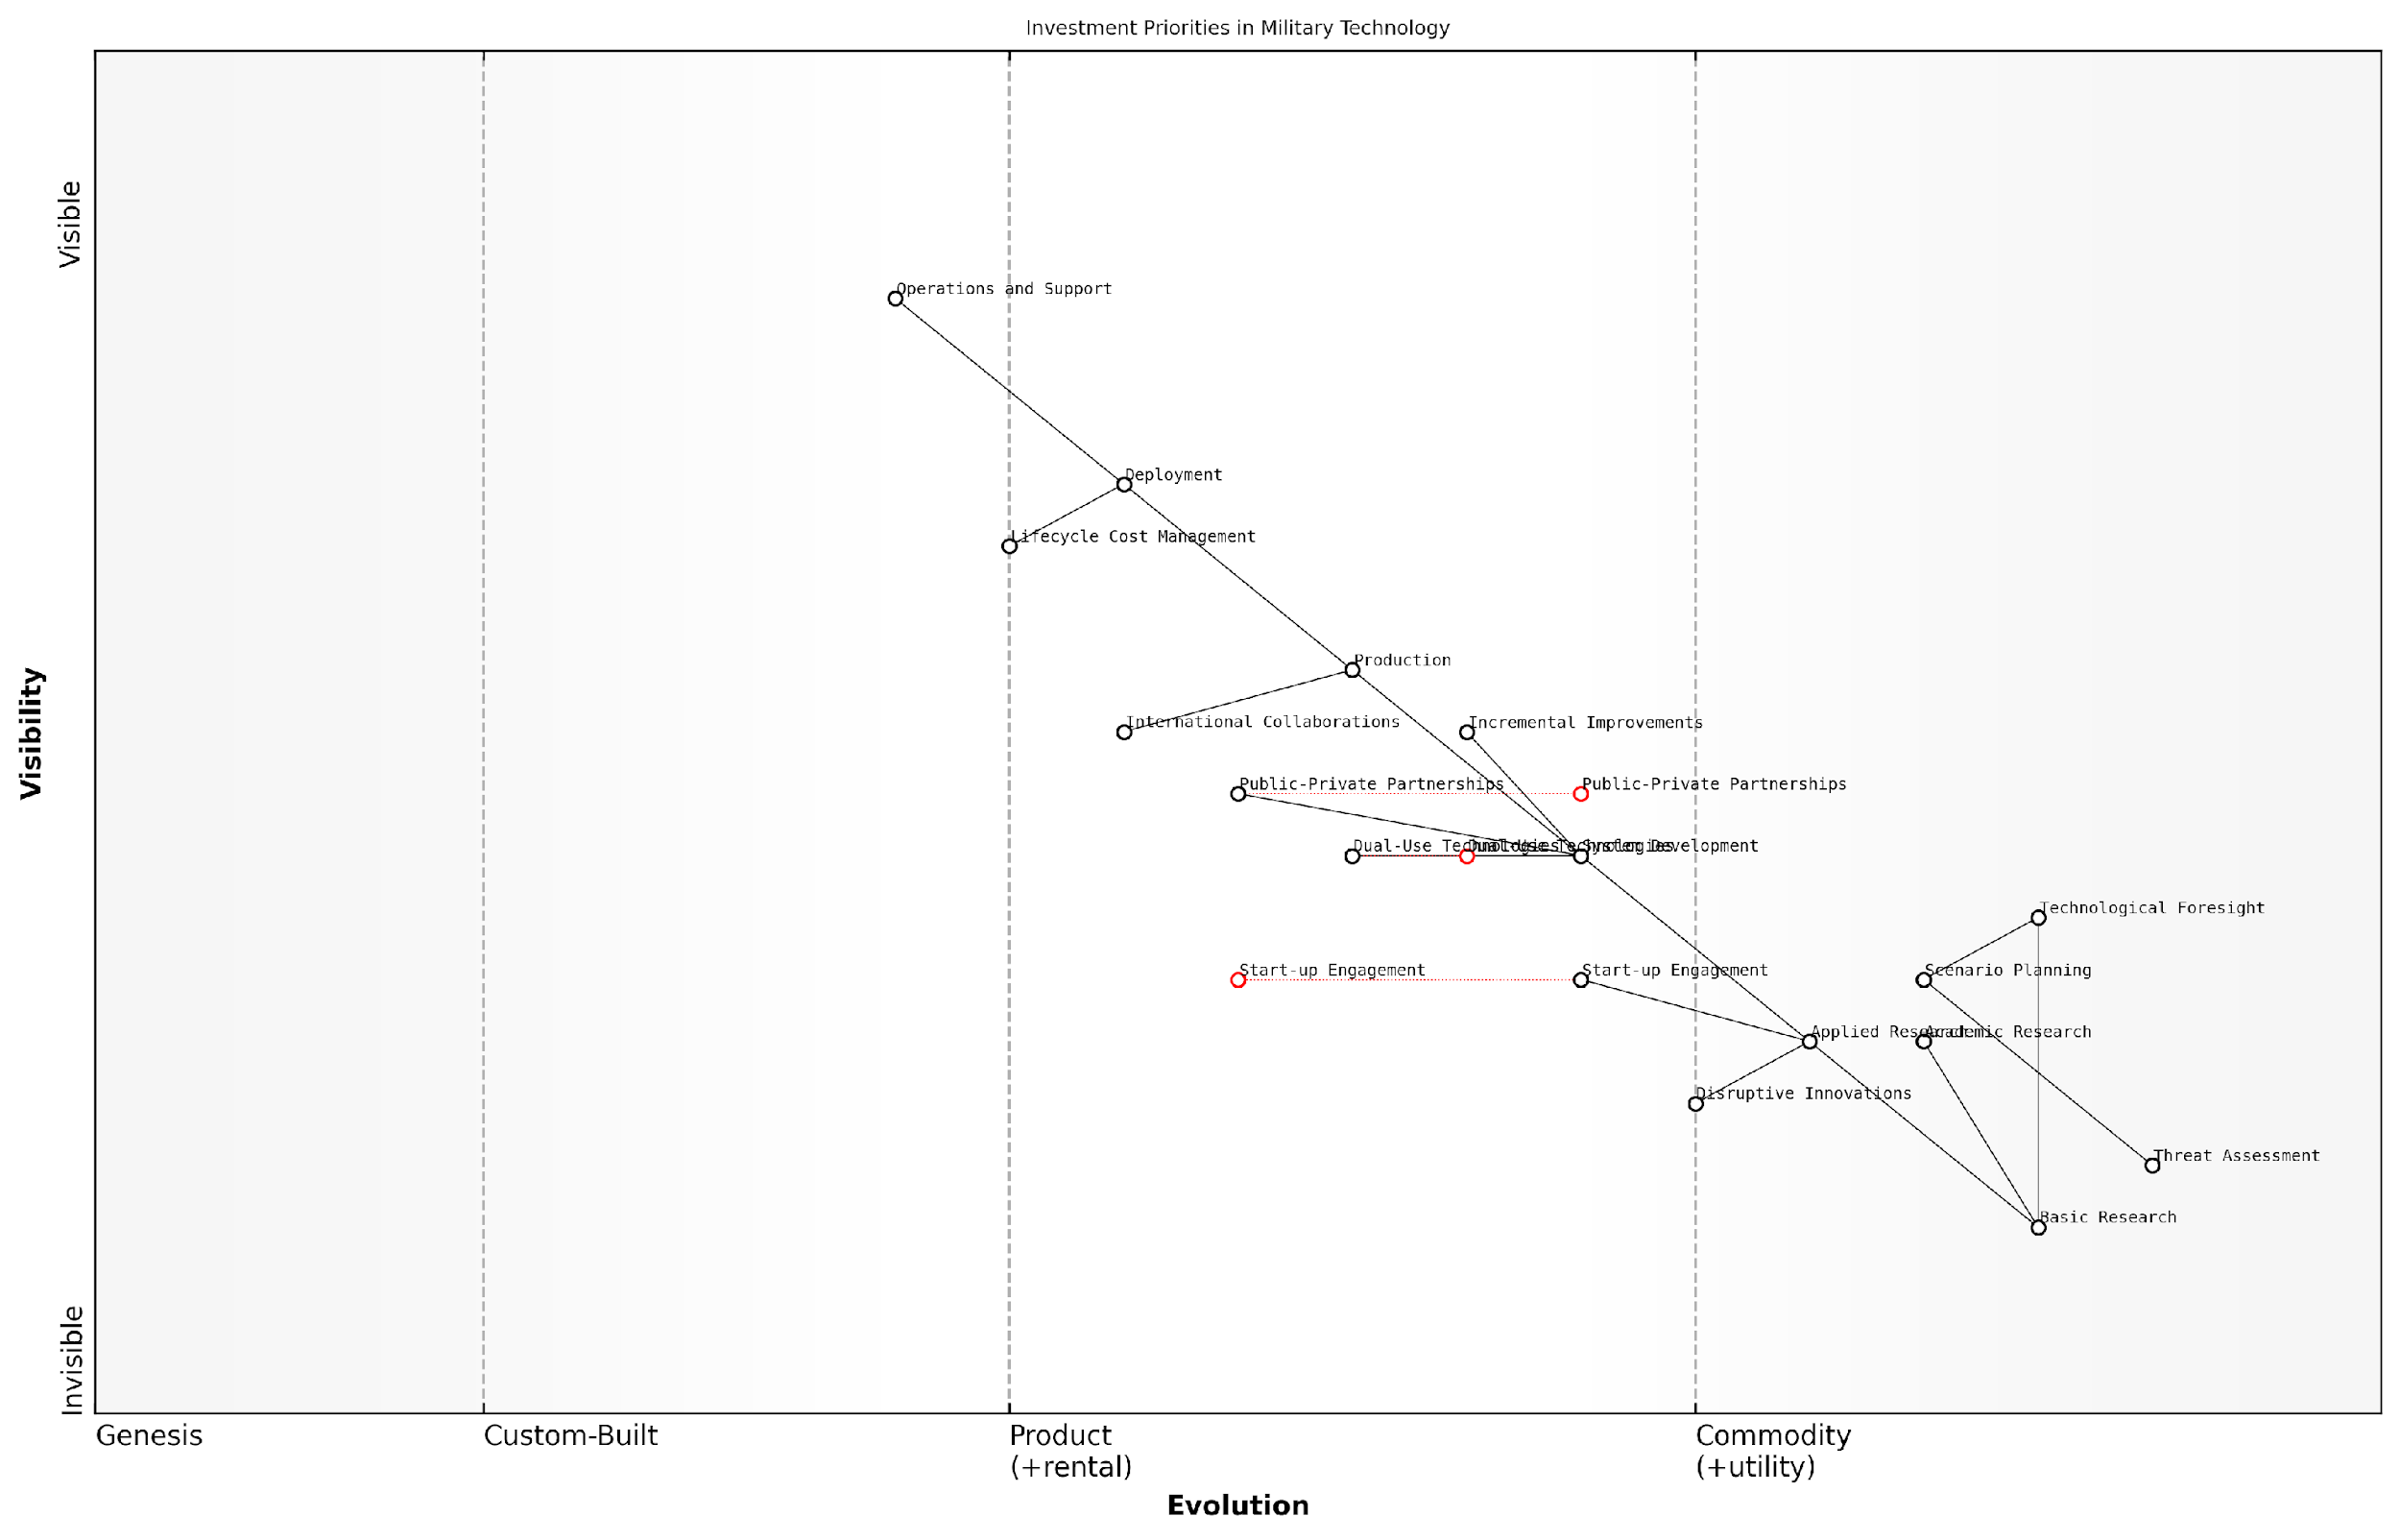

*Draft Wardley Map: [Insert Wardley Map: Investment strategies in military technology]*

[Edit this draft Wardley Map](https://create.wardleymaps.ai/#clone:9b5a413786ca63d6ef)

Wardley Map Assessment

The map reveals a comprehensive approach to military technology investment, balancing long-term research with immediate operational needs. There’s a clear recognition of the importance of external innovation sources and the need for foresight in a rapidly evolving technological landscape. Key opportunities lie in enhancing the integration of disruptive innovations, leveraging dual-use technologies, and creating a more agile research-to-deployment pipeline. The strategic focus should be on maintaining technological superiority through balanced investment across the innovation lifecycle, while also improving the speed and flexibility of technology adoption.

[View full Wardley Map report](http://markdown/wardley_map_reports/wardley_map_report_26_Investment_strategies_in_military_technology.md)

In conclusion, investment strategies in military technology are complex, multifaceted endeavours that require a delicate balance of foresight, risk management, and adaptability. As the pace of technological change continues to accelerate and the nature of warfare evolves, these strategies will play an increasingly critical role in shaping the future of national defence and global security.

### Spin-off effects and civilian applications

The realm of military research and development (R&D) has long been a wellspring of innovation, with far-reaching implications that extend well beyond the battlefield. As an expert in battlefield economics, I’ve observed firsthand how investments in military technology often yield unexpected dividends in civilian sectors, creating a symbiotic relationship between defence and commercial innovation. This phenomenon, known as ‘spin-off effects’, has been a significant driver of technological progress and economic growth throughout modern history.

The concept of spin-off effects is rooted in the substantial resources and cutting-edge research that militaries pour into developing new technologies. These investments often push the boundaries of what’s possible, leading to breakthroughs that can be adapted for civilian use. The economic impact of these spin-offs can be profound, creating new industries, improving productivity, and enhancing quality of life for millions.

* Internet and GPS: Originally developed for military communication and navigation
* Jet engines: Pioneered for military aircraft, now ubiquitous in commercial aviation
* Microwave ovens: A by-product of radar technology research
* Digital cameras: Evolved from spy satellite technology
* Autonomous vehicles: Building on military unmanned vehicle research

The economic impact of these spin-offs is substantial. For instance, the development of the internet, which originated from the US Department of Defense’s ARPANET project, has revolutionised global commerce and communication, creating trillions of dollars in economic value. Similarly, GPS technology, initially designed for military navigation, now underpins a vast array of civilian applications, from smartphone apps to precision agriculture, contributing billions to the global economy annually.

Military R&D is not just about creating better weapons; it’s about pushing the boundaries of human knowledge and capability. The spillover effects into civilian applications often represent the most enduring and valuable outcomes of defence research investments.

However, the process of translating military innovations into civilian applications is not always straightforward. It often requires additional research, development, and adaptation to meet commercial needs and regulatory requirements. This transition phase presents both challenges and opportunities for businesses and entrepreneurs who can bridge the gap between military and civilian applications.

Governments and military organisations are increasingly recognising the value of spin-off effects and are implementing policies to facilitate technology transfer. These include partnerships with universities and private sector companies, as well as dedicated offices for technology transfer within defence departments. Such initiatives aim to maximise the return on investment in military R&D by accelerating the adoption of new technologies in civilian markets.

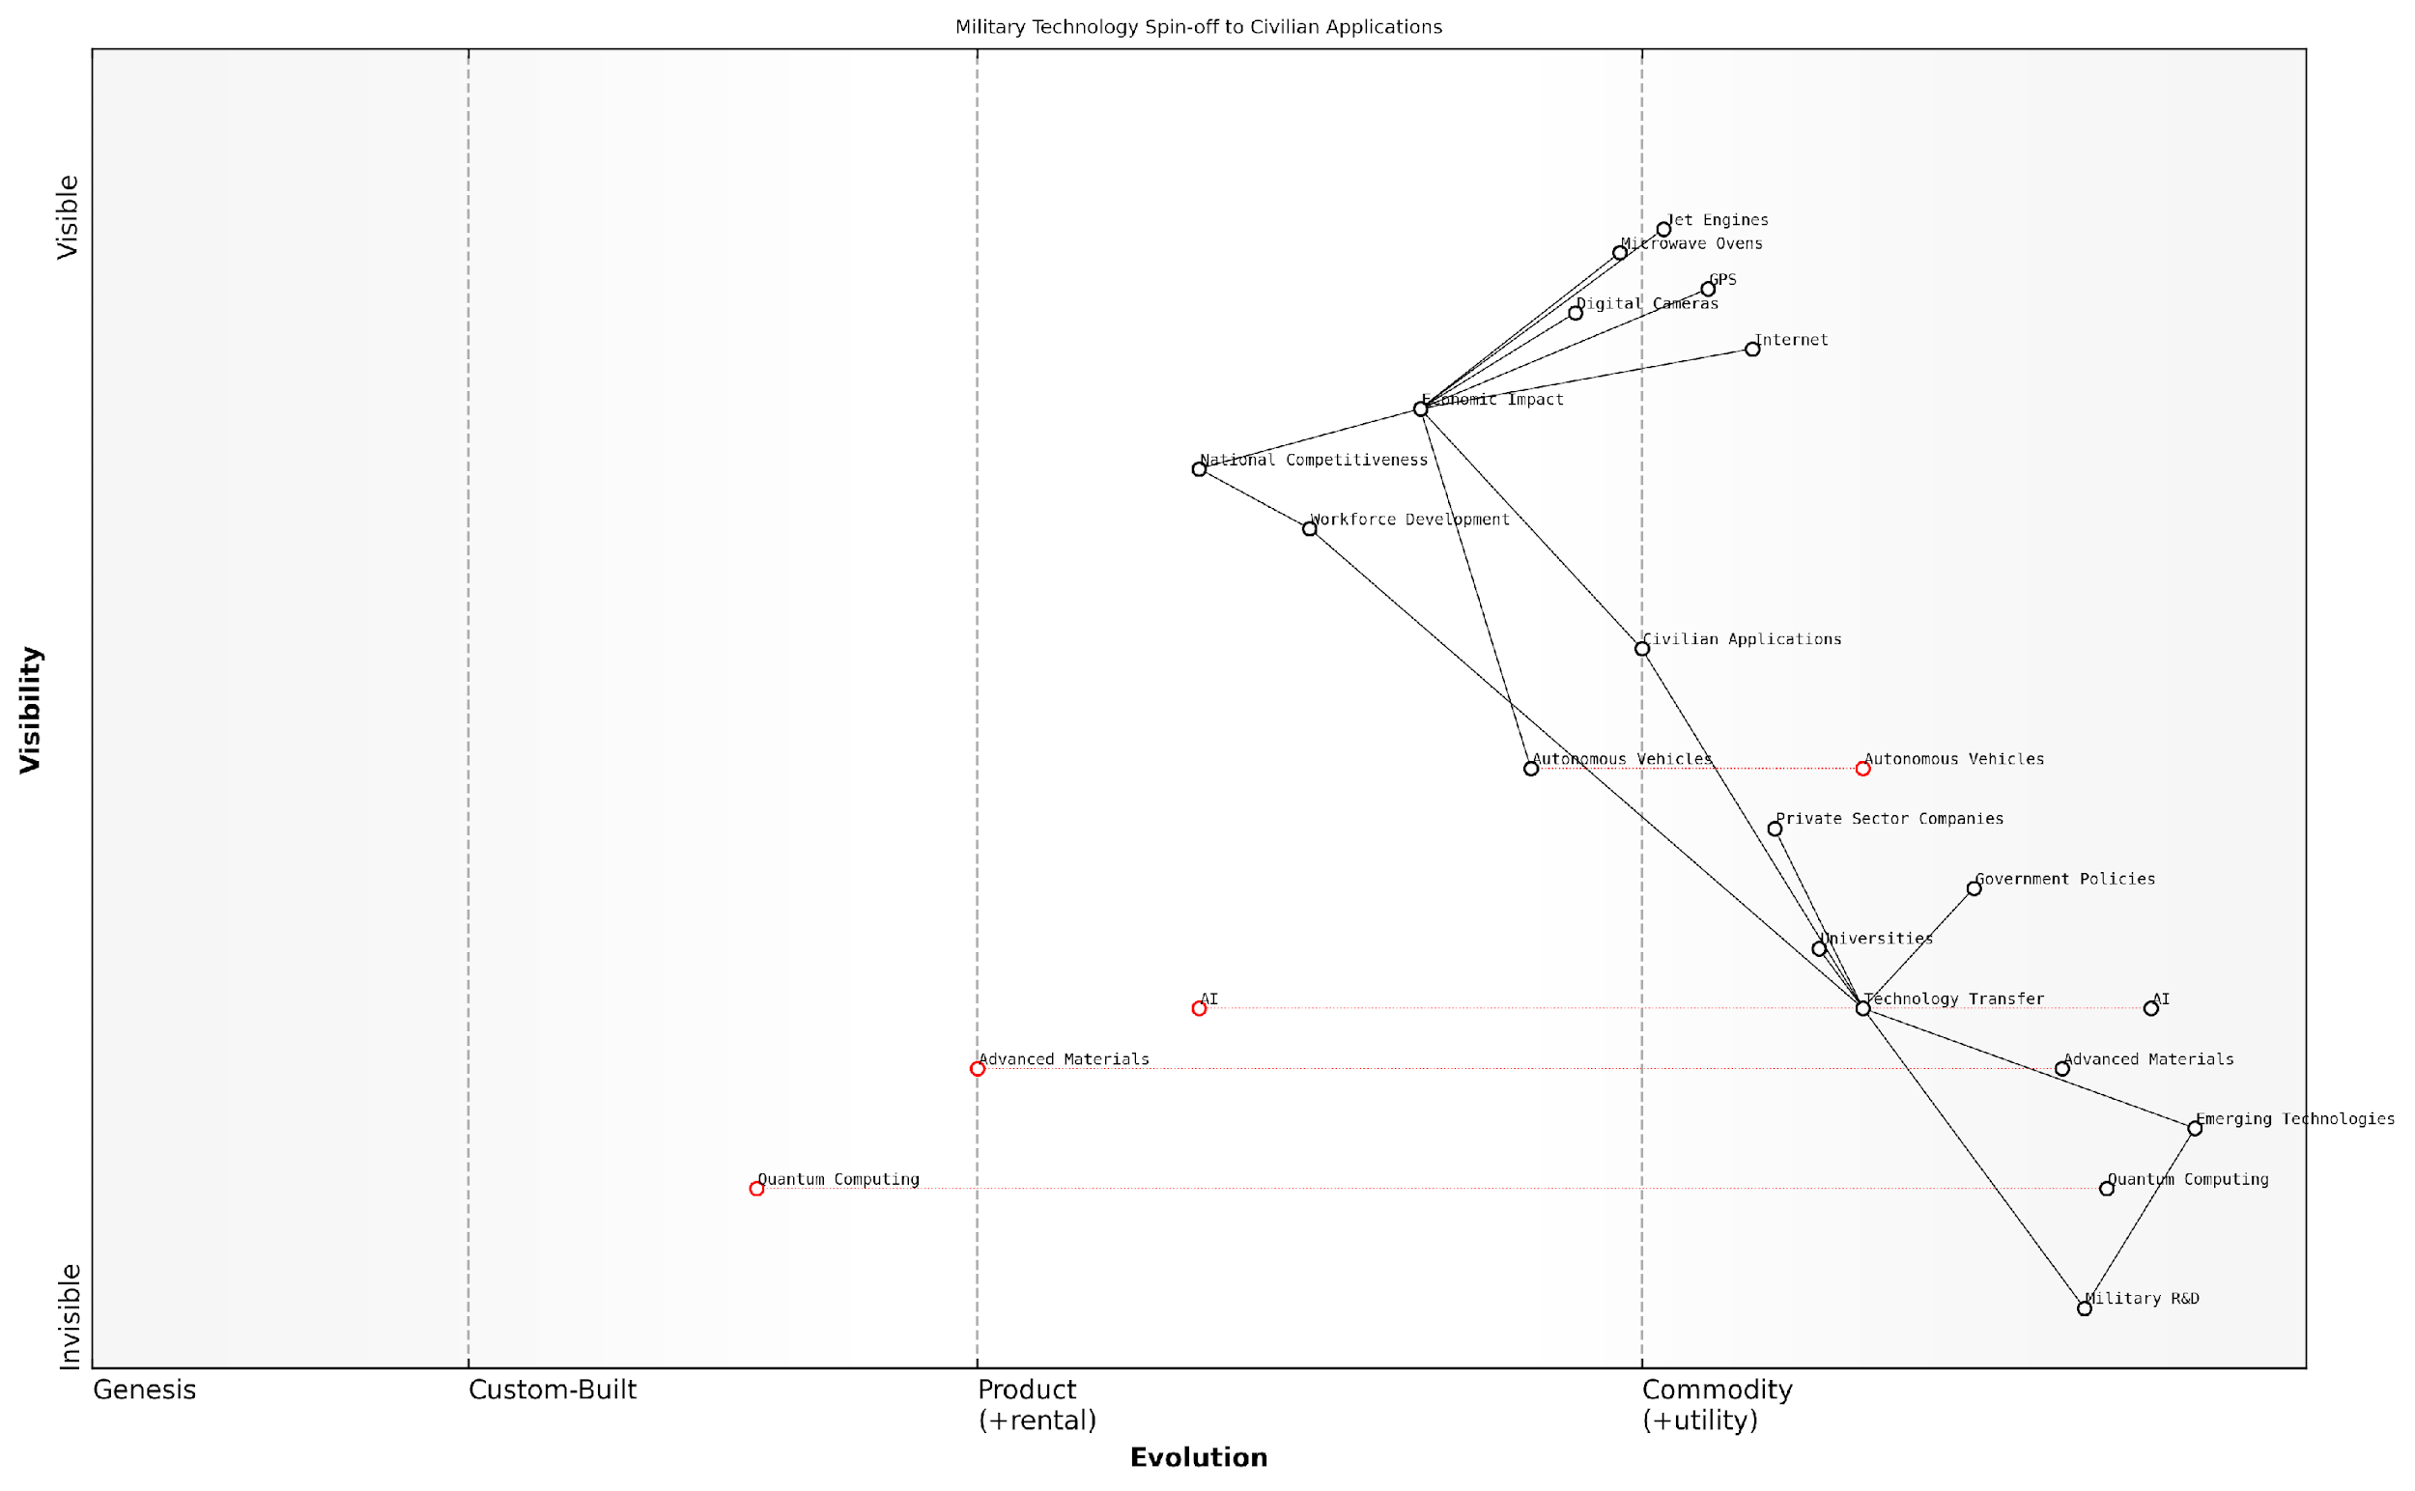

*Draft Wardley Map: [Insert Wardley Map: Spin-off effects and civilian applications]*

[Edit this draft Wardley Map](https://create.wardleymaps.ai/#clone:5b91927e6cf3ee0964)

Wardley Map Assessment

The map reveals a robust system for translating military innovations into civilian applications with significant economic impact. However, there are opportunities to enhance the technology transfer process, particularly for emerging technologies. Strategic focus should be on maintaining leadership in established areas while building capabilities in potentially disruptive technologies like Quantum Computing and Advanced Materials. The ecosystem’s strength lies in its diverse stakeholders, but there’s room for improved collaboration and streamlined processes to accelerate innovation and maintain national competitiveness.

[View full Wardley Map report](http://markdown/wardley_map_reports/wardley_map_report_27_Spin-off_effects_and_civilian_applications.md)

The economic implications of spin-off effects extend beyond direct commercial applications. They also contribute to workforce development, as skills and expertise gained in military R&D can be transferred to civilian sectors. This knowledge transfer helps to build a more skilled and innovative workforce, driving economic growth and competitiveness on a national scale.

Moreover, the potential for civilian applications can influence military R&D priorities and funding decisions. Projects with clear dual-use potential may be viewed more favourably, as they offer the promise of broader economic benefits. This dynamic can lead to a more efficient allocation of research resources and potentially greater public support for defence R&D spending.

The most successful military research programmes are those that not only enhance our defence capabilities but also sow the seeds for future civilian innovations. It’s a delicate balance, but when achieved, it can drive technological progress and economic growth for decades to come.

As we look to the future, emerging fields such as artificial intelligence, quantum computing, and advanced materials science present new frontiers for military R&D with enormous potential for civilian spin-offs. The economic implications of these technologies are difficult to overstate, with the potential to reshape entire industries and create new paradigms of productivity and innovation.

In conclusion, the spin-off effects and civilian applications of military R&D represent a crucial aspect of battlefield economics. They demonstrate the complex interplay between defence spending, technological innovation, and economic growth. As policymakers and military strategists, understanding and leveraging these dynamics is essential for maximising the return on investment in defence research and fostering broader economic prosperity.

### International collaboration and competition in military R&D

In the complex landscape of military research and development (R&D), international collaboration and competition play pivotal roles in shaping the future of defence technologies and capabilities. As an expert who has advised numerous government bodies on defence economics, I can attest to the intricate balance between cooperative efforts and competitive strategies that define this field.

International collaboration in military R&D offers significant advantages, including cost-sharing, risk mitigation, and the pooling of intellectual resources. Such partnerships often lead to breakthroughs that would be difficult for a single nation to achieve independently. For instance, the development of advanced fighter jets like the F-35 Lightning II has involved multiple countries, combining expertise and financial resources to create a state-of-the-art aircraft.

* Cost-sharing: Reduces financial burden on individual nations
* Risk mitigation: Spreads potential failures across partners
* Knowledge exchange: Facilitates transfer of expertise and technologies
* Standardisation: Promotes interoperability among allied forces
* Diplomatic benefits: Strengthens international relations and alliances

However, collaboration is not without its challenges. Intellectual property rights, technology transfer restrictions, and national security concerns can create friction between partners. Moreover, the need to compromise on design specifications to meet diverse requirements can sometimes lead to suboptimal outcomes.

International collaboration in military R&D is a delicate dance of shared interests and national priorities. The key is to find the sweet spot where mutual benefits outweigh individual compromises.

On the other hand, competition in military R&D drives innovation and pushes the boundaries of technological advancement. Nations invest heavily in their domestic defence industries to maintain a competitive edge, often leading to rapid advancements in areas such as artificial intelligence, hypersonic weapons, and cyber capabilities. This competition can result in a technological arms race, with countries vying for supremacy in critical defence domains.

* Innovation driver: Encourages rapid technological advancements
* National capability enhancement: Strengthens domestic defence industries
* Economic benefits: Stimulates job creation and economic growth
* Strategic advantage: Provides military superiority and deterrence
* Spin-off technologies: Often leads to civilian applications and economic benefits

The economic implications of this competition are significant. Nations must carefully balance their R&D investments against other defence and non-defence priorities. The pursuit of cutting-edge technologies can strain national budgets, potentially leading to opportunity costs in other areas of government spending.

In the realm of military R&D, competition is not just about creating the best technologies; it’s about creating the most cost-effective solutions that provide a tangible strategic advantage.

The interplay between collaboration and competition creates a dynamic ecosystem in military R&D. While nations compete to develop superior technologies, they also recognise the value of collaboration in addressing global security challenges. This has led to the emergence of selective partnerships, where countries collaborate on certain projects while competing in others.

For example, NATO’s Science and Technology Organization facilitates collaborative research among member states, focusing on areas of mutual interest while allowing individual nations to pursue their own competitive advantages. Similarly, bilateral agreements between close allies, such as the US-UK Mutual Defence Agreement, enable deep cooperation in sensitive areas like nuclear technology.

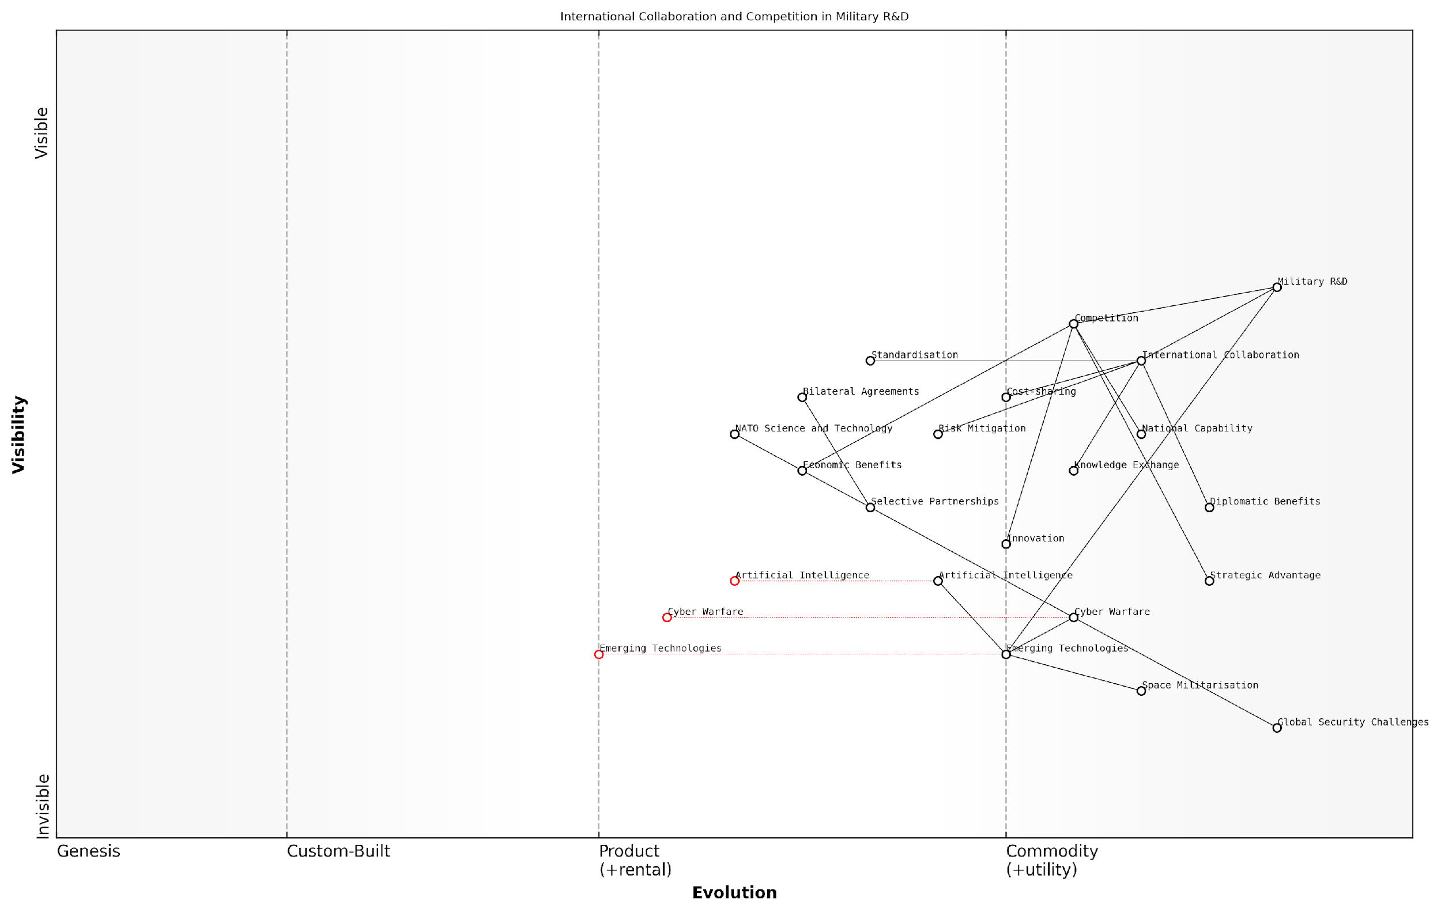

*Draft Wardley Map: [Insert Wardley Map: International collaboration and competition in military R&D]*

[Edit this draft Wardley Map](https://create.wardleymaps.ai/#clone:02e228f7c16aad7796)

Wardley Map Assessment

The map reveals a dynamic and complex landscape of military R&D, where nations must carefully balance collaboration and competition. The rapid evolution of emerging technologies, particularly in AI, cyber warfare, and space militarization, presents both significant opportunities and challenges. Success will depend on strategic partnerships, agile adaptation to technological changes, and maintaining a delicate balance between knowledge sharing and protecting national interests. The future of military R&D will likely be shaped by those who can effectively harness emerging technologies while navigating the intricate web of international collaborations and competitive pressures.

[View full Wardley Map report](http://markdown/wardley_map_reports/wardley_map_report_28_International_collaboration_and_competition_in_mil.md)

Looking ahead, the future of international collaboration and competition in military R&D will likely be shaped by emerging global challenges such as cyber warfare, space militarisation, and the integration of artificial intelligence into military systems. These areas present opportunities for both collaborative efforts to address common threats and competitive pursuits to gain strategic advantages.

In conclusion, the economics of international collaboration and competition in military R&D is a complex field that requires careful navigation. Nations must strike a delicate balance between protecting their interests and leveraging the benefits of cooperation. As an expert in this field, I believe that the most successful strategies will be those that can adeptly manage this balance, fostering innovation while maximising the efficient use of resources in an increasingly interconnected global defence landscape.

## Asymmetric Warfare and Cost-Effective Strategies

### Economic analysis of guerrilla and insurgent tactics

In the realm of asymmetric warfare, guerrilla and insurgent tactics have long been recognised as cost-effective strategies that can significantly impact the economics of conflict. As an expert in battlefield economics, I have observed how these unconventional approaches can dramatically alter the financial dynamics of warfare, often providing a substantial advantage to numerically or technologically inferior forces.

Guerrilla and insurgent tactics are characterised by their low-cost, high-impact nature. These methods typically involve small, mobile groups employing hit-and-run tactics, sabotage, and psychological warfare against a larger, more conventional force. From an economic perspective, these strategies are designed to maximise the cost-benefit ratio for the insurgent force while simultaneously increasing the economic burden on the opposing side.

* Low initial investment: Guerrilla forces often rely on readily available weapons and equipment, reducing procurement costs.
* Minimal infrastructure requirements: Operating in small, mobile units eliminates the need for extensive military bases and supply chains.
* Leveraging local support: Insurgents frequently depend on civilian populations for resources, reducing logistical expenses.
* Targeting high-value assets: Precision strikes on critical infrastructure or valuable military equipment can inflict disproportionate economic damage.

The economic efficiency of guerrilla tactics becomes evident when we examine the cost ratios involved. In my experience advising government bodies, I’ve noted that for every pound spent by insurgent forces, conventional militaries often expend tenfold or more in response. This asymmetry is particularly pronounced in protracted conflicts, where the cumulative economic strain on the larger force can become unsustainable.

A senior military strategist once remarked, ‘In guerrilla warfare, the objective is not to win battles, but to impose a disproportionate economic cost on the enemy. It’s about making the war too expensive to continue.’

The economic impact of guerrilla tactics extends beyond direct military expenditures. These strategies often aim to disrupt the broader economic functioning of the opposing state or region. By targeting infrastructure, trade routes, or economic centres, insurgents can induce significant indirect costs, including reduced productivity, increased security spending, and diminished investor confidence.

Moreover, the psychological aspect of guerrilla warfare plays a crucial role in its economic effectiveness. The constant threat of attack forces conventional forces to maintain a high state of readiness across a wide area, resulting in substantial ongoing costs. This ‘war of nerves’ can lead to overextension of resources and eventual economic exhaustion.

* Force protection costs: Increased spending on defensive measures and personnel security.
* Intelligence gathering expenses: Extensive investments in surveillance and human intelligence to counter elusive threats.
* Psychological impact: Stress on troops leading to higher healthcare and retention costs.
* Political pressure: Economic strain can lead to reduced public support and political will to continue the conflict.

However, it’s crucial to note that the economic advantages of guerrilla tactics are not absolute. Conventional forces have developed counter-insurgency strategies that aim to negate these economic asymmetries. These often involve a combination of targeted military action, economic development initiatives, and efforts to win the ‘hearts and minds’ of local populations.

In my work with public sector organisations, I’ve observed an increasing focus on developing cost-effective counter-insurgency strategies. These often involve leveraging technology for improved intelligence gathering, investing in specialised training for troops, and implementing economic programmes designed to undermine local support for insurgent groups.

As a prominent economist in the field noted, ‘The most effective counter to guerrilla economics is not always military in nature. Sometimes, the best strategy is to address the underlying economic grievances that fuel the insurgency in the first place.’

In conclusion, the economic analysis of guerrilla and insurgent tactics reveals a complex interplay of direct and indirect costs, psychological factors, and long-term strategic considerations. While these methods can provide a significant cost advantage in asymmetric conflicts, their effectiveness is not guaranteed and can be mitigated by well-designed counter-strategies. As the nature of warfare continues to evolve, understanding the economic dimensions of these tactics remains crucial for policymakers, military strategists, and economists alike.

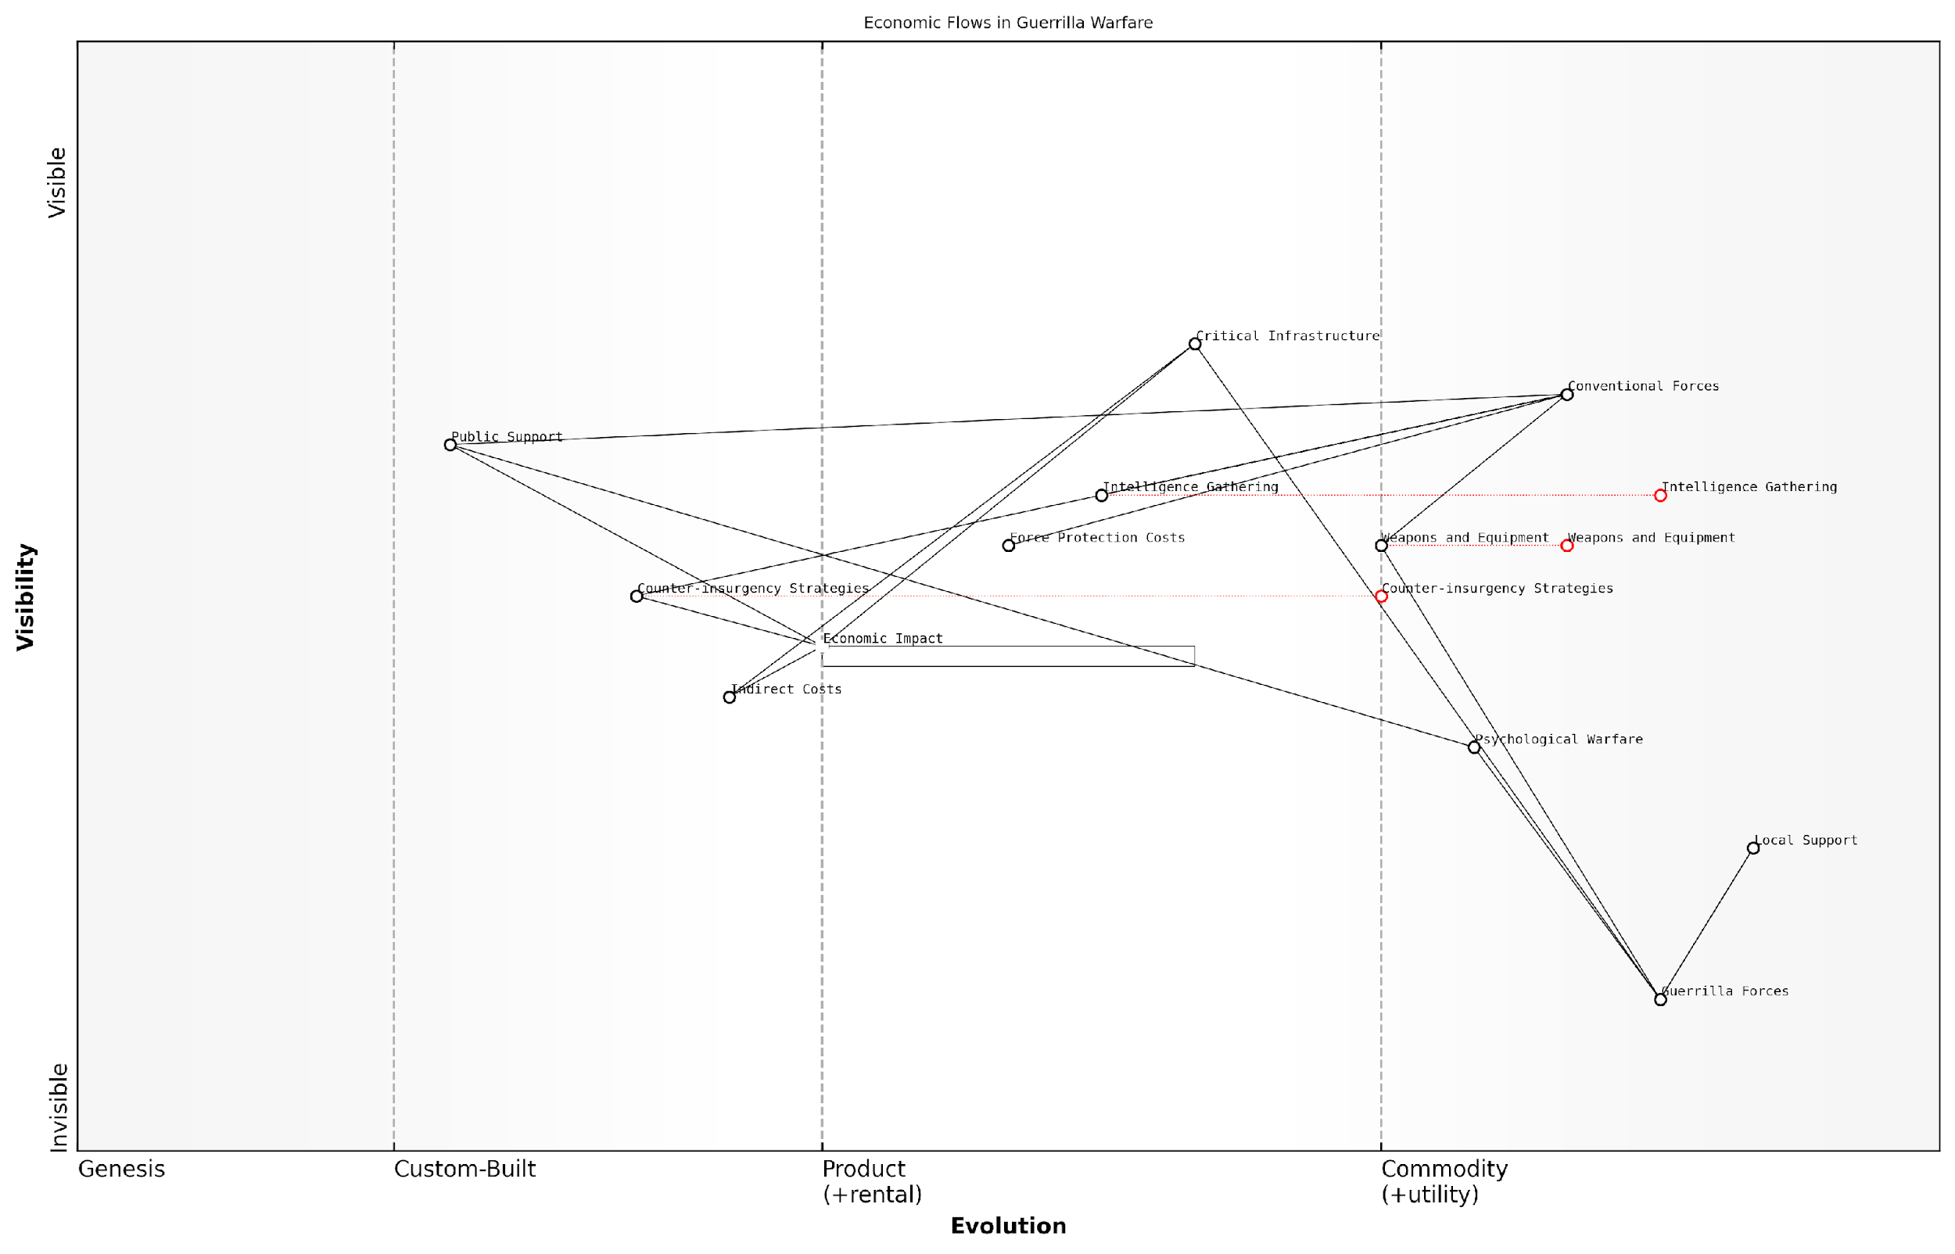

*Draft Wardley Map: [Insert Wardley Map: Economic analysis of guerrilla and insurgent tactics]*

[Edit this draft Wardley Map](https://create.wardleymaps.ai/#clone:67bbe83ed879bf9b1b)

Wardley Map Assessment

This Wardley Map reveals the complex and interconnected nature of economic flows in guerrilla warfare. It highlights the importance of local support, psychological warfare, and managing economic impacts in asymmetric conflicts. Conventional forces face challenges in adapting to this landscape, while guerrilla forces leverage their position to maximise impact with minimal resources. Future strategies should focus on developing more flexible, cost-effective approaches that integrate military, economic, and social dimensions of conflict.

[View full Wardley Map report](http://markdown/wardley_map_reports/wardley_map_report_29_Economic_analysis_of_guerrilla_and_insurgent_tacti.md)

### Cyber warfare and its economic implications

In the realm of battlefield economics, asymmetric warfare and cost-effective strategies have emerged as critical considerations for modern military planners and policymakers. As an expert in this field, I can attest to the profound impact these approaches have on the economic dynamics of conflict, particularly in an era where traditional force-on-force engagements are becoming increasingly rare.

Asymmetric warfare, characterised by significant imbalances in military capabilities between opposing forces, has become a dominant paradigm in contemporary conflicts. This shift has necessitated a re-evaluation of traditional cost-benefit analyses in military strategy, as smaller, less well-equipped forces have demonstrated their ability to effectively challenge larger, more technologically advanced adversaries.

* Economic analysis of guerrilla and insurgent tactics
* Cyber warfare and its economic implications
* The cost-benefit ratio of conventional vs. unconventional warfare

Let us delve into each of these aspects to understand their economic implications on the modern battlefield.

Economic analysis of guerrilla and insurgent tactics reveals a stark contrast to conventional warfare economics. These tactics often rely on low-cost, high-impact operations that can significantly disrupt the operations of a more powerful adversary. From my experience advising government bodies, I’ve observed that the cost-to-impact ratio of guerrilla tactics can be remarkably favourable for the employing force.

A senior military strategist once remarked, ‘In asymmetric warfare, a £1,000 improvised explosive device can disable a £5 million armoured vehicle. This economic disparity forces us to rethink our entire approach to military expenditure and tactical planning.’

This economic efficiency extends to human resources as well. Insurgent forces often operate with minimal overhead, leveraging local support and knowledge to maximise their effectiveness. This stands in stark contrast to the extensive logistical and support structures required by conventional military forces, which can consume a significant portion of defence budgets.

Cyber warfare represents perhaps the most cost-effective form of asymmetric warfare in the modern era. The economic implications of cyber operations are profound and multifaceted. On the offensive side, cyber attacks can be executed at a fraction of the cost of traditional military operations while potentially causing billions in damages to an adversary’s infrastructure, economy, and military capabilities.

* Low initial investment for potentially high returns
* Ability to target critical infrastructure and economic assets
* Plausible deniability and reduced risk of escalation
* Potential for sustained, long-term economic impact on the target

However, the economic implications of cyber warfare extend beyond offensive capabilities. Defending against cyber threats requires significant, ongoing investment in both technology and human capital. Nations and military organisations must constantly evolve their cyber defences to protect against an ever-changing threat landscape, creating a perpetual cycle of investment and adaptation.

As a prominent cybersecurity expert noted, ‘The economics of cyber defence are inherently challenging. Defenders must secure countless potential vulnerabilities, while attackers need only find one weakness to exploit. This asymmetry drives a continuous escalation of cyber defence spending.’

When comparing the cost-benefit ratio of conventional versus unconventional warfare, the economic advantages of asymmetric approaches become clear. Conventional warfare typically involves enormous expenditures on advanced weapons systems, large standing armies, and extensive support infrastructure. While these capabilities remain necessary for national defence, their cost-effectiveness in many modern conflict scenarios is increasingly questioned.

Unconventional warfare, by contrast, often allows forces to achieve strategic objectives at a fraction of the cost. This economic efficiency is particularly evident in protracted conflicts, where the ability to sustain operations over time becomes a critical factor. The lower resource requirements of unconventional tactics can allow smaller nations or non-state actors to effectively resist or deter more powerful adversaries, fundamentally altering the economic calculus of military engagements.

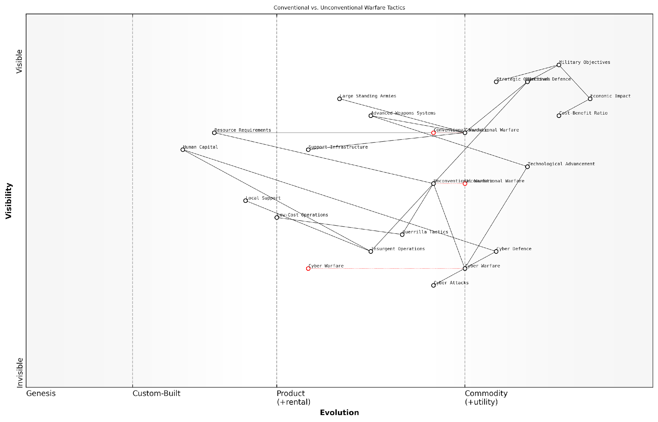

*Draft Wardley Map: [Insert Wardley Map: Cyber warfare and its economic implications]*

[Edit this draft Wardley Map](https://create.wardleymaps.ai/#clone:748545a43cff9ad8b9)

Wardley Map Assessment

This Wardley Map illustrates a critical juncture in military strategy, highlighting the shift from conventional to unconventional and cyber warfare. The strategic position emphasises the need for rapid adaptation to technological advancements, particularly in cyber domains, while maintaining a strong focus on economic implications and cost-effectiveness. The map suggests significant opportunities in developing advanced cyber capabilities and unconventional tactics, while also indicating potential vulnerabilities in over-reliance on traditional warfare methods. To maintain strategic advantage, military organisations must prioritise flexibility, technological innovation, and resource efficiency, with a particular emphasis on cyber warfare capabilities and human capital development.

[View full Wardley Map report](http://markdown/wardley_map_reports/wardley_map_report_30_Cyber_warfare_and_its_economic_implications.md)

However, it’s crucial to note that the economic benefits of asymmetric and unconventional strategies are not without their limitations and potential drawbacks. While these approaches can be highly cost-effective in achieving specific tactical or strategic goals, they may struggle to deliver decisive victories or maintain long-term control over territory. Additionally, the use of certain asymmetric tactics, particularly in the cyber domain, can lead to unforeseen economic consequences and potential escalation of conflicts.

As we look to the future of battlefield economics, it’s clear that asymmetric warfare and cost-effective strategies will continue to play a central role in shaping military doctrine and defence spending priorities. The challenge for military planners and policymakers will be to strike a balance between investing in conventional capabilities and developing the flexibility to effectively employ and counter asymmetric approaches. This balancing act will be crucial in ensuring both military effectiveness and economic sustainability in an increasingly complex and unpredictable global security environment.

### The cost-benefit ratio of conventional vs. unconventional warfare

In the complex landscape of modern warfare, the economic considerations of conventional versus unconventional warfare have become increasingly significant. As an expert in battlefield economics, I have observed that the cost-benefit analysis of these two approaches is crucial for military strategists and policymakers alike. This analysis not only impacts tactical decisions but also shapes long-term military doctrines and national security strategies.

Conventional warfare, characterised by large-scale, state-on-state conflicts involving traditional military forces, has historically been associated with enormous costs. These include substantial investments in heavy equipment, extensive personnel training, and significant logistical support. In contrast, unconventional warfare, which encompasses guerrilla tactics, insurgencies, and asymmetric conflicts, often requires less capital-intensive resources but demands a different set of skills and strategies.

The economics of warfare have shifted dramatically in the 21st century. The cost-effectiveness of unconventional tactics has forced us to reconsider our approach to military spending and strategy.

When examining the cost-benefit ratio, several key factors come into play:

* Initial Investment: Conventional warfare typically requires a higher upfront cost for equipment and training.
* Operational Costs: The day-to-day expenses of maintaining a large conventional force often exceed those of smaller, more flexible unconventional units.
* Duration of Conflict: Unconventional warfare can be sustained for longer periods at a lower cost, potentially wearing down a conventionally superior force.
* Adaptability: Unconventional tactics often allow for quicker adaptation to changing circumstances, potentially reducing long-term costs.
* Political and Social Costs: The impact on civilian populations and international relations can have significant long-term economic consequences for both approaches.

In my experience advising government bodies, I’ve noted that the cost-benefit analysis often favours unconventional warfare in certain scenarios, particularly when facing a technologically or numerically superior adversary. For instance, the use of improvised explosive devices (IEDs) by insurgent groups has proven to be a low-cost method of countering expensive armoured vehicles, effectively neutralising billions of pounds worth of military investment.

However, it’s crucial to understand that the effectiveness of unconventional warfare is not solely about monetary costs. The protracted nature of such conflicts can lead to significant indirect economic impacts, including disrupted trade, reduced foreign investment, and long-term instability in affected regions. These factors must be weighed against the apparent cost savings of unconventional tactics.

In the long run, the true cost of warfare extends far beyond the battlefield. The economic ripple effects of prolonged unconventional conflicts can sometimes outweigh the initial savings.

Moreover, the advent of new technologies is blurring the lines between conventional and unconventional warfare. Cyber warfare, for example, represents a form of asymmetric conflict that can be incredibly cost-effective for the aggressor while potentially causing billions in damages to the target. This shift is forcing a re-evaluation of traditional cost-benefit analyses.

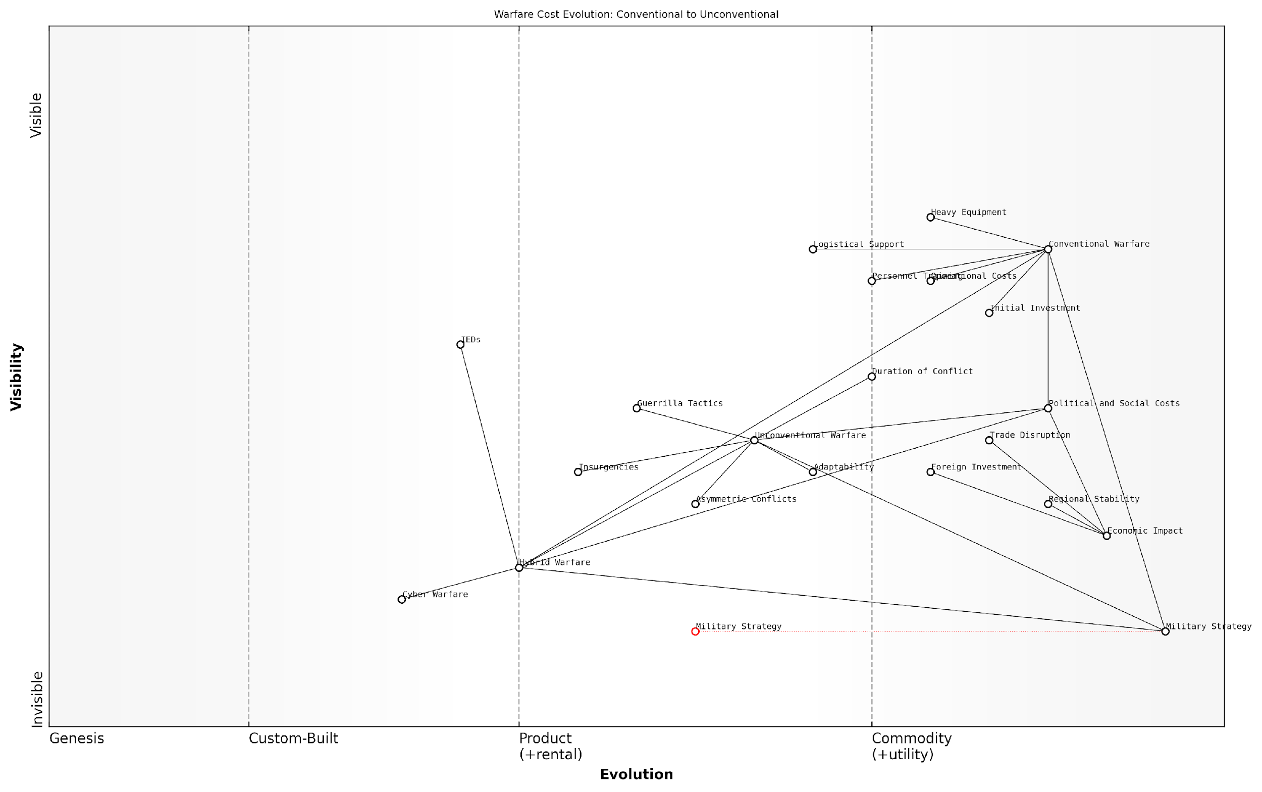

*Draft Wardley Map: [Insert Wardley Map: The cost-benefit ratio of conventional vs. unconventional warfare]*

[Edit this draft Wardley Map](https://create.wardleymaps.ai/#clone:5b619a60cae27b6efa)

Wardley Map Assessment

This Wardley Map reveals a critical shift in warfare strategies towards more cost-effective, adaptable, and technologically advanced approaches. The evolution from Conventional to Unconventional and Hybrid Warfare presents both challenges and opportunities. To maintain strategic advantage, military organisations must balance investments across these domains, with particular focus on emerging areas like Cyber Warfare and Hybrid Warfare. The explicit inclusion of economic and social impacts underscores the need for a holistic approach to warfare strategy that considers broader societal consequences. Adapting to this evolving landscape will require significant changes in military doctrine, training, and equipment procurement, as well as closer integration with other national power elements such as economic and diplomatic capabilities.

[View full Wardley Map report](http://markdown/wardley_map_reports/wardley_map_report_31_The_cost-benefit_ratio_of_conventional_vs._unconve.md)

In conclusion, the cost-benefit ratio of conventional versus unconventional warfare is not a static calculation but a dynamic assessment that must account for evolving technologies, geopolitical contexts, and long-term economic impacts. As military strategists and economists, we must continually refine our models to accurately reflect these changing realities. The future of effective military strategy lies in finding the optimal balance between conventional capabilities and unconventional adaptability, always with an eye towards maximising economic efficiency without compromising national security objectives.

# Chapter 4: Economic Warfare and Strategic Resource Control

## Economic Sanctions as a Tool of War

### Types and effectiveness of economic sanctions

Economic sanctions have become an increasingly prevalent tool in the arsenal of modern warfare, offering a means of exerting pressure on adversaries without resorting to direct military confrontation. As a seasoned expert in battlefield economics, I have observed the evolution and application of various types of economic sanctions across numerous international conflicts. This section will delve into the intricacies of sanction types and their effectiveness, drawing from both historical precedents and contemporary case studies.

Economic sanctions can be broadly categorised into several types, each designed to target specific aspects of a nation’s economy or political structure. Understanding these distinctions is crucial for policymakers and military strategists alike, as the choice of sanction type can significantly impact its effectiveness and potential for unintended consequences.

* Trade sanctions: Restrictions on imports and exports
* Financial sanctions: Freezing assets and limiting access to global financial systems
* Travel bans: Restricting movement of individuals or groups
* Arms embargoes: Prohibiting the sale of weapons and military technology
* Commodity sanctions: Targeting specific resources such as oil or minerals
* Secondary sanctions: Penalising third parties that engage with the sanctioned entity

The effectiveness of economic sanctions is a subject of ongoing debate among economists and policymakers. While sanctions can undoubtedly inflict significant economic pain on target nations, their ability to achieve desired political outcomes is less certain. My experience advising government bodies on sanction strategies has shown that effectiveness often depends on a complex interplay of factors, including the economic resilience of the target nation, the breadth of international support for the sanctions, and the ability to enforce compliance.

Economic sanctions are a blunt instrument. Their effectiveness lies not just in their immediate impact, but in their ability to shape long-term strategic calculations of both the target and its allies.

One of the key considerations in assessing sanction effectiveness is the concept of ‘smart sanctions’. These are targeted measures designed to minimise collateral damage to civilian populations while maximising pressure on decision-makers and key economic sectors. The shift towards smart sanctions reflects a growing understanding of the potential humanitarian costs associated with broad-based economic restrictions.

In my consultancy work, I’ve observed that the most effective sanction regimes often combine multiple types of sanctions, creating a comprehensive approach that limits a target nation’s ability to circumvent restrictions. For instance, coupling financial sanctions with trade restrictions can significantly amplify the economic pressure, making it more difficult for the target to maintain normal economic functions.

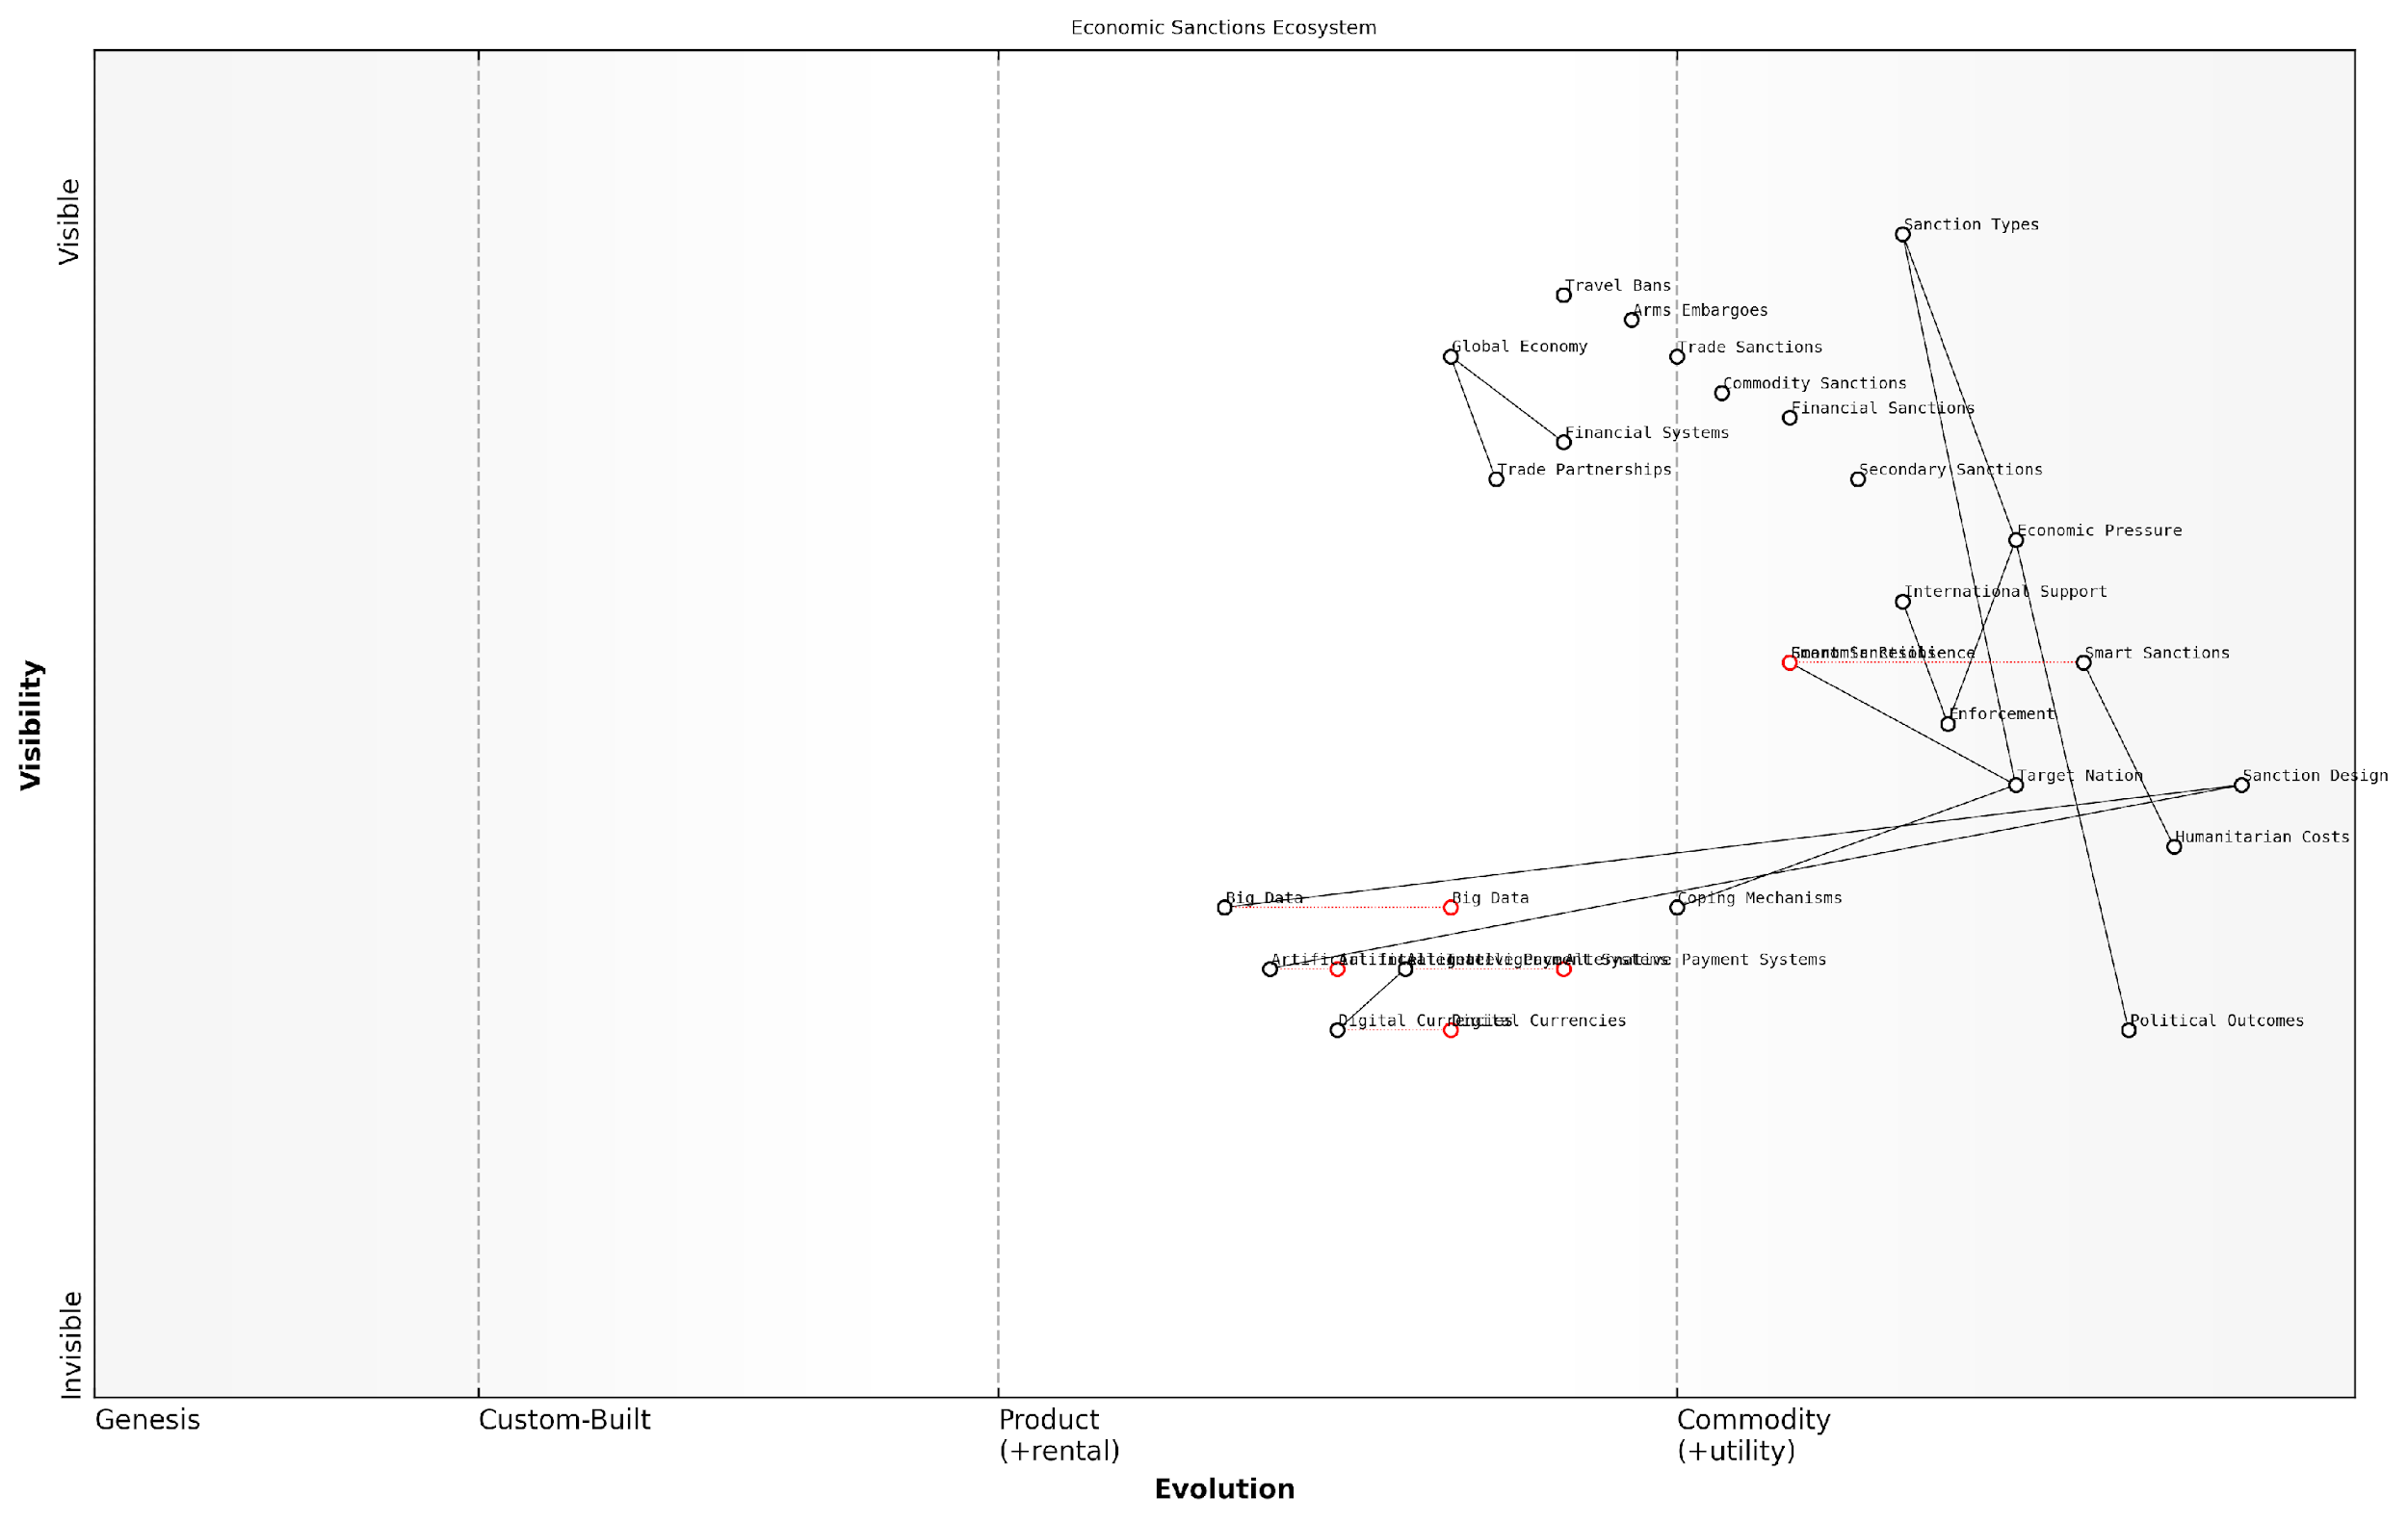

*Draft Wardley Map: [Insert Wardley Map: Types and effectiveness of economic sanctions]*

[Edit this draft Wardley Map](https://create.wardleymaps.ai/#clone:1e3d8eeb3cbafee4bb)

Wardley Map Assessment

The Economic Sanctions Ecosystem is at a critical juncture, balancing between established practices and emerging technologies. The strategic focus should be on developing more targeted, ‘smart’ sanctions leveraging AI and Big Data, while adapting to the challenges posed by Digital Currencies and evolving Coping Mechanisms. Success will depend on maintaining strong International Support, enhancing Enforcement capabilities, and minimising Humanitarian Costs. The ecosystem is likely to become more complex and technologically driven, requiring adaptive strategies and continuous innovation.

[View full Wardley Map report](http://markdown/wardley_map_reports/wardley_map_report_32_Types_and_effectiveness_of_economic_sanctions.md)

However, it’s crucial to note that the effectiveness of sanctions can diminish over time. Target nations often develop coping mechanisms, such as alternative trade partnerships or domestic substitution strategies. This adaptation underscores the importance of continual assessment and adjustment of sanction regimes to maintain their potency.

Moreover, the globalised nature of modern economies presents both opportunities and challenges for sanction effectiveness. While interconnected financial systems make it easier to implement far-reaching financial sanctions, they also create potential for unintended economic ripple effects that can impact neutral parties or even the sanctioning nations themselves.

In the realm of economic warfare, sanctions are a double-edged sword. Their power lies in their ability to inflict economic pain, but their success ultimately depends on our capacity to wield them with precision and foresight.

The effectiveness of sanctions also hinges on clear communication of objectives and conditions for their removal. Ambiguity in this regard can lead to prolonged economic standoffs with diminishing returns. In my experience advising on sanction exit strategies, I’ve found that establishing clear, achievable benchmarks for sanction relief can enhance their overall effectiveness by providing a pathway for resolution.

It’s worth noting that the rise of digital currencies and alternative financial systems poses new challenges to the implementation and effectiveness of traditional financial sanctions. As an expert in this field, I’ve been closely monitoring these developments and their potential to reshape the landscape of economic warfare.

* Increased use of cryptocurrencies to evade financial restrictions
* Development of alternative international payment systems
* Growing economic alliances among sanctioned nations
* Exploitation of legal loopholes in sanction regimes

In conclusion, while economic sanctions remain a powerful tool in the arsenal of economic warfare, their effectiveness is neither universal nor guaranteed. As the global economic landscape continues to evolve, so too must our approach to designing and implementing sanction regimes. The future of economic sanctions will likely involve more sophisticated, targeted approaches that leverage big data and artificial intelligence to enhance precision and minimise unintended consequences.

### Unintended consequences and humanitarian costs

Economic sanctions, while often viewed as a less violent alternative to military intervention, can have far-reaching and often unforeseen consequences that extend well beyond their intended targets. As an expert in battlefield economics, I have observed numerous instances where sanctions have resulted in severe humanitarian crises and economic devastation that persist long after the sanctions are lifted.

The unintended consequences of economic sanctions can be broadly categorised into three main areas: humanitarian impact, economic distortions, and political ramifications. Each of these areas interacts with the others, creating a complex web of effects that can undermine the very objectives the sanctions were meant to achieve.

* Humanitarian Impact: Deterioration of public health, food insecurity, and reduced access to essential services
* Economic Distortions: Rise of black markets, currency devaluation, and long-term damage to productive sectors
* Political Ramifications: Strengthening of authoritarian regimes, increased nationalism, and potential for conflict escalation

The humanitarian costs of sanctions are often the most visible and immediate. In my work advising government bodies on the implementation of sanctions, I’ve consistently emphasised the need to consider the impact on civilian populations. Sanctions can lead to shortages of food, medicine, and other essential goods, disproportionately affecting the most vulnerable segments of society. For instance, comprehensive sanctions imposed on a country heavily reliant on food imports can quickly lead to widespread malnutrition and increased infant mortality rates.

The suffering of innocent civilians under sanctions regimes is not merely collateral damage, but a predictable and often severe consequence that must be factored into any cost-benefit analysis of economic warfare.

Economic distortions resulting from sanctions can have long-lasting effects on a country’s development trajectory. The rise of black markets and smuggling networks not only undermines the effectiveness of sanctions but also creates entrenched criminal enterprises that persist long after sanctions are lifted. Currency devaluation, often a result of restricted international trade, can wipe out savings and push large segments of the population into poverty. Moreover, sanctions can lead to the deterioration of critical infrastructure and productive capacity, setting back economic development by decades.

Perhaps most concerning from a strategic perspective are the political ramifications of sanctions. Contrary to the intended effect of weakening targeted regimes, sanctions can often strengthen authoritarian governments by providing them with a scapegoat for economic hardships. This ‘rally around the flag’ effect can increase nationalism and hostility towards the sanctioning countries, potentially escalating conflicts rather than resolving them. In my experience advising on conflict resolution strategies, I’ve seen how sanctions can harden political positions and make diplomatic solutions more difficult to achieve.

Economic sanctions, when not carefully calibrated, can create a siege mentality that entrenches the very behaviours they aim to change, turning what was intended as a short-term measure into a protracted economic conflict.

The humanitarian costs of sanctions extend beyond the immediate crisis period. Long-term health consequences, disrupted education systems, and the emigration of skilled professionals can create a ‘lost generation’ effect, hampering a country’s ability to recover even after sanctions are lifted. This can lead to cycles of poverty and underdevelopment that persist for decades, potentially sowing the seeds for future conflicts.

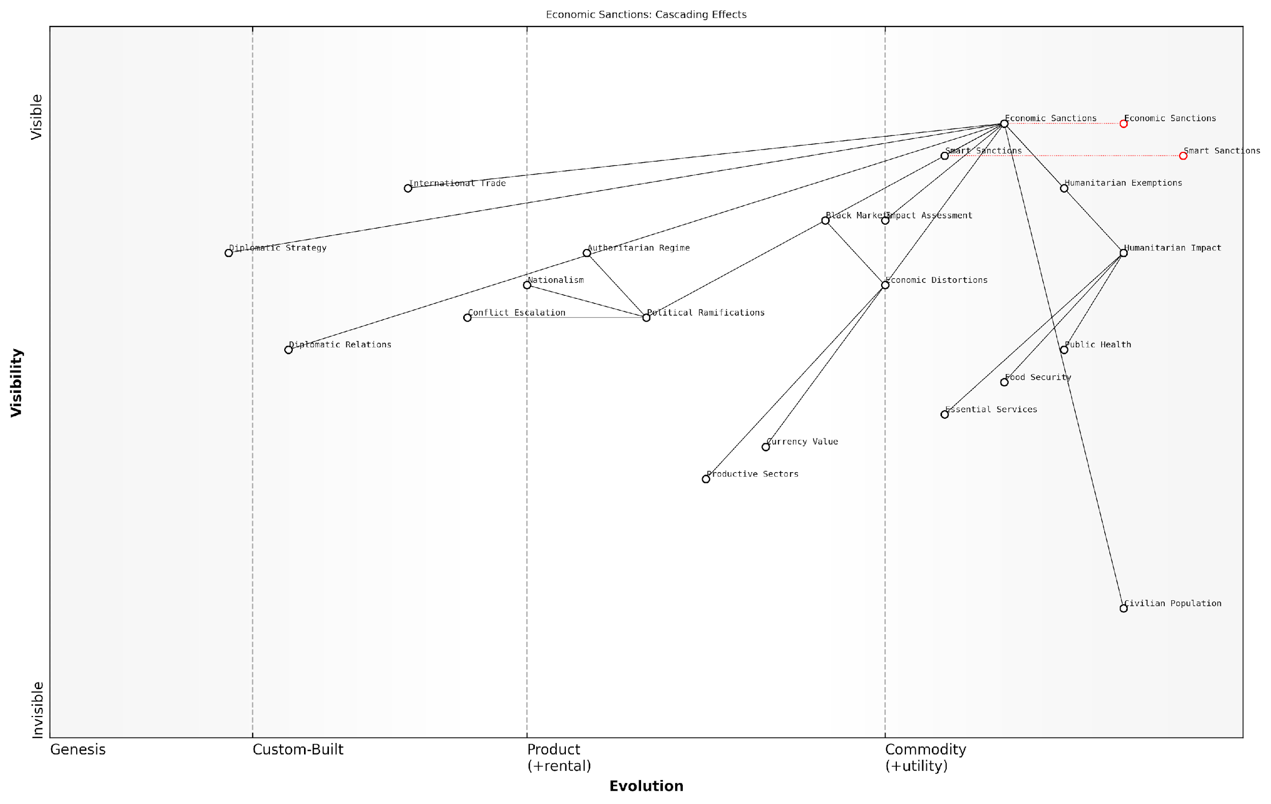

*Draft Wardley Map: [Insert Wardley Map: Unintended consequences and humanitarian costs]*

[Edit this draft Wardley Map](https://create.wardleymaps.ai/#clone:5379ae24a05376a0f0)

Wardley Map Assessment

This Wardley Map reveals the complex and often problematic nature of economic sanctions as a foreign policy tool. While sanctions are a well-established and visible component, their cascading effects on humanitarian conditions, economic structures, and political dynamics are significant. The map highlights the need for a more nuanced, ‘smart’ approach to sanctions that can effectively pressure target regimes while minimising unintended consequences, particularly on civilian populations. Key areas for strategic focus include improving impact assessment capabilities, refining smart sanction methodologies, and strengthening diplomatic strategies to ensure sanctions achieve their intended goals without excessive collateral damage. The evolution towards more targeted, ethically considerate sanction regimes represents a critical path forward in this domain.

[View full Wardley Map report](http://markdown/wardley_map_reports/wardley_map_report_33_Unintended_consequences_and_humanitarian_costs.md)

To mitigate these unintended consequences, policymakers must adopt a more nuanced approach to economic sanctions. This includes implementing targeted or ‘smart’ sanctions that focus on specific individuals or sectors rather than entire economies, incorporating robust humanitarian exemptions, and regularly assessing the impact of sanctions on civilian populations. Additionally, sanctions should be part of a broader diplomatic strategy that includes clear objectives and exit ramps, rather than being seen as an end in themselves.

* Implement targeted ‘smart’ sanctions to minimise civilian impact
* Incorporate robust humanitarian exemptions for essential goods and services
* Regularly assess and adjust sanctions based on their humanitarian impact
* Integrate sanctions into a broader diplomatic strategy with clear objectives and exit criteria

In conclusion, while economic sanctions remain a powerful tool in the arsenal of economic warfare, their use must be tempered with a thorough understanding of their potential for unintended consequences and humanitarian costs. As experts in battlefield economics, it is our responsibility to ensure that policymakers are fully aware of these risks and equipped with strategies to mitigate them. Only through such a balanced approach can economic sanctions hope to achieve their intended objectives without causing disproportionate harm to civilian populations.

### Sanctions evasion and black market economics

As an expert in battlefield economics, I can attest that sanctions evasion and black market economics play a crucial role in the broader context of economic warfare. These phenomena represent the adaptive and often illicit responses to economic sanctions, highlighting the complex interplay between formal economic measures and informal economic activities in conflict situations.

Sanctions evasion refers to the various strategies and tactics employed by targeted entities—be they states, organisations, or individuals—to circumvent the restrictions imposed by economic sanctions. This evasion can take many forms, from sophisticated financial manoeuvres to the exploitation of legal loopholes. The emergence of cryptocurrencies and other digital financial technologies has added new dimensions to sanctions evasion, providing novel methods for concealing transactions and moving funds across borders.

Sanctions evasion is not merely a criminal activity; it’s an economic battlefield where innovation and adaptation are constantly at play. The cat-and-mouse game between sanction enforcers and evaders drives a continuous evolution in both evasion techniques and enforcement strategies.

Black market economics, on the other hand, encompasses the broader underground economic activities that flourish in response to sanctions and other economic restrictions. These informal markets serve as alternative channels for the flow of goods, services, and capital when formal channels are blocked or heavily regulated. In the context of battlefield economics, black markets can become critical lifelines for sanctioned regimes, providing access to otherwise restricted resources and helping to sustain military operations.

* Front companies and shell corporations to obscure ownership and transactions
* Trade-based money laundering to disguise the movement of value through trade transactions
* Exploitation of jurisdictions with weak regulatory oversight
* Use of intermediaries and third-party countries to facilitate transactions
* Bartering systems to avoid traditional financial channels

The economic impact of sanctions evasion and black markets extends far beyond the immediate conflict zone. These activities can distort regional economies, fuel corruption, and undermine the effectiveness of international financial regulations. For military strategists and policymakers, understanding these dynamics is crucial for assessing the true impact of economic sanctions and developing more effective approaches to economic warfare.

From a battlefield economics perspective, the resilience of black markets in conflict zones presents both challenges and opportunities. While they can undermine the intended effects of sanctions, they also provide valuable intelligence on resource flows and economic vulnerabilities. Analysing black market activities can offer insights into the true economic conditions within a sanctioned entity, potentially revealing weaknesses that traditional economic indicators might miss.

In the realm of economic warfare, black markets are double-edged swords. They can prolong conflicts by providing economic lifelines to sanctioned regimes, but they also create vulnerabilities and dependencies that can be exploited by opposing forces.

The technological evolution of financial systems presents new frontiers in the battle against sanctions evasion. Blockchain analytics, artificial intelligence, and big data analysis are increasingly being employed to detect and prevent evasion attempts. However, these same technologies can also be leveraged by those seeking to evade sanctions, leading to an ongoing technological arms race in the financial domain.

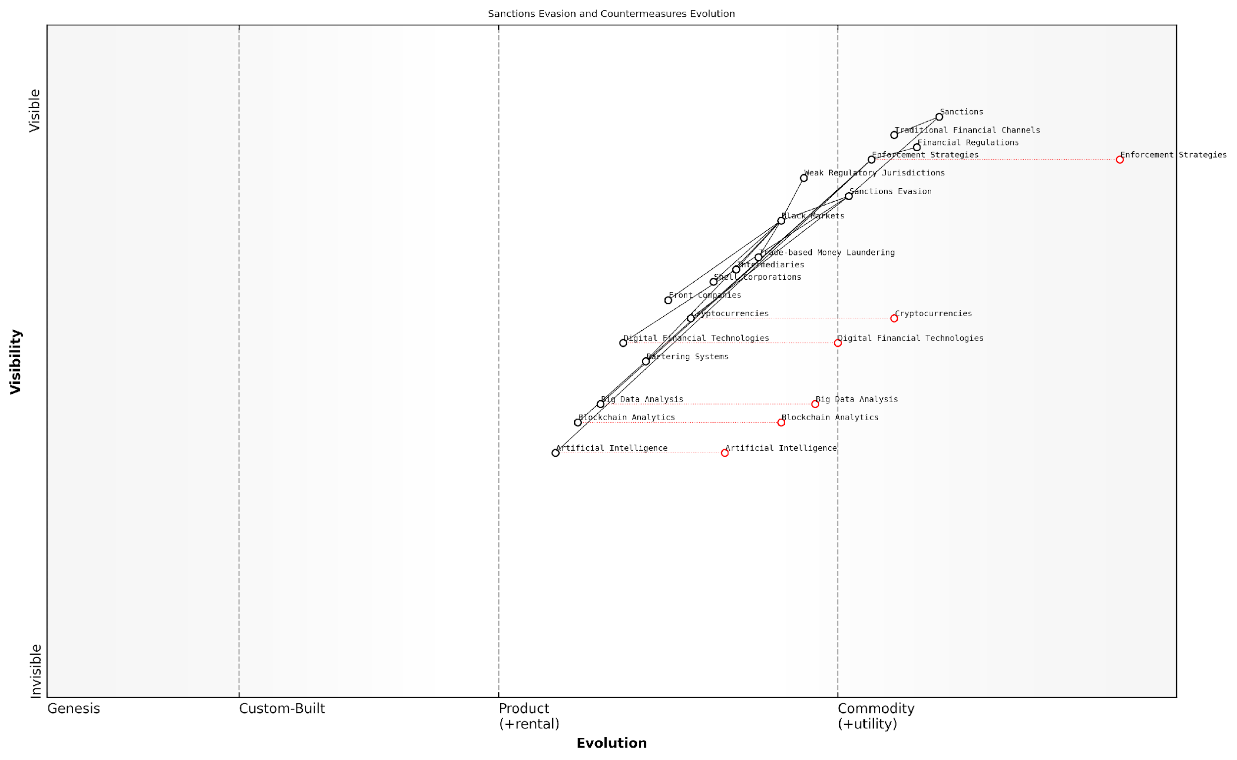

*Draft Wardley Map: [Insert Wardley Map: Sanctions evasion and black market economics]*

[Edit this draft Wardley Map](https://create.wardleymaps.ai/#clone:3b2df82027a6d5998e)

Wardley Map Assessment

The Wardley Map reveals a dynamic and rapidly evolving landscape of sanctions evasion and enforcement. The strategic focus should be on leveraging emerging technologies, particularly AI, blockchain analytics, and big data analysis, to stay ahead of sophisticated evasion techniques. Collaboration between public and private sectors, as well as international cooperation, will be crucial in developing effective countermeasures. The future of sanctions enforcement lies in real-time, AI-driven monitoring of both traditional and digital financial flows, requiring significant investment in technology and human capital.

[View full Wardley Map report](http://markdown/wardley_map_reports/wardley_map_report_34_Sanctions_evasion_and_black_market_economics.md)

In conclusion, sanctions evasion and black market economics represent critical aspects of modern economic warfare. They highlight the limitations of traditional economic sanctions and underscore the need for more nuanced and adaptive approaches to economic statecraft. As battlefield economists, our role is to continually analyse these dynamics, providing policymakers and military strategists with the insights needed to navigate this complex economic landscape effectively.

## Resource Wars and Conflict Economics

### Oil, minerals, and other strategic resources in warfare

The role of strategic resources in warfare has been a critical factor shaping military conflicts throughout history. As an expert in battlefield economics, I can attest that the control and exploitation of oil, minerals, and other valuable resources have not only fuelled wars but have often been the primary motivation behind them. This subsection delves into the intricate relationship between resource acquisition, economic power, and military strategy, drawing from decades of research and real-world case studies.

Oil, often referred to as ‘black gold’, has been at the centre of numerous conflicts since the early 20th century. Its importance in modern warfare cannot be overstated, as it powers military vehicles, aircraft, and naval vessels. Moreover, oil’s economic value makes it a prime target for resource-driven conflicts. The control of oil reserves can provide a nation with significant economic leverage, influencing global markets and geopolitical dynamics.

Oil is not just a commodity; it’s a weapon. The nation that controls the oil supply holds the key to global economic stability and military superiority.

Minerals, including rare earth elements, have emerged as another critical resource in modern warfare. These materials are essential for the production of advanced military technologies, from precision-guided munitions to communication systems. The scarcity of certain minerals has led to increased competition and potential conflicts, particularly in regions rich in these resources.

* Rare earth elements: crucial for electronic warfare systems and guided missile technology
* Uranium: essential for nuclear weapons and naval propulsion systems
* Cobalt and lithium: vital for advanced battery technologies used in military equipment

The economics of resource wars extend beyond the immediate value of the resources themselves. Control over strategic resources can provide a nation with significant economic and political leverage on the global stage. This power can be wielded to influence international relations, impose economic sanctions, or secure favourable trade agreements. Consequently, nations may engage in military conflicts to secure access to these resources, even if the immediate economic benefits do not outweigh the costs of warfare.

Historical examples abound of resource-driven conflicts. The invasion of Kuwait by Iraq in 1990 was largely motivated by the desire to control Kuwait’s vast oil reserves. More recently, conflicts in the Democratic Republic of Congo have been fuelled by competition for control over mineral-rich regions, particularly those containing coltan, a mineral essential for electronic devices.

In the modern era, resource wars are often disguised as ideological or territorial conflicts. However, a deeper economic analysis invariably reveals the resource motivations underlying these disputes.

The economics of resource wars also encompass the strategies employed to secure and defend these resources. Nations invest heavily in military infrastructure to protect resource-rich territories, often leading to increased militarisation of regions with valuable deposits. This, in turn, can escalate tensions and increase the likelihood of conflict.

Furthermore, the global nature of resource markets means that conflicts in resource-rich regions can have far-reaching economic consequences. Price volatility in oil markets, for instance, can be triggered by conflicts in major oil-producing regions, affecting global economic stability and potentially leading to broader geopolitical tensions.

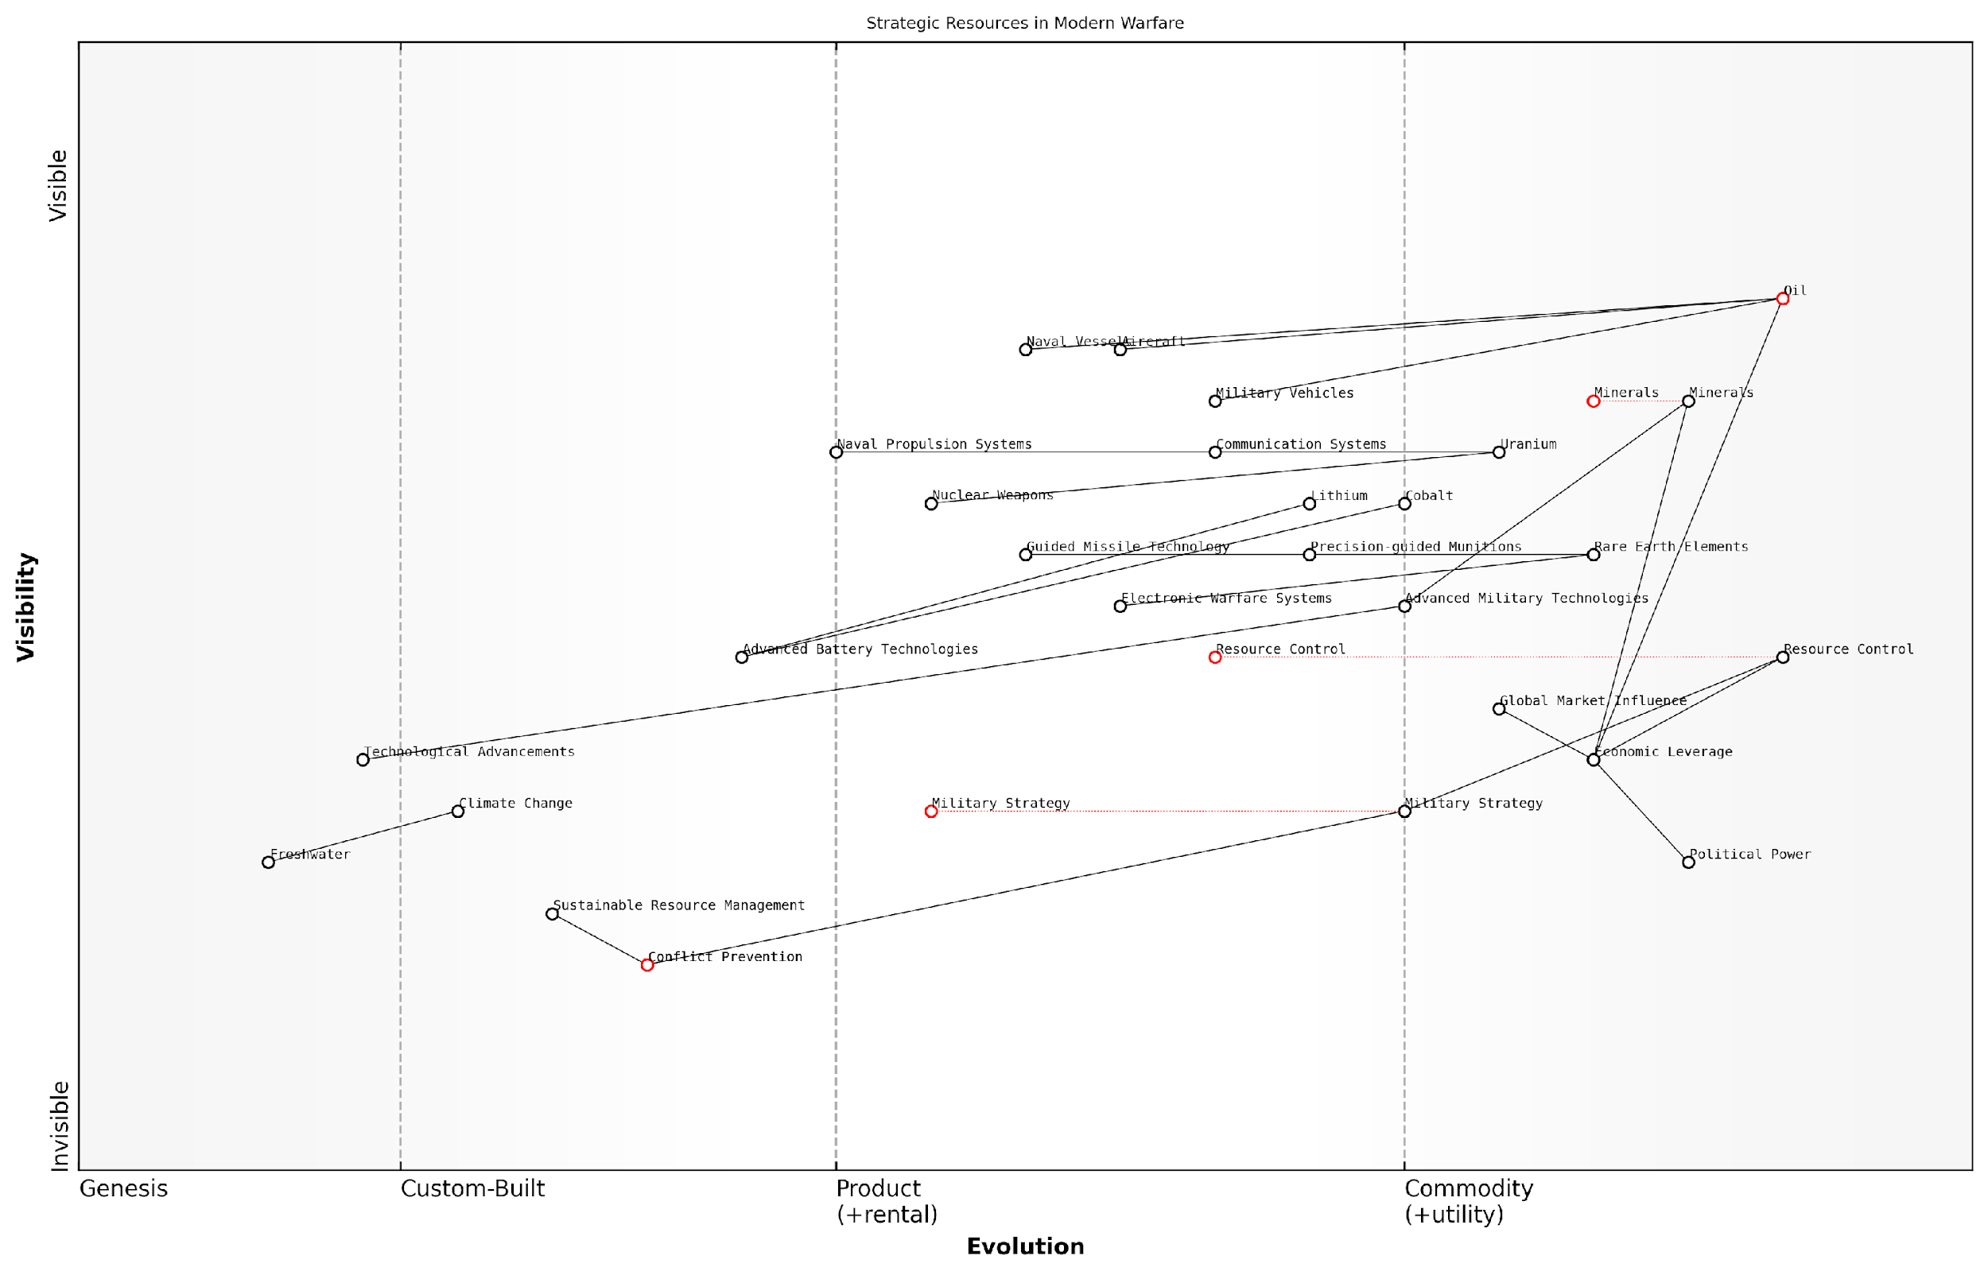

*Draft Wardley Map: [Insert Wardley Map: Oil, minerals, and other strategic resources in warfare]*

[Edit this draft Wardley Map](https://create.wardleymaps.ai/#clone:0b4b637803a0dd64b5)

Wardley Map Assessment

This map reveals the critical role of strategic resources in modern warfare and global politics. While traditional resources like oil remain important, emerging technologies and rare earth elements are becoming increasingly crucial. The key to long-term success lies in balancing resource control with sustainable management and conflict prevention, while continuously advancing military technologies. Nations that can effectively manage this complex interplay of factors will likely hold significant geopolitical advantage in the future.

[View full Wardley Map report](http://markdown/wardley_map_reports/wardley_map_report_35_Oil,_minerals,_and_other_strategic_resources_in_wa.md)

As we look to the future, the landscape of resource-driven conflicts is likely to evolve. Climate change and technological advancements may shift the focus towards new resources, such as freshwater or specific minerals required for green technologies. Understanding these trends is crucial for policymakers and military strategists in anticipating and potentially preventing future resource wars.

In conclusion, the economics of resource wars remain a complex and critical aspect of battlefield economics. The interplay between resource control, economic power, and military strategy continues to shape global conflicts and international relations. As experts in this field, it is our responsibility to provide insights that can inform policy decisions and contribute to more sustainable approaches to resource management and conflict prevention.

### Water scarcity and its impact on military conflicts

Water scarcity has emerged as a critical factor in shaping military conflicts and geopolitical tensions in the 21st century. As an expert in battlefield economics, I can attest that the strategic importance of water resources has grown exponentially, particularly in regions where climate change and population growth are exacerbating existing pressures on water supplies. The economics of water scarcity in military contexts is multifaceted, encompassing issues of resource control, strategic advantage, and potential flashpoints for conflict.

The impact of water scarcity on military conflicts can be analysed through several key lenses:

* Strategic value of water resources
* Water as a weapon of war
* Economic implications of water-related conflicts
* Technological solutions and their costs
* International law and water rights

Firstly, the strategic value of water resources cannot be overstated. In arid and semi-arid regions, control over water sources can provide a significant military advantage. Rivers, aquifers, and desalination plants become high-value targets, both for protection and potential sabotage. The economic calculus of securing these resources often drives military strategy, influencing troop deployments, fortification efforts, and even the development of specialised units focused on water resource protection.

In the coming decades, water will be more important than oil in shaping the geopolitical landscape. Nations will go to war over access to this vital resource.

Secondly, water itself can be weaponised in conflicts. The deliberate destruction of water infrastructure, contamination of water sources, or the strategic diversion of rivers can have devastating effects on both military operations and civilian populations. From an economic perspective, these tactics can be seen as a form of asymmetric warfare, where relatively low-cost actions can have disproportionately large impacts on an adversary’s military capabilities and economic stability.

The economic implications of water-related conflicts are far-reaching. Beyond the immediate costs of military operations, there are long-term economic consequences to consider. These include:

* Reduced agricultural productivity in water-stressed regions
* Increased military spending on water security measures
* Economic migration and its impact on labour markets
* Investment in water-related technologies and infrastructure
* Diplomatic and trade tensions over shared water resources

Technological solutions to water scarcity, such as desalination plants and advanced water recycling systems, present both opportunities and challenges from a battlefield economics perspective. While these technologies can reduce dependence on traditional water sources, they often come with high capital and operational costs. Military planners must weigh the strategic benefits against the economic burden of implementing and protecting such infrastructure in conflict zones.

International law and water rights add another layer of complexity to the economics of water-related conflicts. Disputes over transboundary water resources can escalate into full-scale military confrontations, with significant economic repercussions. The cost of legal battles, diplomatic negotiations, and potential sanctions must be factored into the overall economic analysis of water-related military strategies.

The true cost of water in conflict zones is not measured in currency, but in lives lost, communities displaced, and futures destroyed.

As an expert in this field, I have observed that the most successful military strategies in water-scarce regions are those that integrate comprehensive economic analyses. This includes not only the direct costs of securing water resources but also the broader economic impacts on affected populations, regional stability, and long-term development prospects.

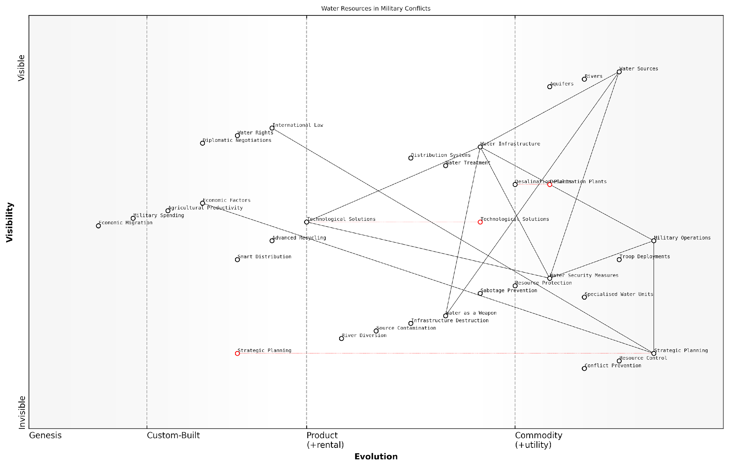

*Draft Wardley Map: [Insert Wardley Map: Water scarcity and its impact on military conflicts]*

[Edit this draft Wardley Map](https://create.wardleymaps.ai/#clone:8c530a26c02d137e23)

Wardley Map Assessment

This Wardley Map reveals the critical role of water resources in military conflicts, highlighting the need for a multifaceted approach that combines military strategy, technological innovation, and diplomatic efforts. The evolving nature of water as both a resource and potential weapon underscores the importance of adaptive strategies and international cooperation. To maintain strategic advantage, focus should be placed on developing advanced water management technologies, strengthening water security measures, and enhancing capabilities in water-related conflict prevention and resolution.

[View full Wardley Map report](http://markdown/wardley_map_reports/wardley_map_report_36_Water_scarcity_and_its_impact_on_military_conflict.md)

In conclusion, water scarcity’s impact on military conflicts represents a critical intersection of resource economics, strategic planning, and geopolitical tensions. As climate change continues to alter global water availability patterns, the economic dimensions of water-related conflicts will only grow in importance. Military leaders and policymakers must develop a nuanced understanding of these dynamics to effectively navigate the complex landscape of 21st-century warfare and conflict prevention.

### Economic motivations behind territorial disputes

Territorial disputes have long been a source of conflict between nations, and while political and historical factors often play a significant role, the economic motivations underlying these disputes are frequently the driving force behind prolonged tensions and potential military engagements. As an expert in battlefield economics, I have observed that the control over valuable resources, strategic trade routes, and economically significant territories can significantly influence a nation’s decision to pursue or maintain territorial claims.

The economic value of disputed territories can manifest in various forms, ranging from tangible natural resources to intangible strategic advantages. Understanding these economic motivations is crucial for policymakers, military strategists, and diplomats seeking to resolve conflicts or prevent their escalation.

* Natural resource wealth (e.g., oil, gas, minerals, water)
* Strategic trade routes and access points
* Arable land and fishing grounds
* Economic exclusion zones (EEZs)
* Industrial and technological infrastructure

Natural resources often lie at the heart of territorial disputes. The presence of oil, natural gas, or valuable minerals can transform seemingly insignificant parcels of land or maritime areas into hotly contested territories. For instance, the ongoing disputes in the South China Sea are largely driven by the region’s vast oil and gas reserves, as well as its rich fishing grounds. The economic potential of these resources has led to increased military presence and the construction of artificial islands, escalating tensions among neighbouring countries.

In my experience advising government bodies on resource-related conflicts, I’ve found that the potential economic gains from controlling these territories often outweigh the immediate costs of military posturing or even limited engagements.

Strategic trade routes and access points represent another significant economic motivation behind territorial disputes. Control over key straits, canals, or port facilities can provide a nation with substantial economic advantages through the ability to regulate trade flows, collect tariffs, or ensure preferential access for domestic industries. The ongoing tensions surrounding the Strait of Hormuz, a critical chokepoint for global oil trade, exemplify how control over strategic waterways can become a focal point of international conflict.

In recent years, the concept of Economic Exclusion Zones (EEZs) has added a new dimension to territorial disputes. These zones, extending up to 200 nautical miles from a country’s coastline, grant exclusive rights to exploit marine resources and conduct economic activities. Overlapping claims to EEZs have led to numerous disputes, particularly in regions with complex coastlines or numerous small islands.

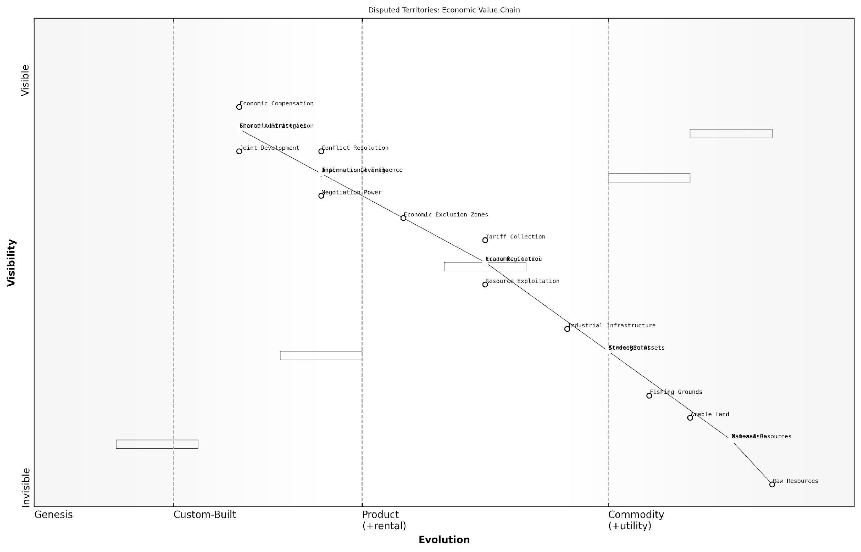

*Draft Wardley Map: [Insert Wardley Map: Economic motivations behind territorial disputes]*

[Edit this draft Wardley Map](https://create.wardleymaps.ai/#clone:744d7e378afd724468)

Wardley Map Assessment

This Wardley Map reveals the complex interplay between economic motivations and territorial disputes. It highlights the critical importance of resource control, strategic assets, and diplomatic leverage in shaping international relations. To navigate this landscape effectively, entities must focus on developing sophisticated economic strategies and diplomatic tools while also exploring collaborative approaches to resource management. The future evolution towards more abstract and utility-like components suggests a need for innovative, technology-driven solutions to manage and resolve territorial disputes.

[View full Wardley Map report](http://markdown/wardley_map_reports/wardley_map_report_37_Economic_motivations_behind_territorial_disputes.md)

The economic motivations behind territorial disputes are not limited to natural resources or strategic locations. In some cases, the industrial or technological infrastructure present in disputed areas can be a significant factor. This is particularly relevant in cases of separatist movements or border disputes involving economically developed regions. The potential loss of industrial capacity, skilled workforce, or technological assets can motivate nations to fiercely defend their territorial claims.

It’s important to note that the economic motivations behind territorial disputes often intersect with other factors, such as national pride, historical claims, or security concerns. However, my research and consultancy experience have consistently shown that economic considerations frequently underpin these other motivations, even when not explicitly stated in official rhetoric.

A senior diplomat once confided to me, ‘While we publicly emphasise historical and cultural ties to the disputed region, our economic analysis of its potential value is what truly drives our negotiation strategy.’

Understanding the economic motivations behind territorial disputes is crucial for developing effective conflict resolution strategies. Traditional diplomatic approaches that focus solely on historical or legal arguments may fail to address the underlying economic interests driving the conflict. Instead, successful resolution often requires creative solutions that address the economic concerns of all parties involved.

* Joint resource development agreements
* Shared administration of strategic assets
* Economic compensation packages
* Free trade zones in disputed areas
* Third-party arbitration with economic considerations

In conclusion, the economic motivations behind territorial disputes play a pivotal role in shaping the landscape of international conflicts. As an expert in battlefield economics, I cannot overstate the importance of thoroughly analysing these economic factors when assessing potential flashpoints or developing strategies for conflict resolution. By recognising and addressing the underlying economic interests, policymakers and military strategists can work towards more sustainable and mutually beneficial solutions to territorial disputes, potentially averting costly military confrontations and fostering regional stability.

## Cyber Economics and Information Warfare

### The cost of cyber attacks and defence

In the rapidly evolving landscape of modern warfare, cyber attacks have emerged as a potent and cost-effective weapon, fundamentally altering the economics of conflict. As a seasoned expert in battlefield economics, I can attest that the cost implications of cyber warfare are profound, multifaceted, and often underestimated by traditional military strategists.

The economic impact of cyber attacks can be categorised into direct costs, indirect costs, and long-term strategic costs. Direct costs include immediate financial losses, system downtime, and resources required for incident response. Indirect costs encompass reputational damage, loss of intellectual property, and decreased operational efficiency. Strategic costs involve long-term impacts on national security, economic competitiveness, and geopolitical standing.

The asymmetry of cyber warfare is its most economically disruptive feature. A relatively small investment in offensive capabilities can yield disproportionate returns, while defensive measures often require substantial and ongoing expenditure.

From a defensive standpoint, the costs are equally significant. Governments and military organisations must invest heavily in cybersecurity infrastructure, personnel training, and continuous system upgrades. The dynamic nature of cyber threats necessitates a constant cycle of investment, creating a substantial economic burden.

* Infrastructure costs: Hardware, software, and network security systems
* Personnel costs: Recruitment, training, and retention of cybersecurity experts
* Research and development: Staying ahead of evolving threats
* Incident response and recovery: Dealing with successful attacks
* Compliance and regulatory costs: Meeting national and international cybersecurity standards

The economic calculus of cyber defence is further complicated by the difficulty in quantifying return on investment. Unlike traditional military assets, the effectiveness of cybersecurity measures is often measured by the absence of successful attacks, making it challenging to justify expenditures to policymakers and budget allocators.

Moreover, the interconnected nature of modern economies means that the costs of cyber attacks can cascade beyond the initial target. A successful attack on critical infrastructure, for instance, can have far-reaching economic consequences, affecting supply chains, financial markets, and public confidence.

In the realm of cyber warfare, economic deterrence takes on new dimensions. The threat of overwhelming retaliation, so effective in conventional warfare, is less credible in cyberspace where attribution is difficult and state actors can operate with plausible deniability.

The economics of cyber warfare also intersect with the broader military-industrial complex. There is a growing market for cyber weapons and defensive tools, creating new economic incentives and power dynamics within the defence industry. This has led to the emergence of a ‘cyber-industrial complex’, with its own set of economic drivers and potential for market distortions.

From a strategic perspective, the cost-benefit analysis of cyber capabilities is reshaping military doctrine. The relatively low cost of entry for cyber warfare capabilities allows smaller nations and non-state actors to challenge larger, more established powers. This democratisation of cyber weapons has significant implications for global power dynamics and economic stability.

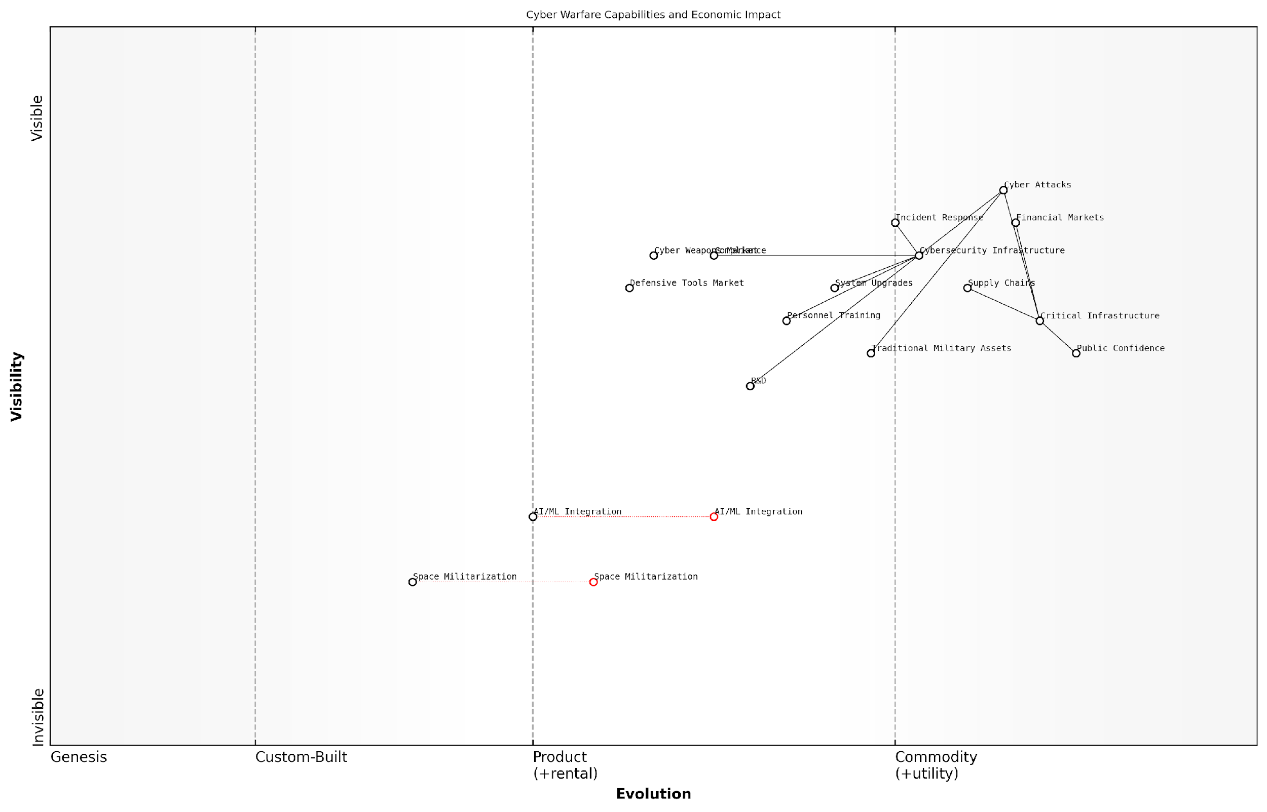

*Draft Wardley Map: [Insert Wardley Map: The cost of cyber attacks and defence]*

[Edit this draft Wardley Map](https://create.wardleymaps.ai/#clone:26434415b9383a3be5)

Wardley Map Assessment

This Wardley Map reveals a cyber warfare landscape in transition, with traditional components facing disruption from emerging technologies. The strategic imperative is to maintain strong current defences while aggressively pursuing innovations in AI/ML and space-based capabilities. Success will require a delicate balance of short-term security enhancements and long-term technological investments, all while managing complex ecosystem relationships and economic impacts. Organisations must be prepared for a future where cyber warfare is increasingly AI-driven and extends into space, necessitating a fundamental rethinking of cybersecurity strategies and capabilities.

[View full Wardley Map report](http://markdown/wardley_map_reports/wardley_map_report_38_The_cost_of_cyber_attacks_and_defense.md)

Looking ahead, the economic dimensions of cyber warfare are likely to become even more complex. The integration of artificial intelligence and machine learning into both offensive and defensive cyber capabilities will introduce new cost considerations and potential force multipliers. Additionally, the increasing militarisation of space and its reliance on cyber systems will expand the battlefield and the associated economic considerations.

In conclusion, the cost of cyber attacks and defence represents a paradigm shift in battlefield economics. It requires a fundamental reevaluation of how we assess military expenditure, calculate risks, and measure strategic advantages. As the digital and physical realms of warfare continue to converge, understanding the economic underpinnings of cyber conflict will be crucial for effective military planning and national security strategy.

### Economic espionage and intellectual property theft

In the realm of cyber economics and information warfare, economic espionage and intellectual property theft have emerged as critical battlefields in modern conflicts. As a seasoned expert in this field, I can attest that these covert activities have profound implications for national security, economic competitiveness, and military capabilities. The digital age has exponentially increased the scale and sophistication of these threats, transforming them into potent weapons of economic warfare.

Economic espionage involves the clandestine acquisition of trade secrets, proprietary information, and other valuable data to gain economic advantage. Intellectual property theft, often a component of economic espionage, specifically targets copyrights, patents, and other forms of protected intellectual assets. Both practices have become increasingly prevalent in the cyber domain, where vast amounts of sensitive information can be exfiltrated with minimal physical risk to the perpetrators.

* State-sponsored cyber espionage campaigns targeting defence contractors
* Industrial espionage aimed at emerging technologies with dual-use potential
* Theft of research and development data from pharmaceutical and biotechnology sectors
* Exfiltration of financial algorithms and trading strategies from financial institutions

The economic impact of these activities is staggering. In my consultations with government bodies, I’ve observed that the annual cost of economic espionage to advanced economies can run into hundreds of billions of pounds. This figure, however, only scratches the surface of the true impact. The long-term consequences of losing cutting-edge research, first-mover advantage in emerging markets, and erosion of military technological superiority are often incalculable.

The theft of intellectual property is not just an economic issue, but a national security concern. It undermines our ability to innovate, compete, and ultimately, to defend ourselves.

From a military perspective, economic espionage and IP theft can directly impact battlefield capabilities. Advanced weapons systems, stealth technologies, and cyber warfare tools are prime targets. The compromise of such technologies can negate years of research and development, potentially shifting the balance of power in future conflicts. Moreover, the blurred lines between civilian and military technologies mean that espionage targeting commercial entities can have significant military implications.

Countering these threats requires a multifaceted approach. In my work advising government agencies, I’ve emphasised the need for robust cybersecurity measures, enhanced counterintelligence capabilities, and international cooperation. However, the asymmetric nature of cyber threats means that defenders must secure countless potential vulnerabilities, while attackers need only find one weakness to exploit.

* Implementation of AI-driven threat detection systems
* Development of quantum-resistant encryption protocols
* Creation of international cyber norms and treaties
* Investment in cyber workforce development and education

The economic incentives for engaging in espionage and IP theft are substantial. For emerging economies, it offers a shortcut to technological advancement, potentially saving years of research and billions in development costs. For established powers, it provides a means to maintain technological superiority and economic dominance. This creates a complex game theory scenario, where the potential gains often outweigh the perceived risks of getting caught.

In the digital age, information is the new oil. Those who control it, shape the future of both the global economy and the modern battlefield.

Looking ahead, the convergence of emerging technologies such as artificial intelligence, quantum computing, and the Internet of Things will likely exacerbate the challenges posed by economic espionage and IP theft. These technologies offer new vectors for attack while simultaneously increasing the value of the information at stake. As an expert in this field, I anticipate that future conflicts may be largely fought in the realm of information and economics, with traditional kinetic warfare serving as a last resort.

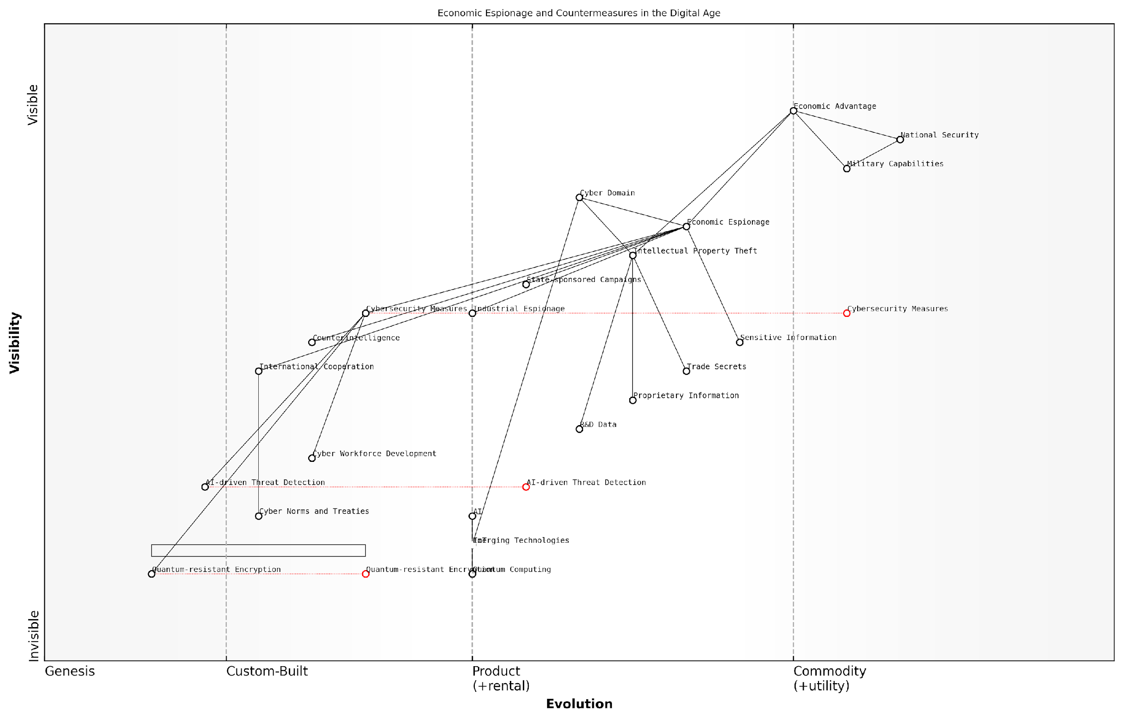

*Draft Wardley Map: [Insert Wardley Map: Economic espionage and intellectual property theft]*

[Edit this draft Wardley Map](https://create.wardleymaps.ai/#clone:81c77ca8526a26a3a6)

Wardley Map Assessment

This Wardley Map reveals a strategic landscape where economic espionage and intellectual property theft pose significant threats to national economic advantage and security. The map emphasises the critical role of the cyber domain and emerging technologies in both offensive and defensive capabilities. To maintain a competitive edge, there’s a clear need for rapid innovation in cybersecurity measures, particularly in AI-driven threat detection and quantum-resistant encryption. The map also highlights the importance of international cooperation and the development of cyber norms to create a more secure global digital environment. Strategic focus should be on accelerating the evolution of defensive capabilities while simultaneously investing in emerging technologies that could reshape the entire landscape in the near future.

[View full Wardley Map report](http://markdown/wardley_map_reports/wardley_map_report_39_Economic_espionage_and_intellectual_property_theft.md)

In conclusion, economic espionage and intellectual property theft represent a critical dimension of modern warfare. Their impact extends far beyond immediate economic losses, shaping the future of military capabilities, national competitiveness, and global power dynamics. As we navigate this complex landscape, it is imperative that policymakers, military strategists, and business leaders alike recognise the centrality of information security to national defence and economic prosperity. The battlefield of the future is digital, and the spoils of war are measured in bits and bytes as much as in territory and resources.

### Disinformation campaigns and their economic impact

In the realm of cyber economics and information warfare, disinformation campaigns have emerged as a potent and cost-effective tool for state and non-state actors to achieve strategic objectives. These campaigns, which involve the deliberate spread of false or misleading information, have far-reaching economic consequences that extend beyond the immediate political or military goals they aim to achieve.

The economic impact of disinformation campaigns can be categorised into direct costs, indirect costs, and long-term structural effects on economies and markets. Understanding these impacts is crucial for policymakers, military strategists, and economic planners who must navigate an increasingly complex information landscape.

* Direct costs of countering disinformation
* Market volatility and economic uncertainty
* Reputational damage to businesses and sectors
* Erosion of trust in institutions and economic systems
* Influence on consumer behaviour and market trends

One of the most immediate economic impacts of disinformation campaigns is the direct cost of countermeasures. Governments and organisations are compelled to invest significant resources in fact-checking initiatives, media literacy programmes, and advanced detection technologies. For instance, the European Union has allocated substantial funds to its East StratCom Task Force, dedicated to identifying and countering Russian disinformation campaigns. These defensive measures, while necessary, represent a diversion of resources that could otherwise be invested in productive economic activities.

The cost of combating disinformation is not just measured in monetary terms, but in the opportunity cost of human capital and technological resources that are diverted from other critical areas of economic development.

Market volatility is another significant economic consequence of disinformation campaigns. False information about geopolitical events, economic policies, or corporate performance can trigger rapid and often irrational market movements. These fluctuations can lead to misallocation of capital, increased hedging costs, and a general atmosphere of economic uncertainty that dampens investment and growth. The 2013 ‘hash crash’, where a false tweet about an explosion at the White House caused a brief but sharp drop in the US stock market, exemplifies the potential for disinformation to create economic shocks.

Reputational damage resulting from targeted disinformation campaigns can have severe and lasting economic impacts on specific businesses or entire sectors. False claims about product safety, corporate practices, or industry standards can erode consumer confidence and lead to boycotts, regulatory scrutiny, and loss of market share. The tourism industry, for example, has been particularly vulnerable to disinformation campaigns that exaggerate security risks or health hazards in specific destinations.

Perhaps the most insidious economic impact of disinformation is the gradual erosion of trust in institutions and economic systems. As false narratives proliferate, they can undermine confidence in financial markets, regulatory bodies, and economic policies. This erosion of trust can lead to decreased participation in formal economic structures, increased transaction costs due to heightened scepticism, and a general slowdown in economic activity.

Trust is the lubricant of economic transactions. When disinformation erodes this trust, the gears of commerce grind more slowly, and economic efficiency suffers across all sectors.

Disinformation campaigns can also significantly influence consumer behaviour and market trends. By shaping public perception and preferences, these campaigns can artificially inflate or deflate demand for certain products or services. This manipulation of market forces can lead to inefficient resource allocation and distorted price signals, ultimately reducing overall economic welfare.

The long-term structural effects of persistent disinformation campaigns on economies are particularly concerning. They can lead to a misallocation of human and financial capital, as resources are directed towards combating or exploiting disinformation rather than productive economic activities. Moreover, the constant need to verify information increases transaction costs across the economy, reducing overall efficiency and competitiveness.

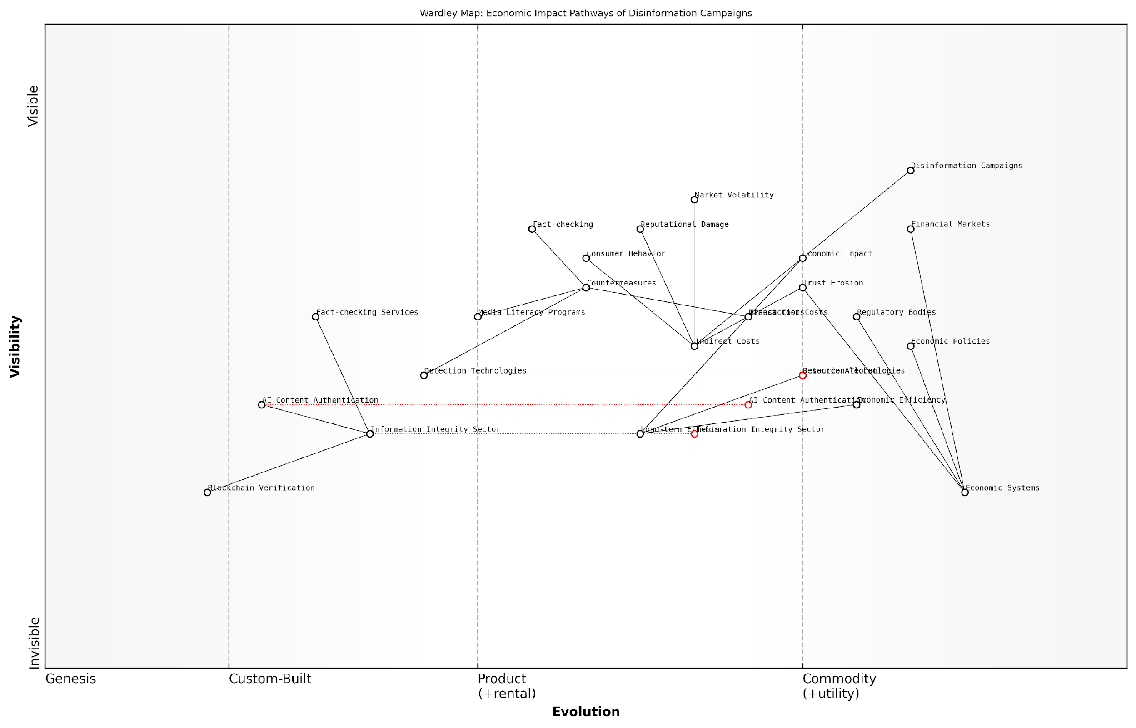

*Draft Wardley Map: [Insert Wardley Map: Disinformation campaigns and their economic impact]*

[Edit this draft Wardley Map](https://create.wardleymaps.ai/#clone:fd47e37a19bc227189)

Wardley Map Assessment

This Wardley Map reveals the complex and evolving landscape of disinformation’s economic impact. It highlights the need for rapid innovation in detection and verification technologies, coupled with adaptive economic policies and regulations. The strategic focus should be on developing a robust Information Integrity Sector that can proactively mitigate the economic risks of disinformation, while simultaneously enhancing the resilience of economic systems to information-based threats. Success will require unprecedented collaboration across sectors and a fundamental rethinking of the relationship between information integrity and economic stability.

[View full Wardley Map report](http://markdown/wardley_map_reports/wardley_map_report_40_Disinformation_campaigns_and_their_economic_impact.md)

In response to these challenges, a new economic sub-sector focused on information integrity and verification has emerged. This sector includes fact-checking services, AI-powered content authentication tools, and blockchain-based verification systems. While this represents a new area of economic activity and innovation, it also reflects the economic burden imposed by the prevalence of disinformation.

As we navigate the complex interplay between information warfare and economic systems, it is clear that the economic impacts of disinformation campaigns extend far beyond the immediate costs of countering false narratives. They touch every aspect of our economic lives, from individual consumer decisions to global market dynamics. Addressing this challenge will require a coordinated effort from governments, businesses, and civil society, as well as innovative economic strategies that can build resilience against the destabilising effects of disinformation.

In the information age, economic security and information integrity are inextricably linked. Our ability to maintain stable and prosperous economies will increasingly depend on our capacity to safeguard the integrity of our information ecosystems.

# Chapter 5: Post-Conflict Economics and Reconstruction

## Economic Recovery Strategies

### Immediate post-war economic challenges

In the aftermath of conflict, nations face a complex array of economic challenges that demand immediate attention and strategic planning. As an expert in post-conflict economics, I can attest that the transition from war to peace is fraught with economic pitfalls that, if not addressed promptly and effectively, can undermine the entire reconstruction process and potentially reignite hostilities.

The immediate post-war economic landscape is often characterised by widespread destruction of physical infrastructure, disrupted markets, depleted human capital, and severely strained financial resources. These challenges are compounded by the urgent need to restore basic services, reintegrate displaced populations, and establish a foundation for sustainable economic growth.

* Macroeconomic instability: High inflation, currency devaluation, and fiscal imbalances
* Destruction of productive capacity: Damaged factories, agricultural land, and transportation networks
* Human capital deficit: Loss of skilled workers through casualties, displacement, or emigration
* Institutional breakdown: Weakened governance structures and regulatory frameworks
* Market disruptions: Broken supply chains, informal economies, and black markets
* Financial sector collapse: Non-functioning banking systems and lack of credit
* Humanitarian crisis: Immediate needs for food, shelter, and healthcare

One of the most pressing challenges is the restoration of macroeconomic stability. In my experience advising post-conflict governments, I’ve observed that runaway inflation and currency devaluation can quickly erode public confidence and hinder investment. Establishing a credible monetary policy and rebuilding fiscal capacity are crucial first steps in creating an environment conducive to economic recovery.

The immediate challenge in post-war economies is not just rebuilding what was destroyed, but laying the groundwork for a new economic order that addresses the root causes of conflict and promotes inclusive growth.

The destruction of productive capacity presents another significant hurdle. War-torn nations often face the daunting task of rebuilding critical infrastructure such as power plants, roads, and communication networks. Without these essential elements, restarting economic activity becomes nearly impossible. In my work with international development agencies, I’ve seen how prioritising the restoration of key infrastructure can jumpstart economic recovery and create much-needed employment opportunities.

The human capital deficit is a challenge that often receives insufficient attention in the immediate aftermath of conflict. The loss of skilled workers, whether through casualties, displacement, or brain drain, can severely hamper economic recovery efforts. Addressing this requires not only education and training programmes but also creating incentives for skilled diaspora to return and contribute to the rebuilding process.

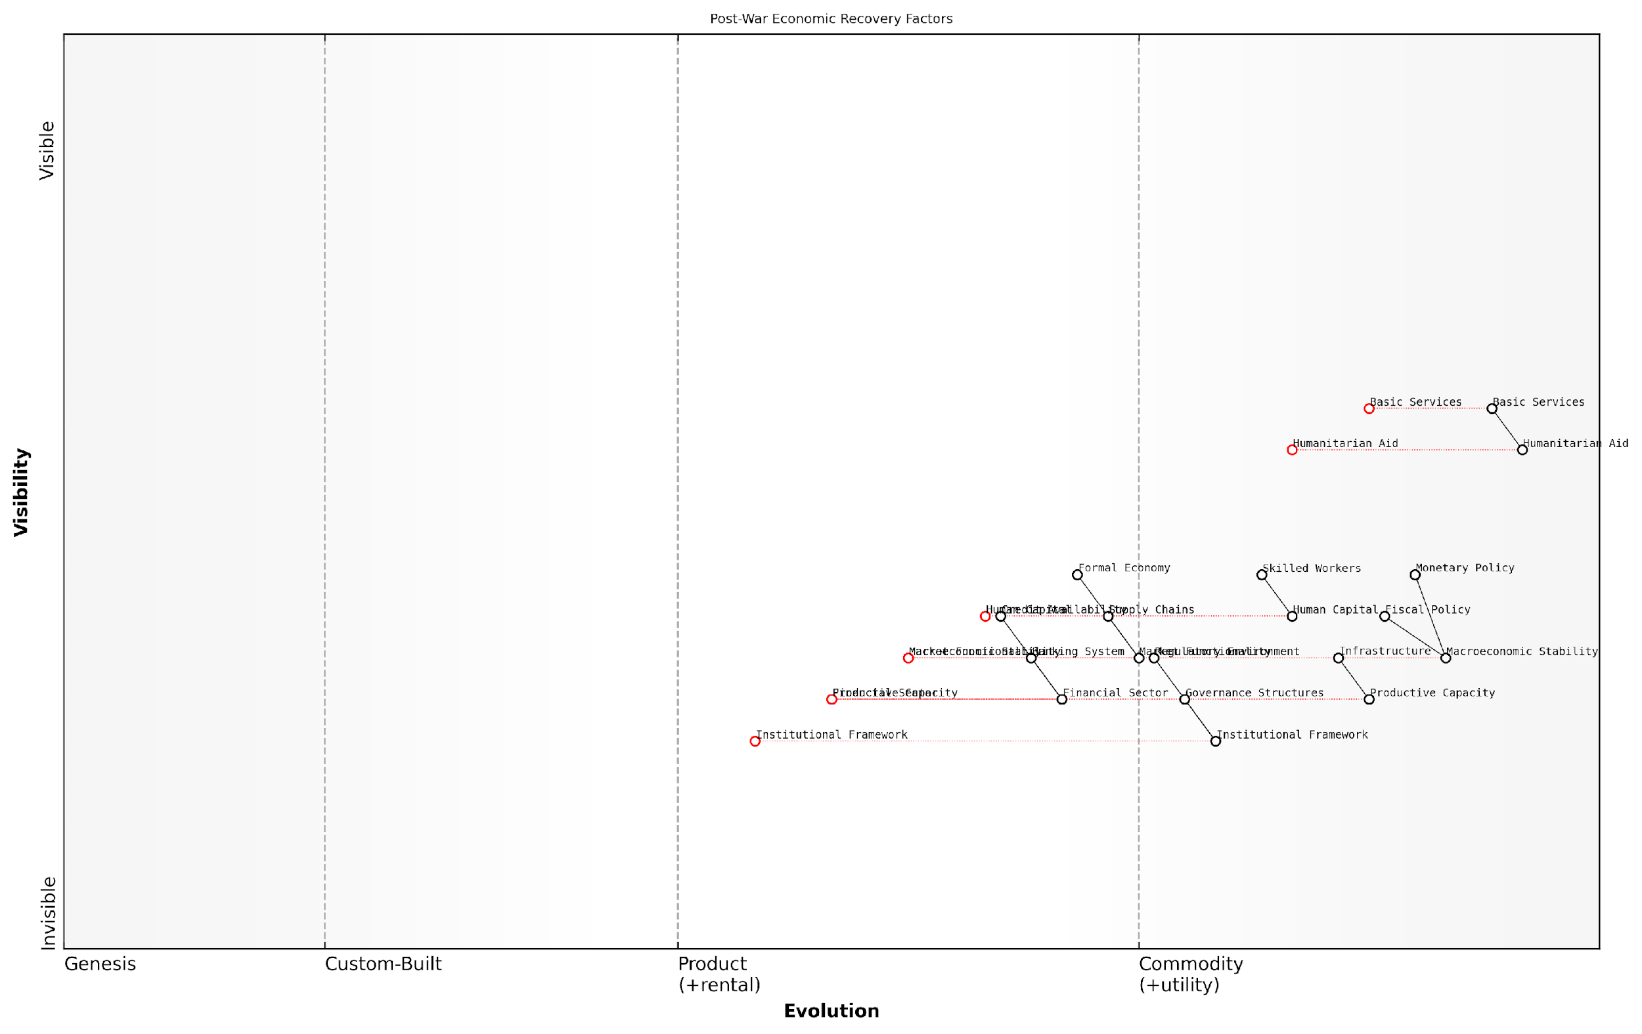

*Draft Wardley Map: [Insert Wardley Map: Immediate post-war economic challenges]*

[Edit this draft Wardley Map](https://create.wardleymaps.ai/#clone:87c512859d781c2e74)

Wardley Map Assessment

The map presents a comprehensive view of post-war economic recovery, highlighting the transition from immediate humanitarian needs to long-term economic stability. The key challenge lies in managing this transition effectively, building robust institutions while maintaining macroeconomic stability. Success will depend on coordinated efforts across all components, with a particular focus on developing the institutional framework and human capital necessary for sustainable growth.

[View full Wardley Map report](http://markdown/wardley_map_reports/wardley_map_report_41_Immediate_post-war_economic_challenges.md)

Institutional breakdown is another critical challenge that demands immediate attention. The weakening or collapse of governance structures and regulatory frameworks can lead to a vacuum that is often filled by informal or illicit economic activities. Restoring the rule of law, rebuilding public institutions, and establishing a transparent regulatory environment are essential for attracting investment and fostering sustainable economic growth.

Market disruptions, including broken supply chains and the proliferation of informal economies, pose significant challenges to economic recovery. In my consultancy work, I’ve advised governments on strategies to reintegrate informal economic activities into the formal sector while simultaneously working to rebuild and diversify supply chains. This often involves a delicate balance of incentives and regulations to encourage compliance without stifling economic activity.

The collapse of the financial sector is a particularly pernicious challenge that can impede recovery across all sectors of the economy. Restoring confidence in the banking system, recapitalising financial institutions, and re-establishing credit flows are critical for funding reconstruction efforts and supporting private sector growth. In some cases, I’ve recommended the temporary use of alternative financial systems, such as mobile banking, to bypass damaged traditional banking infrastructure.

The immediate post-war period is a critical window of opportunity. How we address these economic challenges in the short term will determine the trajectory of recovery and the prospects for lasting peace in the long term.

Finally, the humanitarian crisis that often accompanies the end of conflict presents both an immediate challenge and an opportunity for economic recovery. Addressing urgent needs for food, shelter, and healthcare not only alleviates human suffering but can also serve as a catalyst for economic activity. I’ve observed how well-designed aid programmes can stimulate local markets and create employment opportunities, laying the groundwork for more sustainable economic development.

Addressing these immediate post-war economic challenges requires a coordinated, multi-faceted approach that balances short-term stabilisation with long-term development goals. It demands close collaboration between national governments, international organisations, and the private sector. As we move forward in this chapter, we will explore specific strategies and case studies that illustrate how nations have successfully navigated these challenges and set the stage for sustainable economic recovery in the wake of conflict.

### Long-term reconstruction planning and execution

Long-term reconstruction planning and execution is a critical component of post-conflict economic recovery strategies. As an expert in battlefield economics, I can attest that the success of these efforts often determines the trajectory of a nation’s recovery and its ability to maintain peace in the years following a conflict. The complexity of this process cannot be overstated, as it involves a delicate balance of economic, social, and political considerations.

Effective long-term reconstruction planning begins with a comprehensive assessment of the damage inflicted during the conflict. This assessment must go beyond mere physical infrastructure and consider the broader economic ecosystem, including human capital, institutional capacity, and social cohesion. Based on my experience advising governments in post-conflict situations, I’ve observed that the most successful reconstruction efforts are those that adopt a holistic approach, addressing not only the visible scars of war but also the underlying economic vulnerabilities that may have contributed to the conflict in the first place.

* Conduct a thorough damage assessment across all sectors of the economy
* Identify key economic drivers and potential growth sectors
* Assess the state of human capital and skills gaps
* Evaluate the capacity of existing institutions to support reconstruction
* Analyse the social and political landscape to ensure equitable recovery

Once the assessment is complete, the next crucial step is the development of a comprehensive reconstruction plan. This plan should outline clear objectives, prioritise interventions, and establish realistic timelines. It’s essential to strike a balance between addressing immediate needs and laying the groundwork for long-term sustainable development. In my work with post-conflict nations, I’ve found that the most effective plans are those that are flexible enough to adapt to changing circumstances while maintaining a clear vision for the future.

A well-crafted reconstruction plan is not just a roadmap for recovery; it’s a blueprint for building a more resilient and prosperous society than existed before the conflict.

The execution phase of long-term reconstruction is where the true challenges often emerge. It requires coordinated efforts across multiple stakeholders, including government agencies, international donors, NGOs, and the private sector. Based on my observations in the field, successful execution hinges on several key factors:

* Strong governance and transparent management of reconstruction funds
* Capacity building within local institutions to ensure sustainable progress
* Engagement of the local population in the reconstruction process
* Phased implementation that allows for learning and adjustment
* Continuous monitoring and evaluation to track progress and identify issues

One of the most critical aspects of long-term reconstruction is the restoration and modernisation of critical infrastructure. This includes not only physical infrastructure such as roads, power grids, and water systems but also digital infrastructure that is increasingly vital in the modern economy. In my experience, prioritising infrastructure projects that have the greatest multiplier effect on economic activity can accelerate the overall recovery process.

Another crucial element is the revitalisation of the private sector. Encouraging entrepreneurship and attracting foreign direct investment can create jobs and stimulate economic growth. However, this often requires addressing systemic issues such as corruption, regulatory barriers, and lack of access to finance. I’ve advised governments on implementing business-friendly reforms and establishing public-private partnerships to jumpstart economic activity in post-conflict settings.

The private sector is the engine of long-term economic growth. Reconstruction efforts that fail to create an enabling environment for business are unlikely to achieve sustainable results.

Human capital development is another critical component of long-term reconstruction. This involves not only rebuilding educational institutions but also providing targeted training programmes to address skills gaps in the workforce. In my work, I’ve seen the transformative impact of initiatives that combine education with economic opportunities, particularly for youth and former combatants.

Lastly, it’s important to recognise that long-term reconstruction is not a linear process. It often involves setbacks and requires continuous adaptation. The ability to learn from experience and adjust strategies accordingly is crucial. This is where robust monitoring and evaluation systems come into play, providing the data needed to make informed decisions and demonstrate progress to stakeholders.

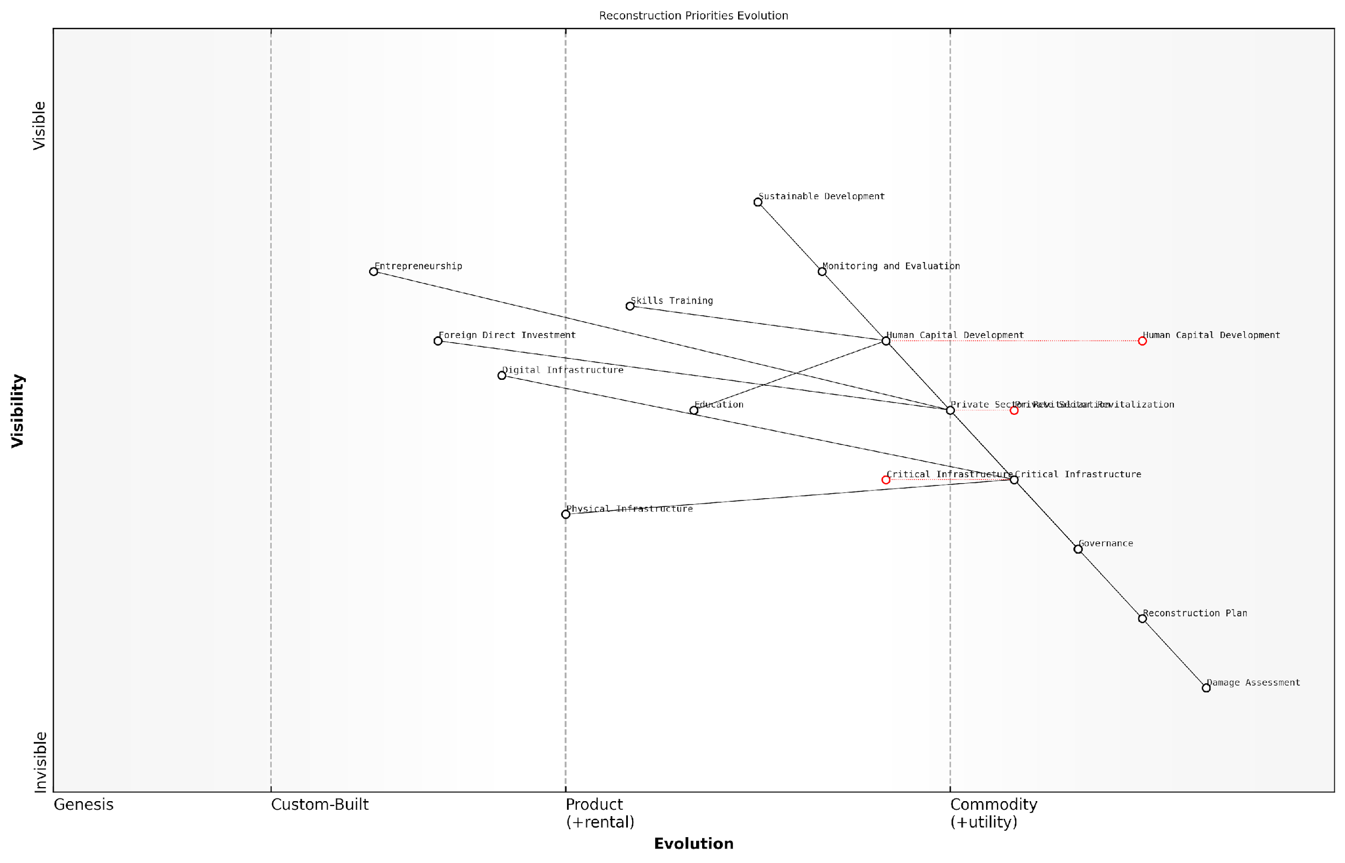

*Draft Wardley Map: [Insert Wardley Map: Long-term reconstruction planning and execution]*

[Edit this draft Wardley Map](https://create.wardleymaps.ai/#clone:b359d76ac40911b74e)

Wardley Map Assessment

This Wardley Map presents a comprehensive and well-structured approach to post-conflict reconstruction, balancing immediate needs with long-term development goals. The strategic focus on evolving critical infrastructure, private sector revitalization, and human capital development is commendable. However, there’s a need to address potential bottlenecks in governance and ensure that digital transformation is fully integrated into the reconstruction process. The explicit focus on sustainable development sets a positive long-term vision. To maximise success, efforts should be made to increase agility in governance, balance foreign investment with local entrepreneurship, and rapidly develop digital skills and infrastructure. The integrated approach to human capital development is a particular strength that should be leveraged for competitive advantage in attracting investment and fostering innovation.

[View full Wardley Map report](http://markdown/wardley_map_reports/wardley_map_report_42_Long-term_reconstruction_planning_and_execution.md)

In conclusion, long-term reconstruction planning and execution is a complex, multifaceted process that requires a strategic approach, sustained commitment, and the ability to navigate a constantly changing landscape. When done effectively, it can not only repair the damage of conflict but also create the foundation for a more prosperous and stable future.

### The role of international aid and investment

In the complex landscape of post-conflict reconstruction, international aid and investment play a pivotal role in shaping the economic recovery of war-torn nations. As an expert who has advised numerous governments and international organisations on post-conflict economic strategies, I can attest to the critical importance of external financial support in rebuilding shattered economies and fostering long-term stability.

International aid and investment serve as catalysts for economic recovery, providing the necessary capital, expertise, and resources to jumpstart reconstruction efforts. These external inputs are often essential in the immediate aftermath of conflict, when domestic resources are depleted, infrastructure is damaged, and local institutions may lack the capacity to mobilise sufficient funds for recovery.

* Emergency humanitarian aid to address immediate needs
* Reconstruction grants for rebuilding critical infrastructure
* Technical assistance for capacity building and institutional reform
* Concessional loans to support macroeconomic stabilisation
* Foreign direct investment to stimulate private sector growth

The effectiveness of international aid and investment in post-conflict settings hinges on several key factors. Firstly, the alignment of aid with local priorities and needs is crucial. Too often, I have observed well-intentioned but misguided aid programmes that fail to address the most pressing issues facing recovering economies. Secondly, the coordination among donors and with the recipient government is essential to avoid duplication of efforts and ensure a coherent recovery strategy.

Effective post-conflict reconstruction is not just about the quantity of aid, but the quality of its delivery and its alignment with local needs and capacities.

One of the most challenging aspects of managing international aid in post-conflict situations is balancing short-term relief with long-term development goals. In my experience advising governments, I’ve emphasised the importance of transitioning from emergency aid to sustainable development assistance as quickly as feasible. This transition often involves shifting from grant-based aid to investment-oriented support that can catalyse private sector growth and domestic resource mobilisation.

Foreign direct investment (FDI) plays a particularly crucial role in this transition. While often hesitant to enter post-conflict markets, foreign investors can bring not only capital but also technology transfer, management expertise, and access to global markets. Governments and international organisations must work together to create an enabling environment for FDI, addressing issues such as political stability, regulatory frameworks, and infrastructure development.

* Establishment of investment promotion agencies
* Creation of special economic zones or tax incentives
* Improvement of legal and regulatory frameworks
* Development of public-private partnership models
* Risk mitigation instruments to encourage foreign investment

However, it’s crucial to acknowledge the potential pitfalls of over-reliance on international aid and investment. In some cases, large influxes of external funding can create aid dependency, distort local markets, or exacerbate existing inequalities. A balanced approach that gradually increases domestic resource mobilisation and fosters local ownership of the recovery process is essential for sustainable economic development.

The ultimate goal of international aid and investment should be to work themselves out of a job, creating self-sustaining economic growth and development in post-conflict nations.

Moreover, the role of multilateral institutions such as the World Bank, International Monetary Fund, and regional development banks cannot be overstated. These organisations not only provide significant financial resources but also play a crucial role in coordinating aid efforts, providing technical expertise, and helping to restore confidence in the recovering economy.

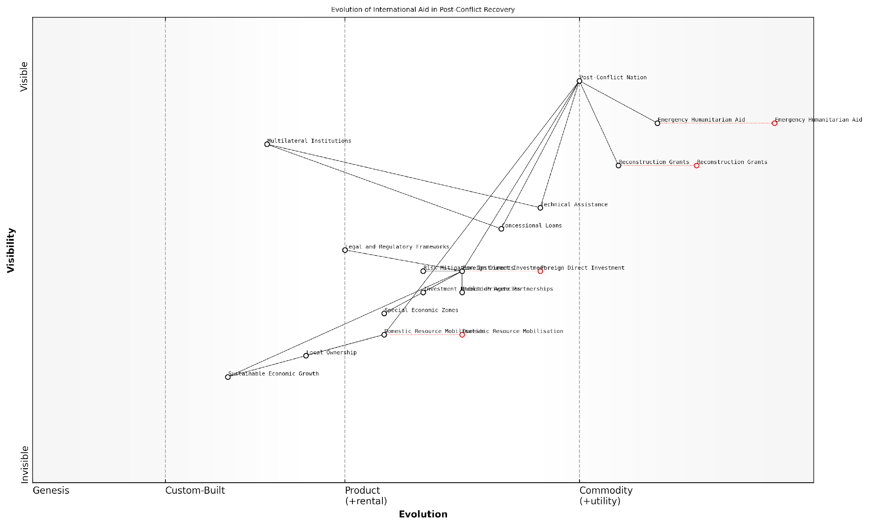

*Draft Wardley Map: [Insert Wardley Map: The role of international aid and investment]*

[Edit this draft Wardley Map](https://create.wardleymaps.ai/#clone:85fef80441b1c31c2b)

Wardley Map Assessment

This Wardley Map reveals a strategic landscape in transition, moving from immediate post-conflict aid to sustainable economic development. The key challenge lies in managing this transition effectively, balancing short-term needs with long-term sustainability. Success will depend on strengthening local ownership, attracting responsible foreign investment, and building robust domestic economic capabilities. The map highlights the need for a coordinated approach involving multiple stakeholders, with a clear path towards reducing aid dependency and fostering self-sustaining economic growth.

[View full Wardley Map report](http://markdown/wardley_map_reports/wardley_map_report_43_The_role_of_international_aid_and_investment.md)

In conclusion, international aid and investment are indispensable components of post-conflict economic recovery strategies. When properly managed and aligned with local needs and capacities, they can provide the necessary boost to rebuild infrastructure, restore basic services, and lay the foundation for sustainable economic growth. However, the ultimate success of these efforts depends on their ability to foster local ownership, build domestic capacities, and gradually transition from aid dependency to self-sustaining economic development.

## Demobilization and Reintegration Economics

### Cost analysis of demobilisation programs

Demobilisation programs are a critical component of post-conflict reconstruction, serving as the bridge between active military service and civilian life for countless combatants. As an expert in battlefield economics, I can attest that the cost analysis of these programs is a complex and multifaceted endeavour, with far-reaching implications for both the economic recovery and long-term stability of post-conflict regions.

The cost analysis of demobilisation programs encompasses a wide range of direct and indirect expenses, each of which must be carefully considered to ensure the program’s effectiveness and sustainability. These costs can be broadly categorised into immediate, short-term, and long-term expenditures, all of which play a crucial role in the success of the demobilisation process.

* Immediate costs: Initial registration and identification of combatants
* Short-term costs: Disarmament, temporary housing, and basic needs provision
* Long-term costs: Skills training, education, and ongoing support services

One of the most significant challenges in conducting a cost analysis of demobilisation programs is the inherent unpredictability of post-conflict environments. Factors such as the number of combatants, the extent of their needs, and the overall security situation can dramatically impact the resources required for successful demobilisation. As such, cost analyses must incorporate a degree of flexibility and contingency planning to account for these variables.

In my experience advising government bodies on post-conflict reconstruction, I’ve found that the most successful demobilisation programs are those that view costs not as mere expenditures, but as investments in future stability and economic growth.

A comprehensive cost analysis of demobilisation programs must also consider the opportunity costs associated with various approaches. For instance, while providing immediate cash payments to demobilised combatants may seem like a quick and straightforward solution, it may not be as cost-effective in the long run as investing in skills training and education programs that enhance employability and reduce the risk of future conflict.

Furthermore, the cost analysis should account for the potential economic benefits of successful demobilisation. These can include reduced military expenditure, increased labour force participation, and improved investor confidence in the post-conflict economy. By factoring in these potential gains, policymakers can make more informed decisions about resource allocation and program design.

* Reduced military expenditure through downsizing of armed forces
* Increased labour force participation as ex-combatants enter civilian workforce
* Improved investor confidence leading to economic growth and job creation

It’s also crucial to consider the costs of not implementing effective demobilisation programs. Failed or inadequate demobilisation can lead to renewed conflict, increased crime rates, and persistent economic instability – all of which carry significant economic and social costs. As such, a thorough cost analysis should include a risk assessment component that weighs the potential costs of program failure against the investment required for successful implementation.

A senior official from a post-conflict nation once told me, ‘The cost of demobilisation may seem high, but it pales in comparison to the cost of continued conflict or failed reintegration.’

In recent years, technological advancements have opened up new possibilities for cost-effective demobilisation programs. For instance, biometric registration systems can streamline the identification and tracking of program participants, while mobile banking solutions can facilitate more efficient and transparent disbursement of financial support. These innovations should be factored into cost analyses, as they may offer significant long-term savings despite higher initial implementation costs.

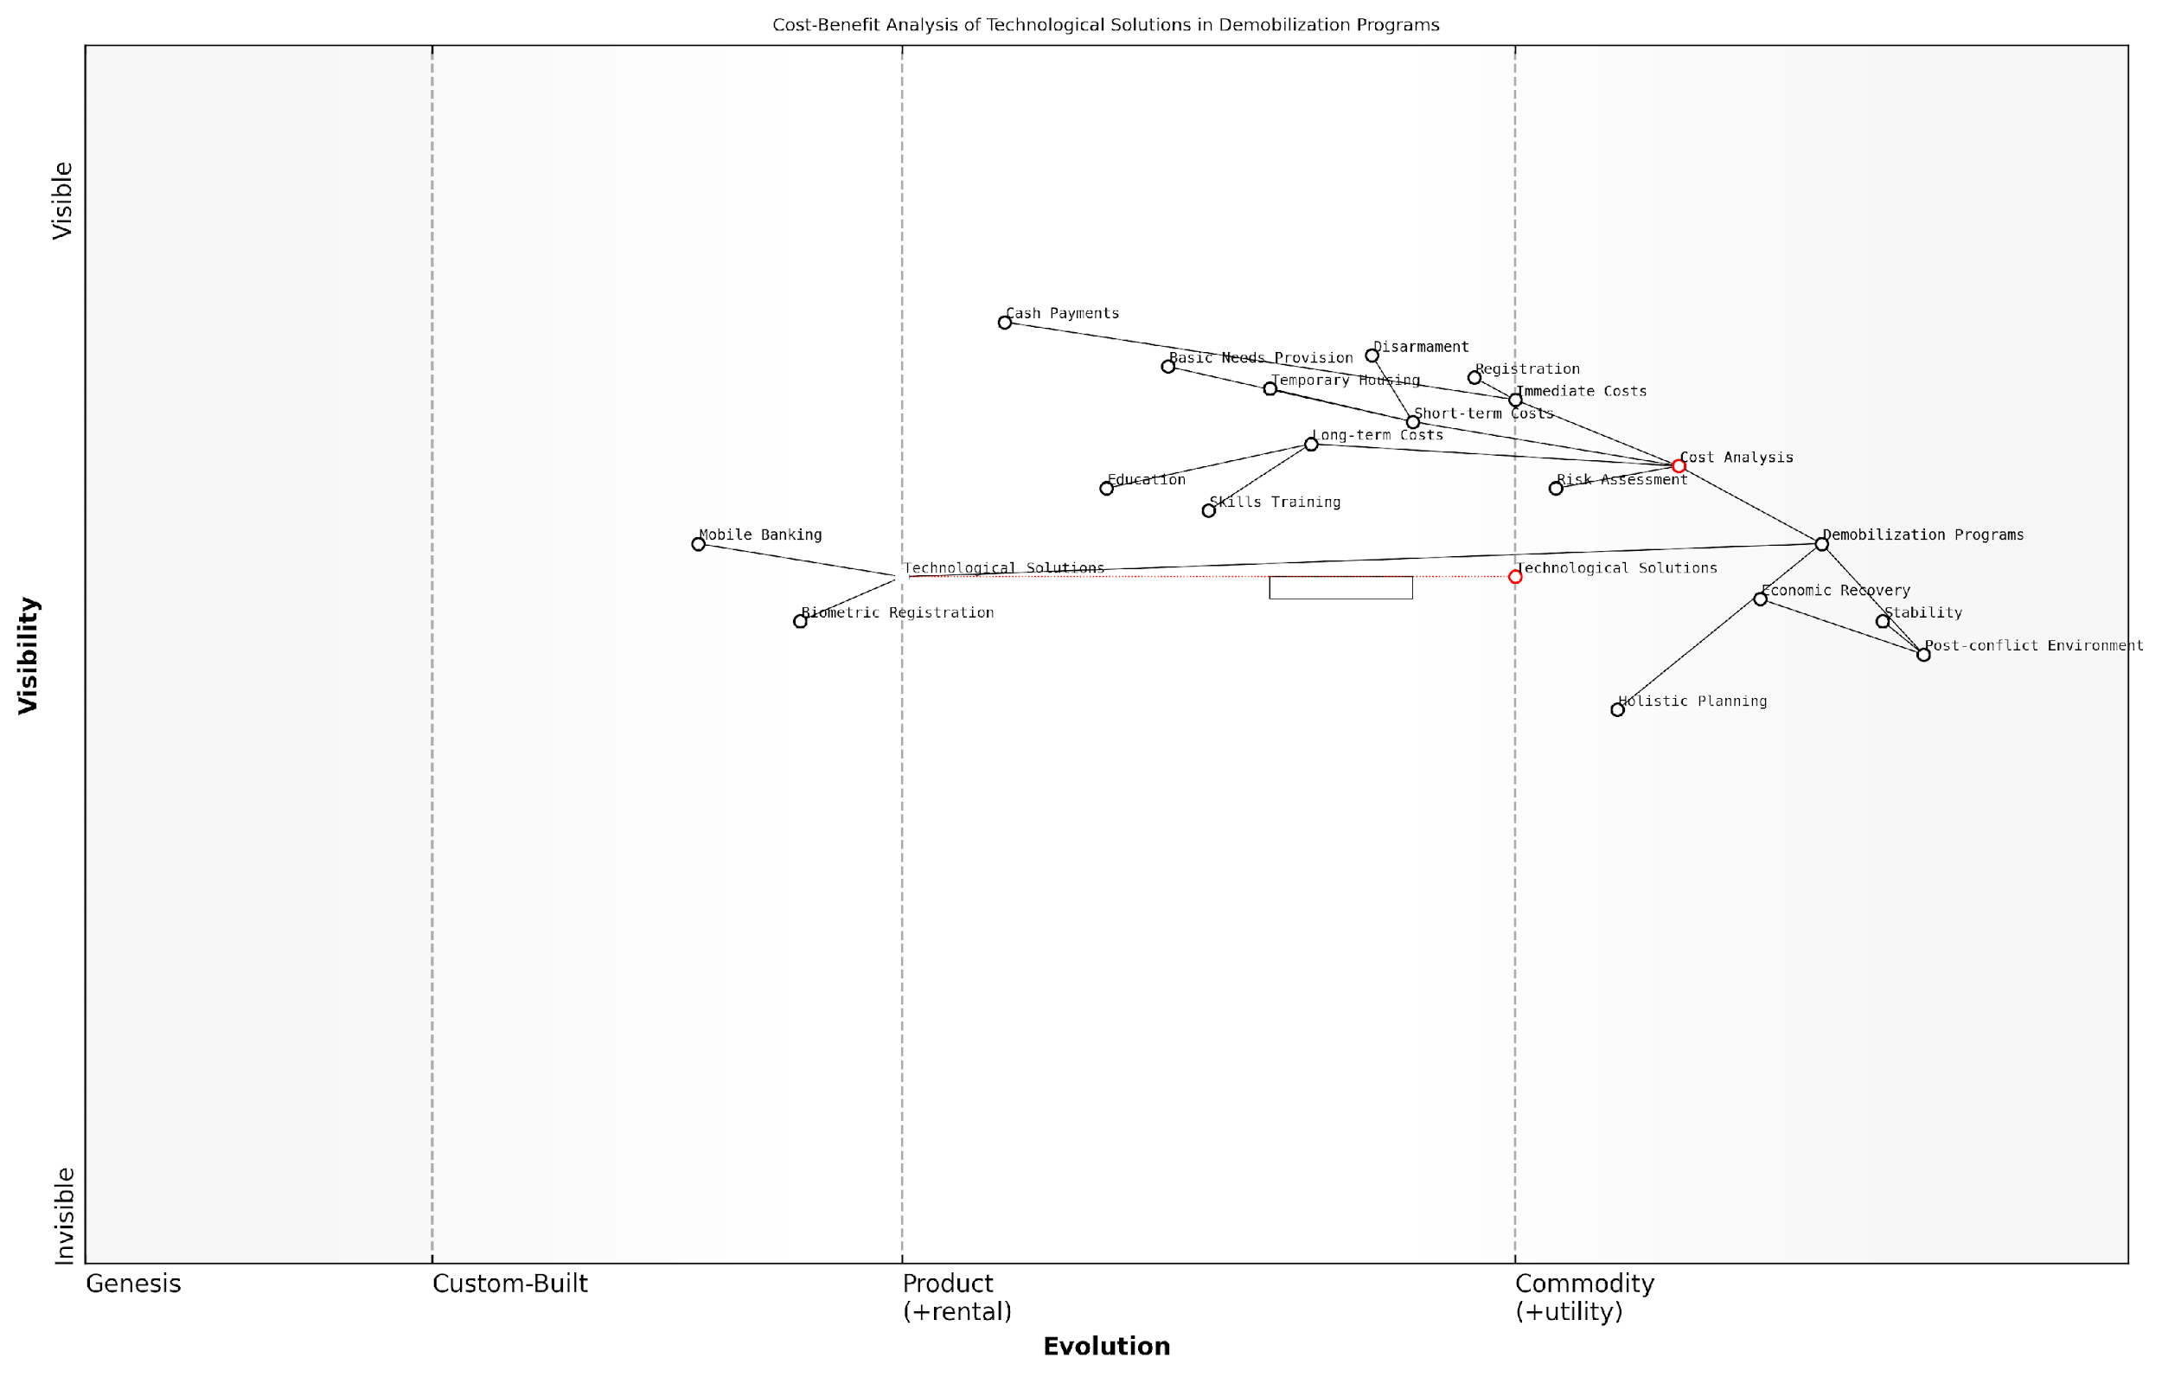

*Draft Wardley Map: [Insert Wardley Map: Cost analysis of demobilisation programs]*

[Edit this draft Wardley Map](https://create.wardleymaps.ai/#clone:974e7c8d80f78fe14e)

Wardley Map Assessment

The map reveals a demobilisation program at a critical juncture, poised to leverage technological solutions for enhanced efficiency and effectiveness. The strategic focus should be on accelerating the adoption and integration of these technologies while maintaining a holistic view of costs and risks. By prioritising innovation in areas like mobile banking and biometric registration, the program can significantly improve its impact and cost-effectiveness. However, careful attention must be paid to potential risks and the need for capability development to fully realise these benefits.

[View full Wardley Map report](http://markdown/wardley_map_reports/wardley_map_report_44_Cost_analysis_of_demobilization_programs.md)

Lastly, it’s important to note that the cost analysis of demobilisation programs should not be conducted in isolation. It must be integrated into the broader economic planning for post-conflict reconstruction, taking into account the interplay between demobilisation efforts and other critical areas such as infrastructure development, governance reform, and social services provision. This holistic approach ensures that resources are allocated efficiently across all aspects of post-conflict recovery, maximising the overall impact of reconstruction efforts.

In conclusion, the cost analysis of demobilisation programs is a critical tool for ensuring the effective transition from conflict to peace. By carefully considering all aspects of program costs – from immediate expenses to long-term investments and potential economic benefits – policymakers and program designers can create more sustainable and impactful demobilisation initiatives. This not only supports the successful reintegration of ex-combatants but also contributes to the broader goals of economic recovery and lasting stability in post-conflict societies.

### Economic reintegration of ex-combatants

The economic reintegration of ex-combatants is a critical component of post-conflict reconstruction and peacebuilding efforts. As an expert in battlefield economics, I can attest that this process is not only essential for the individuals involved but also for the broader economic stability and security of the recovering nation. The successful reintegration of former fighters into civilian life can significantly reduce the risk of conflict recurrence and contribute to sustainable economic growth.

Economic reintegration programmes aim to provide ex-combatants with the means to earn a sustainable livelihood through civilian employment or self-employment. These initiatives are complex and multifaceted, requiring a deep understanding of both the local economic context and the unique challenges faced by former fighters.

Economic reintegration is not just about providing jobs; it’s about transforming combatants into productive members of society who have a stake in peace and stability.

Key components of successful economic reintegration programmes include:

* Skills training and vocational education
* Job placement assistance and career counselling
* Micro-enterprise development and access to credit
* Psychosocial support and community reconciliation
* Land allocation and agricultural support in rural areas
* Formal education opportunities and literacy programmes

The economic reintegration process faces numerous challenges, including limited absorption capacity of local economies, skills mismatch between ex-combatants and available jobs, stigmatisation, and competition with other vulnerable groups for limited resources. These challenges require careful planning and a nuanced approach to programme design and implementation.

One of the most critical aspects of economic reintegration is ensuring that programmes are market-driven and aligned with local economic development strategies. This approach not only increases the likelihood of sustainable employment for ex-combatants but also contributes to overall economic growth and stability.

The success of economic reintegration hinges on creating opportunities that benefit both ex-combatants and their communities, fostering a sense of shared prosperity and reducing potential resentment.

The cost-benefit analysis of economic reintegration programmes is complex but generally favourable. While these initiatives require significant upfront investment, the long-term benefits in terms of reduced security risks, increased economic productivity, and social cohesion often outweigh the costs. However, it’s crucial to design programmes that are financially sustainable and can transition from donor-funded to locally-owned initiatives over time.

Innovative approaches to economic reintegration have emerged in recent years, leveraging technology and private sector partnerships. For instance:

* Mobile-based skills training and job matching platforms
* Public-private partnerships for apprenticeship programmes
* Social enterprise models that employ ex-combatants
* Blockchain technology for secure and transparent benefit distribution
* Green economy initiatives that combine reintegration with environmental conservation

These innovative approaches not only enhance the effectiveness of reintegration efforts but also contribute to broader economic modernisation and diversification in post-conflict settings.

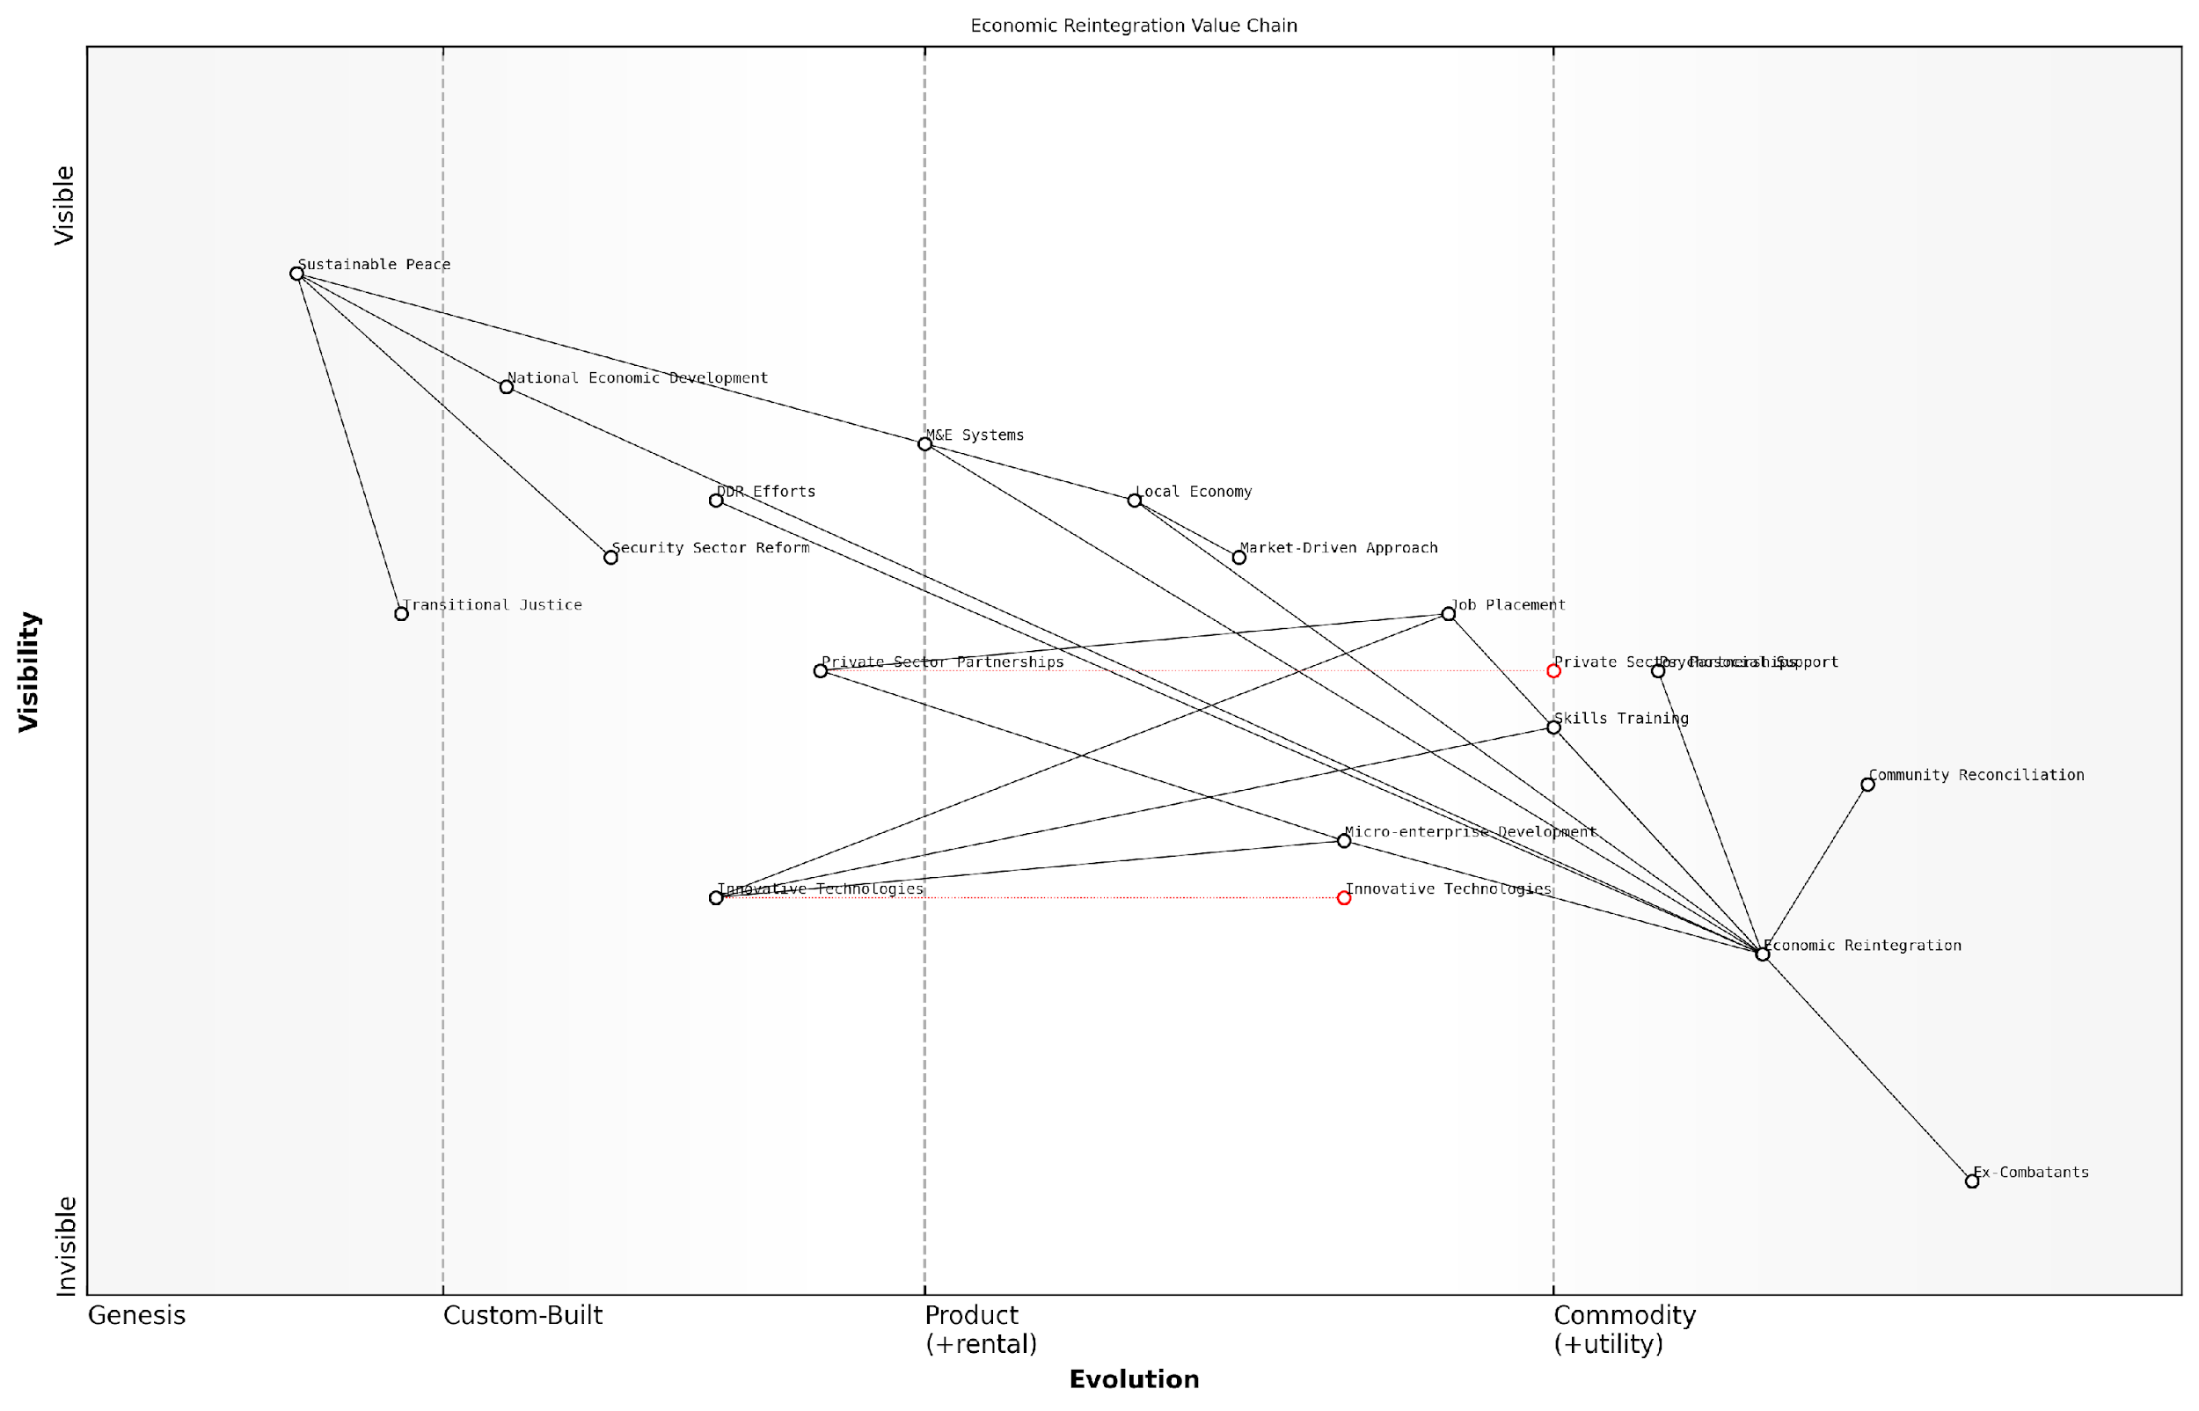

*Draft Wardley Map: [Insert Wardley Map: Economic reintegration of ex-combatants]*

[Edit this draft Wardley Map](https://create.wardleymaps.ai/#clone:cbc8e6730f070f1504)

Wardley Map Assessment

The map represents a comprehensive and well-structured approach to ex-combatant reintegration. However, there are significant opportunities to enhance effectiveness through technology adoption, stronger market alignment, and more integrated programming. The key to success lies in balancing immediate support needs with long-term economic and social integration, all while leveraging emerging technologies and private sector partnerships. The evolution of this system towards more market-driven, technology-enabled approaches could significantly improve outcomes and sustainability of reintegration efforts.

[View full Wardley Map report](http://markdown/wardley_map_reports/wardley_map_report_45_Economic_reintegration_of_ex-combatants.md)

Monitoring and evaluation are crucial components of economic reintegration programmes. Robust M&E systems help track progress, identify challenges, and provide evidence for programme adjustments. Key indicators typically include employment rates, income levels, business survival rates for micro-enterprises, and measures of social cohesion and community acceptance.

It’s important to note that economic reintegration cannot be viewed in isolation from other aspects of post-conflict reconstruction. It must be coordinated with broader disarmament, demobilisation, and reintegration (DDR) efforts, as well as with national economic development plans, security sector reform, and transitional justice mechanisms.

Economic reintegration is not just an economic issue; it’s a critical component of the social contract between ex-combatants and the state, essential for building lasting peace and stability.

In conclusion, the economic reintegration of ex-combatants is a complex but essential process in post-conflict settings. It requires a multidimensional approach that addresses both the immediate needs of former fighters and the long-term economic development of the country. When executed effectively, these programmes can transform potential spoilers into stakeholders in the peace process, contributing to sustainable economic growth and stability.

### Long-term economic impacts of veteran support

The long-term economic impacts of veteran support represent a critical yet often overlooked aspect of post-conflict economics and reconstruction. As an expert in battlefield economics, I can attest that the way a nation manages its veteran population has far-reaching consequences that extend well beyond the immediate post-war period. These impacts touch various sectors of the economy and can significantly influence a country’s long-term economic stability and growth.

One of the primary considerations in assessing the long-term economic impacts of veteran support is the cost-benefit analysis of comprehensive care programmes. While the initial outlay for robust veteran support systems may seem substantial, the alternative – neglecting the needs of former service members – often results in much higher societal and economic costs over time.

* Healthcare costs: Ongoing medical and mental health support for veterans, including treatment for service-related injuries and conditions
* Education and training: Programmes to facilitate the transition of veterans into civilian workforce, including skills development and higher education support
* Housing assistance: Initiatives to ensure stable housing for veterans, preventing homelessness and associated social costs
* Disability compensation: Long-term financial support for veterans with service-related disabilities
* Pension systems: Retirement benefits for career service members and their dependents

The economic impact of these support systems extends far beyond the direct costs to government budgets. Effective veteran support programmes can yield significant positive externalities for the broader economy. For instance, by facilitating the successful reintegration of veterans into the civilian workforce, countries can capitalise on the unique skills and experiences these individuals bring to the table.

A senior economist at a leading think tank notes, ‘Veterans who successfully transition to civilian careers often become highly productive members of the workforce, contributing to economic growth and innovation in various sectors.’

Moreover, the economic multiplier effect of veteran support programmes should not be underestimated. Investments in veteran healthcare, education, and housing not only benefit the recipients but also stimulate economic activity in related industries. This can lead to job creation and increased consumer spending, contributing to overall economic growth.

However, it’s crucial to recognise that the long-term economic impacts of veteran support are not uniformly positive. Poorly designed or underfunded programmes can lead to unintended negative consequences. For example, over-reliance on disability compensation without adequate reintegration support may discourage workforce participation, potentially leading to lost productivity and increased strain on social welfare systems.

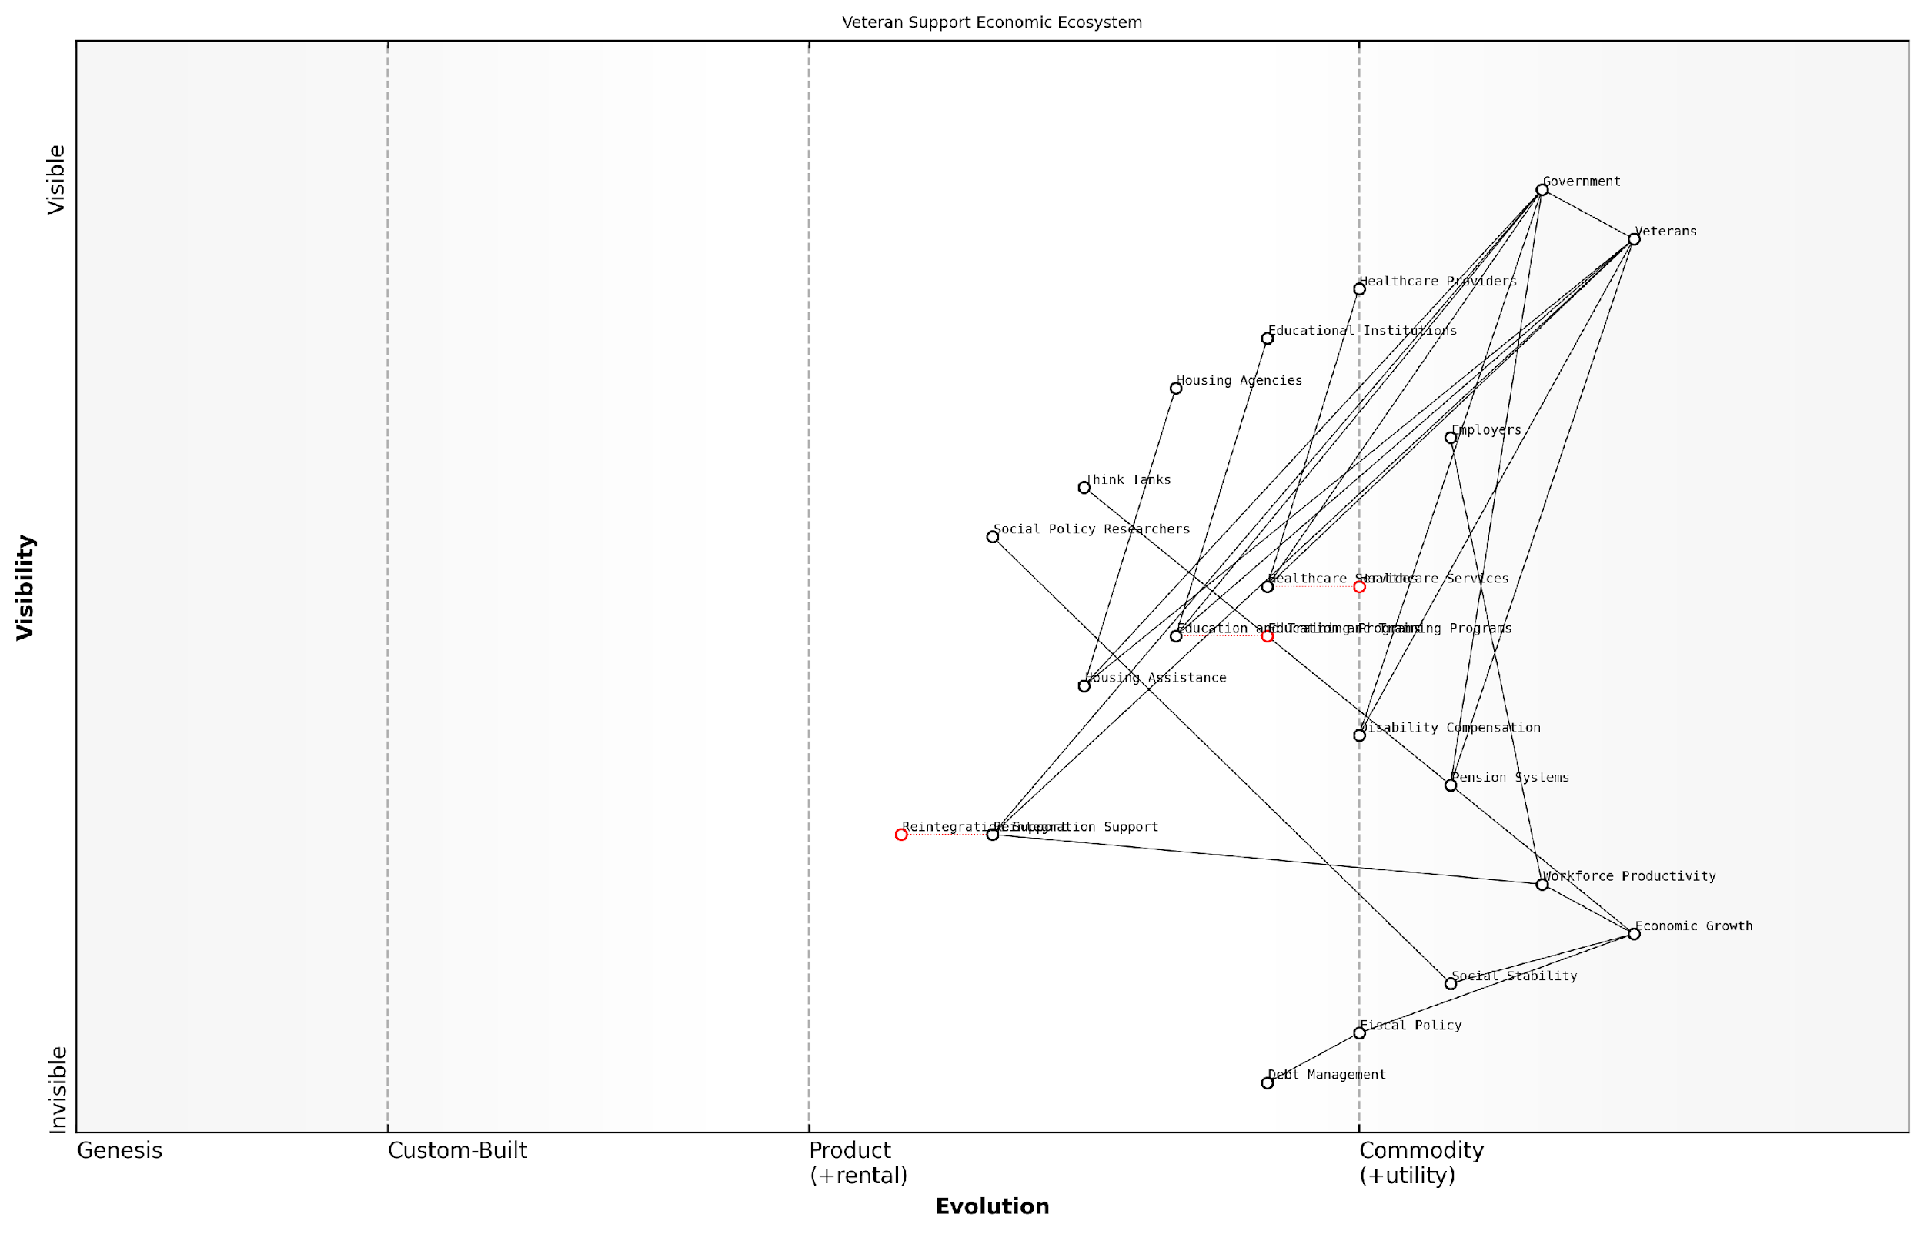

*Draft Wardley Map: [Insert Wardley Map: Long-term economic impacts of veteran support]*

[Edit this draft Wardley Map](https://create.wardleymaps.ai/#clone:3688500577c573d94c)

Wardley Map Assessment

This Wardley Map reveals a comprehensive and strategically aligned veteran support ecosystem with a clear focus on long-term economic impacts. The key opportunity lies in evolving less developed components like Reintegration Support and creating stronger integrations across services. By leveraging data analytics and emerging technologies, there’s significant potential to enhance the economic outcomes for veterans and the broader economy. The challenge will be in coordinating diverse stakeholders and maintaining adaptability in a rapidly changing economic landscape.

[View full Wardley Map report](http://markdown/wardley_map_reports/wardley_map_report_46_Long-term_economic_impacts_of_veteran_support.md)

From a macroeconomic perspective, the long-term impacts of veteran support can influence a nation’s fiscal policy and debt management. Countries with large veteran populations and generous support programmes may face challenges in balancing these commitments with other economic priorities. This is particularly relevant in the context of ageing populations and increasing healthcare costs.

It’s also worth considering the intergenerational aspects of veteran support. The children of well-supported veterans often have better educational and economic outcomes, contributing to long-term social mobility and economic growth. Conversely, inadequate support can perpetuate cycles of poverty and social challenges that span generations.

As a prominent social policy researcher observes, ‘The economic impacts of veteran support ripple through society for decades, influencing everything from workforce productivity to healthcare systems and social cohesion.’

In conclusion, the long-term economic impacts of veteran support are complex and multifaceted. While the immediate costs of comprehensive support programmes can be substantial, the potential long-term benefits – both economic and social – are significant. Policymakers and economists must take a holistic, long-term view when assessing the true economic impact of veteran support, considering not just direct costs but also the broader implications for economic growth, social stability, and national well-being.

* Conduct regular economic impact assessments of veteran support programmes
* Invest in data collection and analysis to inform evidence-based policy decisions
* Develop flexible support systems that can adapt to changing economic conditions and veteran needs
* Foster public-private partnerships to enhance the effectiveness and efficiency of veteran support initiatives
* Integrate veteran support considerations into broader economic and social policy frameworks

By adopting a strategic, long-term approach to veteran support, nations can not only fulfil their moral obligations to those who have served but also harness the potential of veterans as valuable contributors to long-term economic prosperity and social cohesion.

## Conflict Prevention through Economic Means

### Economic development as a tool for peace

Economic development has long been recognised as a powerful tool for preventing conflicts and fostering peace. As an expert in battlefield economics, I have observed firsthand how economic prosperity can significantly reduce the likelihood of armed conflicts and promote stability in volatile regions. This subsection explores the intricate relationship between economic development and peace, drawing from both theoretical frameworks and practical experiences in post-conflict environments.

At its core, economic development as a tool for peace operates on the principle that prosperous societies have more to lose from conflict and are therefore less likely to engage in warfare. This concept, often referred to as the ‘capitalist peace theory’, suggests that economic interdependence and shared prosperity create strong incentives for peaceful cooperation between nations and communities.

Economic development is not just about growth figures; it’s about creating a stake in peace for every member of society. When people have jobs, access to education, and hope for the future, they are far less likely to be drawn into conflict.

In my experience advising governments and international organisations, I’ve identified several key mechanisms through which economic development contributes to peace:

* Poverty Reduction: By alleviating poverty, economic development removes one of the primary drivers of conflict. When basic needs are met, individuals are less likely to resort to violence or be recruited by extremist groups.
* Job Creation: Employment opportunities, particularly for youth, provide alternatives to joining armed groups and reduce social unrest.
* Infrastructure Development: Improved infrastructure not only boosts economic activity but also enhances social cohesion by connecting communities and facilitating trade.
* Education and Skills Training: Investing in human capital creates a more skilled workforce, increases economic opportunities, and promotes social mobility.
* Institutional Strengthening: Economic development often goes hand-in-hand with improvements in governance, rule of law, and institutional capacity, all of which are crucial for maintaining peace.

However, it’s crucial to note that the relationship between economic development and peace is not always straightforward. In some cases, rapid economic growth can exacerbate existing inequalities or create new tensions if not managed carefully. This is why a nuanced approach to economic development is essential, one that takes into account local contexts, promotes inclusive growth, and addresses potential sources of conflict.

One of the most effective strategies I’ve encountered is the concept of ‘peace through prosperity’ initiatives. These programmes focus on creating economic opportunities in conflict-prone areas, often through targeted investments, microfinance schemes, and support for small and medium enterprises. By fostering economic interdependence between different communities or regions, these initiatives create a network of stakeholders invested in maintaining peace.

In my years of consulting, I’ve seen how economic cooperation can transform former adversaries into business partners. When people’s livelihoods depend on peace, they become its strongest advocates.

International trade and foreign direct investment also play crucial roles in using economic development as a tool for peace. By increasing economic interdependence between nations, trade relationships create mutual interests in stability and conflict prevention. However, it’s important to ensure that these economic relationships are equitable and do not create new forms of dependency or exploitation.

The role of technology in economic development and peacebuilding cannot be overstated. Digital platforms, for instance, can provide access to markets, education, and financial services in remote or conflict-affected areas. Moreover, technology can facilitate transparency in governance and economic transactions, reducing corruption and building trust in institutions.

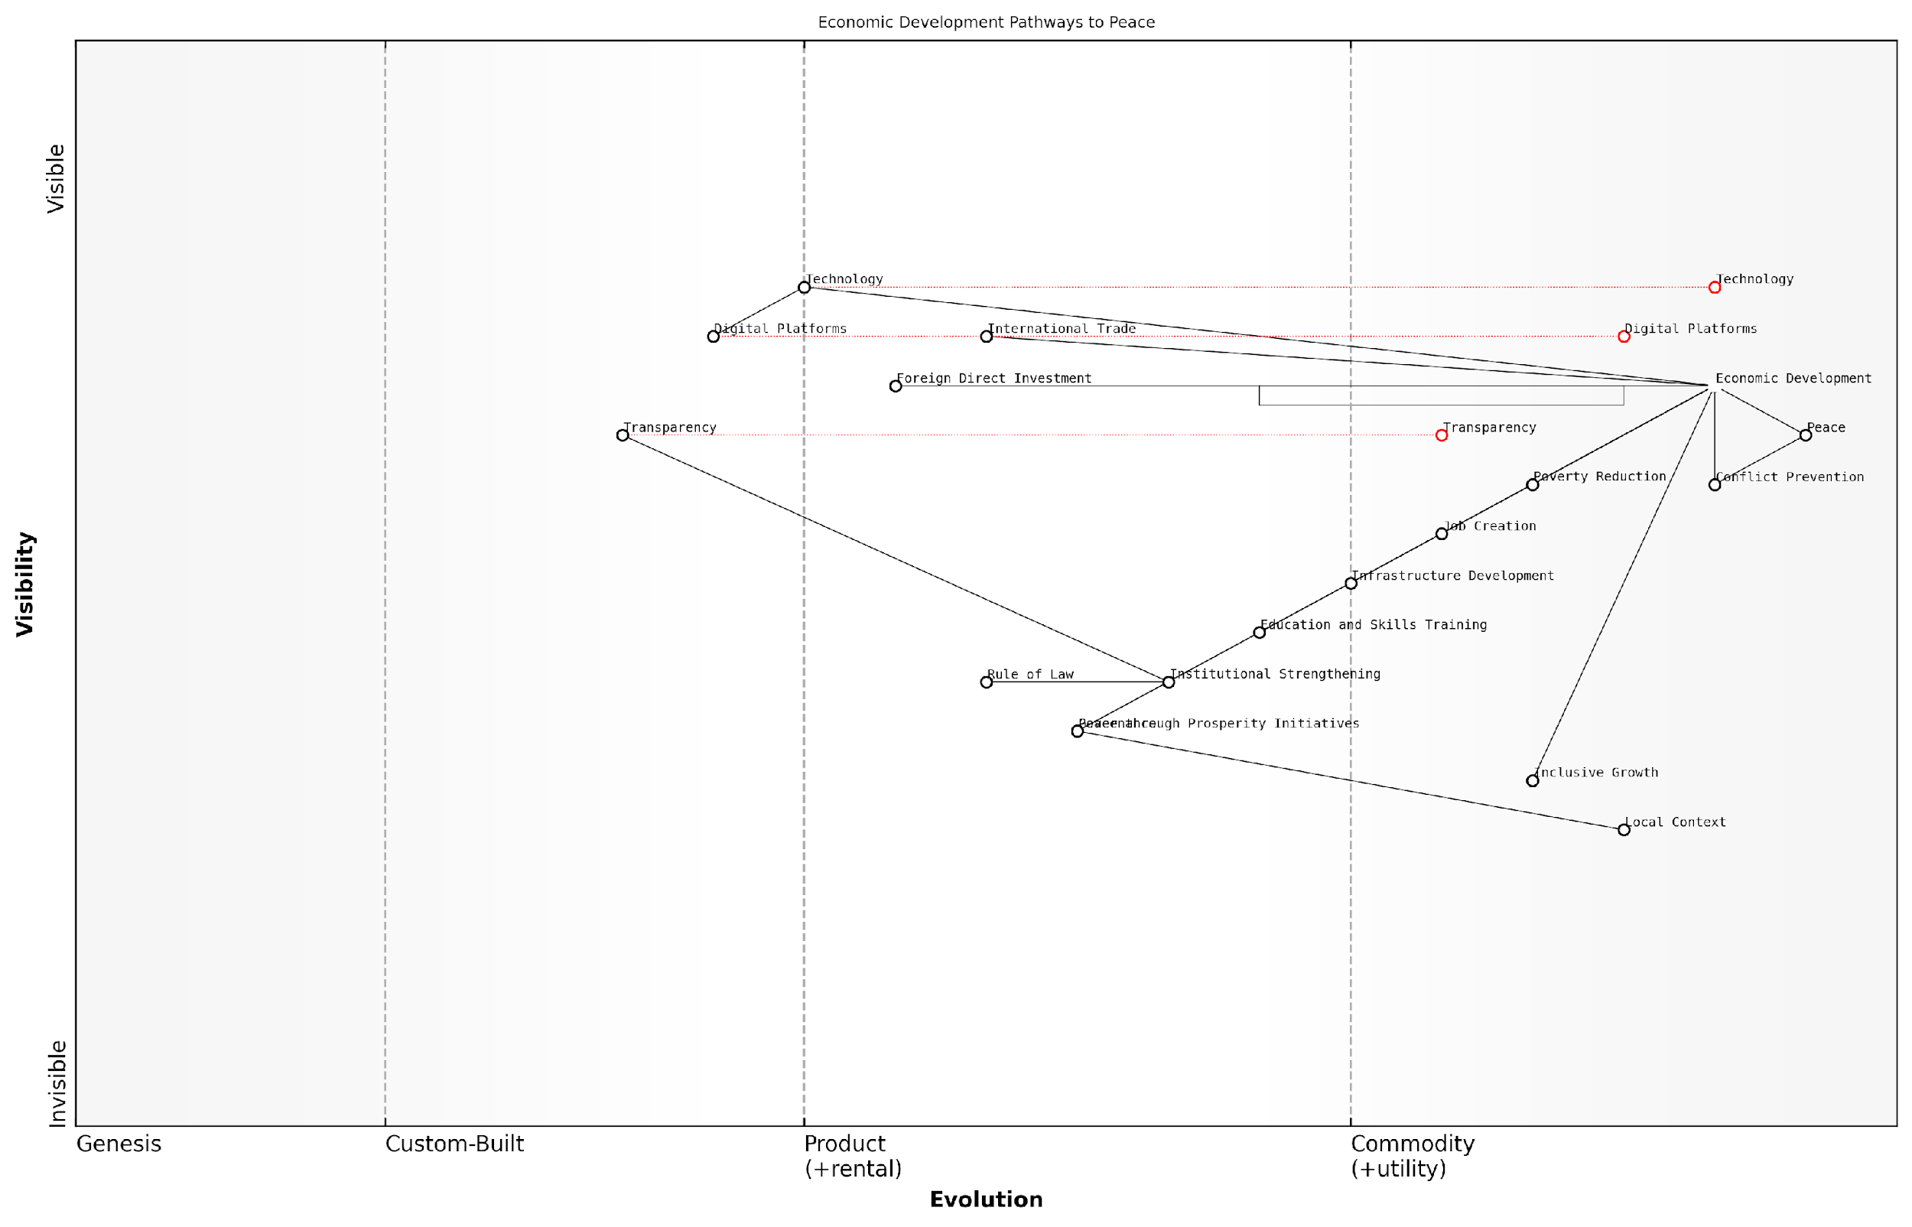

*Draft Wardley Map: [Insert Wardley Map: Economic development as a tool for peace]*

[Edit this draft Wardley Map](https://create.wardleymaps.ai/#clone:b8e311797eeaf11aba)

Wardley Map Assessment

This Wardley Map presents a comprehensive view of economic development as a pathway to peace, recognizing the complex interplay between various factors. The strategic position emphasises the importance of technology, transparency, and local context in driving economic growth and conflict prevention. Key opportunities lie in leveraging digital platforms and innovative technologies to enhance traditional development approaches, while risks primarily stem from potential neglect of local contexts and institutional weaknesses. The map suggests a need for a holistic, technology-enabled approach to economic development that carefully balances global best practices with local realities, always keeping the ultimate goal of sustainable peace in focus.

[View full Wardley Map report](http://markdown/wardley_map_reports/wardley_map_report_47_Economic_development_as_a_tool_for_peace.md)

Despite the potential of economic development as a tool for peace, it’s important to recognise its limitations. Economic factors alone cannot resolve deep-seated political, ethnic, or religious conflicts. Moreover, the benefits of economic development may take time to materialise, requiring sustained commitment and patience from all stakeholders.

In conclusion, economic development remains a powerful and essential tool for conflict prevention and peacebuilding. By creating prosperity, opportunity, and interdependence, it can address many of the root causes of conflict and create strong incentives for peace. However, to be truly effective, economic development strategies must be carefully tailored to local contexts, promote inclusive growth, and be integrated with broader peacebuilding efforts. As we look to the future, the challenge for policymakers and practitioners will be to harness the full potential of economic development in an increasingly complex and interconnected global landscape.

### International trade and interdependence

International trade and economic interdependence have emerged as powerful tools for conflict prevention in the realm of battlefield economics. As an expert who has advised numerous governments on this subject, I can attest to the transformative potential of economic ties in fostering peace and stability. The intricate web of global commerce creates a complex system of mutual dependencies that can significantly raise the costs of conflict, thereby deterring potential aggressors and promoting peaceful resolution of disputes.

At its core, the concept of using international trade as a conflict prevention mechanism is rooted in the theory of commercial liberalism. This theory posits that as nations become more economically interconnected, the potential costs of conflict increase dramatically, making war an increasingly unattractive option. The logic is straightforward: countries that rely on each other for trade, investment, and economic growth have a vested interest in maintaining stable and peaceful relations.

When goods don’t cross borders, soldiers will.

This oft-cited quote, attributed to a prominent 19th-century economist, encapsulates the essence of using trade as a tool for peace. In my experience working with defence ministries and foreign affairs departments, I’ve observed a growing recognition of this principle, leading to the integration of economic considerations into broader national security strategies.

* Creation of economic interdependencies through bilateral and multilateral trade agreements
* Establishment of joint economic zones and cross-border infrastructure projects
* Promotion of foreign direct investment as a means of fostering mutual interests
* Development of regional economic integration initiatives to align economic interests

One of the most compelling examples of trade fostering peace is the European Union (EU). Born from the ashes of World War II, the EU’s predecessor, the European Coal and Steel Community, was explicitly designed to make war between France and Germany ‘not merely unthinkable, but materially impossible’ by integrating their coal and steel industries. This economic integration has since expanded to create one of the world’s largest single markets, contributing significantly to the longest period of peace in Western Europe’s modern history.

However, it’s crucial to note that the relationship between trade and peace is not always straightforward. Economic interdependence can sometimes create new sources of tension, particularly when there are significant imbalances or when economic leverage is used coercively. For instance, disputes over trade practices or market access can escalate into broader geopolitical conflicts if not managed carefully.

Moreover, the effectiveness of economic interdependence as a conflict prevention tool can vary depending on the nature of the political systems involved. Democratic peace theory suggests that economic ties are more likely to prevent conflicts between democracies, as these governments are more responsive to the economic interests of their citizens and businesses.

Economic interdependence raises the stakes for conflict, but it doesn’t guarantee peace. It’s a powerful tool, not a panacea.

This insight from a seasoned diplomat underscores the need for a nuanced approach to leveraging economic ties for conflict prevention. In my consultancy work, I often emphasise the importance of complementing trade relationships with robust diplomatic channels, cultural exchanges, and security cooperation to create a multifaceted approach to peace-building.

Looking to the future, the role of international trade and economic interdependence in conflict prevention is likely to evolve in response to emerging global challenges. The rise of digital trade, the growing importance of data flows, and the increasing interconnectedness of global supply chains are creating new forms of economic interdependence that may have profound implications for international security.

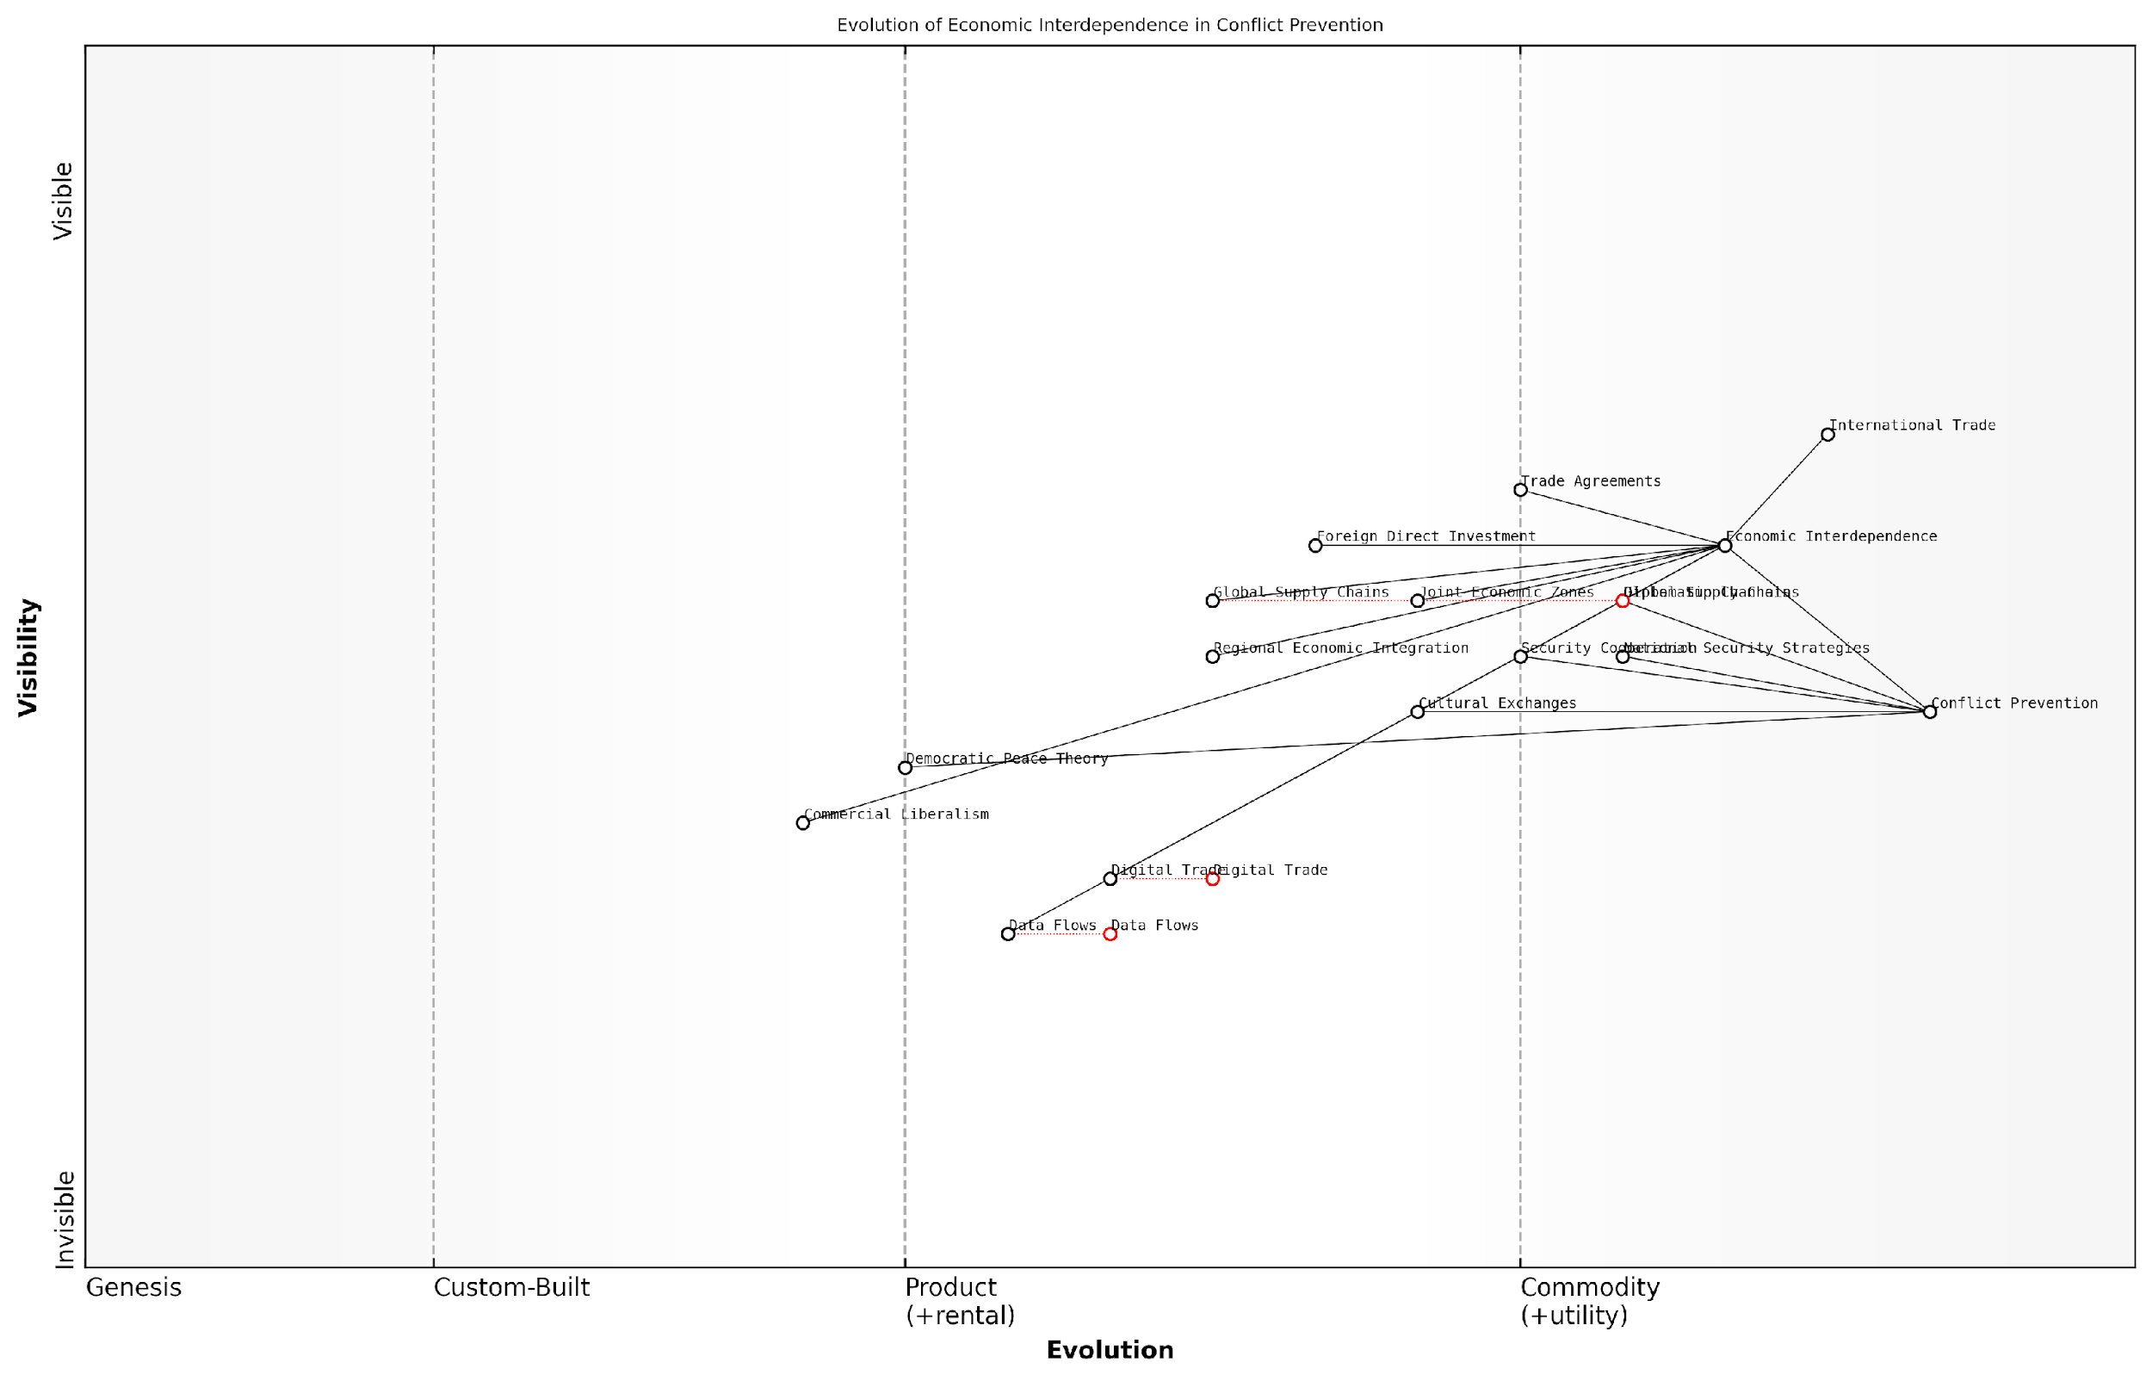

*Draft Wardley Map: [Insert Wardley Map: International trade and interdependence]*

[Edit this draft Wardley Map](https://create.wardleymaps.ai/#clone:f73d766eae1722b4c7)

Wardley Map Assessment

This Wardley Map reveals a system in transition, balancing established economic interdependence mechanisms with rapidly evolving digital components. The strategic imperative is to adapt traditional approaches to the digital age while leveraging new technologies to enhance economic ties and conflict prevention. Success will require agile policymaking, investment in digital capabilities, and a reimagining of economic diplomacy for the 21st century.

[View full Wardley Map report](http://markdown/wardley_map_reports/wardley_map_report_48_International_trade_and_interdependence.md)

As we navigate these changes, policymakers and military strategists must remain attuned to the complex interplay between economic interests and security considerations. The challenge lies in harnessing the peace-promoting potential of trade while mitigating the risks of economic vulnerabilities being exploited for strategic advantage.

In conclusion, international trade and economic interdependence represent powerful, if complex, tools for conflict prevention in the context of battlefield economics. By creating a web of shared interests and raising the economic stakes of conflict, trade relationships can contribute significantly to global stability. However, their effectiveness depends on careful management, complementary diplomatic efforts, and a nuanced understanding of the evolving global economic landscape. As we move forward, integrating economic considerations into broader security strategies will be crucial for fostering a more peaceful and prosperous world.

### The cost-effectiveness of preventive economic measures

As an expert in battlefield economics with extensive experience advising government bodies, I can attest that the cost-effectiveness of preventive economic measures is a critical yet often overlooked aspect of conflict prevention. This subsection explores how proactive economic strategies can mitigate the risk of armed conflicts, potentially saving billions in military expenditures and human lives.

Preventive economic measures encompass a wide range of strategies aimed at addressing the root causes of conflicts before they escalate into full-blown military engagements. These measures are typically far less expensive than the costs associated with warfare and post-conflict reconstruction, making them an attractive option for policymakers and military strategists alike.

* Economic development programmes
* Targeted foreign aid and investment
* Trade agreements and economic integration
* Debt relief initiatives
* Resource-sharing agreements
* Support for good governance and anti-corruption measures

One of the most compelling arguments for preventive economic measures is their potential return on investment. Studies have shown that for every pound spent on conflict prevention, up to £16 can be saved on post-conflict peacekeeping and reconstruction efforts. This remarkable cost-benefit ratio underscores the economic wisdom of addressing potential conflicts at their source.

Investing in preventive measures is not just morally right, it’s economically smart. The cost of prevention is a fraction of what we spend on conflict resolution and post-war reconstruction.

Economic development programmes, in particular, have proven to be highly effective in reducing the likelihood of conflict. By addressing poverty, unemployment, and inequality – common drivers of social unrest – these initiatives can significantly decrease the risk of violence. For instance, a comprehensive economic development plan implemented in a fragile region might cost £100 million over five years, but could potentially prevent a conflict that would otherwise cost billions in military operations and reconstruction.

Trade agreements and economic integration serve as powerful tools for conflict prevention by creating mutual dependencies between nations. When countries have strong economic ties, the cost of conflict becomes prohibitively high for all parties involved. The European Union stands as a prime example of how economic integration can foster long-term peace and stability among former adversaries.

Resource-sharing agreements offer another cost-effective approach to preventing conflicts, particularly in regions where competition over natural resources is a potential flashpoint. By establishing clear frameworks for the equitable distribution of resources, these agreements can defuse tensions before they escalate into armed confrontations.

In my experience advising governments, I’ve seen how resource-sharing agreements can transform potential conflict zones into areas of cooperation. The initial diplomatic costs are negligible compared to the long-term benefits of peace and shared prosperity.

However, it’s crucial to note that the effectiveness of preventive economic measures is not always immediately apparent, which can make them a hard sell in political environments focused on short-term gains. Long-term commitment and patience are essential, as the benefits of these strategies often materialise over years or even decades.

Moreover, the success of preventive economic measures depends heavily on their thoughtful design and implementation. Poorly executed initiatives can exacerbate existing tensions or create new ones, potentially doing more harm than good. Therefore, a thorough understanding of local contexts, careful planning, and ongoing monitoring and evaluation are critical to ensuring the cost-effectiveness of these measures.

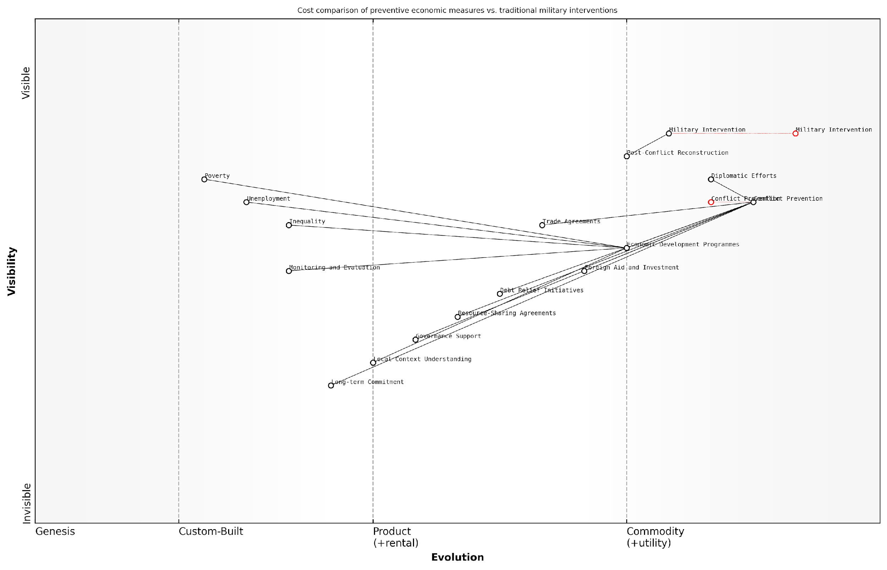

*Draft Wardley Map: [Insert Wardley Map: The cost-effectiveness of preventive economic measures]*

[Edit this draft Wardley Map](https://create.wardleymaps.ai/#clone:a03b7a6b149c8a49a4)

Wardley Map Assessment

This Wardley Map presents a compelling case for the potential cost-effectiveness of preventive economic measures over traditional military interventions in managing potential conflicts. It highlights the importance of understanding local contexts, maintaining long-term commitment, and addressing root economic causes of conflicts. The strategic positioning of various components suggests a need to evolve conflict management approaches towards more proactive, economically-focused strategies. While challenges exist, particularly in terms of local understanding and long-term commitment, the map indicates significant opportunities for innovation and improved effectiveness in conflict prevention through economic means. Implementing the suggested strategies could lead to a paradigm shift in international conflict management, potentially resulting in more sustainable peace and development outcomes.

[View full Wardley Map report](http://markdown/wardley_map_reports/wardley_map_report_49_The_cost-effectiveness_of_preventive_economic_meas.md)

In conclusion, the cost-effectiveness of preventive economic measures in conflict prevention is compelling. While they require upfront investment and long-term commitment, these strategies offer a significantly more economical alternative to the enormous costs of warfare and post-conflict reconstruction. As we continue to face complex global challenges, integrating these preventive approaches into our national security and foreign policy frameworks will be crucial for fostering a more stable and prosperous world.

# Conclusion: The Future of Battlefield Economics

## Emerging Trends and Challenges

### AI and autonomous systems in warfare

As we stand on the precipice of a new era in military technology, the integration of Artificial Intelligence (AI) and autonomous systems into warfare represents one of the most significant shifts in battlefield economics since the advent of gunpowder. This transformative trend is reshaping the very fabric of military strategy, resource allocation, and the economic calculus of conflict.

The economic implications of AI and autonomous systems in warfare are profound and multifaceted. On one hand, these technologies promise to dramatically reduce human casualties and the associated costs of training, deployment, and veteran care. On the other, they require substantial upfront investment in research, development, and infrastructure, potentially widening the gap between technologically advanced nations and those with more limited resources.

* Reduced personnel costs through automation of routine tasks and dangerous missions
* Increased efficiency in logistics and supply chain management
* Enhanced decision-making capabilities through real-time data analysis
* Potential for asymmetric warfare as smaller nations leverage AI to compete with larger powers
* Shift in military spending from traditional hardware to software and data infrastructure

The economics of AI in warfare extend beyond mere cost considerations. These technologies have the potential to fundamentally alter the speed and nature of conflict. AI-driven systems can process information and make decisions at speeds far beyond human capability, potentially compressing the timeframes in which economic and military decisions must be made. This acceleration could have profound implications for global financial markets, resource allocation, and the economic strategies employed by nations in times of conflict.

The integration of AI into military systems is not just a technological evolution, but an economic revolution that will redefine the cost-benefit analysis of warfare for generations to come.

However, the adoption of AI and autonomous systems in warfare also presents significant challenges and potential economic pitfalls. The development of these technologies is enormously expensive and fraught with uncertainty. Nations must carefully weigh the economic risks of investing heavily in unproven technologies against the potential strategic advantages they may provide.

* High upfront costs for research, development, and implementation
* Potential for rapid obsolescence, necessitating continuous investment
* Cybersecurity concerns and the economic impact of potential AI vulnerabilities
* Ethical considerations and potential international regulations that may limit development or deployment
* Economic implications of AI arms races and the potential for mutually assured economic destruction

Moreover, the economic ripple effects of AI and autonomous systems in warfare extend far beyond the military sphere. These technologies have significant dual-use potential, with innovations in military AI often finding applications in civilian sectors. This crossover effect could lead to accelerated economic growth and productivity gains in the broader economy, potentially offsetting some of the costs associated with military AI development.

The economic benefits of military AI research may well exceed its costs, as innovations in autonomous systems and machine learning find applications across all sectors of the economy.

As we look to the future, it is clear that AI and autonomous systems will play an increasingly central role in shaping the economics of the battlefield. Nations that successfully navigate the economic challenges of developing and deploying these technologies may gain significant strategic advantages. However, the potential for rapid technological change also introduces new uncertainties into the global balance of power, with profound implications for international relations and economic stability.

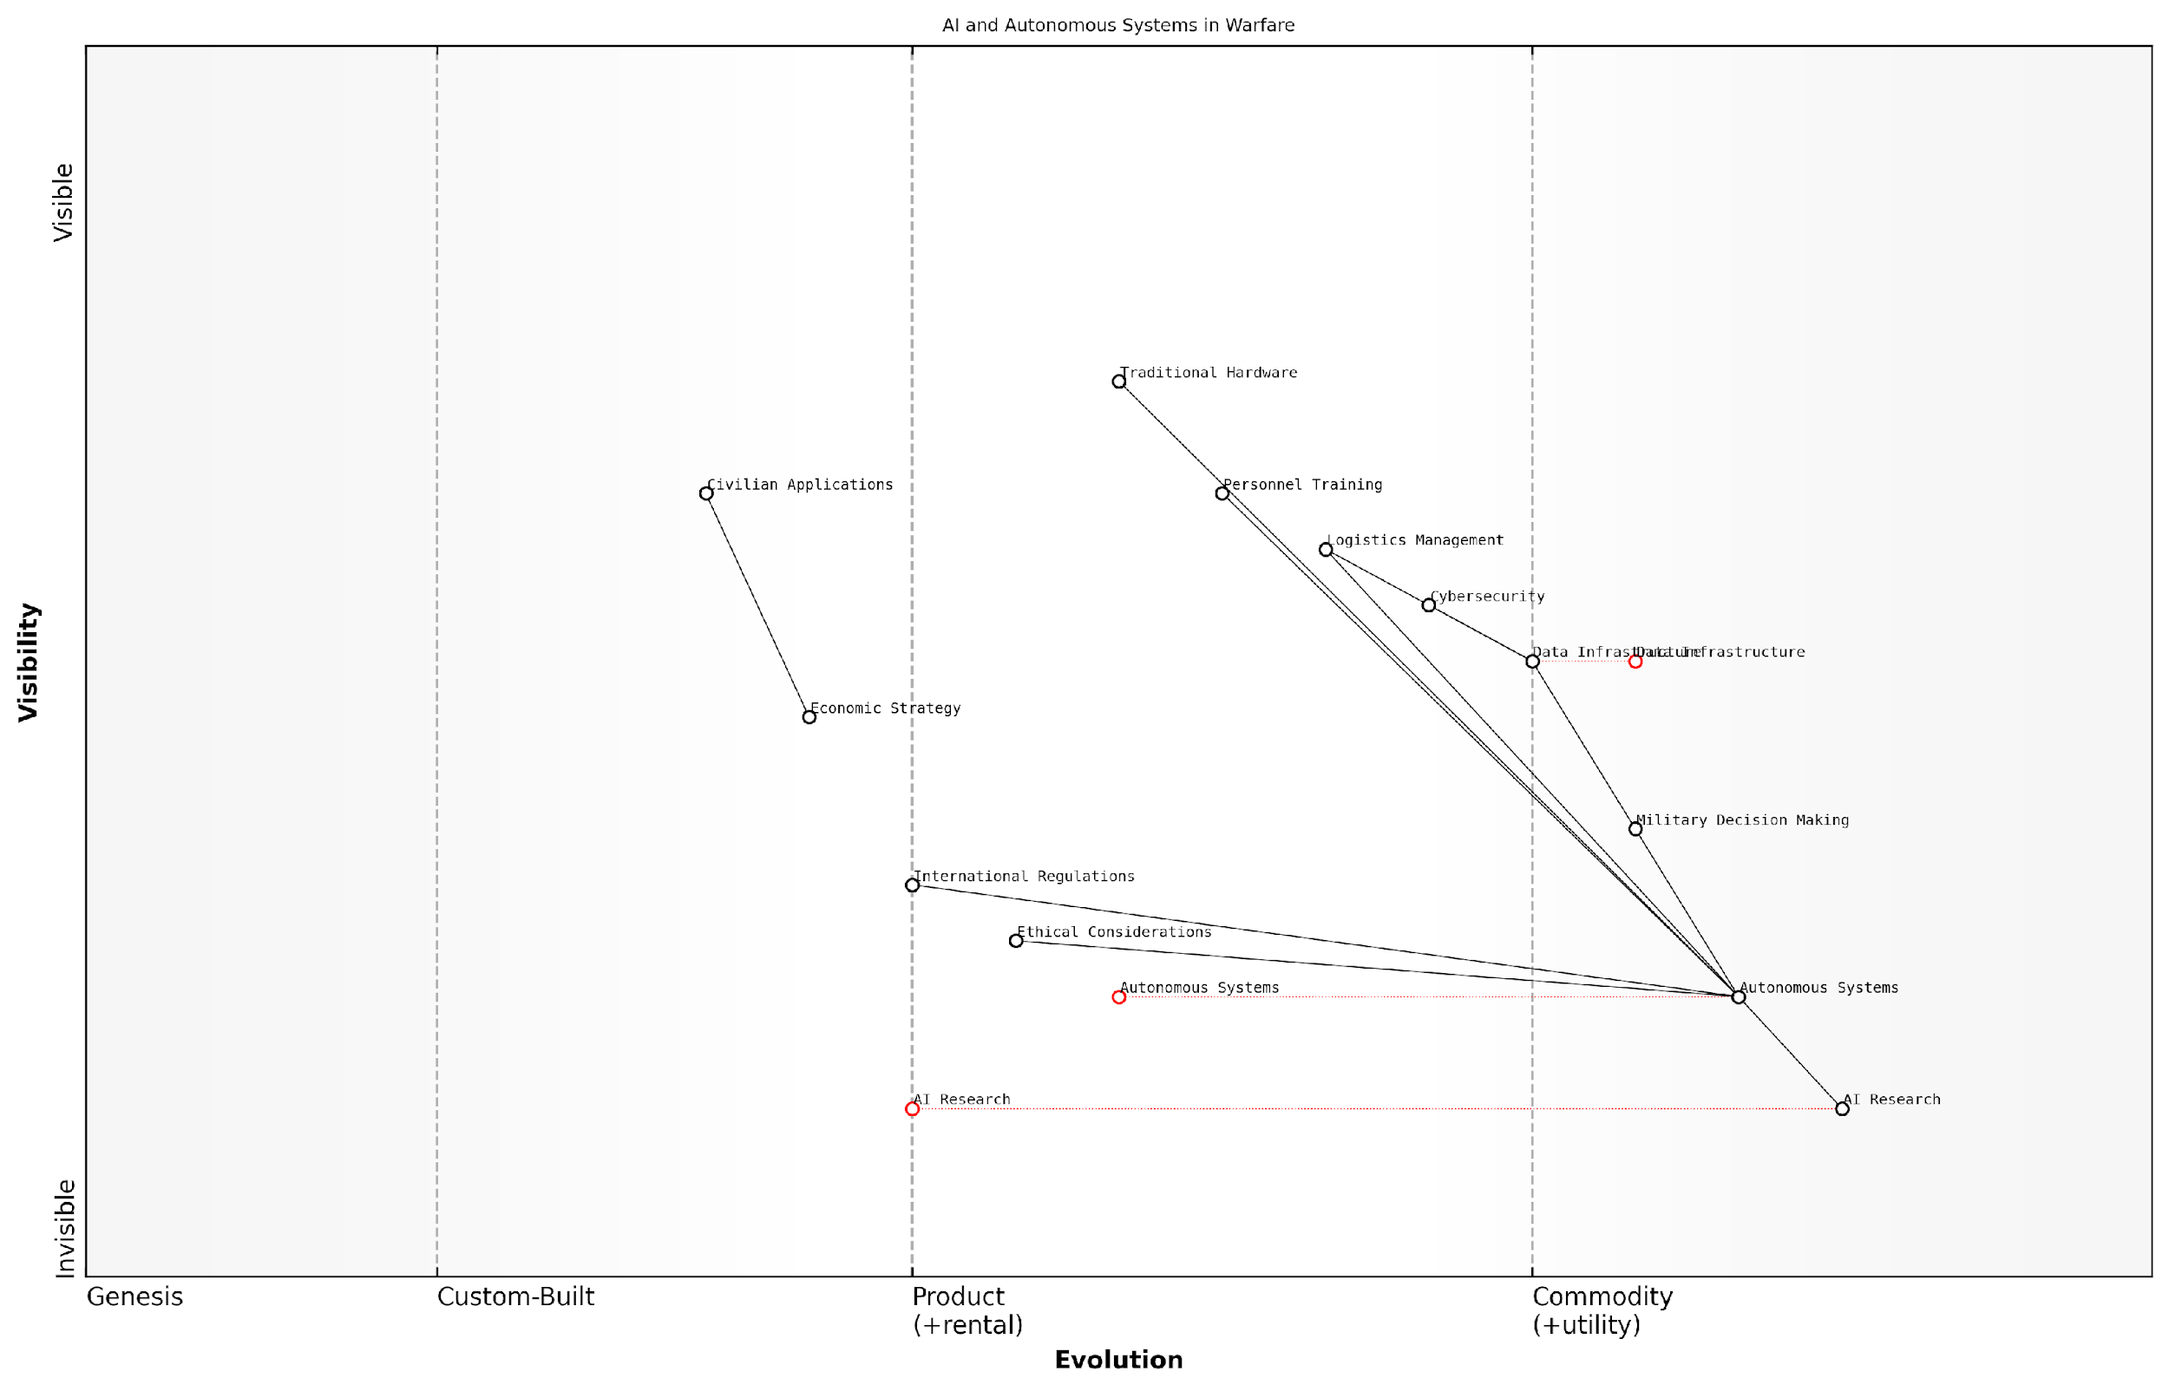

*Draft Wardley Map: [Insert Wardley Map: AI and autonomous systems in warfare]*

[Edit this draft Wardley Map](https://create.wardleymaps.ai/#clone:4424b4b75d24a91a05)

Wardley Map Assessment

This Wardley Map reveals a military ecosystem in transition, moving towards AI-driven and autonomous warfare. The strategic focus should be on accelerating AI and autonomous systems development while proactively addressing ethical and regulatory challenges. Success will depend on balancing technological advancement with responsible implementation, fostering a robust ecosystem that spans from research to practical applications, and maintaining a competitive edge in critical areas like AI research and data infrastructure. The integration of these advanced technologies with traditional military elements and the exploration of civilian applications present significant opportunities for innovation and strategic advantage.

[View full Wardley Map report](http://markdown/wardley_map_reports/wardley_map_report_50_AI_and_autonomous_systems_in_warfare.md)

In conclusion, the integration of AI and autonomous systems into warfare represents both a tremendous opportunity and a significant challenge for military planners and economists alike. As these technologies continue to evolve, they will undoubtedly reshape the economic landscape of conflict, forcing us to reconsider long-held assumptions about the costs and conduct of war. The nations and military organisations that can effectively harness the economic potential of AI while mitigating its risks will be best positioned to navigate the complex and rapidly changing battlefield of the future.

### Space militarization and its economic implications

As we venture into the future of battlefield economics, the militarisation of space emerges as a critical frontier with far-reaching economic implications. The expansion of military activities beyond Earth’s atmosphere represents a paradigm shift in strategic thinking and resource allocation, presenting both unprecedented challenges and opportunities for nations and private entities alike.

The economic ramifications of space militarisation are multifaceted and profound. At its core, this emerging trend necessitates substantial investments in cutting-edge technologies, specialised personnel, and entirely new infrastructure. The costs associated with developing, launching, and maintaining space-based military assets are astronomical, often dwarfing traditional defence expenditures.

* Research and development of space-capable weapons systems
* Launch infrastructure and vehicles
* Satellite networks for communication, surveillance, and navigation
* Space debris mitigation and management
* Training and support for specialised space forces

However, these investments also drive innovation and economic growth in adjacent sectors. The spillover effects of space militarisation on civilian technologies and industries cannot be overstated. From advanced materials and propulsion systems to miniaturised electronics and artificial intelligence, the pursuit of military dominance in space catalyses breakthroughs that often find applications in the broader economy.

The economic potential of space militarisation extends far beyond defence contracts. It’s a catalyst for innovation that will reshape industries and create entirely new markets in the coming decades.

The geopolitical landscape is also profoundly affected by space militarisation, with economic consequences rippling through international relations. Nations that achieve superiority in space gain significant strategic and economic advantages, potentially altering global power dynamics. This creates a new dimension of economic competition, where countries vie for control over orbital assets and extraterrestrial resources.

The economics of space resource exploitation become intertwined with military objectives, as the ability to secure and defend access to valuable off-world materials becomes a matter of national security. This convergence of economic and military interests in space is likely to shape future conflicts and alliances, with profound implications for global trade and resource distribution.

* Competition for lunar and asteroid mining rights
* Development of space-based solar power stations
* Establishment of military bases on celestial bodies
* Creation of new legal and economic frameworks for space activities

The private sector’s role in space militarisation introduces another layer of economic complexity. As governments increasingly rely on commercial entities for space launch capabilities and satellite services, a new industrial ecosystem is emerging. This public-private partnership model in space defence not only distributes costs but also accelerates innovation, creating a virtuous cycle of technological advancement and economic growth.

However, the economic benefits of space militarisation must be weighed against the potential risks and costs. The weaponisation of space could lead to an arms race, diverting resources from other critical areas of national development. Moreover, the vulnerability of space-based assets to attack or disruption poses significant economic risks, given the increasing dependence of global commerce and communication on satellite infrastructure.

The militarisation of space is a double-edged sword. While it drives innovation and creates new economic opportunities, it also introduces unprecedented vulnerabilities to our interconnected global economy.

As we navigate this new frontier of battlefield economics, policymakers and military strategists must grapple with complex cost-benefit analyses. The economic implications of space militarisation extend far beyond traditional defence budgeting, encompassing long-term technological development, resource allocation, and even the fundamental structure of future economies.

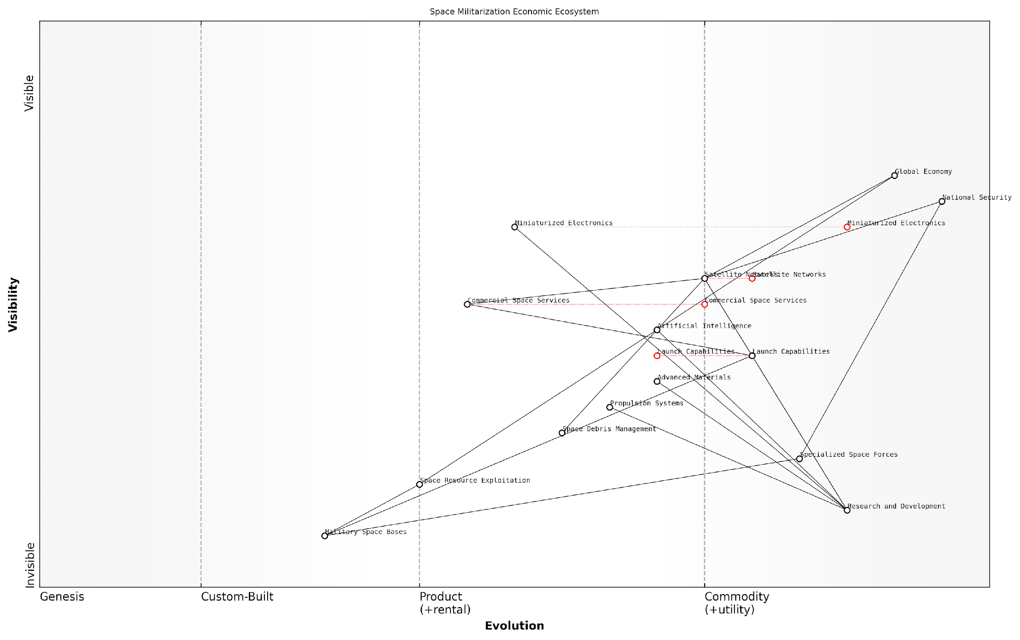

*Draft Wardley Map: [Insert Wardley Map: Space militarization and its economic implications]*

[Edit this draft Wardley Map](https://create.wardleymaps.ai/#clone:ba74006472d4f4de90)

Wardley Map Assessment

The space militarization economic ecosystem is at a critical juncture, with rapidly evolving capabilities in launch and satellite technologies creating new opportunities and challenges. The strategic focus should be on balancing commercial development with security concerns, addressing emerging challenges like space debris, and positioning for future opportunities in space resource exploitation. Success will require careful navigation of international relations, significant technological innovation, and adaptive policy frameworks.

[View full Wardley Map report](http://markdown/wardley_map_reports/wardley_map_report_51_Space_militarization_and_its_economic_implications.md)

In conclusion, the economic implications of space militarisation are vast and multifaceted. As this trend continues to evolve, it will undoubtedly reshape the landscape of battlefield economics, introducing new challenges, opportunities, and paradigms that will define the future of both warfare and economic development in the 21st century and beyond.

### Climate change and future resource conflicts

As we peer into the future of battlefield economics, one of the most pressing and transformative factors we must consider is the impact of climate change on global resource distribution and the potential for conflict. The nexus between climate change, resource scarcity, and military confrontation represents a critical area of concern for policymakers, military strategists, and economists alike.

Climate change is already altering the geopolitical landscape, reshaping access to vital resources such as water, arable land, and energy sources. These shifts are likely to exacerbate existing tensions and create new flashpoints for conflict. As an expert who has advised numerous government bodies on this issue, I can attest to the growing anxiety among national security professionals regarding the potential for climate-induced resource wars.

* Water scarcity: Increasing competition for freshwater resources, particularly in transboundary river basins
* Food security: Shifting agricultural zones and declining crop yields leading to potential conflicts over arable land
* Energy resources: Changing accessibility to fossil fuels and the race for renewable energy sources
* Arctic resources: Melting ice caps opening new shipping routes and access to previously unreachable natural resources
* Climate migration: Large-scale population movements due to environmental changes, potentially destabilising regions

The economic implications of these climate-induced resource conflicts are profound. Nations will need to reassess their military strategies, allocating significant resources to adapt to new environmental realities. This may include investments in climate-resilient infrastructure, development of new technologies for resource extraction and management, and the creation of specialised military units equipped to operate in extreme weather conditions.

Climate change is not just an environmental issue, but a fundamental security challenge that will reshape the economic calculus of warfare in the 21st century.

From an economic perspective, the costs associated with preparing for and mitigating climate-related conflicts are likely to be substantial. However, these investments must be weighed against the potential costs of inaction, which could be catastrophic. Governments and militaries will need to develop sophisticated economic models to assess the long-term implications of climate change on their strategic interests and resource security.

One of the most challenging aspects of addressing climate-induced resource conflicts is the need for international cooperation in a potentially more fractious global environment. Economic incentives and disincentives will play a crucial role in shaping behaviour and encouraging collaborative approaches to resource management. This may include the development of new international frameworks for resource sharing, investment in joint climate adaptation projects, and the creation of economic mechanisms to compensate countries disproportionately affected by climate change.

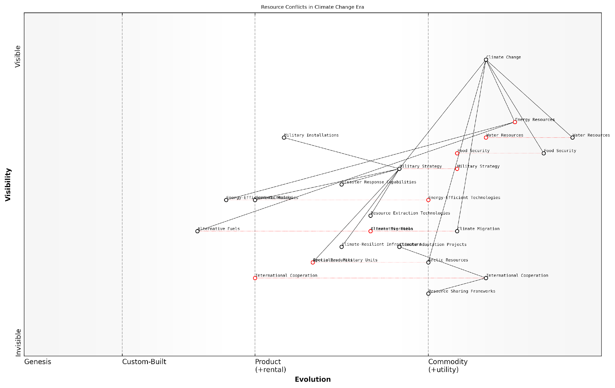

*Draft Wardley Map: [Insert Wardley Map: Climate change and future resource conflicts]*

[Edit this draft Wardley Map](https://create.wardleymaps.ai/#clone:5500d1b41fcbaa2d5d)

Wardley Map Assessment

This map presents a future where climate change significantly reshapes military strategy and resource management. Success will depend on developing advanced climate adaptation capabilities, fostering international cooperation, and securing critical resources. Nations must balance competition for scarce resources with the need for collaborative solutions to global climate challenges. The strategic focus should be on building resilience, innovating in key technological areas, and creating flexible, adaptive strategies for an uncertain climate future.

[View full Wardley Map report](http://markdown/wardley_map_reports/wardley_map_report_52_Climate_change_and_future_resource_conflicts.md)

The economics of climate change adaptation in a military context will also become increasingly important. This includes the need to ‘climate-proof’ military installations, adapt equipment and training for extreme weather conditions, and develop new capabilities for disaster response and humanitarian assistance. These adaptations will require significant investment but are essential for maintaining operational effectiveness in a changing environment.

Furthermore, the shift towards a low-carbon economy will have profound implications for military logistics and energy security. The development of alternative fuels and energy-efficient technologies will become a strategic imperative, not just for environmental reasons, but as a matter of national security. This transition will create new economic opportunities but also potential vulnerabilities that must be carefully managed.

The military that best adapts to the realities of climate change will have a significant strategic and economic advantage in future conflicts.

In conclusion, the intersection of climate change and resource conflicts represents one of the most complex and pressing challenges in the field of battlefield economics. It requires a fundamental reassessment of how we value and allocate resources, both in peacetime and during conflicts. As we move forward, the ability to anticipate, prepare for, and mitigate climate-induced resource conflicts will become a critical determinant of national security and economic stability. The nations and militaries that successfully navigate this new landscape will be those that embrace innovative economic thinking and adaptive strategies in the face of unprecedented environmental change.

## Towards a More Economically Informed Military Strategy

### Integrating economic analysis into military decision-making

As we look towards the future of battlefield economics, the integration of economic analysis into military decision-making processes emerges as a critical factor in shaping effective and sustainable military strategies. This integration represents a paradigm shift in how military leaders and policymakers approach strategic planning, resource allocation, and operational execution.

The traditional approach to military decision-making has often prioritised tactical and operational considerations, sometimes at the expense of long-term economic viability. However, the increasing complexity of modern conflicts, coupled with budgetary constraints and public scrutiny, necessitates a more holistic approach that incorporates robust economic analysis at every level of military planning and execution.

In the 21st century, military success will be as much about economic acumen as it is about battlefield prowess. The commander who fails to consider the economic implications of their decisions is fighting with one arm tied behind their back.

Integrating economic analysis into military decision-making involves several key components:

* Cost-benefit analysis of military operations and strategies
* Long-term economic impact assessments of military interventions
* Resource optimisation and allocation models
* Economic intelligence gathering and analysis
* Incorporation of economic factors into war gaming and scenario planning
* Development of economically sustainable military capabilities

One of the most significant challenges in this integration is the development of analytical frameworks that can effectively bridge the gap between economic theory and military practice. These frameworks must be robust enough to capture the complexities of modern warfare while remaining accessible and actionable for military decision-makers who may not have extensive economic training.

To address this challenge, military organisations are increasingly collaborating with economists, data scientists, and financial analysts to develop sophisticated modelling tools and decision support systems. These tools aim to provide real-time economic insights that can inform tactical and strategic decisions on the battlefield.

The military commander of tomorrow will need to be as comfortable with economic models as they are with tactical maps. Economic literacy is becoming a core competency for effective military leadership.

Another crucial aspect of integrating economic analysis into military decision-making is the cultivation of an organisational culture that values and prioritises economic considerations. This cultural shift requires changes in military education and training programmes, as well as in the criteria used for promotions and leadership selections.

Furthermore, the integration of economic analysis must extend beyond the military itself to encompass the broader defence ecosystem, including defence contractors, research institutions, and policymaking bodies. This holistic approach ensures that economic considerations are embedded throughout the entire cycle of military planning, procurement, and operations.

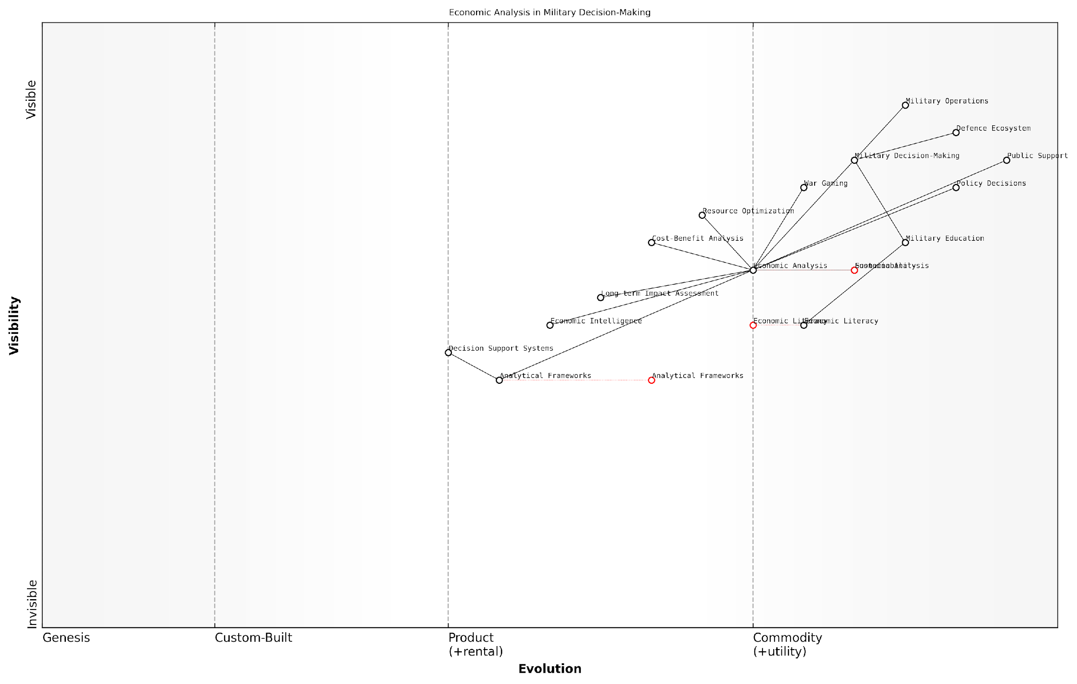

*Draft Wardley Map: [Insert Wardley Map: Integrating economic analysis into military decision-making]*

[Edit this draft Wardley Map](https://create.wardleymaps.ai/#clone:29b267634c2b5ffee6)

Wardley Map Assessment

This Wardley Map reveals a strategic shift towards integrating sophisticated economic analysis into military decision-making. While foundational elements are in place, there are significant opportunities for innovation and capability development, particularly in areas of Economic Intelligence, Decision Support Systems, and Long-term Impact Assessment. Prioritising Economic Literacy and advancing analytical tools will be crucial for maintaining strategic advantage. The evolution towards more economically informed military strategies has the potential to revolutionise warfare, emphasising sustainability and long-term effectiveness over traditional metrics of military success.

[View full Wardley Map report](http://markdown/wardley_map_reports/wardley_map_report_53_Integrating_economic_analysis_into_military_decisi.md)

The benefits of integrating economic analysis into military decision-making are manifold. It enables more efficient use of limited resources, enhances the sustainability of military operations, and improves the ability to predict and mitigate the economic consequences of military actions. Moreover, it provides a common language for military leaders to communicate with political decision-makers and the public, potentially leading to better-informed policy decisions and increased public support for military initiatives.

However, this integration also presents challenges. There is a risk of over-reliance on economic metrics at the expense of other crucial factors such as strategic necessity or humanitarian considerations. Additionally, the inherent unpredictability of warfare means that even the most sophisticated economic models will have limitations.

Economic analysis in military decision-making is not about finding the cheapest option, but about maximising strategic value and long-term sustainability. It’s about fighting smarter, not just cheaper.

As we move forward, the successful integration of economic analysis into military decision-making will require ongoing research, experimentation, and refinement of methodologies. It will necessitate a new generation of military leaders who are as comfortable with economic concepts as they are with military doctrine. Ultimately, this integration has the potential to revolutionise military strategy, leading to more effective, efficient, and sustainable approaches to national defence and global security.

### Balancing economic and security considerations

In the complex landscape of modern warfare, the delicate balance between economic considerations and security imperatives has become increasingly crucial. As an expert in battlefield economics, I have observed firsthand how this balance can significantly impact the effectiveness of military strategies and national security policies. The future of military decision-making lies in the seamless integration of economic analysis with traditional security assessments, creating a holistic approach that maximises both fiscal responsibility and operational effectiveness.

One of the primary challenges in balancing economic and security considerations is the inherent tension between short-term operational needs and long-term fiscal sustainability. Military leaders and policymakers must navigate this tension by adopting a more nuanced approach to resource allocation and strategic planning. This approach requires a deep understanding of both economic principles and security dynamics, as well as the ability to synthesise these often-competing factors into coherent and effective policies.

* Implementing cost-benefit analyses for major military operations and acquisitions
* Developing economic impact assessments for security policies and interventions
* Incorporating economic forecasting into long-term defence planning
* Establishing cross-functional teams of economists and security experts within defence organisations
* Utilising advanced economic modelling techniques to simulate the financial implications of various security scenarios

The integration of economic considerations into security decision-making processes can yield significant benefits. For instance, by conducting thorough economic analyses of proposed military interventions, policymakers can better anticipate and mitigate potential negative economic consequences, both domestically and in the target region. This approach not only enhances the overall effectiveness of military operations but also contributes to more sustainable and stable post-conflict environments.

The future of military strategy lies not in choosing between economic prudence and security imperatives, but in finding innovative ways to achieve both simultaneously. Our national security depends on our ability to leverage economic insights to enhance our military capabilities and strategic decision-making.

However, balancing economic and security considerations is not without its challenges. One of the primary obstacles is the often-divergent time horizons between economic and security objectives. While economic policies typically focus on long-term stability and growth, security imperatives may demand immediate action. Reconciling these temporal differences requires a sophisticated understanding of both domains and the development of flexible, adaptive strategies that can accommodate both short-term security needs and long-term economic goals.

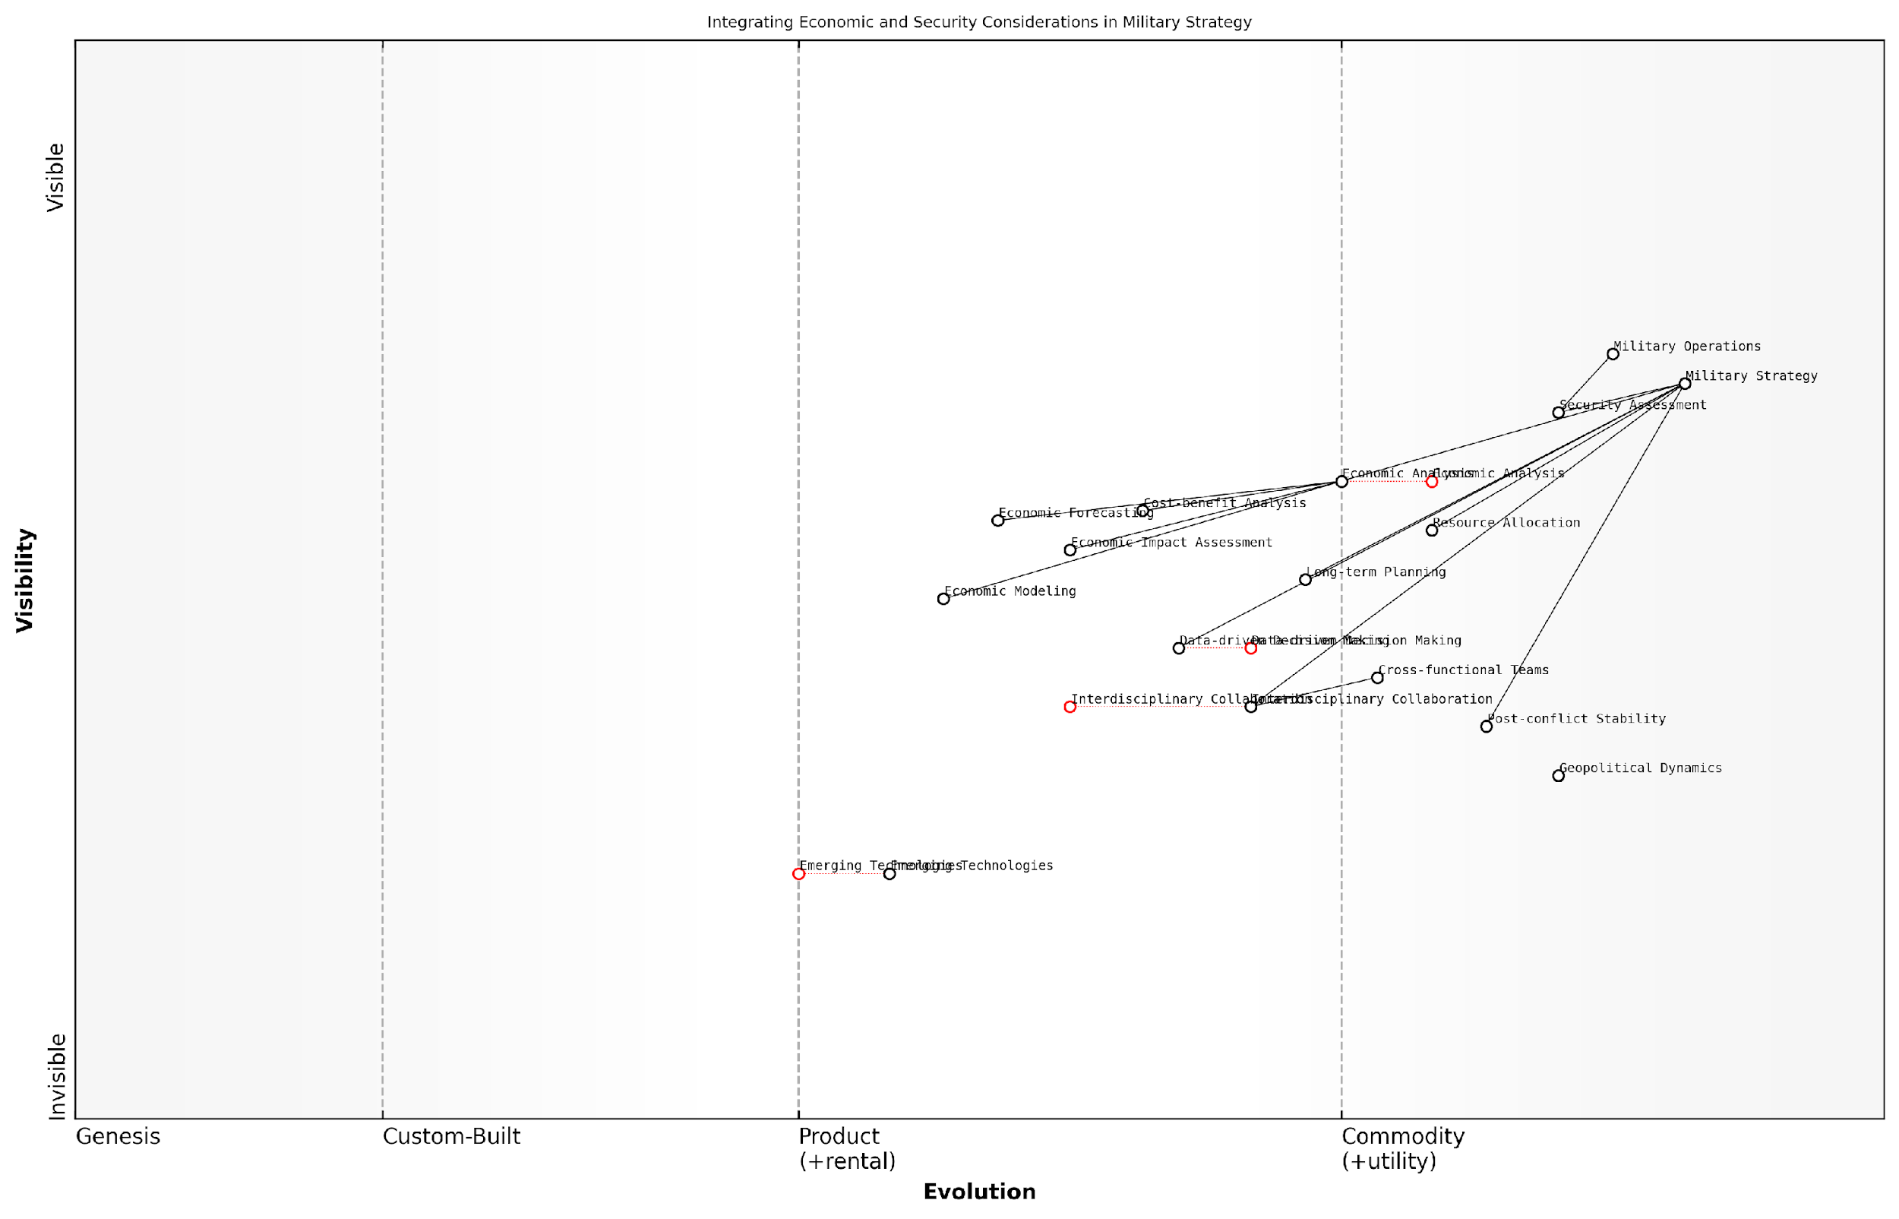

*Draft Wardley Map: [Insert Wardley Map: Balancing economic and security considerations]*

[Edit this draft Wardley Map](https://create.wardleymaps.ai/#clone:2d202974396fa54df1)

Wardley Map Assessment

This Wardley Map reveals a strategic landscape where military strategy is increasingly influenced by economic considerations and technological advancements. The integration of economic analysis into military decision-making represents a significant shift, potentially leading to more comprehensive and sustainable strategic outcomes. Key areas for development include enhancing interdisciplinary collaboration, improving data-driven decision-making processes, and effectively leveraging emerging technologies. The focus on post-conflict stability also indicates a more holistic approach to military strategy that considers long-term economic and social impacts. To maintain strategic advantage, it will be crucial to evolve capabilities in economic modelling and analysis while also staying at the forefront of technological advancements. The map underscores the need for a dynamic, adaptive approach to military strategy that balances immediate security concerns with broader economic considerations and future technological developments.

[View full Wardley Map report](http://markdown/wardley_map_reports/wardley_map_report_54_Balancing_economic_and_security_considerations.md)

Another critical aspect of balancing economic and security considerations is the need for enhanced collaboration between economic experts and military strategists. In my experience advising government bodies, I have found that fostering a culture of interdisciplinary cooperation can lead to more robust and effective decision-making processes. This collaboration can take various forms, from joint training programmes to the establishment of dedicated economic units within military organisations.

* Creating joint economic-military simulation exercises
* Developing specialised training programmes in battlefield economics for military officers
* Establishing economic advisory boards for key military decision-making bodies
* Implementing regular economic impact reviews of ongoing military operations
* Fostering academic partnerships to advance research in the field of battlefield economics

The future of battlefield economics will likely see an increased emphasis on quantitative analysis and data-driven decision-making. Advanced economic modelling techniques, coupled with big data analytics, will enable military leaders to make more informed choices about resource allocation, force structure, and operational planning. However, it is crucial to remember that these tools should complement, rather than replace, human judgement and expertise.

In the coming decades, the most successful military organisations will be those that can seamlessly integrate economic intelligence into their strategic calculus. The ability to balance economic and security considerations will become a key determinant of national power and global influence.

As we look towards the future, it is clear that the relationship between economics and security will continue to evolve. Emerging technologies, changing geopolitical dynamics, and new forms of conflict will present both challenges and opportunities for balancing economic and security considerations. Adaptability and continuous learning will be essential for military organisations and policymakers alike as they navigate this complex landscape.

In conclusion, the effective balancing of economic and security considerations represents a critical frontier in the field of battlefield economics. By embracing this holistic approach, military leaders and policymakers can enhance the effectiveness of their strategies, optimise resource allocation, and ultimately strengthen national security in an increasingly complex and interconnected world. The future of military success lies not just in firepower or technological superiority, but in the intelligent application of economic principles to the art of war.

### The role of economists in shaping future military doctrine

As we look towards the future of military strategy and doctrine, the role of economists in shaping these critical areas is becoming increasingly paramount. The complex interplay between economic factors and military operations necessitates a more integrated approach, where economic expertise is not merely an afterthought but a fundamental component of strategic planning and decision-making.

Economists bring a unique perspective to military doctrine, offering analytical tools and frameworks that can enhance the effectiveness and efficiency of military operations. Their expertise in resource allocation, cost-benefit analysis, and long-term economic forecasting can provide invaluable insights into the sustainability and viability of military strategies. Moreover, as conflicts increasingly involve economic warfare and resource competition, the input of economists becomes crucial in developing comprehensive and resilient military doctrines.

* Developing economic models for conflict scenarios
* Assessing the long-term economic impacts of military strategies
* Optimising resource allocation in military planning
* Analysing the economic dimensions of emerging threats
* Integrating economic considerations into wargaming and simulations

One of the key areas where economists can contribute significantly is in the development of sophisticated economic models tailored to conflict scenarios. These models can help military planners anticipate the economic consequences of various strategic decisions, both for their own forces and for adversaries. By incorporating variables such as resource scarcity, market dynamics, and global economic trends, these models can provide a more holistic view of the battlefield, extending beyond traditional military considerations.

The integration of economic analysis into military planning is not just beneficial, it’s essential for developing robust and adaptable strategies in an increasingly complex global environment.

Furthermore, economists can play a crucial role in assessing the long-term economic impacts of military strategies. This is particularly important in an era where the aftermath of conflicts can have far-reaching economic consequences, affecting not only the nations directly involved but also regional and global economies. By providing insights into potential economic ripple effects, economists can help military strategists develop doctrines that are not only militarily effective but also economically sustainable in the long run.

The optimisation of resource allocation in military planning is another area where economists can make significant contributions. As military budgets face increasing scrutiny and pressures, the need for efficient allocation of resources becomes paramount. Economists can apply principles of opportunity cost and marginal utility to help military planners make informed decisions about investments in personnel, equipment, and technology. This can lead to more cost-effective military doctrines that maximise operational capabilities within budgetary constraints.

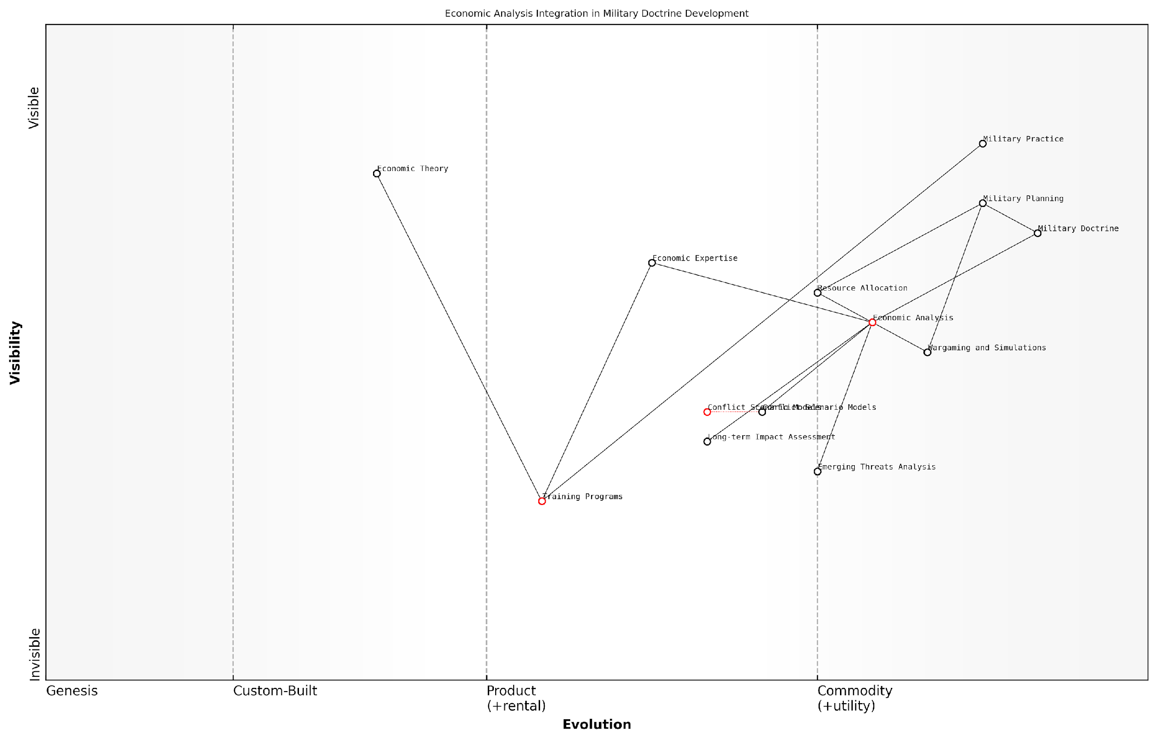

*Draft Wardley Map: [Insert Wardley Map: The role of economists in shaping future military doctrine]*

[Edit this draft Wardley Map](https://create.wardleymaps.ai/#clone:3ce63349a21161ce0e)

Wardley Map Assessment

This Wardley Map reveals a strategic shift towards integrating economic analysis more deeply into military doctrine. The positioning of components suggests a recognition of the importance of economic considerations in modern military strategy. Key opportunities lie in evolving conflict scenario models, enhancing long-term impact assessments, and bridging the gap between economic theory and military practice through improved training programs. The successful evolution of these components could lead to more economically informed and potentially more effective military strategies. However, careful attention must be paid to potential bottlenecks in economic expertise and training. Overall, this map indicates a forward-thinking approach to military doctrine that could provide significant strategic advantages if executed effectively.

[View full Wardley Map report](http://markdown/wardley_map_reports/wardley_map_report_55_The_role_of_economists_in_shaping_future_military_.md)

As new threats emerge in the global landscape, economists can provide valuable insights into their economic dimensions. For instance, in the realm of cyber warfare, economists can help assess the potential economic impacts of cyber attacks and develop strategies for protecting critical economic infrastructure. Similarly, in addressing challenges like climate change and resource scarcity, economists can contribute to military doctrines that account for these economic realities and their potential to spark or exacerbate conflicts.

The integration of economic considerations into wargaming and military simulations represents another frontier where economists can shape future military doctrine. By incorporating economic variables and scenarios into these exercises, military planners can develop a more nuanced understanding of how economic factors can influence conflict outcomes. This can lead to the development of more comprehensive and realistic military doctrines that are better equipped to handle the complexities of modern warfare.

In the future, the most effective military strategists will be those who can seamlessly integrate economic thinking into their tactical and operational planning.

However, for economists to effectively shape future military doctrine, there needs to be a concerted effort to bridge the gap between economic theory and military practice. This may involve developing specialised training programmes that equip economists with a deeper understanding of military operations and strategic thinking. Conversely, military leaders and planners should be encouraged to develop a stronger grounding in economic principles and their applications to military contexts.

In conclusion, the role of economists in shaping future military doctrine is set to grow significantly. As warfare becomes increasingly intertwined with economic factors, the insights and analytical tools provided by economists will be crucial in developing effective, efficient, and sustainable military strategies. By fostering closer collaboration between economists and military strategists, we can create a more holistic approach to military doctrine that is better equipped to navigate the complex challenges of the 21st century battlefield.

# Appendix: Book Generation Details

* Initial Topic: Battlefield Economics: The Hidden Forces Shaping Military Conflicts
* Refined Topic: Battlefield Economics: The Hidden Forces Shaping Military Conflicts
* Total Output Tokens: 0
* Total LLM Cost: $0.00

# Appendix: Further Reading on Wardley Mapping

The following books, primarily authored by Mark Craddock, offer comprehensive insights into various aspects of Wardley Mapping:

## Core Wardley Mapping Series

1. **Wardley Mapping, The Knowledge: Part One, Topographical Intelligence in Business**
   * Author: Simon Wardley
   * Editor: Mark Craddock
   * Part of the Wardley Mapping series (5 books)
   * Available in Kindle Edition
   * [Amazon Link](https://www.amazon.com/dp/B0BVSXB5W5)

* This foundational text introduces readers to the Wardley Mapping approach:
  + Covers key principles, core concepts, and techniques for creating situational maps
  + Teaches how to anchor mapping in user needs and trace value chains
  + Explores anticipating disruptions and determining strategic gameplay
  + Introduces the foundational doctrine of strategic thinking
  + Provides a framework for assessing strategic plays
  + Includes concrete examples and scenarios for practical application
* The book aims to equip readers with:
  + A strategic compass for navigating rapidly shifting competitive landscapes
  + Tools for systematic situational awareness
  + Confidence in creating strategic plays and products
  + An entrepreneurial mindset for continual learning and improvement

1. **Wardley Mapping Doctrine: Universal Principles and Best Practices that Guide Strategic Decision-Making**
   * Author: Mark Craddock
   * Part of the Wardley Mapping series (5 books)
   * Available in Kindle Edition
   * [Amazon Link](https://www.amazon.com/dp/B0C2SFTR7Z)

* This book explores how doctrine supports organisational learning and adaptation:
  + Standardisation: Enhances efficiency through consistent application of best practices
  + Shared Understanding: Fosters better communication and alignment within teams
  + Guidance for Decision-Making: Offers clear guidelines for navigating complexity
  + Adaptability: Encourages continuous evaluation and refinement of practices
* Key features:
  + In-depth analysis of doctrine’s role in strategic thinking
  + Case studies demonstrating successful application of doctrine
  + Practical frameworks for implementing doctrine in various organisational contexts
  + Exploration of the balance between stability and flexibility in strategic planning
* Ideal for:
  + Business leaders and executives
  + Strategic planners and consultants
  + Organisational development professionals
  + Anyone interested in enhancing their strategic decision-making capabilities

1. **Wardley Mapping Gameplays: Transforming Insights into Strategic Actions**
   * Author: Mark Craddock
   * Part of the Wardley Mapping series (5 books)
   * Available in Kindle Edition
   * [Amazon Link](https://www.amazon.com/dp/B0C7CR9R9Q)

* This book delves into gameplays, a crucial component of Wardley Mapping:
  + Gameplays are context-specific patterns of strategic action derived from Wardley Maps
  + Types of gameplays include:
    - User Perception plays (e.g., education, bundling)
    - Accelerator plays (e.g., open approaches, exploiting network effects)
    - De-accelerator plays (e.g., creating constraints, exploiting IPR)
    - Market plays (e.g., differentiation, pricing policy)
    - Defensive plays (e.g., raising barriers to entry, managing inertia)
    - Attacking plays (e.g., directed investment, undermining barriers to entry)
    - Ecosystem plays (e.g., alliances, sensing engines)
* Gameplays enhance strategic decision-making by:
  1. Providing contextual actions tailored to specific situations
  2. Enabling anticipation of competitors’ moves
  3. Inspiring innovative approaches to challenges and opportunities
  4. Assisting in risk management
  5. Optimising resource allocation based on strategic positioning
* The book includes:
  + Detailed explanations of each gameplay type
  + Real-world examples of successful gameplay implementation
  + Frameworks for selecting and combining gameplays
  + Strategies for adapting gameplays to different industries and contexts

1. **Navigating Inertia: Understanding Resistance to Change in Organisations**
   * Author: Mark Craddock
   * Part of the Wardley Mapping series (5 books)
   * Available in Kindle Edition
   * [Amazon Link](https://www.amazon.com/dp/B0C34FX8XC)

* This comprehensive guide explores organisational inertia and strategies to overcome it:
* Key Features:
  + In-depth exploration of inertia in organisational contexts
  + Historical perspective on inertia’s role in business evolution
  + Practical strategies for overcoming resistance to change
  + Integration of Wardley Mapping as a diagnostic tool
* The book is structured into six parts:
  1. Understanding Inertia: Foundational concepts and historical context
  2. Causes and Effects of Inertia: Internal and external factors contributing to inertia
  3. Diagnosing Inertia: Tools and techniques, including Wardley Mapping
  4. Strategies to Overcome Inertia: Interventions for cultural, behavioural, structural, and process improvements
  5. Case Studies and Practical Applications: Real-world examples and implementation frameworks
  6. The Future of Inertia Management: Emerging trends and building adaptive capabilities
* This book is invaluable for:
  + Organisational leaders and managers
  + Change management professionals
  + Business strategists and consultants
  + Researchers in organisational behaviour and management

1. **Wardley Mapping Climate: Decoding Business Evolution**
   * Author: Mark Craddock
   * Part of the Wardley Mapping series (5 books)
   * Available in Kindle Edition
   * [Amazon Link](https://www.amazon.com/dp/B0BVHF2MBH)

* This comprehensive guide explores climatic patterns in business landscapes:
* Key Features:
  + In-depth exploration of 31 climatic patterns across six domains: Components, Financial, Speed, Inertia, Competitors, and Prediction
  + Real-world examples from industry leaders and disruptions
  + Practical exercises and worksheets for applying concepts
  + Strategies for navigating uncertainty and driving innovation
  + Comprehensive glossary and additional resources
* The book enables readers to:
  + Anticipate market changes with greater accuracy
  + Develop more resilient and adaptive strategies
  + Identify emerging opportunities before competitors
  + Navigate complexities of evolving business ecosystems
* It covers topics from basic Wardley Mapping to advanced concepts like the Red Queen Effect and Jevon’s Paradox, offering a complete toolkit for strategic foresight.
* Perfect for:
  + Business strategists and consultants
  + C-suite executives and business leaders
  + Entrepreneurs and startup founders
  + Product managers and innovation teams
  + Anyone interested in cutting-edge strategic thinking

## Practical Resources

1. **Wardley Mapping Cheat Sheets & Notebook**
   * Author: Mark Craddock
   * 100 pages of Wardley Mapping design templates and cheat sheets
   * Available in paperback format
   * [Amazon Link](https://www.amazon.com/dp/B09TPDM9PP)

* This practical resource includes:
  + Ready-to-use Wardley Mapping templates
  + Quick reference guides for key Wardley Mapping concepts
  + Space for notes and brainstorming
  + Visual aids for understanding mapping principles
* Ideal for:
  + Practitioners looking to quickly apply Wardley Mapping techniques
  + Workshop facilitators and educators
  + Anyone wanting to practise and refine their mapping skills

## Specialized Applications

1. **UN Global Platform Handbook on Information Technology Strategy: Wardley Mapping The Sustainable Development Goals (SDGs)**
   * Author: Mark Craddock
   * Explores the use of Wardley Mapping in the context of sustainable development
   * Available for free with Kindle Unlimited or for purchase
   * [Amazon Link](https://www.amazon.com/dp/B09PNKFHG4)

* This specialised guide:
  + Applies Wardley Mapping to the UN’s Sustainable Development Goals
  + Provides strategies for technology-driven sustainable development
  + Offers case studies of successful SDG implementations
  + Includes practical frameworks for policy makers and development professionals

1. **AIconomics: The Business Value of Artificial Intelligence**
   * Author: Mark Craddock
   * Applies Wardley Mapping concepts to the field of artificial intelligence in business
   * [Amazon Link](https://www.amazon.com/dp/B0C6V9VZ9B)

* This book explores:
  + The impact of AI on business landscapes
  + Strategies for integrating AI into business models
  + Wardley Mapping techniques for AI implementation
  + Future trends in AI and their potential business implications
* Suitable for:
  + Business leaders considering AI adoption
  + AI strategists and consultants
  + Technology managers and CIOs
  + Researchers in AI and business strategy

These resources offer a range of perspectives and applications of Wardley Mapping, from foundational principles to specific use cases. Readers are encouraged to explore these works to enhance their understanding and application of Wardley Mapping techniques.

Note: Amazon links are subject to change. If a link doesn’t work, try searching for the book title on Amazon directly.